The DevOps is the combination of two words, one is **Development** and other is **Operations**. It is a culture to promote the development and operation process collectively.

## What is DevOps?

The DevOps is a combination of two words, one is software Development, and second is Operations.

DevOps allows a single team to handle the entire application lifecycle, from development to **testing, deployment**, and **operations**.

DevOps helps you to reduce the disconnection between software developers, quality assurance (QA) engineers, and system administrators.

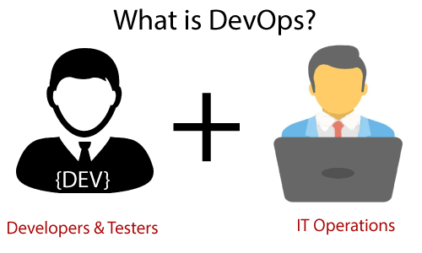

DevOps promotes collaboration between Development and Operations team to deploy code to production faster in an automated & repeatable way.

DevOps has become one of the most valuable business disciplines for enterprises or organizations. With the help of DevOps, **quality**, and **speed** of the application delivery has improved to a great extent.

## Why is DevOps is Needed?

* Before DevOps, The operation and development team worked in complete isolation.
* After the design-build, the testing and deployment are performed respectively. That's why they consumed more time than actual build cycles.
* Without the use of DevOps, the team members are spending a large amount of time on designing, testing, and deploying instead of building the project.
* Manual code deployment leads to human errors in production.
* Coding and operation teams have their separate timelines and are not in synch, causing further delays.

## Why is DevOps used?

DevOps allows Agile Development Teams to implement Continuous Integration and Continuous Delivery. This helps them to launch products faster into the market.

Other Important reasons are:

**1. Predictability:**DevOps offers significantly lower failure rate of new releases

**2. Reproducibility:**Version everything so that earlier version can be restored anytime.

**3. Maintainability:**Effortless process of recovery in the event of a new release crashing or disabling the current system.

**4. Time to market:**DevOps reduces the time to market up to 50% through streamlined software delivery. This is particularly the case for digital and mobile applications.

**5. Greater Quality:**DevOps helps the team to provide improved quality of application development as it incorporates infrastructure issues.

**6. Reduced Risk:**DevOps incorporates security aspects in the software delivery lifecycle. It helps in reduction of defects across the lifecycle.

**7. Resiliency:**The Operational state of the software system is more stable, secure, and changes are auditable.

**8. Cost Efficiency:**DevOps offers cost efficiency in the software development process which is always an aspiration of IT companies’ management.

**9. Breaks larger code base into small pieces:**DevOps is based on the agile programming method. Therefore, it allows breaking larger code bases into smaller and manageable chunks.

## DevOps Lifecycle

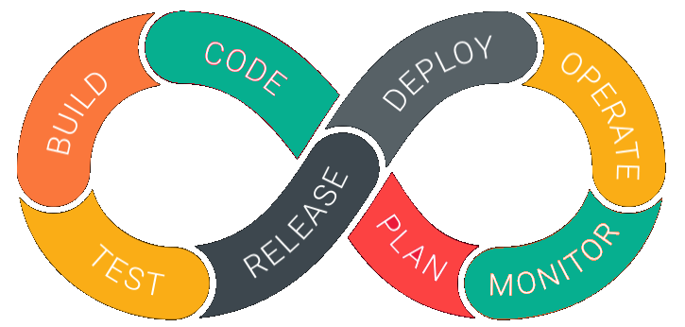

DevOps is deep integration between development and operations. Understanding DevOps Concepts is not possible without knowing DevOps lifecycle.

**1. Development**

In this DevOps stage the development of software takes place constantly. In this phase, the entire development process is separated into small development cycles. This benefits DevOps team to speed up software development and delivery process.

**2. Testing**

QA team use tools like Selenium to identify and fix bugs in the new piece of code.

**3. Integration**

In this stage, new functionality is integrated with the prevailing code, and testing takes place. Continuous development is only possible due to continuous integration and testing.

**4. Deployment**

In this phase, the deployment process takes place continuously. It is performed in such a manner that any changes made any time in the code, should not affect the functioning of high traffic website.

**5. Monitoring**

In this phase, operation team will take care of the inappropriate system behavior or bugs which are found in production.

## How is DevOps different from Agile? DevOps Vs Agile

Stakeholders and communication chain a typical IT process.

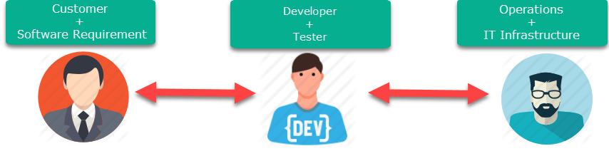

Agile addresses gaps in Customer and Developer communications

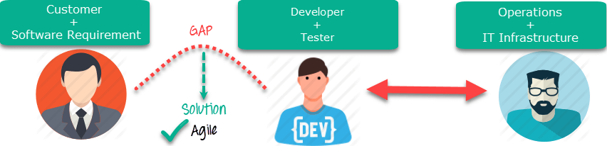Agile Process

DevOps addresses gaps in Developer and IT Operations communications

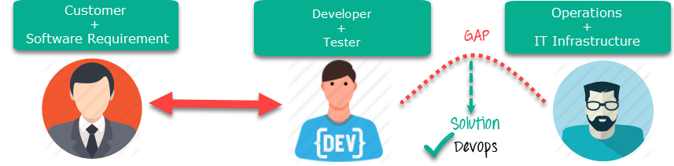DevOps Process

## DevOps Principles

Here, are six principles which are essential when adopting DevOps:

**1. Customer-Centric Action:**DevOps team must take customer-centric action for that they should constantly invest in products and services.

**2. End-To-End Responsibility:**The DevOps team need to provide performance support until they become end-of-life. This enhances the level of responsibility and the quality of the products engineered.

**3. Continuous Improvement:**DevOps culture focuses on continuous improvement to minimize waste. It continuously speeds up the improvement of product or services offered.

**4. Automate everything:**Automation is a vital principle of DevOps process. This is not only for the software development but also for the entire infrastructure landscape.

**5. Work as one team:**In the DevOps culture role of the designer, developer, and tester are already defined. All they needed to do is work as one team with complete collaboration.

**6. Monitor and test everything:**It is very important for DevOps team to have a robust monitoring and testing procedures.

## Who is a DevOps Engineer?

A DevOps Engineer is an IT professional who works with software developers, system operators, and other production IT staff to administer code releases. DevOps should have hard as well as soft skills to communicate and collaborate with development, testing, and operations teams.

DevOps approach needs frequent, incremental changes to code versions, which means frequent deployment and testing regimens. Although DevOps engineers need to code occasionally from scratch, it is important that they should have the basics of software development languages.

A DevOps engineer will work with development team staff to tackle the coding and scripting needed to connect elements of code, like libraries or software development kits.

**Roles, Responsibilities, and Skills of a DevOps Engineer**

DevOps engineers work full-time. They are responsible for the production and ongoing maintenance of a software application’s platform.

Following are some expected Roles, Responsibilities, and Skills that is expected from DevOps engineer:

* Able to perform system troubleshooting and problem-solving across platform and application domains.
* Manage project effectively through open, standards-based platforms
* Increase project visibility thought traceability
* Improve quality and reduce development cost with collaboration
* Analyse, design and evaluate automation scripts & systems
* Ensuring critical resolution of system issues by using the best cloud security solutions services
* DevOps engineer should have the soft skill of problem-solver and quick-learner

## DevOps Architecture Features

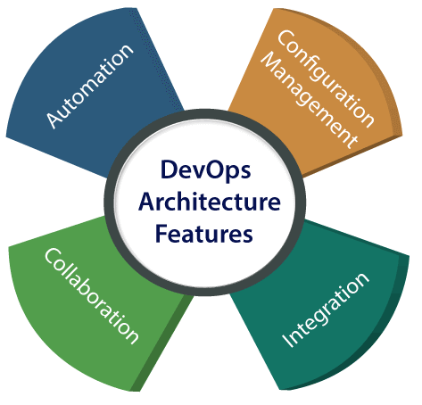

### **Automation**

Automation can reduce time consumption, especially during the testing and deployment phase. The productivity increases, and releases are made quicker by automation. This will lead in catching bugs quickly so that it can be fixed easily. For contiguous delivery, each code is defined through automated tests, cloud-based services, and builds. This promotes production using automated deploys.

### **2) Collaboration**

The Development and Operations team collaborates as a DevOps team, which improves the cultural model as the teams become more productive with their productivity, which strengthens accountability and ownership. The teams share their responsibilities and work closely in sync, which in turn makes the deployment to production faster.

### **3) Integration**

Applications need to be integrated with other components in the environment. The integration phase is whore the existing code is combined with new functionality and then tested. Continuous integration and testing enable continuous development. The frequency in the releases and micro-services leads to significant operational challenges. To overcome such problems, continuous integration and delivery are implemented to deliver in a **quicker, safer**, and **reliable manner**.

### **4) Configuration management**

It ensures the application to interact with only those resources that are concerned with the environment in which it runs. The configuration files are not created where the external configuration to the application is separated from the source code. The configuration file can be written during deployment, or they can be loaded at the run time, depending on the environment in which it is running.

## DevOps Advantages and Disadvantages

Here are some advantages and disadvantages that DevOps can have for business, such as:

### **Advantages**

* DevOps is an excellent approach for quick development and deployment of applications.
* It responds faster to the market changes to improve business growth.
* DevOps escalate business profit by decreasing software delivery time and transportation costs.
* DevOps clears the descriptive process, which gives clarity on product development and delivery.
* It improves customer experience and satisfaction.
* DevOps simplifies collaboration and places all tools in the cloud for customers to access.
* DevOps means collective responsibility, which leads to better team engagement and productivity.

### **Disadvantages**

* DevOps professional or expert's developers are less available.
* Developing with DevOps is so expensive.
* Adopting new DevOps technology into the industries is hard to manage in short time.
* Lack of DevOps knowledge can be a problem in the continuous integration of automation projects.