The DevOps is the combination of two words, one is **Development** and other is **Operations**. It is a culture to promote the development and operation process collectively.

DevOps tools such as **Git, Ansible, Docker, Puppet, Jenkins, Chef, Nagios**, and **Kubernetes**.

What is DevOps?

The DevOps is a combination of two words, one is software Development, and second is Operations.

DevOps allows a single team to handle the entire application lifecycle, from development to **testing, deployment**, and **operations**.

DevOps helps you to reduce the disconnection between software developers, quality assurance (QA) engineers, and system administrators.

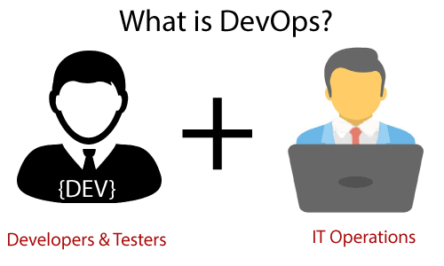

DevOps promotes collaboration between Development and Operations team to deploy code to production faster in an automated & repeatable way.

DevOps has become one of the most valuable business disciplines for enterprises or organizations. With the help of DevOps, **quality**, and **speed** of the application delivery has improved to a great extent.

## Why DevOps?

Before going further, we need to understand why we need the DevOps over the other methods.

* The operation and development team worked in complete isolation.
* After the design-build, the testing and deployment are performed respectively. That's why they consumed more time than actual build cycles.
* Without the use of DevOps, the team members are spending a large amount of time on designing, testing, and deploying instead of building the project.
* Manual code deployment leads to human errors in production.
* Coding and operation teams have their separate timelines and are not in synch, causing further delays.

## DevOps Architecture Features

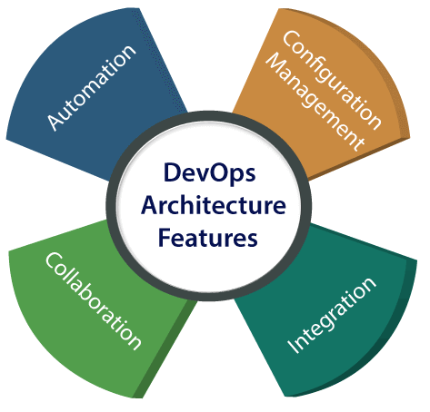

### **Automation**

Automation can reduce time consumption, especially during the testing and deployment phase. The productivity increases, and releases are made quicker by automation. This will lead in catching bugs quickly so that it can be fixed easily. For contiguous delivery, each code is defined through automated tests, cloud-based services, and builds. This promotes production using automated deploys.

### **2) Collaboration**

The Development and Operations team collaborates as a DevOps team, which improves the cultural model as the teams become more productive with their productivity, which strengthens accountability and ownership. The teams share their responsibilities and work closely in sync, which in turn makes the deployment to production faster.

### **3) Integration**

Applications need to be integrated with other components in the environment. The integration phase is whore the existing code is combined with new functionality and then tested. Continuous integration and testing enable continuous development. The frequency in the releases and micro-services leads to significant operational challenges. To overcome such problems, continuous integration and delivery are implemented to deliver in a **quicker, safer**, and **reliable manner**.

### **4) Configuration management**

It ensures the application to interact with only those resources that are concerned with the environment in which it runs. The configuration files are not created where the external configuration to the application is separated from the source code. The configuration file can be written during deployment, or they can be loaded at the run time, depending on the environment in which it is running.

## DevOps Advantages and Disadvantages

Here are some advantages and disadvantages that DevOps can have for business, such as:

### **Advantages**

* DevOps is an excellent approach for quick development and deployment of applications.
* It responds faster to the market changes to improve business growth.
* DevOps escalate business profit by decreasing software delivery time and transportation costs.
* DevOps clears the descriptive process, which gives clarity on product development and delivery.
* It improves customer experience and satisfaction.
* DevOps simplifies collaboration and places all tools in the cloud for customers to access.
* DevOps means collective responsibility, which leads to better team engagement and productivity.

### **Disadvantages**

* DevOps professional or expert's developers are less available.
* Developing with DevOps is so expensive.
* Adopting new DevOps technology into the industries is hard to manage in short time.
* Lack of DevOps knowledge can be a problem in the continuous integration of automation projects.