**Docker vs. VM**

The significant differences between docker containers and virtual machines. are their operating system support, security, portability, and performance.

**Operating System Support**

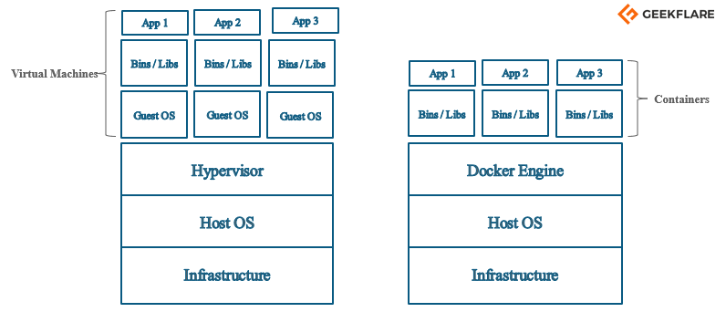

The operating system support of Virtual machine and Docker container is very different. From the image above, you can see each virtual machine has its guest operating system above the host operating system, which makes virtual machines heavy. While on the other hand, Docker containers share the host operating system, and that is why they are lightweight.

Sharing the host operating system between the containers make them very light and helps them to boot up in just a few seconds. Hence, the overhead to manage the container system is very low compared to that of virtual machines.

The docker containers are suited for situations where you want to run multiple applications over a single operating system kernel. But if you have applications or servers that need to run on different operating system flavors, then virtual machines are required.

**Security**

The virtual machine does no share operating system, and there is strong isolation in the host kernel. Hence, they are more secure as compared to Containers. A container have a lot of security risks, and vulnerabilities as the containers have shared host kernel.

Also, since docker resources are shared and not namespaced, an attacker can exploit all the containers in a cluster if he/she gets access to even one container. In a virtual machine, you don’t get direct access to the resources, and hypervisor is there to restrict the usage of resources in a VM.

**Portability**

Docker containers are easily portable because they do not have separate operating systems. A container can be ported to a different OS, and it can start immediately. On the other hand, virtual machines have separate OS, so porting a virtual machine is difficult as compared to containers, and it also takes a lot of time to port a virtual machine because of its size.

For development purposes where the applications must be developed and tested in different platforms, Docker containers are the ideal choice.

**Performance**

Comparing Virtual machines and Docker Containers would not be fair because they both are used for different purposes. But the lightweight architecture of docker its less resource-intensive feature makes it a better choice than a virtual machine. As a result, of which containers can startup very fast compared to that of virtual machines, and the resource usage varies depending on the load or traffic in it.

Unlike the case of virtual machines, there is no need to allocate resources permanently to containers. Scaling up and duplicating the containers is also an easy task compared to that of virtual machines, as there is no need to install an operating system in them.

|  |  |
| --- | --- |
| **Virtual Machine** | **Docker Container** |
| Hardware-level process isolation | OS level process isolation |
| Each VM has a separate OS | Each container can share OS |
| Boots in minutes | Boots in seconds |
| VMs are of few GBs | Containers are lightweight (KBs/MBs) |
| Ready-made VMs are difficult to find | Pre-built docker containers are easily available |
| VMs can move to new host easily | Containers are destroyed and re-created rather than moving |
| Creating VM takes a relatively longer time | Containers can be created in seconds |
| More resource usage | Less resource usage |