Docker for Windows

Docker has out-of-the-box support for Windows, but you need to have the following configuration in order to install Docker for Windows.

System Requirements

|  |  |
| --- | --- |
| Windows OS | Windows 10 64 bit |
| Memory | 2 GB RAM (recommended) |

You can download Docker for Windows from − <https://docs.docker.com/docker-for-windows/>

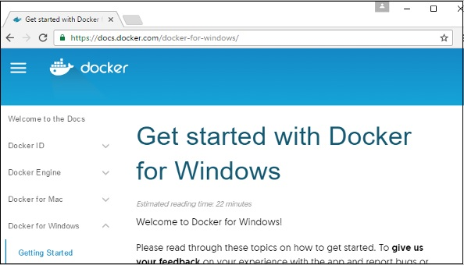

Docker ToolBox

Docker ToolBox has been designed for older versions of Windows, such as Windows 8.1 and Windows 7. You need to have the following configuration in order to install Docker for Windows.

System Requirements

|  |  |
| --- | --- |
| Windows OS | Windows 7 , 8, 8.1 |
| Memory | 2 GB RAM (recommended) |
| Virtualization | This should be enabled. |

You can download Docker ToolBox from − <https://www.docker.com/products/docker-toolbox>

