Push & Pull from Docker Hub Registry

---------------------------------------------------

#1. Create an account in <http://hub.docker.com>, which is public Docker Image registry

Say username is vskreddy187

#2. Build an image using your docker client, with below command

docker build -t vskreddy187/abcddd .

#3. Now login to docker hub using below command

docker login

Now it asks for username, password of docker hub, enter them, to successfully login

#4. Push your image to DOcker hub using below command

docker push vskreddy187/abcddd

#5. Verify if pushed image exists in docker hub, as shown below

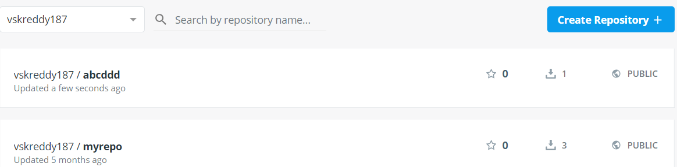

#6. Now delete image locally, using below command

docker rmi vskreddy187/abcddd

#7. Now pull image from docker hub using below command

docker pull vskreddy187/abcddd

#8. Now verify if pulle dimage exists locally

docker image ls

Note: Some organizations use private Docker registries, to maintain their internal Docker images