What is Continuous Integration?

Continuous Integration is a development practice that requires developers to integrate code into a shared repository at regular intervals.

Jenkins is a popular tool for performing continuous integration of software projects.

Jenkins is a powerful application that allows continuous integration and continuous delivery of projects, regardless of the platform you are working on.

Jenkins is a free source that can handle any kind of build or continuous integration.

Jenkins will be installed on a server where the central build will take place.

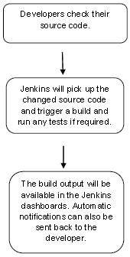

## What is Jenkins Pipeline

In Jenkins, a pipeline is a group of events or jobs which are interlinked with one another in a sequence.

In simple words, Jenkins Pipeline is a combination of plugins that support the integration and implementation of **continuous delivery pipelines** using Jenkins.

### What is Continuous Delivery Pipelines? How it Works?

In a Jenkins pipeline, every job or event has some sort of dependency on at least one or more events.

[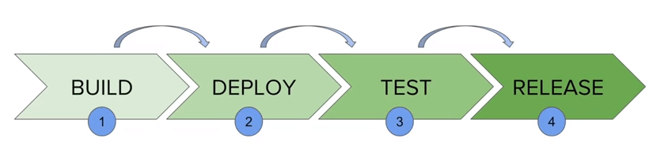](https://www.guru99.com/images/1/091318_0510_JenkinsPipe1.png)

The picture above represents a continuous delivery pipeline in Jenkins. It contains a group of states called build, deploy, test and release. These events are interlinked with each other. Every state has its events, which work in a sequence called a continuous delivery pipeline.

Jenkins Pipeline Concepts

**Pipeline**

The pipeline is a set of instructions given in the form of code for continuous delivery and consists of instructions needed for the entire build process. With pipeline, you can build, test, and deliver the application.

**Stage**

A stage block contains a series of steps in a pipeline. That is, the build, test, and deploy processes all come together in a stage. Generally, a stage block is used to visualize the Jenkins pipeline process.

**Step**

A step is nothing but a single task that executes a specific process at a defined time. A pipeline involves a series of steps.