Install Express.js
Firstly, you have to install the express framework globally to create web application using Node terminal. Use the following command to install express framework globally.
- npm install -g express
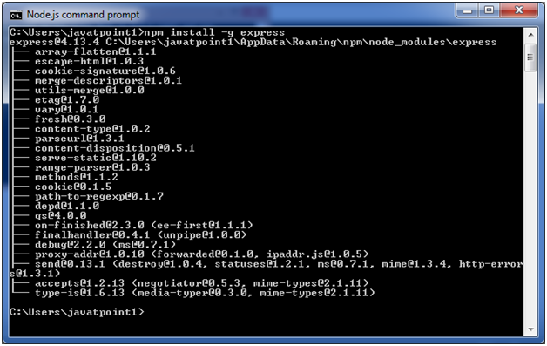

Installing Express
Use the following command to install express:
- npm install express --save
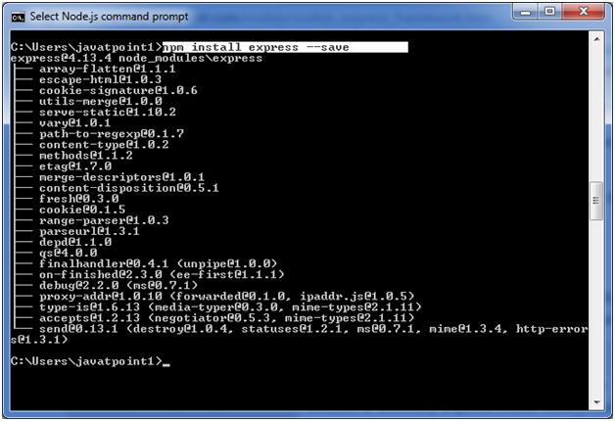
The above command install express in node_module directory and create a directory named express inside the node_module. You should install some other important modules along with express. Following is the list:
- body-parser: This is a node.js middleware for handling JSON, Raw, Text and URL encoded form data.
- cookie-parser: It is used to parse Cookie header and populate req.cookies with an object keyed by the cookie names.
- multer: This is a node.js middleware for handling multipart/form-data.
- npm install body-parser --save
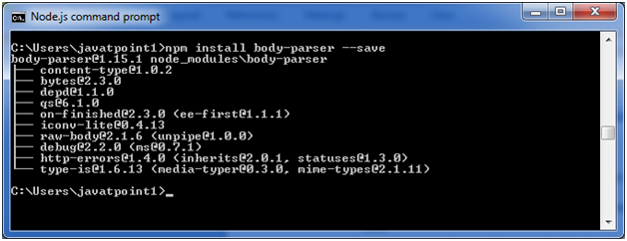
- npm install cookie-parser --save
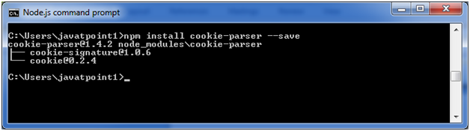
- npm install multer --save
