Express.js Middleware
- Middleware functions as the name suggests can be used to make changes in the request/response lifecycle of the express.
- Middleware functions execute before sending the response back to the user. You can use multiple middleware functions chained together and they execute in a order.
- Express.js Middleware are functions that are invoked by the Express.js routing before the request handler.
- As the name specified, Middleware appears in the middle between an initial request and final intended route.
- In stack, middleware functions are always invoked in the order in which they are added.
- ExpressJS is a simple HTTP server and it does not come with a lot of features out of the box. Middleware act almost like extensions for the Express server and provide additional functionalities in the "middle" of a request.
- Many third-party extenssions like morgan for logging, multer for handling file uploads, are used routinely.
- Middleware is commonly used to perform tasks like body parsing for URL-encoded or JSON requests, cookie parsing for basic cookie handling, or even building JavaScript modules on the fly.
- Express will execute the middleware in the order it is initialized.

What is a Middleware function
- Middleware functions are the functions that access to the request and response object (req, res) in request-response cycle.
- A middleware function can perform the following tasks:
  - It can execute any code.
  - It can make changes to the request and the response objects.
  - It can end the request-response cycle.
  - It can call the next middleware function in the stack.

Express.js Middleware
Following is a list of possibly used middleware in Express.js app:
- Application-level middleware
- Router-level middleware
- Error-handling middleware
- Built-in middleware
- Third-party middleware
Application middleware example:
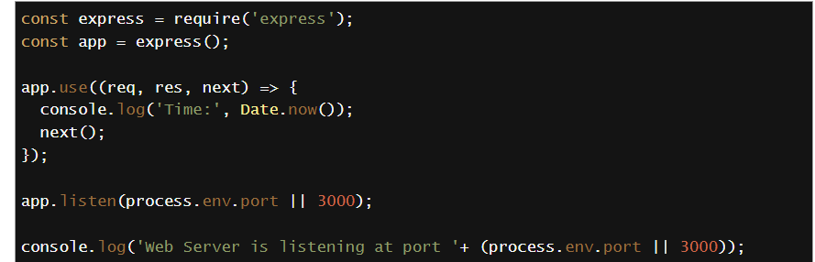
Router middleware example:
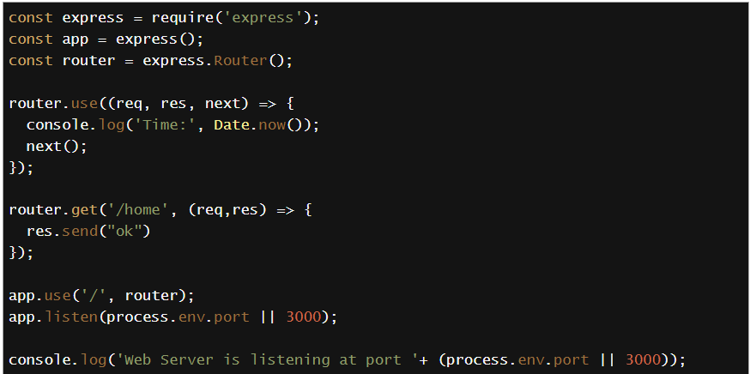
Error middleware example
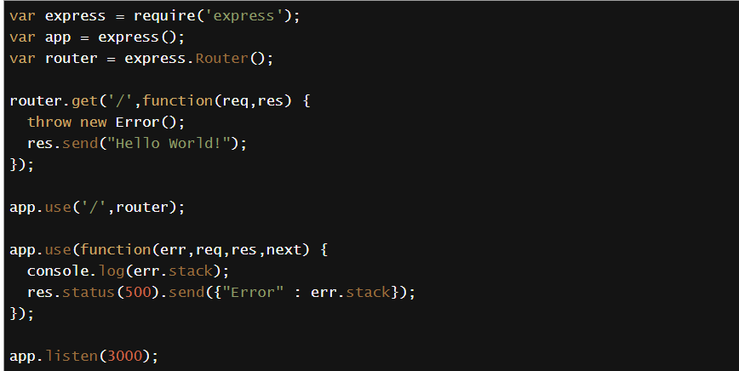
Built in middleware
express.static()
express.json()
express.urlencoded()

Third-party middleware
body-parser(npm install --save body-parser)
