Node.js Console

The Node.js console module provides a simple debugging console similar to JavaScript console mechanism provided by web browsers.

There are three console methods that are used to write any node.js stream:

1. console.log()
2. console.error()
3. console.warn()

Node.js console.log()

The console.log() function is used to display simple message on console.

*File: console_example1.js*

52.1M

953

Java Try Catch

1. console.log('Hello JavaTpoint');

Open Node.js command prompt and run the following code:

1. node console_example1.js

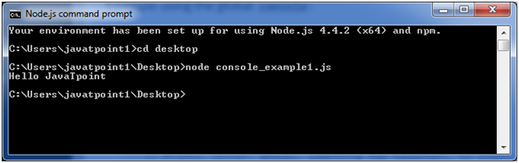

We can also use format specifier in console.log() function.

*File: console_example2.js*

1. console.log('Hello %s', NodeJs);

Open Node.js command prompt and run the following code:

1. node console_example2.js

Node.js console.error()

The console.error() function is used to render error message on console.

*File: console_example3.js*

1. console.error(**new** Error('Hell! This is a wrong method.'));

Open Node.js command prompt and run the following code:

1. node console_example3.js

Node.js console.warn()

The console.warn() function is used to display warning message on console.

*File: console_example4.js*

1. **const** name = 'John';
2. console.warn(`Don't mess with me ${name}! Don't mess with me!`);

Open Node.js command prompt and run the following code:

1. node console_example4.js