# NodeJs

* Node.js is an open-source server-side runtime environment built on Chrome's V8 JavaScript engine.
* Node.js is a cross-platform environment and library for running JavaScript applications which is used to create networking and server-side applications.
* Node.js is an open source, cross-platform JavaScript runtime environment.
* ***Open-source-source code is publicly available for sharing and modification.***
* Node.js is a very powerful JavaScript-based platform It is used to develop I/O intensive web applications like video streaming sites, single-page applications, and other web applications.
* It is open source and free to use. It can be downloaded from this link <https://nodejs.org/en/>
* Node.js is used by thousands of developers around the world.
* Many of the basic modules of Node.js are written in JavaScript. Node.js is mostly used to run real-time server applications.
* Node.js also provides a rich library of various JavaScript modules to simplify the development of web applications.
* Node.js = Runtime Environment + JavaScript Library
* Node.js can be used to build different types of applications such as command line application, web application, single page applications, REST API etc. similar to PHP, Java, or ASP.NET.
* Node.js is an open source, cross-platform runtime environment for developing server-side and networking applications. Node.js applications are written in JavaScript, and can be run within the Node.js runtime on OS X, Microsoft Windows, and Linux.
* Node.js was written and introduced by Ryan Dahl in 2009.
* Node.js also provides a rich library of various JavaScript modules which simplifies the development of web applications using Node.js to a great extent.
* Node.js = Runtime Environment + JavaScript Library

# Why learn Node.Js?

* Build end-to-end JavaScript applications.
* Majority of companies are migrated to NodeJS as a backend technology.
* Huge community support

# Prerequisites

* JavaScript fundamentals
* Advanced JavaScript
* ES2015(ES6) topics

# JavaScript Engine

* JavaScript code we write cannot be understood by the computer
* A JavaScript engine is a program that converts javascript code that developers write into machine code that allows a computer to perform specific tasks.
* JavaScript engines are typically developed by web browser vendors
  + V8- Open-source JavaScript engine developed by Google for chrome
  + SpiderMonkey- The JavaScript engine for Mozilla Firefox
  + JavaScriptCore- Open-source JavaScript engine developed by Apple for Safari
  + Chakra- A JavaScript Engine for the original Microsoft Edge(The latest version of edge uses V8)

# JavaScript Runtime

* JavaScript runtime is an environment which provides all the necessary components in order to use and run a JavaScript program
* Every browser has a JavaScript Engine
* A Javascript Engine is one component in the JavaScript Runtime

# What can you build with Node.js

* Traditional websites
* Backend services like APIs
* Real-time applications
* Streaming services
* CLI tools
* Multilayer games

# Features of Node.js

* **Asynchronous and Event Driven** − All APIs of Node.js library are asynchronous, that is, non-blocking. It essentially means a Node.js based server never waits for an API to return data. The server moves to the next API after calling it and a notification mechanism of Events of Node.js helps the server to get a response from the previous API call.
* **Very Fast** − Being built on Google Chrome's V8 JavaScript Engine, Node.js library is very fast in code execution.
* **Single Threaded but Highly Scalable** − Node.js uses a single threaded model with event looping. Event mechanism helps the server to respond in a non-blocking way and makes the server highly scalable as opposed to traditional servers which create limited threads to handle requests. Node.js uses a single threaded program and the same program can provide service to a much larger number of requests than traditional servers like Apache HTTP Server.
* **No Buffering** − Node.js applications never buffer any data. These applications simply output the data in chunks.
* **Open source:**Node.js has an open source community which has produced many excellent modules to add additional capabilities to Node.js applications.
* **License** − Node.js is released under the [MIT license](https://raw.githubusercontent.com/joyent/node/v0.12.0/LICENSE).

# Advantages of Node.js

* Node.js is an open-source framework under MIT license. (MIT license is a free software license originating at the Massachusetts Institute of Technology (MIT).)
* Uses JavaScript to build entire server side application.
* Lightweight framework that includes bare minimum modules. Other modules can be included as per the need of an application.
* Asynchronous by default. So it performs faster than other frameworks.
* Cross-platform framework that runs on Windows, MAC or Linux

# Setup Node.js Development Environment

Node.js development environment can be setup in Windows, Mac, Linux and Solaris. The following tools/SDK are required for developing a Node.js application on any platform.

1. Node.js
2. Node Package Manager (NPM)( NPM (Node Package Manager) is included in Node.js installation since Node version 6.0., so there is no need to install it separately.)
3. IDE (Integrated Development Environment)

**Different parts of Node.js**

The following diagram depicts some important parts of Node.js

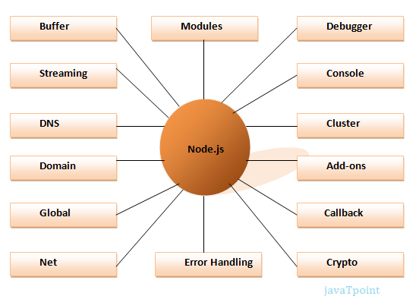

A Node.js application consists of the following three important components −

* **Import required modules** − We use the **require** directive to load Node.js modules.
* **Create server** − A server which will listen to client's requests similar to Apache HTTP Server.
* **Read request and return response** − The server created in an earlier step will read the HTTP request made by the client which can be a browser or a console and return the response.