Install ReactJS

There are two ways to set up an environment for successful ReactJS application.

* Using the npm command
  1. Install NodeJS and NPM
  2. Install React and React DOM
  3. Install Webpack
  4. Install Babel
* Using the create-react-app command
  1. Install NodeJS and NPM
  2. Install React
     1. npm install -g create-react-app

**How to create ReactJS APP**

**using npx**

* npx is npm package runner
* it gets installed when you install npm
* npx create-react-app app-name

**using npm**

* install create-react-app package globally (npm install -g create-react-app -g)
* create-react-app app-name

**Folder-Structure**

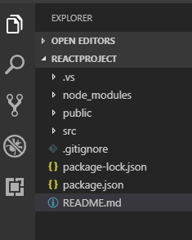

In React application, there are several files and folders in the root directory. Some of them are as follows:

1. **node_modules:** It contains the React library and any other third party libraries needed.
2. **public:** It holds the public assets of the application. It contains the index.html where React will mount the application by default on the <div id="root"></div> element.
3. **src:** It contains the App.css, App.js, App.test.js, index.css, index.js, and serviceWorker.js files. Here, the App.js file always responsible for displaying the output screen in React.
4. **package-lock.json:** It is generated automatically for any operations where npm package modifies either the node modules tree or package.json. It cannot be published. It will be ignored if it finds any other place rather than the top-level package.
5. **package.json:** It holds various metadata required for the project. It gives information to npm, which allows to identify the project as well as handle the project’s dependencies.
6. **README.md:** It provides the documentation to read about React topics.