React Redux

**Redux is a pattern and library for managing and updating application state, using events called "actions".**

 It serves as a centralized store for state that needs to be used across your entire application.

Redux is an open-source JavaScript library used to manage application state.

React uses Redux for building the user interface.

It allows React components to read data from a Redux Store, and dispatch **Actions** to the **Store** to update data.

Redux helps apps to scale by providing a sensible way to manage state through a unidirectional data flow model.

React Redux is conceptually simple. It subscribes to the Redux store, checks to see if the data which your component wants have changed, and re-renders your component.

## **Why use React Redux?**

* React Redux is the official **UI bindings** for react Application. It is kept up-to-date with any API changes to ensure that your React components behave as expected.
* It encourages good 'React' architecture.
* It implements many performance optimizations internally, which allows to components re-render only when it actually needs.

## **Redux Architecture**

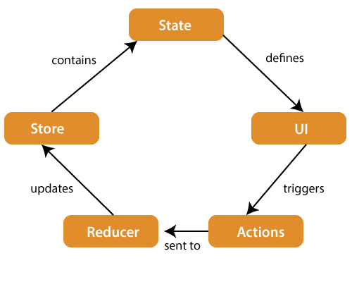

## **Redux Installation**

**Requirements:** React Redux requires React 16.8.3 or later version.

To use React Redux with React application, you need to install the below command.

npm install redux react-redux --save

Redux is more useful when:

* You have large amounts of application state that are needed in many places in the app
* The app state is updated frequently over time
* The logic to update that state may be complex
* The app has a medium or large-sized codebase, and might be worked on by many people