**ReactJS | Router**

**React Router** is a standard library for routing in React. It enables the navigation among views of various components in a React Application, allows changing the browser URL, and keeps the UI in sync with the URL.

Your development environment is ready. Let us now install React Router in our Application.

**Installing React Router:** React Router can be installed via [npm](https://www.geeksforgeeks.org/node-js-npm-node-package-manager/) in your React application. Follow the steps given below to install Router in your React application:

* **Step 1:** [cd](https://www.geeksforgeeks.org/cd-command-in-linux-with-examples/) into your project directory i.e **geeks**.
* **Step 2:** To install the React Router use the following command:

***npm install – -save react-router-dom***

After installing react-router-dom, add its components to your React application.

**Adding React Router Components:** The main Components of React Router are:

* **BrowserRouter:** BrowserRouter is a router implementation that uses the HTML5 history API(pushState, replaceState and the popstate event) to keep your UI in sync with the URL. It is the parent component that is used to store all of the other components.
* **Routes:** It’s a new component introduced in the v6 and a upgrade of the component. The main advantages of Routes over Switch are:
  + Relative s and s
  + Routes are chosen based on the best match instead of being traversed in order.
* **Route:** Route is the conditionally shown component that renders some UI when its path matches the current URL.
* **Link:** Link component is used to create links to different routes and implement navigation around the application. It works like HTML [anchor tag](https://www.geeksforgeeks.org/html-a-tag/).

To add React Router components in your application, open your project directory in the editor you use and go to **app.js** file. Now, add the below given code in app.js.

|  |
| --- |
| import {      BrowserRouter as Router,      Routes,      Route,      Link  } from 'react-router-dom'; |

**Note:** BrowserRouter is aliased as Router.

**Using React Router:** To use React Router, let us first create few components in the react application. In your project directory, create a folder named **component** inside the src folder and now add 3 files named **home.js**, **about.js** and **contact.js** to the component folder.  
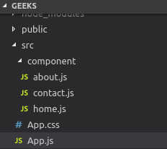  
Let us add some code to our 3 components:

* **Home.js:**

|  |
| --- |
| import React from 'react';    **function** Home (){  **return** <h1>Welcome to the world of Geeks!</h1>  }    export **default** Home; |

* **About.js:**

|  |
| --- |
| import React from 'react';    **function** About () {  **return** <div>          <h2>GeeksforGeeks is a computer science portal **for** geeks!</h2>            Read more about us at :          <a href="<https://www.geeksforgeeks.org/about/>">              https://www.geeksforgeeks.org/about/          </a>      </div>  }  export **default** About; |

* **Contact.js:**

|  |
| --- |
| import React from 'react';    **function** Contact (){  **return** <address>              You can find us here:<br />              GeeksforGeeks<br />              5th & 6th Floor, Royal Kapsons, A- 118, <br />              Sector- 136, Noida, Uttar Pradesh (201305)          </address>  }    export **default** Contact; |

Now, let us include React Router components to the application:

* **BrowserRouter:** Add BrowserRouter aliased as Router to your app.js file in order to wrap all the other components. BrowserRouter is a parent component and can have only single child.

|  |
| --- |
| class App extends Component {    render() {  **return** (         <Router>             <div className="App">             </div>         </Router>     );    }  } |

* **Link:** Let us now create links to our components. Link component uses the **to** prop to describe the location where the links should navigate to.

|  |
| --- |
| <div className="App">      <ul>        <li>          <Link to="/">Home</Link>        </li>        <li>          <Link to="/about">About Us</Link>        </li>        <li>          <Link to="/contact">Contact Us</Link>        </li>      </ul>  </div> |

* Now, run your application on the local host and click on the links you created. You will notice the url changing according the value in **to** props of the Link component.  
  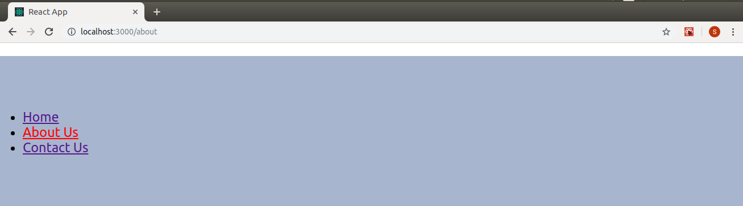
* **Route:** Route component will now help us to establish the link between component’s UI and the URL. To include routes to the application, add the code give below to your app.js.

|  |
| --- |
| <Route exact path='/' element={< Home />}></Route>  <Route exact path='/about' element={< About />}></Route>  <Route exact path='/contact' element={< Contact />}></Route> |

* Components are linked now and clicking on any link will render the component associated with it.  
  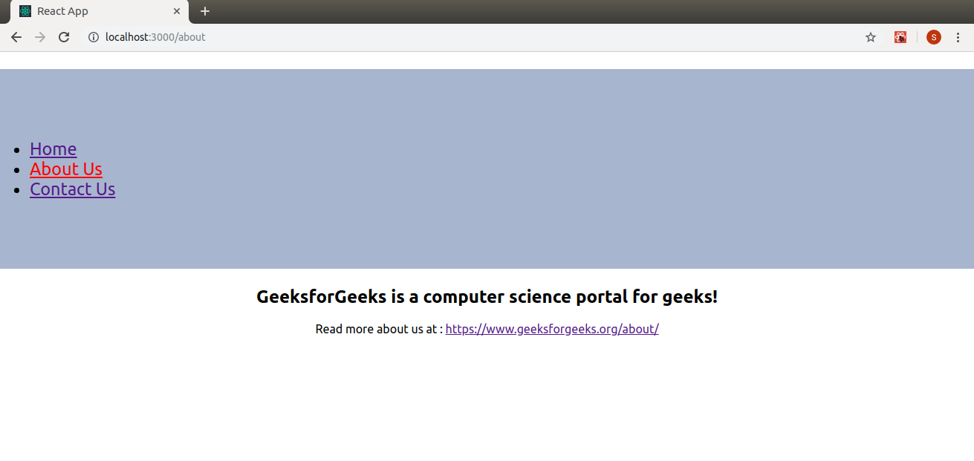  
  Let us now try to understand the props associated with the Route component.
  + **1.exact:** It is used to match the exact value with the URL. For Eg., exact path=’/about’ will only render the component if it exactly matches the path but if we remove exact from the syntax, then UI will still be rendered even if the strucute is like /about/10.  
    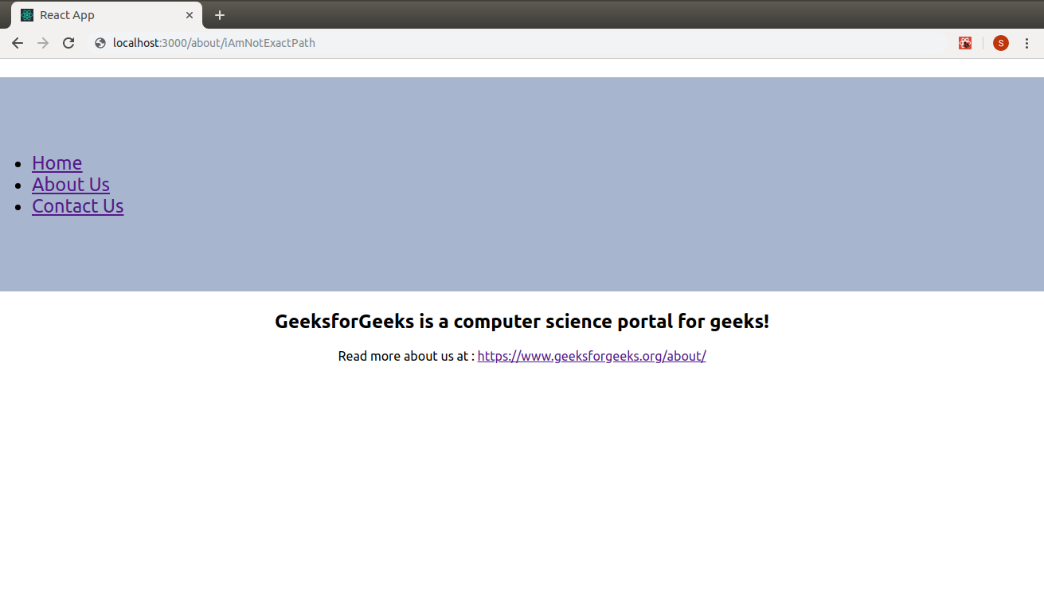
  + **2. path:** Path specifies a pathname we assign to our component.
  + **3. element:** It refers to the component which will render on matching the path.

**Note:** By default, routes are inclusive which means more than one Route component can match the URL path and render at the same time. If we want to render a single component, we need to use **routes**.

* **Routes:** To render a single component, wrap all the routes inside the Routes Component.

|  |
| --- |
| <Routes>      <Route exact path='/' element={< Home />}></Route>      <Route exact path='/about' element={< About />}></Route>      <Route exact path='/contact' element={< Contact />}></Route>  </Routes> |

* Switch groups together several routes, iterates over them and finds the first one that matches the path. Thereby, the corresponding component to the path is rendered.

After adding all the components here is our complete source code:

|  |
| --- |
| import React, { Component } from 'react';  import { BrowserRouter as Router,Routes, Route, Link } from 'react-router-dom';  import Home from './component/home';  import About from './component/about';  import Contact from './component/contact';  import './App.css';    class App extends Component {    render() {  **return** (         <Router>             <div className="App">              <ul className="App-header">                <li>                  <Link to="/">Home</Link>                </li>                <li>                  <Link to="/about">About Us</Link>                </li>                <li>                  <Link to="/contact">Contact Us</Link>                </li>              </ul>             <Routes>                   <Route exact path='/' element={< Home />}></Route>                   <Route exact path='/about' element={< About />}></Route>                   <Route exact path='/contact' element={< Contact />}></Route>            </Routes>            </div>         </Router>     );    }  }    export **default** App; |

Now, we you can click on the links and navigate to different components. React Router keeps your application UI in sync with the URL.  
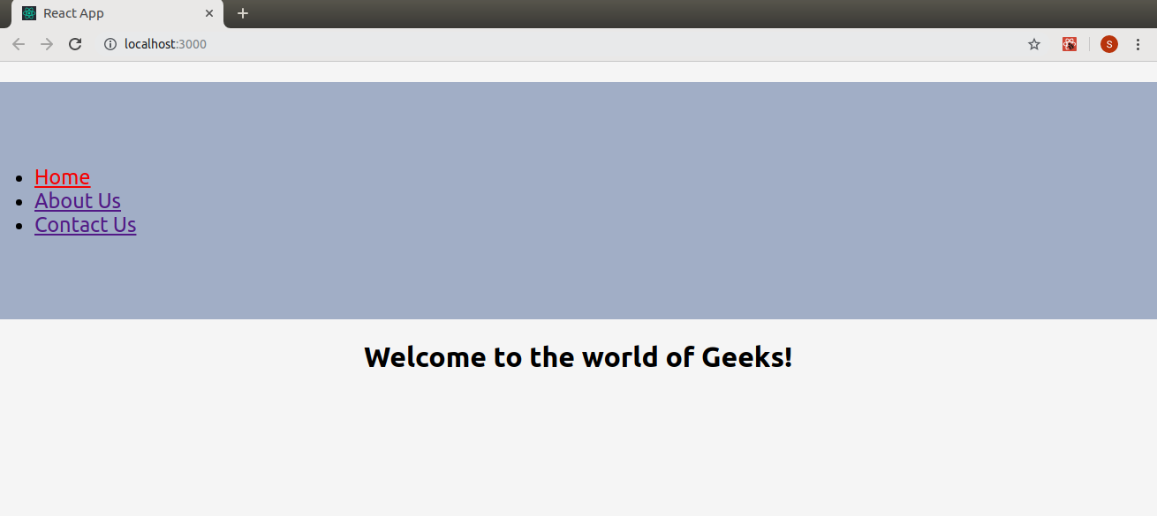  
  
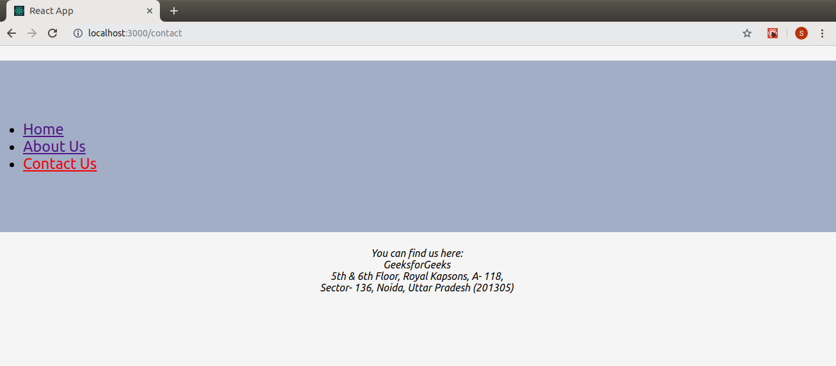  
Finally, we have successfully implemented navigation in our React application using React Router.