**Exersice No 1**

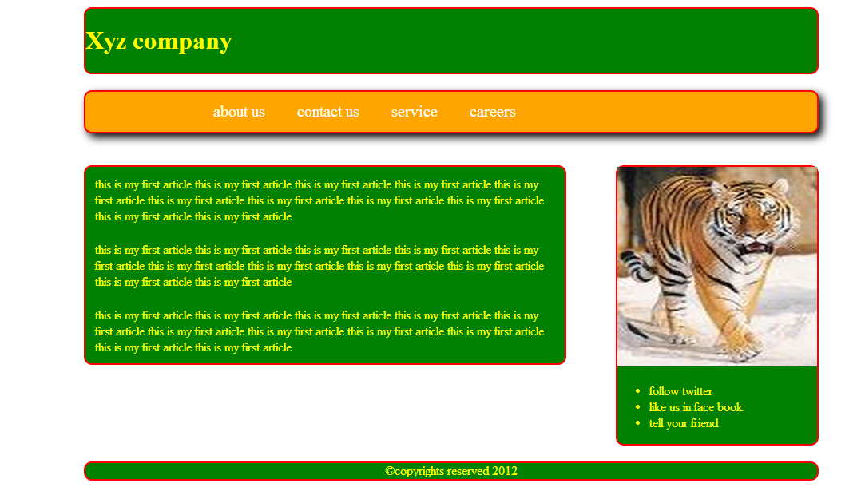

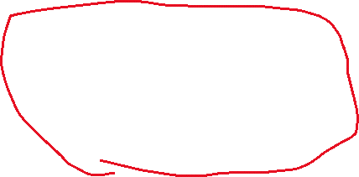

Design the page for the following layout having header, footer, navigation(menu bar), articles, aside(side bar)

