***Name: Santushti Sharma***

***Roll No. : 10314802719***

***(B-34)***

***College : MAIT***

***Introduction to***

***Programming***

**Experiment-1**

**Aim:** To write a program to print ‘Hello world’.

**Program:**

#include <stdio.h>

#include <conio.h>

void main(){

clrscr();

printf(“Hello world”);

getch();

}

**Output**

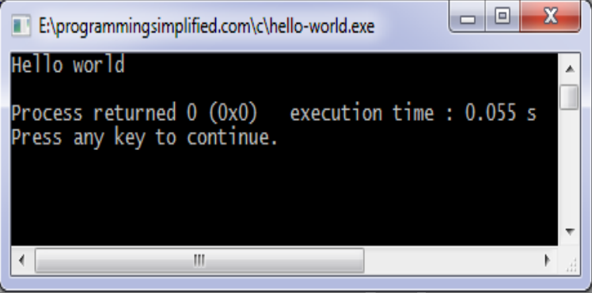

**Experiment-2**

**Aim:** To write a program to print sum of 2 numbers.

**Program:**

#include <stdio.h>

#include <conio.h>

int main(){

float a, b, sum;

clrscr();

printf(“Enter two numbers to add”);

scanf(“%f”, &a);

scanf(“%f”, &b);

sum = a + b;

printf(“Sum of entered numbers = %f”, sum);

return 0;

}

**Output**

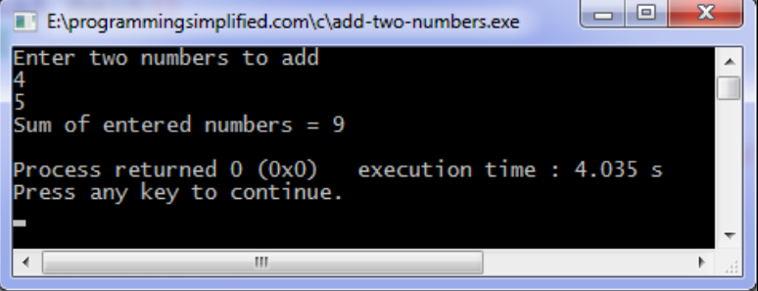

**Experiment-3**

**Aim:** To perform all the basic mathematical operations( i.e., +, -, /, * )

**Program:**

#include <stdio.h>

#include <conio.h>

int main(){

float a, b, sum, prod, div, sub;

clrscr();

printf(“Enter two integers”);

scanf(“%f%f”, &a, &b);

sum = a + b;

prod = a * b;

div = a / b;

sub = a – b;

printf(“Sum = %f”, sum);

printf(“\n Difference = %f”, sub);

printf(“\n Multiplication = %f”, prod);

printf(“\n Division = %f”, div);

return 0;

}

**Output**

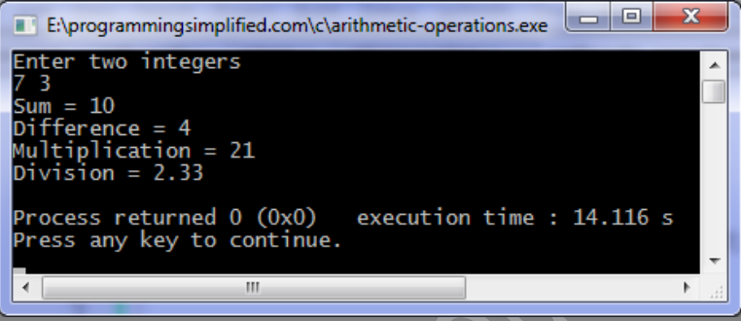

**Experiment-4**

**Aim:** To write a program to solve the following equation where a and b are the input from user

**C = 2a + b/a – (a/2.5)* b *(a/3 – b)**

**Program:**

#include <stdio.h>

#include <conio.h>

int main(){

float a, b, c;

printf("Enter the value of a: ");

scanf(“%f”, &a);

printf("\n Enter the value of b: ");

scanf("%f", &b);

c = (2)*(a)+(b/a) – (a/(2.5))*(b)*((a/3)- b);

printf("\n The value af c is =%f", c):

return 0;

}

**Output**

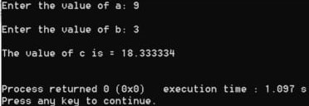

**Experiment-5**

**Aim:** To write a program to print the ASCII value of the character entered by the user.

**Program:**

#include <stdio.h>

#include <conio.h>

int main(){

char word;

printf(“Enter a character :”);

scanf(“%c”, &word);

printf(“The ASCII value of %c is %d”, word, word);

return 0;

}

**Output**

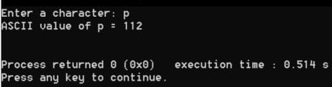

**Experiment-6**

**Aim:** To write a program to find whether the number entered by user is positive, negative or zero.

**Program:**

#include <stdio.h>

#include <conio.h>

int main(){

int num;

printf(“Enter a number :”);

scanf(“%d”, &num);

if(num < 0)

printf(“It’s a negative number!”);

else if(num > 0)

printf(“It’s a positive number!”);

else

printf(“It’s a zero!”);

return 0;

}

**Output**

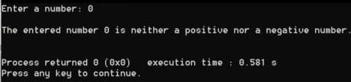

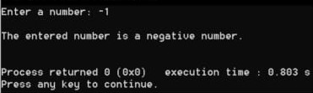

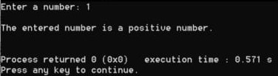

**Experiment-7**

**Aim:** To write a program to find whether the number entered by user is odd or even.

**Program:**

#include <stdio.h>

#include <conio.h>

int main(){

int num;

printf(“Enter an integer:”);

scanf(“%d”, &num);

if(num%2 == 0)

printf(“%d is an even number”, num);

else

printf(“%d is an odd number”, num);

return 0;}

**Output**

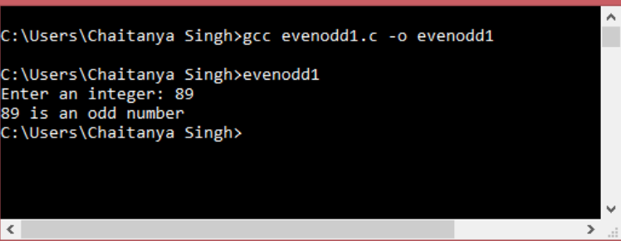

**Experiment-8**

**Aim:** To write a program to find the largest of three numbers entered by the user.

**Program:**

#include <stdio.h>

#include <conio.h>

int main(){

int a, b, c;

printf(“Enter the first number:”);

scanf(“%d”, &a);

printf(“Enter the second number:”);

scanf(“%d”, &b);

printf(“Enter the third number:”);

scanf(“%d”, &c);

if(a>b)

{

If(a>c)

printf(“Greatest number is %d”, a);

else

printf(“Greatest number is %d”, c);

}

else

{

If(b>c)

printf(“Greatest number is %d”, b);

else

printf(“Greatest number is %d”, c);;

}

return 0;

}

**Output**

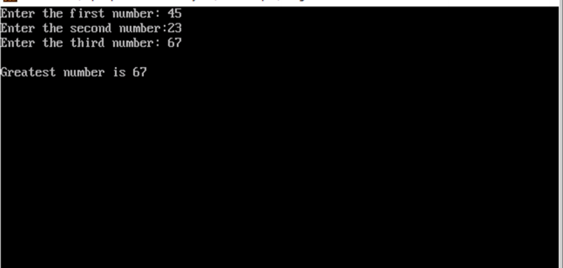

**Experiment-9**

**Aim:** To write a program to swap two numbers without using third variable.

**Program:**

#include <stdio.h>

#include <conio.h>

int main(){

int a, b;

printf(“Enter the value of x and y respectively.”);

scanf(“%d”, &a);

scanf(“%d”, &b);

printf(“Before Swapping: \n”);

printf(“x = %d \n y = %d \n”, a, b);

printf(“After Swapping: \n”);

a = a + b;

b = a – b;

a = a – b;

printf(“x = %d \n y = %d ”, a, b);

return 0;

}

**Output**

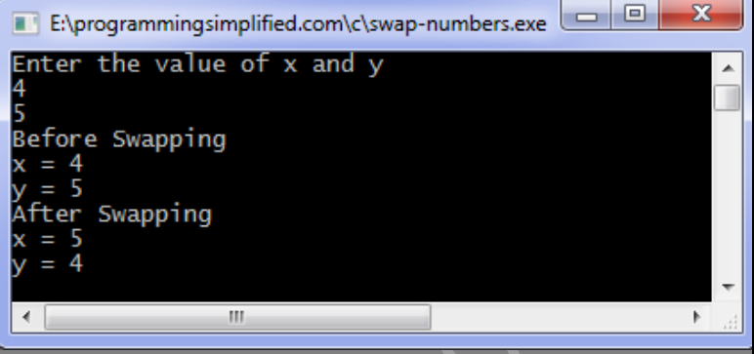

**Experiment-10**

**Aim:** To write a program to convert temperature in Fahrenheit to Degree Celsius.

**Program:**

#include <stdio.h>

#include <conio.h>

int main(){

int temp;

printf(“Enter the temperature in Fahrenheit:”);

scanf(“%f”, &temp);

temp =

printf(“Temperature in degree Celsius: %d C”, temp);

return 0;

}

**Output**

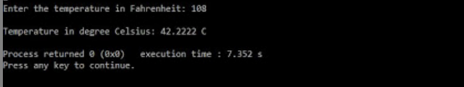

**Experiment-11**

**Aim:** To write a program to find whether a string entered by a user is palindrome or not.

**Program:**

#include <stdio.h>

#include <conio.h>

int main(){

int n, rev = 0, rem, originalN;

printf(“Enter a three-digit integer: ")

scanf( “%d”, &n);

originalN = n;

while (n != 0){

rem = n % 10;

rev = rev * 10 + rem;

n /= 10;

}

if (originalN == rev)

printf("\n The entered three-digit number %d is a palindrome.", originalN);

else

printf(“\n The entered three-digit number %d is not a palindrome.", originalN);

return 0;

}

**Output**

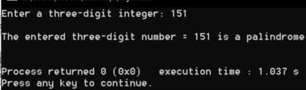

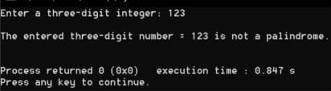

**Experiment-12**

**Aim:** To write a program to find the quadratic equation roots entered by user.

**Program:**

#include <stdio.h>

#include <conio.h>

#imclude <maths.h>

int main(){

double a, b, c, discriminant, root1, root2, realPart, imagPart;

printf("Enter the value of a (Coefficient of x2 of the quadratic equation ax2+bx+c = 0):”);

scanf(“ %lf”, &a);

printf("\n Enter the value of b (Coefficient of x of the quadratic equation ax2+bx+c = 0):");

scanf("%lf", &b);

printf("\n Enter the value of c (Constant term of the quadratic equation ax2+bx+c = 0): ");

scanf(“%lf”, &c);

if (discriminant> 0){

rootl = (-b + sqrt(discriminant))/ (2 * a) ;

root2 = (-b - sqrt(discriminant)/ (2 * a) ;

printf("The value of first real root r1 of the quadratic equation ax2+bx+c =0 is = %lf", root1);

printf("The value of second real root r2 of the quadratic equation ax2+bx+c = 0 is %lf", root2);

}

else if (discriminant == 0){

root2 = -b/(2*a);

root1 = root2;

printf("The value of both first and second real root of the quadratic equation ax2+bx+c =0 is same and is equal to r1 = r2 = %lf", root1);

}

else{

realPart = -b/(2* a);

imagPart = sqrt(-discriminant)/ (2 *a);

printf(“The value of first imaginary root r1 of the quadratic equation ax2+bx+c = 0 is = %lf + %lf", realPart, imagPart);

printf("\n The value of second imaginary root r2 of the quadratic equation ax2+bx+c=0 is =%lf - %lf”, realPart, imagPart);}

return 0;}

**Output**

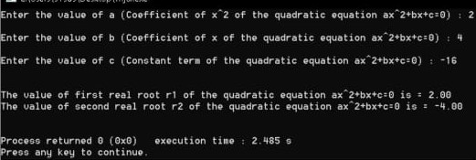

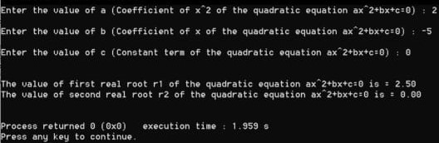

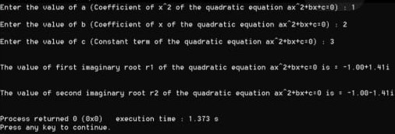

**Experiment-13**

**Aim:** Write a program to print the factorial of given number.

**Program:**

#include <stdio.h>

#include <conio.h>

int main(){

int num, ans = 1;

printf(“Enter a number :”);

scanf(“%d”, &num);

for(int i = num; i > 1; --i)

{

ans *= i;

}

printf(“Factorial of %d is %d”, num, ans);

return 0;

}

**Output**

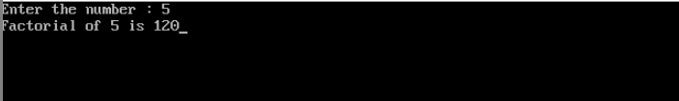

**Experiment-14**

**Aim:** Write a program to evaluate the following algebraic expression after reading the necessary values from user.

**Program:**

#include <stdio.h>

#include <conio.h>

int main(){

clrscr();

int a,b,x,m,n,y;

float r,z,e;

printf("Enter the numbers a,b,x :\n");

scanf("%d",&a); scanf("%d",&b);

scanf("%d",&x);

r=((a*x)+b)/((a*x)-b);

printf("r =%f",r);

printf("\nEnter the numbers m,n :\n");

scanf("%d",&m);

scanf("%d",&n);

z=2.5*log(m)-cos(3.14/6)+(pow(m,2)-pow(n,2))+sqrt(2*m*n);

printf("z =%f",z);

printf("\nEnter the number y :\n");

scanf("%d",&y);

e=pow(y,5)+10*pow(y,4)+8*pow(y,3)+4*y+2;

printf("e =%f",e);

return 0;

}

**Output**

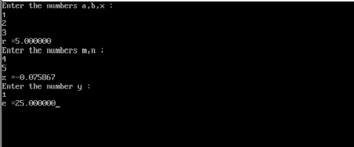

**Experiment-15**

**Aim:** Write a program to find the sum of geometric series.

**Program:**

#include <stdio.h>

#include <conio.h>

#include <maths.h>

int main(){

clrscr();

int a, r, s = 0, n, t;

printf("Enter the first term, common ratio and the number of terms of the series :\n");

scanf("%d%d%d", &a, &r, &n);

t = a;

s = a;

printf("The terms of the Geometric Progression are :\n");

printf("%d, ", a);

for( int i = 0; i < n; ++i)

{t*=r;

s+=t;

if (i < (n -1))

printf(“%d”, t);

}

printf(“The sum of the progression is: %d”, s);

return 0;

}

**Output**

