**C++ Language Basic**

**Why Learn C++?**

40 years ago, a Ph.D. student by the name of Bjarne Stroustrup tinkered around with the C programming language, which was and still is a language well-respected for its flexibility and low-level functionality. Little did he know, he created a new language that can now be found in:

* Operating systems
* Web browsers
* Microcontrollers
* Video games
* And elsewhere!

#### Take-Away Skills

This course will start with the fundamental programming concepts before digging deeper into the more advanced C++ topics. You will build everything.

Take a look at the **hello.cpp** file in the code editor that is placed in the middle of the screen. It’s a C++ program!

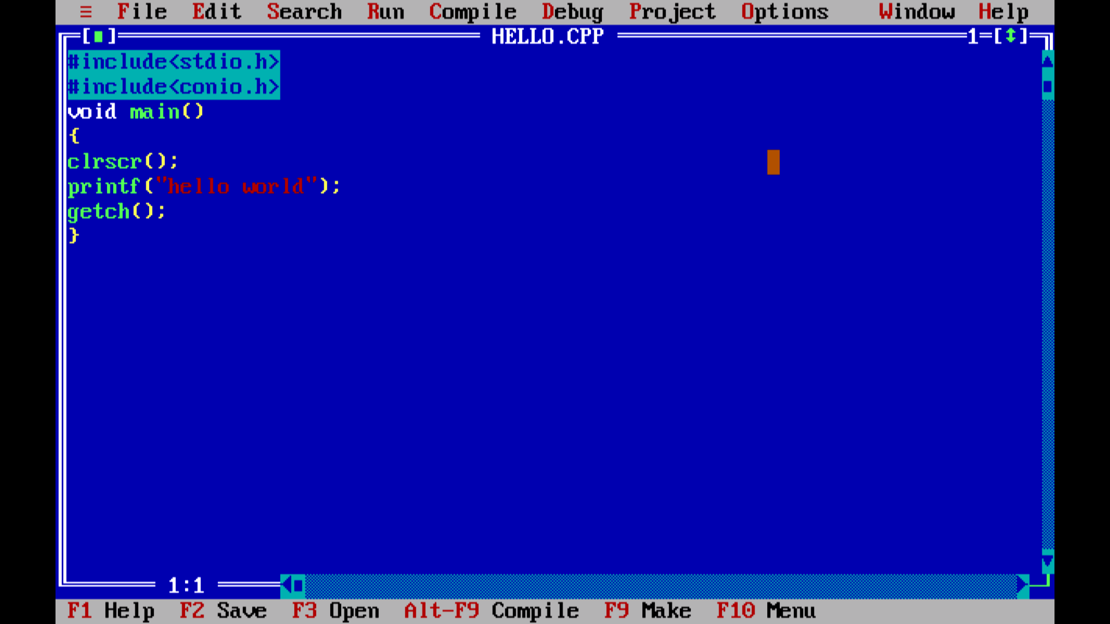

C++ programs are stored in files which usually have the file extension **.cpp** which simply stands for “C Plus Plus”.

The code inside our C++ file is a classic first step all new programmers take — they greet the world through the terminal!

The *terminal* is the black panel on the right. It should be blank right now. The code in the text editor will print text out onto the terminal. More specifically, it will print the phrase hello world.

The output of the program is below-



C++, like most programming languages, runs line by line, from top to bottom. Here is the structure of a C++ program:

#

#include <stdio.h>

#include<conio.h>

Void main()

Clrscr();

{

Printf(“hello world”);

getch();

}

**Header files**

**Clear Screen**

**Code → Save → Compile → Execute**

C++ is a compiled language. That means that to get a C++ program to run, you must first translate it from a human-readable form to something a machine can “understand.” That translation is done by a program called a *compiler*.

When you program in C++, you mainly go through 4 phases during development:

1. **Code** — writing the program
2. **Save** — saving the program
3. **Compile** — compiling via the terminal
4. **Execute** — executing via the terminal

And repeat (debug the errors if needed).

**C LANGUAGE**

**C programming** language is a MUST for students and working professionals to become a great Software Engineer specially when they are working in Software Development Domain. I will list down some of the key advantages of learning C Programming:

* Easy to learn
* Structured language
* It produces efficient programs
* It can handle low-level activities
* It can be compiled on a variety of computer platforms

# **Facts about C**

* C was invented to write an operating system called UNIX.
* C is a successor of B language which was introduced around the early 1970s.
* The language was formalized in 1988 by the American National Standard Institute (ANSI).
* The UNIX OS was totally written in C.
* Today C is the most widely used and popular System Programming Language.
* Most of the state-of-the-art software have been implemented using C.

**PROGRAM**

Here is a program of C Language where addition of two numbers is shown.

In the first picture we have written the code for the addition of two numbers .

* Write the C program here we have used turbo c++ for programming you can choose as per your choice.
* Then save the program.
* After that go through with the compilation process.
* Finally execute the program

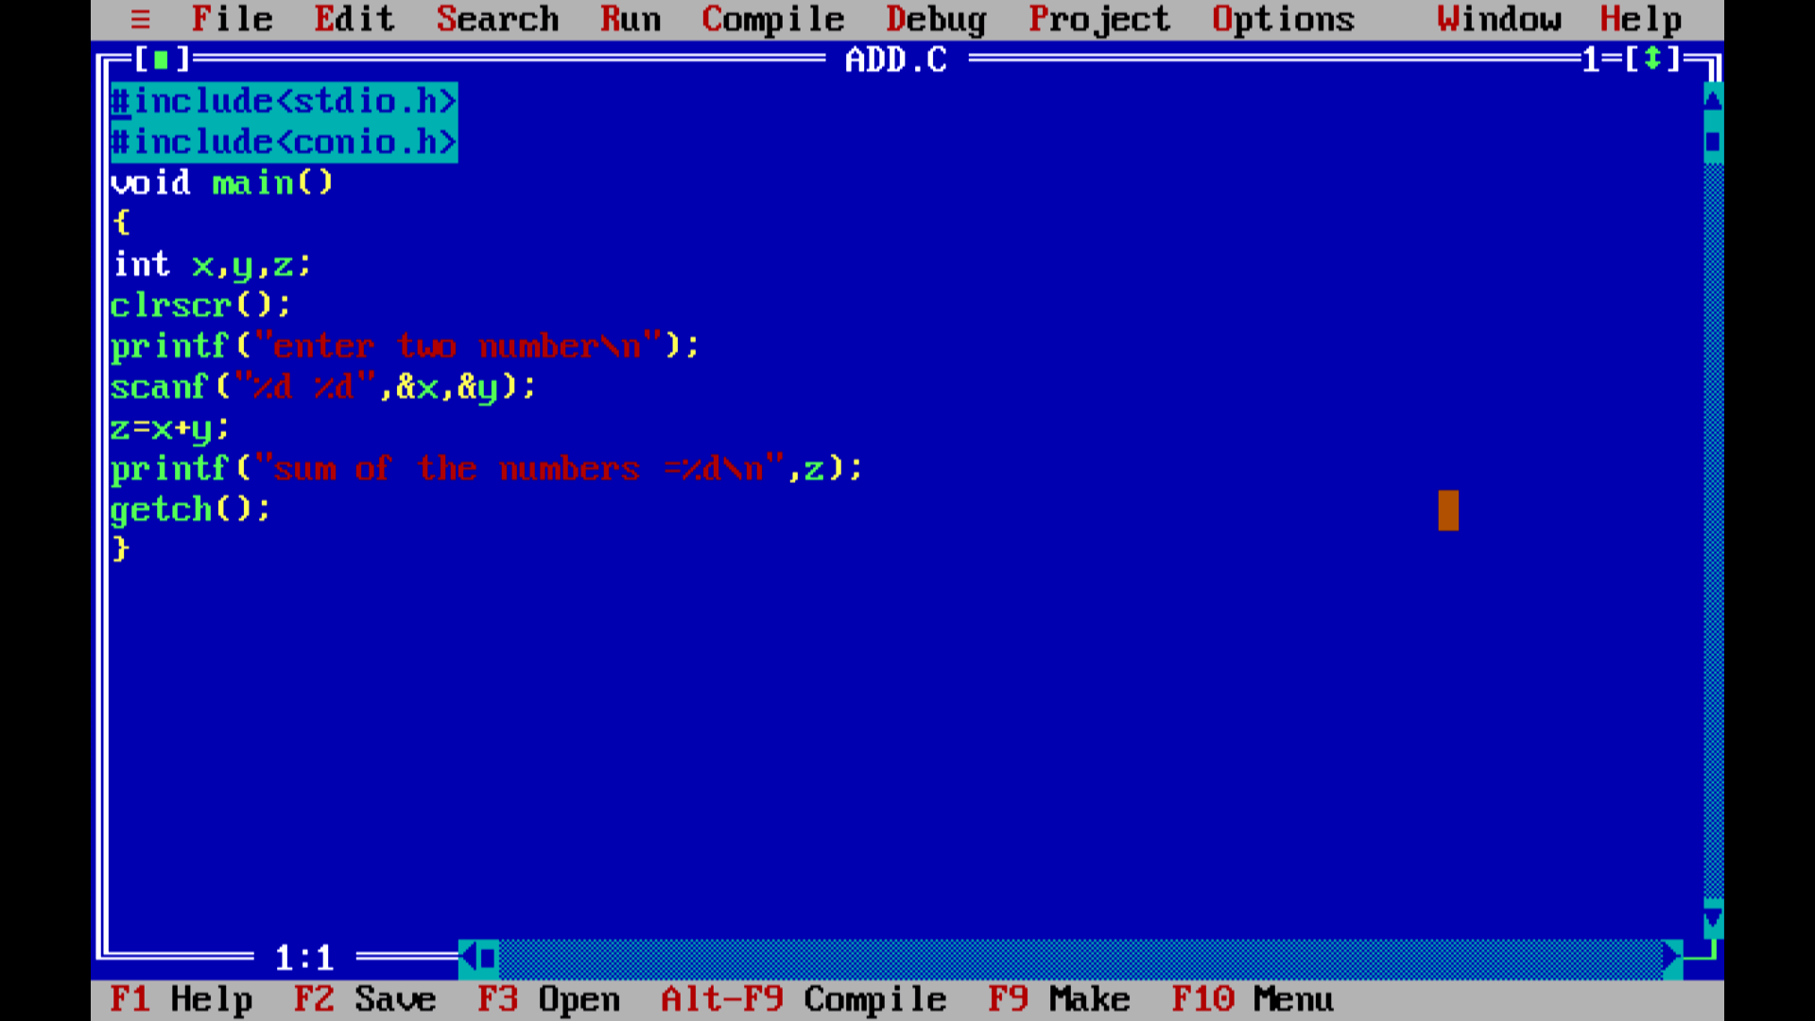

* The output of the program is given below-

