Project Report on

<ONLINE-LEARNING WEBSITE>

**Minor Project**

**WEBSITE NAME-SMART LEARNER**

Integrated Master of Computer Application (IMCA)

By

<ANUJA RANE, ZEESHAN ANSARI, SRAJAN SHRIVASTAVA >

<Enrolment number – 0810CA18DD10, 0810CA18DD41, 0810CA17DD37.>

<8th Semester>

Under the supervision of

<Professor- RAKESH VERMA>

IPS Academy Indore

School of Computers

RAJIV GANDHI PROUDYOGIKI VISHWAVIDHYALAYA, BHOPAL

2022

**CERTIFICATE**

The is to certify that **<ANUJA RANE, ZEESHAN ANSARI, SRAJAN SHRIVASTAVA>,** **<0810CA18DD10 , 0810CA18DD41 , 0810CA17DD37>,** of Integrated Master of Computer Application (IMCA**), SOC IPS ACADEMY** has successfully completed their **<8th Semester>** minor project entitled **< E-LEARNING WEBSITE>**, under the guidance of <**Professor- RAKESH VERMA**> as a part of fulfilment of academic curriculum.

**External Examiner Internal Examiner**

**Date Date**

Director

IPS Academy Indore

School of Computers

**ACKNOWLEDGEMENT**

The satisfaction that accompanies that the successful completion of any task would be incomplete without the mention of people whose ceaseless corporation made it possible whose constant guidance and encouragement crown all efforts with success.

We are grateful to our guide **<Professor- RAKESH VERMA>** for the guidance, inspiration and constructive suggestions that helpful us in preparation of this project.

We also thanks who have helped in successful completion of the project.

Date: Student Name

Anuja Rane, Zeeshan Ansari, Srajan Shrivvastava

Place: IPS Academy Indore <Enrollment No.>

0810CA18DD10, 0810CA18DD41, 0810CA17DD37

IMCA-8th Semester

**INDEX**

1. **INTRODUCTION**

**\*PROJECT INTRODUCTION**

**\*PROBLEM DEFINITION**

**\*MOTIVATION**

**\*OBJECTIVE**

**\*PROPOSED SOLUTION**

1. **SPECIFICATION**

**\*PLATFORM SPECIFICATION**

**\*TOOLS AND TECHNOLOGY**

**\*SOFTWARE SPECIFICATION**

**\*SCOPE AND MARKETING**

1. **BACKGROUND RELATED WORK**

**\*EXISTING SYSTEM**

**\*PROPOSED SYSTEM**

**\*SCOPE OF PROPOSED SYSTEM**

1. **SYSTEM ANALYSIS AND DESIGN**

**\*FEASIBILITY STUDY**

**\*TECHNICAL FEASIBILITY**

**\*ECONOMICAL FEASIBILITY**

**\*OPERATIONAL FEASIBILITY**

1. **REQUIREMENTS**

**\*FUNCTIONAL REQUIREMENT**

**\*NON-FUNCTIONAL REQUREMENT**

1. **SCREENSHOTS**
2. **IMPLEMENTATION**
3. **DATABASE DESCRIPTION**
4. **DFD MODEL**
5. **CONCLUSION**

**INTRODUCTION**

**Introduction**- Modern technologies are revolutionizing the traditional teaching, testing the previously unknown form of organisation of the education process. This situation has far-reaching consequences for the image and functioning of higher education and the role and activities of the academic teacher. Additional skills and performance of professional duties in the online environment is a challenge for academics. They are not always willing to explore new forms of education, and sometimes perceive e-learning as a risky process.

This website is designed to provide learning material to students, the main purpose of this website is to provide online learning material at any time at any place. Generally you can register as a student to use this service by clicking on the REGISTER button. When you click on this button a registration form will appear on your window. You can register by providing their name, email id, contact number etc. There are a variety of courses available such as design, computer languages, development, freelancing, and more.

A bookshelf section is also available on the top right corner. In this section we provide a number of books for students available online. We share knowledge with the world to Get inspired, Learn new skills and Make discoveries. We’ve seen again and again how the seemingly simple act of creating can be a force for growth, change, and discovery in people’s lives. We want to inspire and multiply the kind of creative exploration that furthers expression, learning and application.

**Problem definition**- With the advent in technology and with the perpetual increase in the strength of the students and the number of departments in the educational institutions, it is laborious to exchange the study materials between the students and the faculties. The main objective of the E-Learning is to help the students get over the traditional methods of learning and make them accustomed to the internet where the notes for their respective subjects are easily available. It provides an automation procedure of studying the notes online.

**Motivation-**It motivated learners are more likely to undertake challenging activities, be actively engaged, enjoy and adopt a new approach of learning and exhibit enhanced performance, persistence and creativity .Online -learning provides students with a different opportunity to learn regardless of where they are and when they are available. In an e-learning environment, students are able to participate in self-faced and interactive learning that is otherwise impossible.

**Objective**-The Major objectives Of e-Learning are as follows:-

* Enhance the quality of learning and teaching
* Meet the learning style or needs of students
* Improve the efficiency and effectiveness
* Improve user-accessibility and time flexibility to engage learners in the learning process

### Setting Effective e-Learning Goals:-

Setting effective eLearning goals is important in implementing eLearning as it will help in producing great results if one knows how to use it. The key success of effective eLearning is not only to set goals but to set the right goals. Therefore, it is significant to understand the types of different goals and its unique differences because each goal has its own objectives.

### S.M.A.R.T

In the current era, the S.M.A.R.T goals technique is a popular method used for goal setting as it is a simple way to engage and collaborate which leads to success. Although there are a few variations of this technique, the most common and well-set goals which should meet the criteria for setting effective eLearning goals are illustrated below:

* S: Specific  
  Focus on the primary intended outcome for eLearning and have a specific goal for success.
* M: Measurable  
  Select eLearning tools which can be measured but beware of the timing of the data to ensure the collection of feedback for further improvement.
* A: Attainable  
  It is a consensus to use common tools available to avoid any conflicts in opinions especially if it is a shared goal, and always remember that all goals should be achievable.
* R: Realistic  
  Set a goal that aligns with the potential unique inputs as the right goal will realistically challenge eLearning circumstances. So, be realistic to set a timeline.
* T: Time-Based  
  Set a proper timeline for the accomplishment of the goal. Allow time for changes before the datelines as there is a present of learning curves for both educators and students when implementing a new eLearning tool.

**Proposed solution-** The working of the system will be well planned and organized. The data will be stored properly in data stores, which will help in retrieval of information as well as its storage. The main proposed solution of this website will not only provide a result or solution to the linking problem which is mentioned about it will provide a status report which will give a proposed solution to this problem.

The main solution of this project will be that we will try to make this website more and more user friendly so that it will be more and more beneficial for others.

**SPECIFICATION**

**Platform Specification-**

* Web
* Android

**Tools and technology -**

Front End: HTML , CSS, JavaScript

Back End: PHP , MYSQL

**Software specification-**

**HTML**:HTML or **Hypertext Markup Language** is the standard markup language used to create web pages.HTML is written in the form of HTML elements consisting of tags enclosed in angle brackets (like <html>). HTML tags most commonly come in pairs like <h1> and </h1>, although some tags represent empty elements and so are unpaired, for example <img>. The first tag in a pair is the start tag, and the second tag is the end tag (they are also called opening tags and closing tags). Though not always necessary, it is best practice to append a slash to tags which are not paired with a closing tag. The purpose of a web browser is to read HTML documents and compose them into visible or audible web pages. The browser does not display the HTML tags, but uses the tags to interpret the content of the page. HTML describes the structure of a website semantically along with cues for presentation, making it a markup language rather than a programming language.HTML elements form the building blocks of all websites. HTML allows images and objects to be embedded and can be used to create interactive forms. It provides a means to create structured documents by denoting structural semantics for text such as headings, paragraphs, lists, links, quotes and other items. It can embed scripts written in languages such as JavaScript which affect the behaviour of HTML web pages.

**CASCADING STYLE SHEETS (CSS):** It is a style sheet language used for describing the look and formatting of a document written in a markup language. While most often used to style web pages and interfaces written in HTML and XHTML, the language can be applied to any kind of XML document, including plain XML, SVG and XUL. CSS is a cornerstone specification of the web and almost all web pages use CSS style sheets to describe their presentation.CSS is designed primarily to enable the separation of document content from document presentation, including elements such as the layout, colors, and fonts. This separation can improve content accessibility, provide more flexibility and control in the specification of presentation characteristics, enable multiple pages to share formatting, and reduce complexity and repetition in the structural content.

**MySQL**:

MySQL is developed, distributed, and supported by Oracle Corporation. MySQL is a database system used on the web that runs on a server. MySQL is ideal for both small and large applications. It is very fast, reliable, and easy to use. It supports standard SQL. MySQL can be compiled on a number of platforms. The data in MySQL is stored in tables. A table is a collection of related data, and it consists of columns and rows. Databases are useful when storing information categorically.

**FEATURES OF MySQL**:

Internals and portability:

• Written in C and C++.

• Tested with a broad range of different compilers.

• Works on many different platforms.

• Uses multi-layered server design with independent modules.

**WHY TO USE MySQL**:

• Leading open source RDBMS

• Ease of use – No frills

• Fast

• Robust

• Security

• Multiple OS support

• Free

• Technical support

• Support large database– up to 50 million rows, file size limit up to 8 Million TB

**PHP:**

• PHP is an acronym for "PHP Hypertext Pre-processor."

• PHP is a widely-used, open source scripting language.

• PHP scripts are executed on the server.

• PHP costs nothing, it is free to download and use.

**WHY PHP?**

• PHP runs on various platforms (Windows, Linux, Unix, Mac OS X, etc.)

• PHP is compatible with almost all servers used today (Apache, IIS, etc.)

• PHP supports a wide range of databases.

**Scope and marketing-** Scope of the project is very broad in terms of other tracking systems. It is an online system. According to a recent study in a global level online learning program, India is reported to have the second highest number of online course enrollments. The only country leading is the United States. With more than 1,55,000 students registered, 15% of students are from India. The online education scenario in India has tremendous potential and opportunities galore for the rising young population. Increased Internet penetration and acceptance of online courses by mainstream employers are enabling factors for the spread of cost-effective electronic leaning. There is a misplaced notion, that employers prefer students with traditional brick and mortar college degrees. On the contrary, corporate organizations in India are recognizing the high skill levels of students who have undergone online courses certification programs from highly acclaimed educational institutions. Electronic-learning through certified online courses provides a wide range of courses that caters to the core interests of the student, thus creating a fertile arena for future advancement.

**BACKGROUND AND RELATED WORK**

**Existing system-** In the existing system the exams are done only manually but in the proposed system we have to computerize the exams using this application.

**Lack of security of data**

* More man power.
* Time consuming.
* Consumes a large volume of spare work.
* Needs manual calculations.
* No direct role for the higher officials.

**Proposed system** - The proposed system will be implemented with the help of an online website. The aim of the proposed system is to develop a system of improved facilities. The proposed system can overcome all the limitations of the existing system. The system provides proper security and reduces manual work.

* Security of data.
* Ensure data accuracy.
* Proper control of the higher officials.
* Minimize manual data entry.
* Minimum time needed for the various processing.

**Scope of proposed system-** The scope is actually simple i.e; all the work that needs to be done in order to achieve a project's objectives. In other words, the scope involves the process of identifying and documenting specific project goals, outcomes, milestones, tasks, costs, and timeline dates specific to the project objectives.

**SYSTEM ANALYSIS AND DESIGN**

**Feasibility study**- The assessment is based on outline design of system requirements in terms of Input, Processes, Output, Fields , Programs and Procedures.

Purpose of this consultancy is to provide the sound basis for developing the project concept, by identifying project preconditions, opportunities and risks for its implementation.

**Technical feasibility-** Under the technical feasibility study we study about components of the project. First head office, the company is computerized with its main work stations. Company needs to put a computer system to head office, work stations, and every section networked to a centralized computer centre called SERVER. Each officer and each section is provided with a computer, which is called the client system. This network is organized in such a manner that data from any computer in the network can be transferred to the server system and can be accessed through any other computer in the network. This Network is a form of LAN(local area network) with required access authorization.

**Economical feasibility-** Economic feasibility is to determine the most frequently used method for evaluating the effectiveness of a new system. The procedure is to determine the benefits that are expected.

**Operational feasibility**- Any one user of the corporation who has authorization, with the basic knowledge of computers can use this software. Large number of employees across all the departments/sections in the corporation will be interacting with this system. Every employee is trained to handle this software. The software will not allow the user to enter invalid data either by mistake or by intention. In such a case it will also display a message for the user.

**Non functional requirement-** Non functional requirements describe the capability and constraints of women security websites that will enhance its functionality.

**Functional requirement-** These are the requirements that the end user specifically demands as basic facilities that this women security system should offer.

**SCREEN SHOTS**

**Main page**

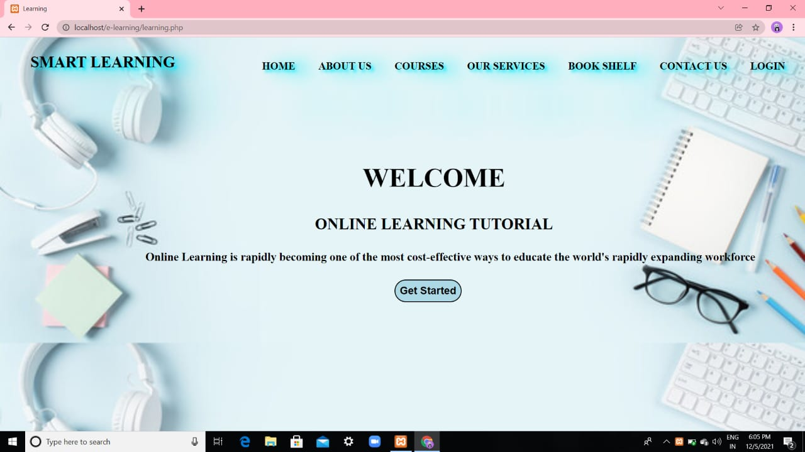

**Registration**

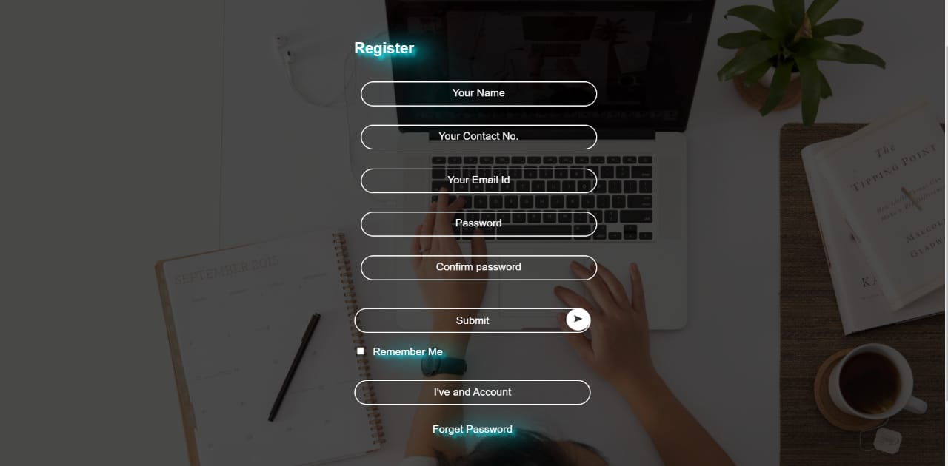

**Login**

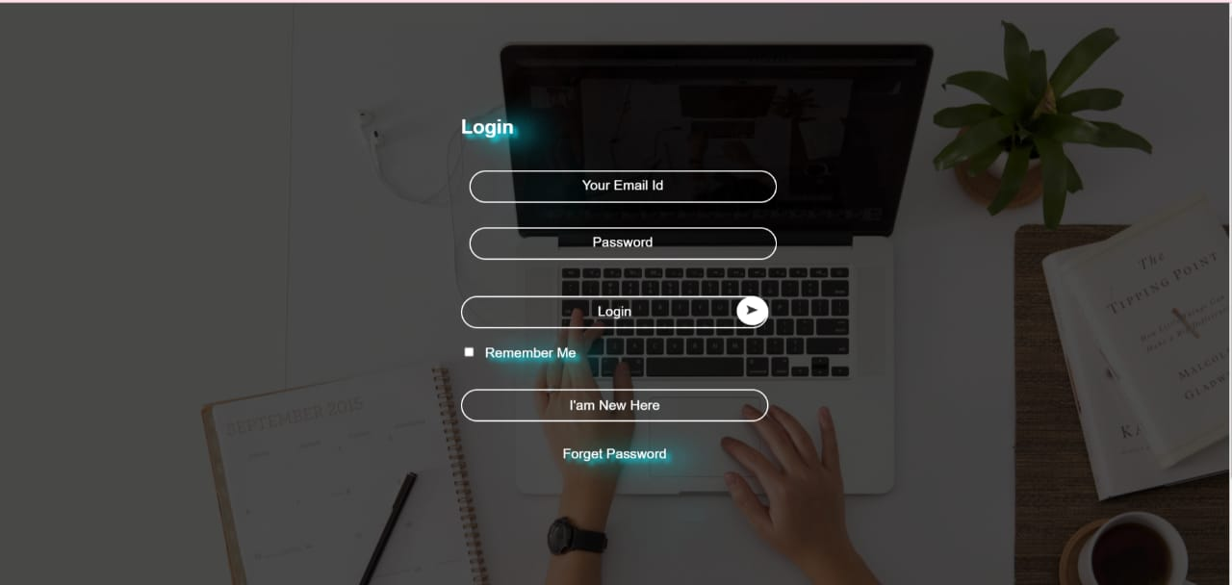

**Home page**



**Our Courses**

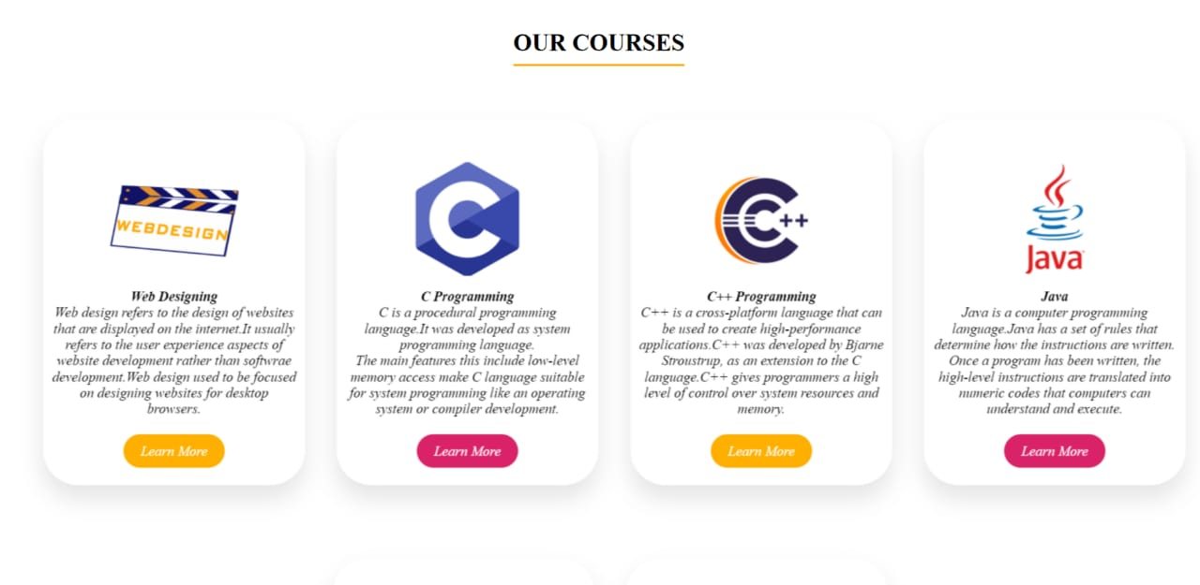

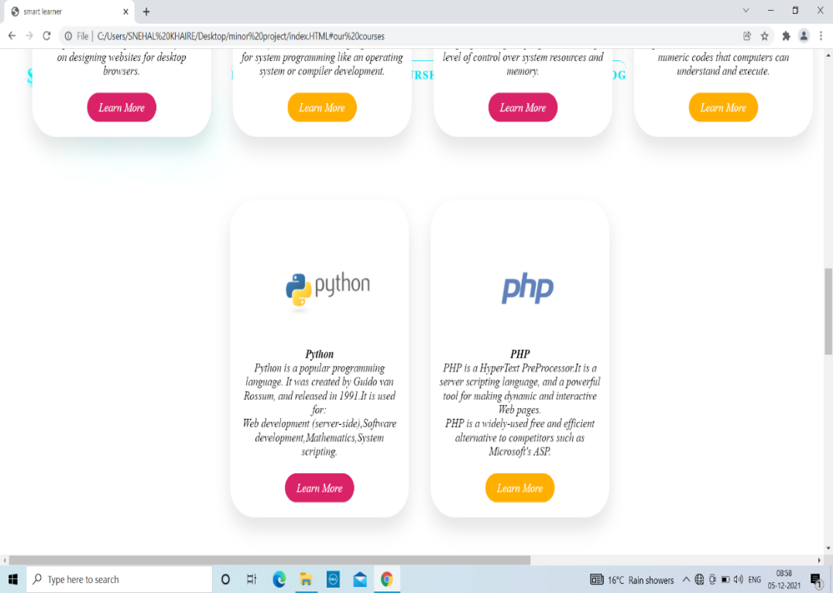

**Web Design**



**About HTML**

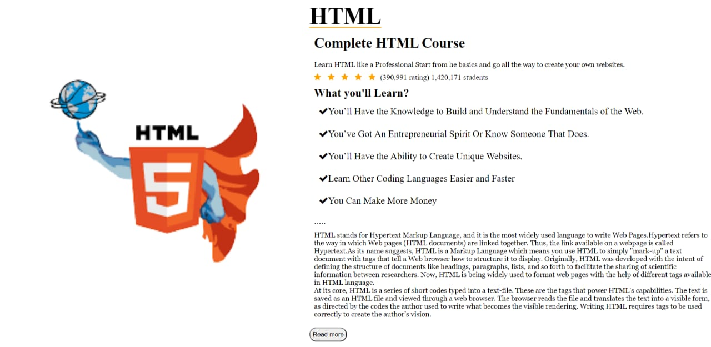

**PHP**

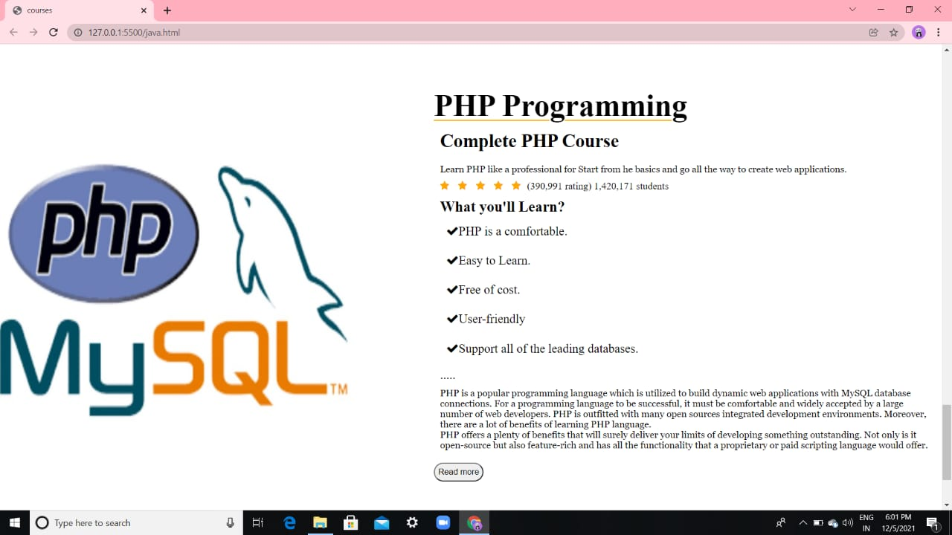

**C Programming**

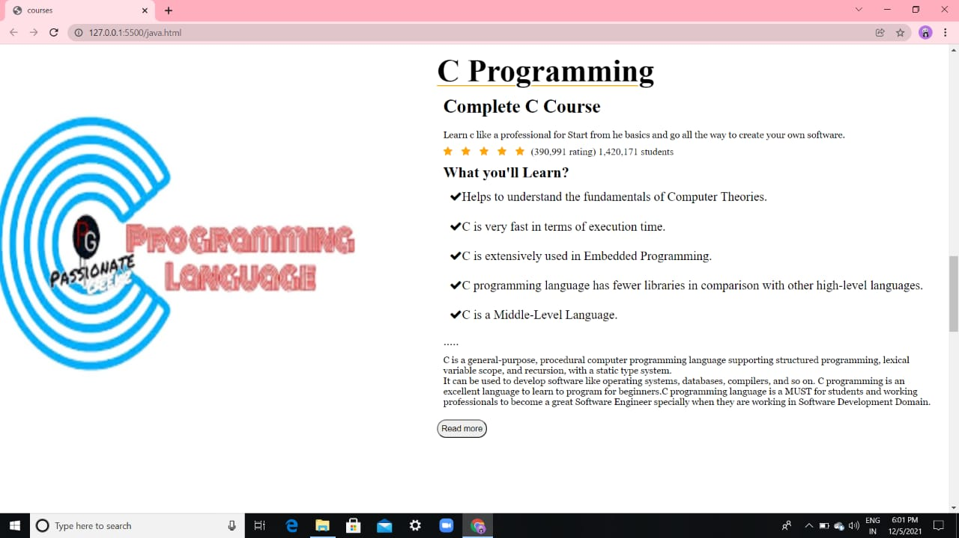

**JAVA**

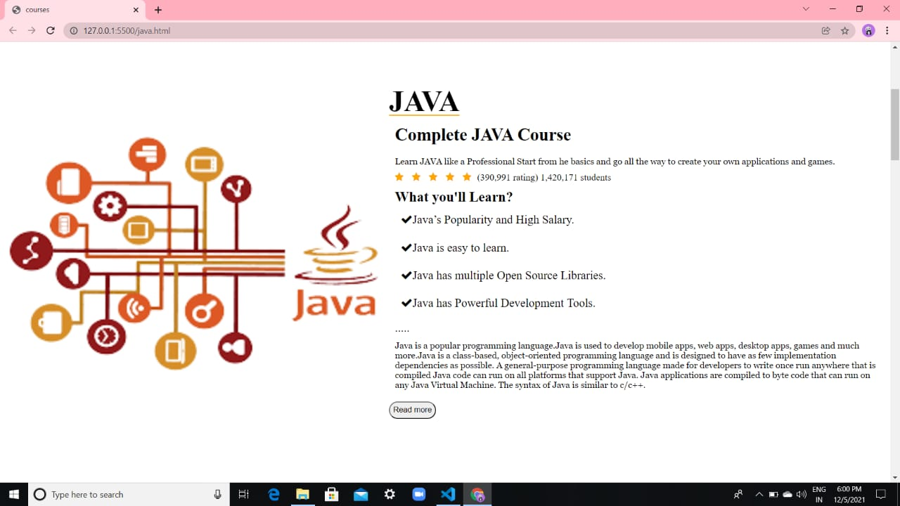

**PYTHON**

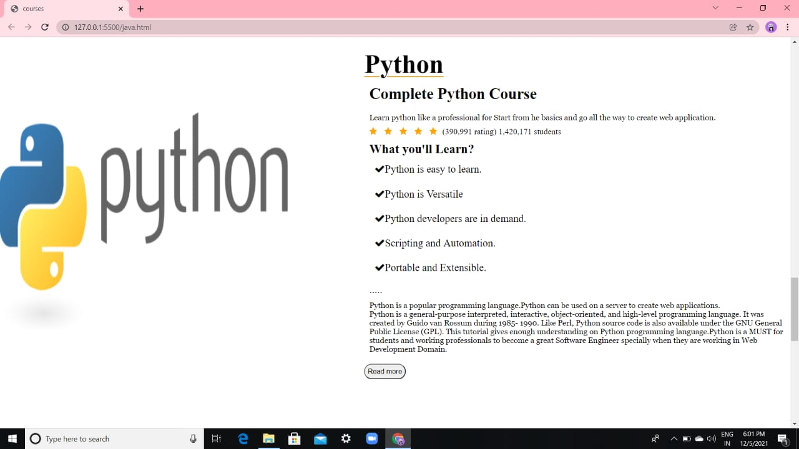

**ABOUT US**

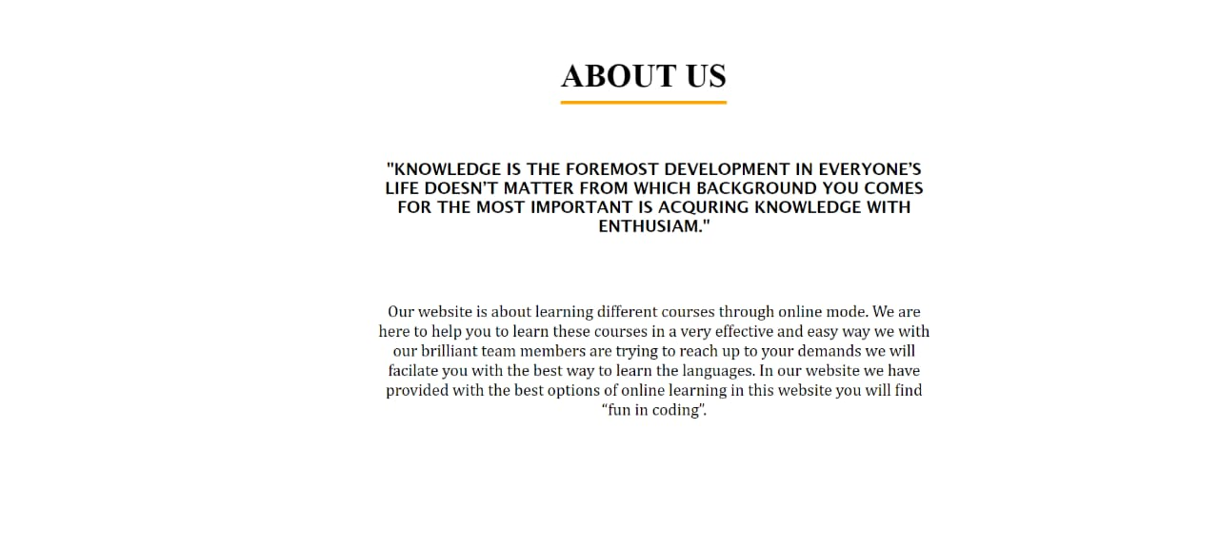

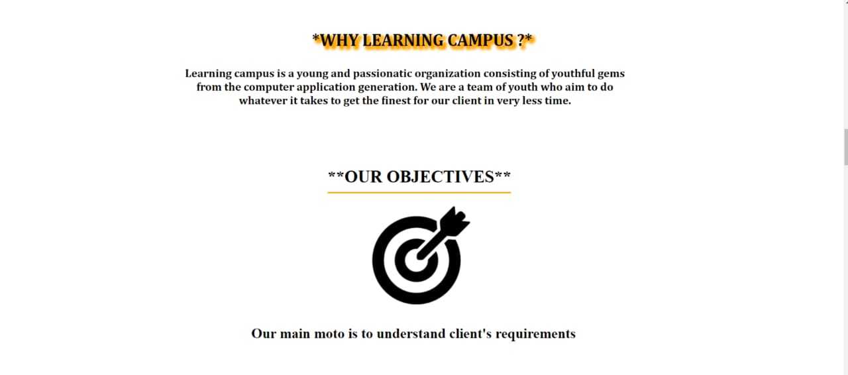

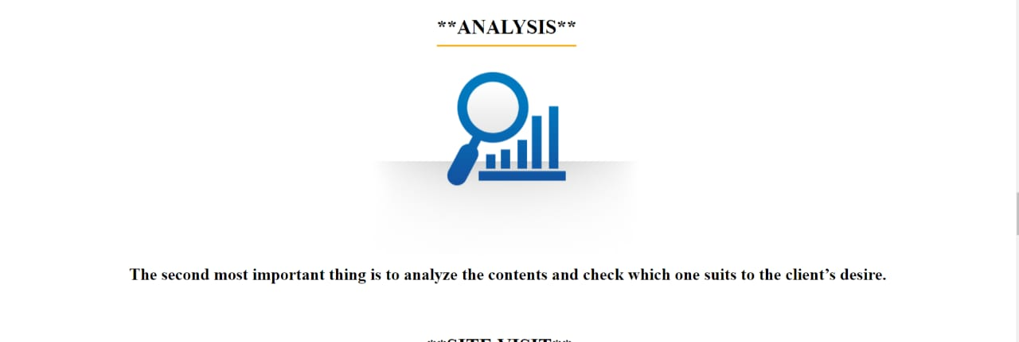



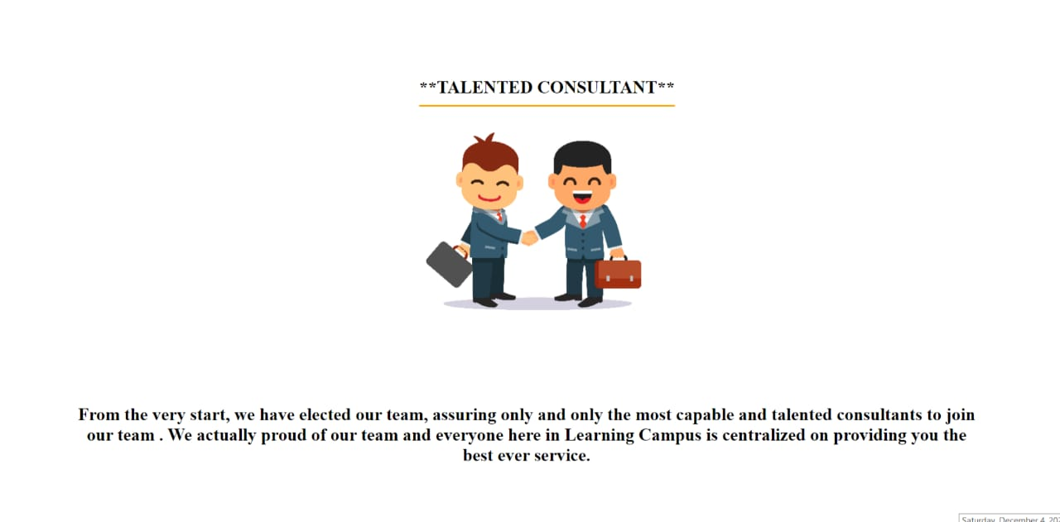

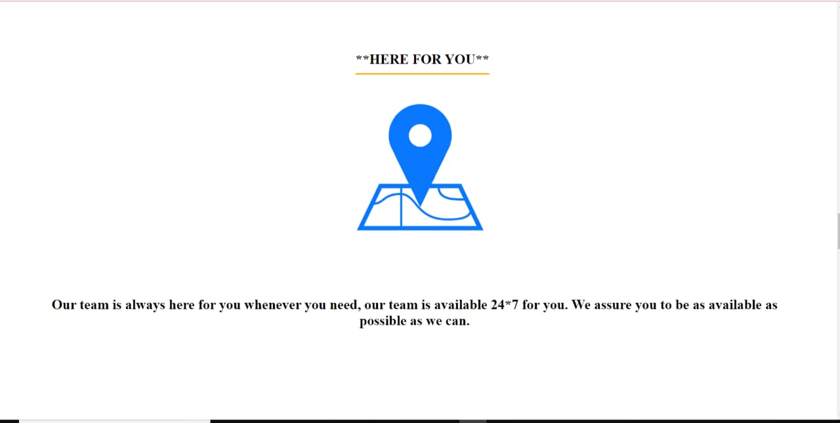

**OUR SERVICES**

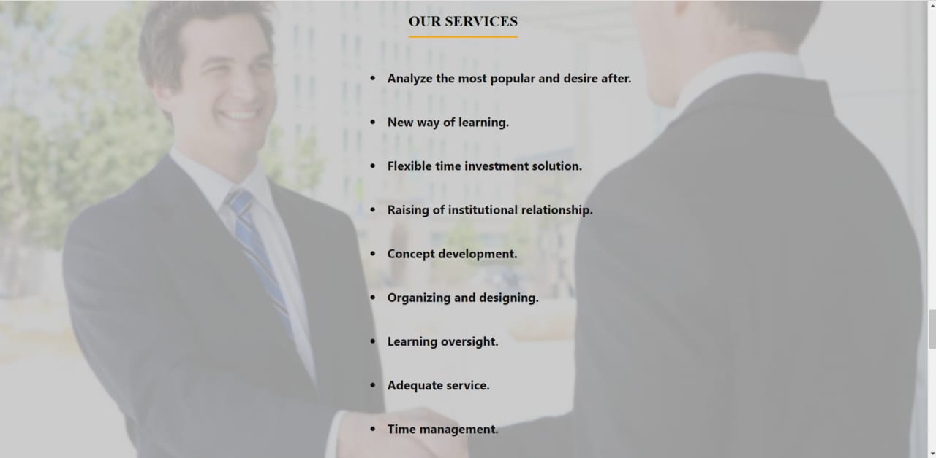

**FEATURED BOOKS**

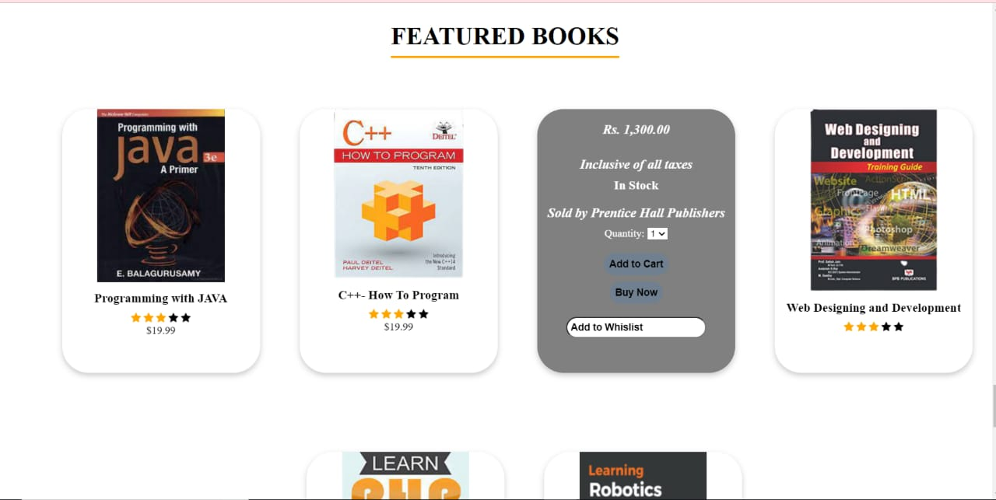

**CONTACT US**

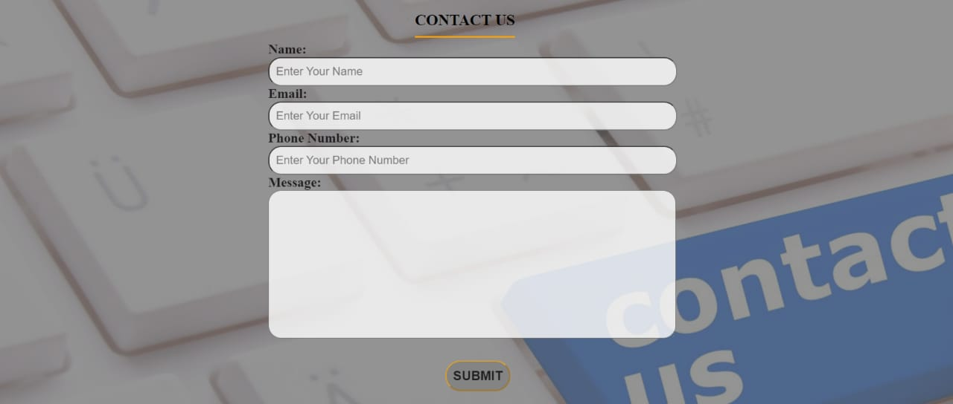

**IMPLEMENTATION**

**Implementation** is the stage of the project when the theoretical design is turned out into a working system. Thus, it can be considered to be the most critical stage in achieving a successful new system and in giving the user confidence that the new system will work and be effective. The implementation stage involves careful planning, investigation of the existing system and it’s constraints on implementation, designing of methods to achieve changeover and evaluation of changeover methods.

**DATABASE DESCRIPTION**

**DATABASE DESCRIPTION:** We are using xampp server for mysql and apache for executing the php code for backend work. In this project the database name is elearning.

**DFD MODEL**

SEND EMAIL

FORGET PASSWORD

LOGIN

START PRACTICE

REGISTER

CONTINUE TO LEARNING

YES

NO

**CONCLUSION**

Smart learner is not just a change of technology. It is part of a redefinition of how we as a species transmit knowledge, skills, and values to younger generations of workers and students. This book makes a few predictions of how e-learning and the functions it serves will continue to develop. Learners will have access to millions or billions of knowledge modules. Some will be Web pages with simple text and graphics. Others may include multimedia simulations. In many fields, online-learning has become the default way to conduct training or to provide education.