Processing and analysing BTS airline delay data with Python
NIB7143CEM Programming for Data Science
MSc in Data Science | NIBM and Coventry University
Field | Details
Student name | ____________________________
Student ID | ____________________________
Submission date | ____________________________
Report word count | 3927 approximately; includes main tables, excludes references, appendices and figure captions
Repository | https://github.com/sanudisarithma/bts-flight-delay-pipeline
Demonstration video | ____________________________
Source details requiring completion: original download date and the applicable dataset licence.

Contents
1 Introduction
2 System design
3 Storage format investigation
4 Data pipeline and analysis
5 Scale and distributed processing
6 Professional practice
7 Reflection
References
Appendices A to D

1 Introduction
This project develops and evaluates a Python pipeline for examining airline delays using a local extract of the Airline On-Time Statistics and Delay Causes dataset. The data was obtained through a Kaggle distribution attributed to the United States Bureau of Transportation Statistics (BTS). BTS publishes information about domestic airline punctuality, cancellations, diversions and delay causes [1]. The local extract contains 398,233 records and 21 columns, covering June 2003 to January 2025. Each record represents a carrier, airport and month, rather than an individual passenger or flight.
The analytical question is how recorded arrival-delay rates vary over time and between carriers, and whether historical carrier-airport information helps estimate subsequent monthly delay rates. The engineering question is how to process this dataset reproducibly while making defensible choices about validation, data structures, storage and execution scale.
The implementation separates reusable loading, cleaning and analysis classes from executable scripts. It preserves the original CSV, records data-quality decisions, produces descriptive figures, compares predictive baselines and a regression model, and benchmarks storage formats. A separate Spark experiment reproduces an aggregation at three data sizes. Fifteen automated test cases check selected processing behaviours.
The main finding is that 19.64% of arrived flights in usable records were at least fifteen minutes late. This is a weighted aggregate, not an average of monthly percentages. The results also show that storage and processing choices depend on the workload: Parquet supports compact column reads, while Spark only outperformed pandas in the largest tested case under a tuned configuration. The following sections explain the implementation, evidence and limitations behind these conclusions.
Table 1 Dataset summary.
Property | Value
Records and columns | 398,233 and 21
Unit of observation | Carrier, airport and month
Period | June 2003 to January 2025
Distinct carriers and airports | 38 and 425
Download date | To be confirmed by the data owner
Licence | To be verified against the dataset distribution

2 System design

2.1 Architecture and responsibilities
The reusable preprocess package contains loading, cleaning, analysis, configuration, utility and exception modules. Executable scripts coordinate these components for individual tasks. This separation allows the same processing classes to support exploratory analysis and benchmarking without duplicating the cleaning rules. Configuration resolves paths relative to the project directory, while generated tables and figures are placed in dedicated output folders.
Data flows from the raw CSV through CsvLoader, an ordered Cleaner and DelayAnalyzer. The cleaning output is also written to Parquet for the Spark experiment. The raw file is not overwritten. This distinction makes it possible to compare processing decisions against the original input and regenerate outputs when the implementation changes.
Figure 1 is the supplied system architecture diagram. It should be read together with the executable scripts: the scripts orchestrate work, while the package implements reusable behaviour. Figure 2 shows the class relationships.
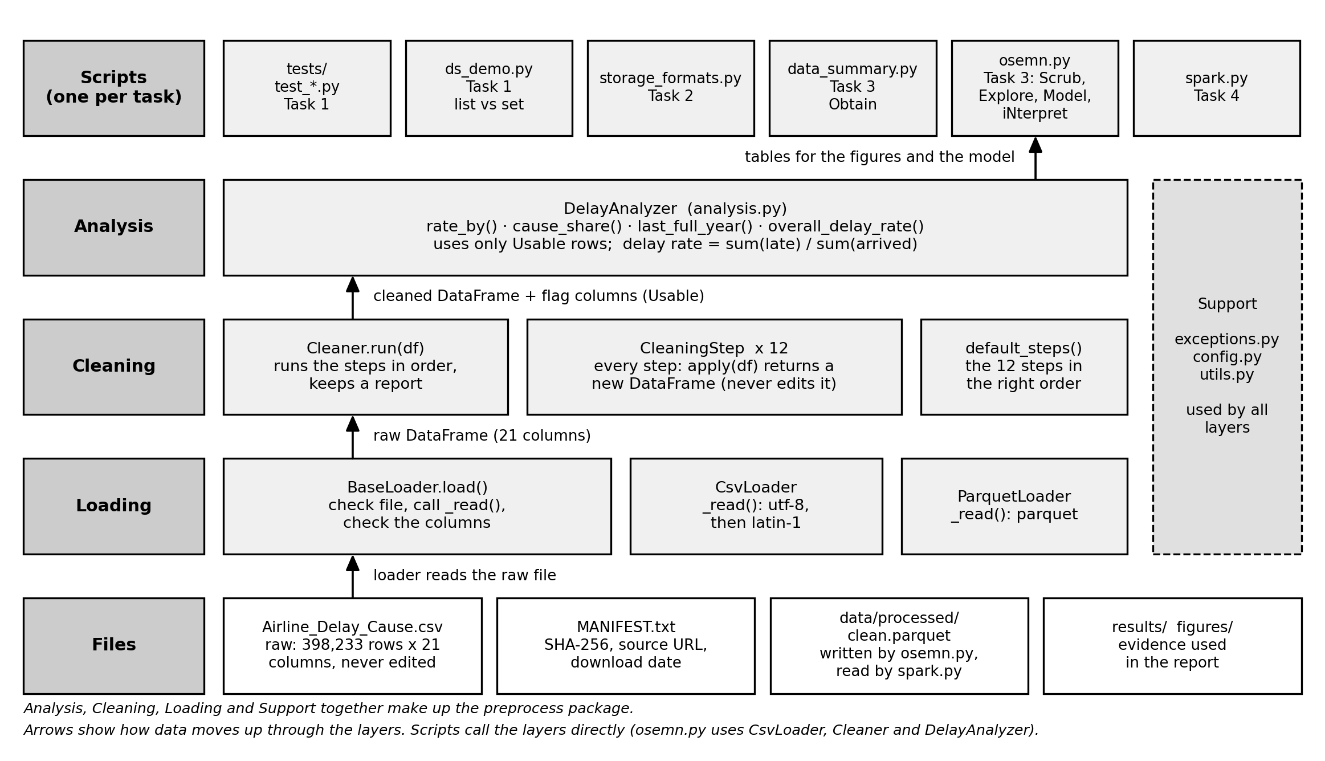
Figure 1 System architecture of the processing pipeline.

2.2 Class relationships and object orientation
BaseLoader supplies a common loading sequence: validate the path, read the file, normalise column headings, check required columns and record the successful row count. CsvLoader and ParquetLoader override _read() for their respective formats. This relationship avoids repeating schema validation whenever a new supported input format is introduced. Python supports inheritance and method overriding, while underscore-prefixed attributes express a non-public convention rather than enforced access protection [2].
CleaningStep defines the interface used by individual transformations. Twelve subclasses perform tasks such as text normalisation, numeric conversion, duplicate detection and validity flagging. Cleaner holds these objects in an ordered collection and calls each through apply(). It therefore depends on shared behaviour instead of inspecting each concrete step type. A new step can be introduced through the same interface, although its position and input requirements still need review.
DelayAnalyzer accepts cleaned records and selects rows marked usable. Its responsibility is aggregation rather than cleaning. Keeping the two responsibilities separate makes it easier to explain why a record was excluded and prevents analytical methods from silently applying different quality policies. However, a larger number of classes creates navigation overhead. The design is justified by reusable processing stages, not by assuming that more classes automatically improve software.
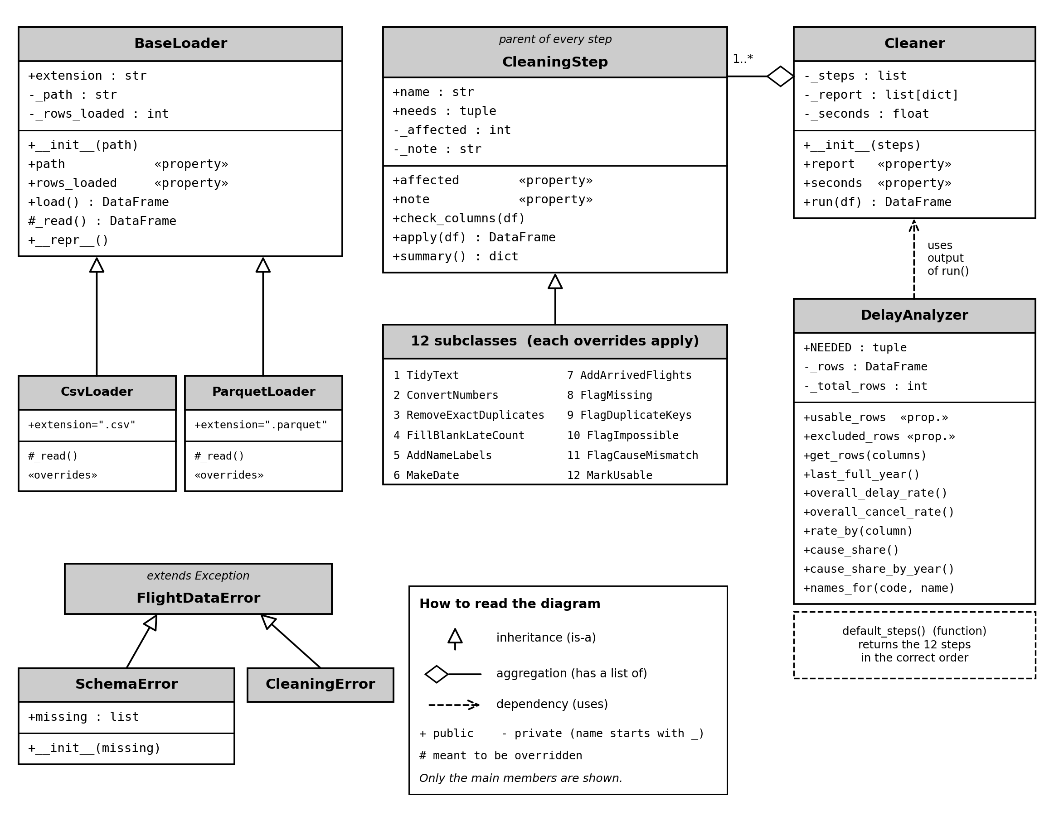
Figure 2 Class relationships in the preprocess package.

2.3 State and error handling
Loader counts, cleaning reports and elapsed time are maintained as instance state. Properties provide controlled access to these values. Cleaner.report constructs a new DataFrame from the stored report, so modifying the returned table does not alter the saved report. Tests verify this behaviour. The design protects ordinary callers from accidental modification, but it does not claim that Python makes the internal attributes inaccessible.
Failures are distinguished by their meaning. Invalid argument types or empty inputs raise ValueError; absent files raise FileNotFoundError; missing required columns raise SchemaError. SchemaError and CleaningError inherit from FlightDataError, allowing callers to catch domain failures together while retaining detailed information. Unexpected exceptions inside a cleaning step are wrapped in CleaningError using exception chaining, preserving the original cause for diagnosis.
The most useful method for understanding this design is Cleaner.run(). It validates the input before beginning. Inside try, it applies each step and accumulates a temporary report. The domain-exception handler re-raises known errors unchanged. A second handler wraps unexpected failures and includes the step name. The else block replaces the stored report only after all steps succeed. Finally, elapsed time is recorded whether the run succeeds or fails. Appendix A contains the method listing with these operations identified.
This arrangement prevents a partial report from replacing the last successful report. Built-in cleaning steps return copies, preserving the caller's input. That guarantee depends on step implementations respecting their contract: an arbitrary extension could still mutate its argument. A failure test checks the supported path using a deliberately failing step after a normal text transformation.

2.4 Data structures and testing
Lists preserve the execution order of cleaning steps. That order matters because numeric conversion must precede checks for impossible numeric values. Sets are used to identify missing required columns. Dictionaries associate codes with display labels and accumulate summaries. Tuples represent fixed column collections and serve as compound dictionary keys for carrier-airport pairs.
The latest manual demonstration performed 20,000 membership checks over 425 airport codes. List lookup took approximately 0.0325 seconds and set lookup 0.0006 seconds, with the script reporting a speed ratio of about 58. These rounded measurements illustrate this workload; they are not universal guarantees. The same demonstration counted 4,326 distinct carrier-airport pairs and showed why a mutable list cannot be used as a dictionary key.
The test suite uses small synthetic inputs and temporary files, so it does not require the large BTS download. Fifteen parametrised cases passed in the latest local validation run. They include an inclusive date-window regression test and cover successful loading, missing files, malformed paths, schema failure, invalid cleaning inputs, non-destructive processing, exclusion of negative counts, domain-exception preservation, chained unexpected failures and report isolation. The failure test also checks that elapsed time is recorded and the previous report survives. pytest.raises is used to assert expected exceptions [3]. These tests establish selected behavioural properties; they do not prove that every public method or every possible dataset is correct. Public docstrings and broader boundary coverage still require review against the coursework requirements.

3 Storage format investigation

3.1 Measurement method
The storage experiment uses the full dataset of 398,233 rows and 21 columns. It compares CSV, JSON Lines, pickle and Parquet, including gzip for the first three and uncompressed, Snappy and Zstandard variants for Parquet. For each variant, the script records disk size, full write time, full read time and the time required to obtain arr_delay alone. The pandas I/O interface provides the corresponding readers and writers [4].
Each timing is repeated six times. The first run is discarded as warm-up, leaving five observations whose median, minimum and maximum are reported. The latest run used Python 3.14.2 on Windows 11 with an Intel processor, twelve logical cores and approximately 34 GB RAM. Relevant versions were pandas 2.3.3, NumPy 2.5.4 and PyArrow 26.0.1. Table 2 presents the measured values; Figure 3 shows their graphical comparison.
These repeated local measurements are affected by caching and background activity. An earlier JSON memory failure was logged; the complete successful manual run supplies the reported measurements.
Table 2 Storage size and timing results. Seconds are medians of five retained runs; parentheses show minimum and maximum.
Format | Size MB | Write s | Read all s | One column s
CSV | 62.661 | 2.914  (2.778-3.767) | 0.865  (0.777-0.906) | 0.303  (0.296-0.320)
CSV gzip | 14.607 | 5.613  (5.420-6.105) | 0.753  (0.747-0.766) | 0.378  (0.371-0.688)
JSON lines | 179.067 | 2.020  (1.954-2.326) | 3.274  (3.136-3.597) | 3.115  (3.064-3.260)
JSON lines gzip | 22.592 | 4.735  (4.666-4.907) | 3.182  (3.108-3.359) | 3.276  (3.101-3.305)
Pickle | 59.169 | 0.089  (0.084-0.117) | 0.076  (0.074-0.089) | 0.078  (0.076-0.081)
Pickle gzip | 9.749 | 3.162  (3.140-3.182) | 0.141  (0.140-0.162) | 0.143  (0.140-0.143)
Parquet (no compression) | 11.062 | 0.412  (0.403-0.425) | 0.085  (0.084-0.095) | 0.006  (0.005-0.006)
Parquet snappy | 9.713 | 0.443  (0.436-0.468) | 0.100  (0.093-0.110) | 0.006  (0.006-0.007)
Parquet zstd | 8.198 | 0.473  (0.467-0.488) | 0.096  (0.090-0.097) | 0.007  (0.007-0.029)
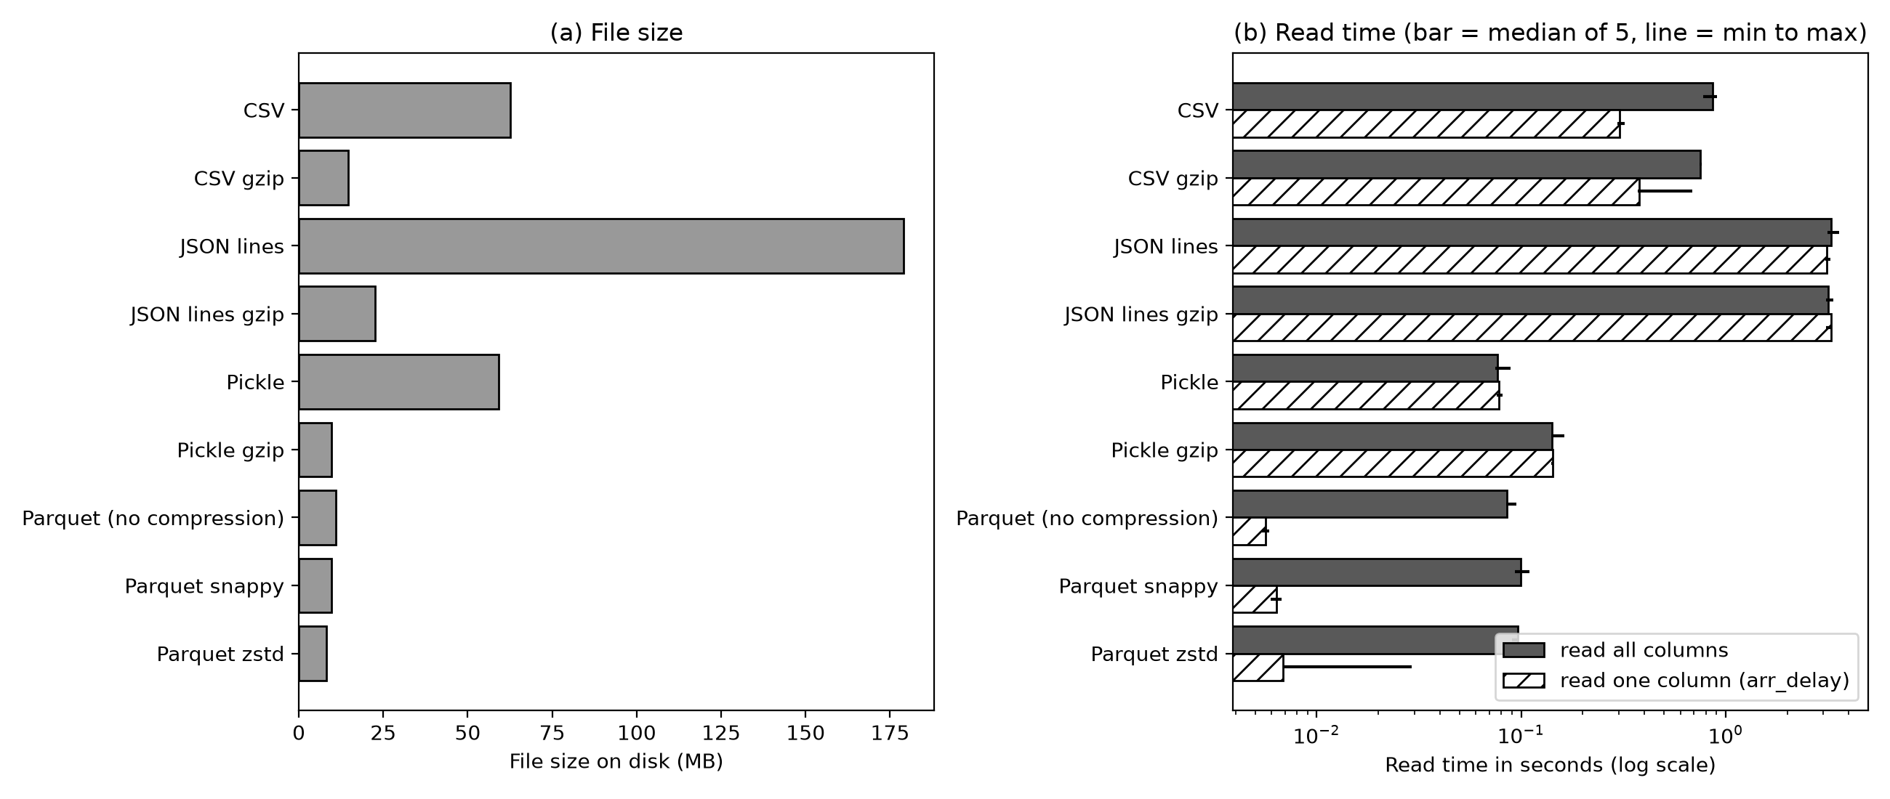
Figure 3 Storage format measurements on 398,233 rows.

3.2 Results and decision
Uncompressed CSV occupied 62.661 MB, while JSON Lines occupied 179.067 MB. Their median full-read times were 0.865 and 3.274 seconds respectively. Uncompressed pickle read the complete data in 0.076 seconds, but occupied 59.169 MB. Parquet with Zstandard occupied only 8.198 MB and read the complete table in 0.096 seconds. These observations show that smallest size and fastest complete read are separate objectives.
Column selection changes the comparison. Parquet variants obtained the selected column in approximately 0.006 to 0.007 seconds. CSV required 0.303 seconds, and JSON Lines required 3.115 seconds. The implemented JSON and pickle column tests load the full object before selecting the column, so their timings measure the actual implementation rather than implying native column projection. Parquet's column-oriented organisation supports this selective workload [5].
Parquet is therefore appropriate for the cleaned analytical data shared with Spark. Zstandard gives the smallest tested file, while Snappy offers a comparable practical alternative. Pickle remains attractive for short-lived Python-only complete-object reads, but loading an untrusted pickle is unsafe. CSV remains useful for inspection and interchange. Parquet would be a poor choice for a workflow dominated by manually editing small text files or appending individual records in place.
YAML was evaluated separately on 10,000 rows because its verbose representation and conversion cost make full-data benchmarking less useful here. On that sample, YAML occupied 4.817 MB and took 1.503 seconds to read; CSV occupied 1.557 MB and took 0.020 seconds. These sample results must not be mixed with the full-dataset table as though they used identical inputs.

4 Data pipeline and analysis

4.1 Obtain
The input is the Kaggle-distributed BTS airline delay dataset [6]. Its local SHA-256 digest is 74bb02986758aa8fa7d74b723c9a9cfeaeb6ee9c97589fcba5c58607cc16922c. The summary and pipeline scripts verified that this digest matches the manifest. A checksum demonstrates that the local extract has not changed relative to that manifest; it does not establish the dataset licence, historical accuracy or download date. Those provenance fields require confirmation from the person who acquired the file.
The extract includes numeric counts and delay minutes, categorical carrier and airport codes, and year/month fields. There are 38 carrier codes and 425 airport codes. June 2003 and January 2025 define the coverage boundaries; consequently, 2003 and 2025 are partial years. Comparisons must acknowledge these unequal observation periods.

4.2 Scrub
Cleaning preserves traceability by retaining quality flags and reporting affected records. There were no exact duplicate rows or duplicate carrier-airport-month keys in this extract. Text-normalisation and numeric-conversion checks also reported zero corrections. Reporting these zero findings shows that checks were executed, rather than suggesting that every cleaning operation necessarily changed data.
For 293 records, the late-flight count was blank when the associated cancelled/diverted counts indicated that no flight arrived. The pipeline replaced those blanks with zero. It retained 657 records with missing numeric information but excluded them from usable analysis. Two records containing negative values were also excluded. Together these conditions left 397,574 usable records from 398,233 input records; the 659 excluded records remained traceable in the cleaned output.
The pipeline identified ten records with inconsistent cause counts and nine with inconsistent cause minutes. These conditions may overlap and should not be added as though they necessarily represent nineteen different records. The records were flagged but retained for analysis. This decision preserves coverage but means cause-based summaries include a small amount of identified inconsistency. A useful sensitivity check would compare results with those records excluded.
Fourteen carrier codes and twenty-four airport codes had more than one associated name over time. Additional label columns provide consistent display names while retaining the original names. The report counts 141,018 carrier-label differences and 18,676 airport-label differences. Their sum represents column-specific changes, not necessarily distinct affected records. This distinction matters because one record can have both changes.
Table 3 Main data-quality findings and processing decisions. Counts may overlap.
Finding | Count | Decision
Missing numeric information | 657 rows | Flagged; excluded from usable analysis
Negative values | 2 rows | Flagged; excluded
Blank late count when no flights arrived | 293 rows | Replaced with zero
Cause count mismatch | 10 rows | Flagged; retained
Cause minute mismatch | 9 rows | Flagged; retained
Multiple carrier names | 14 codes | Added display labels; retained originals
Multiple airport names | 24 codes | Added display labels; retained originals
Exact duplicates and duplicate keys | 0 | No removals required
Final usable records | 397,574 | 659 input records excluded from analysis

4.3 Explore
The arrival-delay rate is calculated as total flights delayed at least fifteen minutes divided by total arrived flights. Arrived flights are derived by subtracting cancellations and diversions from the recorded flight total. Aggregating numerator and denominator before division weights each group's contribution by flight volume. Averaging monthly percentages would give small and large groups equal influence and could produce a different answer.
Figure 4 shows annual delay percentages. Among complete years, 2020 had the lowest rate at 9.95% and 2007 the highest at 24.79%. This describes the observed records; it does not establish why the difference occurred. Figure 5 pools observations by calendar month. September had the lowest rate at 15.13%, while June had the highest at 23.55%. Changes in route composition, traffic and observation years could contribute to these patterns.
Figure 6 compares fifteen busy carriers over the complete years 2022-2024. F9 recorded the highest arrival-delay rate at 30.51%, while PT recorded the lowest at 14.51%. Across all carriers in that window, the rate was 20.66%. The selection explicitly applies both the lower and upper year bounds, excluding January 2025. A regression test verifies this boundary using contrasting rates inside and outside the selected years. Carrier differences remain descriptive: route mix, airport exposure and operating conditions can affect the comparison, so the ranking is not a controlled measure of management performance.
Figure 7 shows the distribution of delay minutes across recorded causes. Across all years, late aircraft accounted for approximately 38.43%, carrier causes 31.42%, the national airspace system 24.62%, weather 5.36% and security 0.17%. These are shares of attributed delay minutes, not probabilities that an individual flight will encounter each cause. Cause classification and overlapping operational processes also limit causal interpretation.
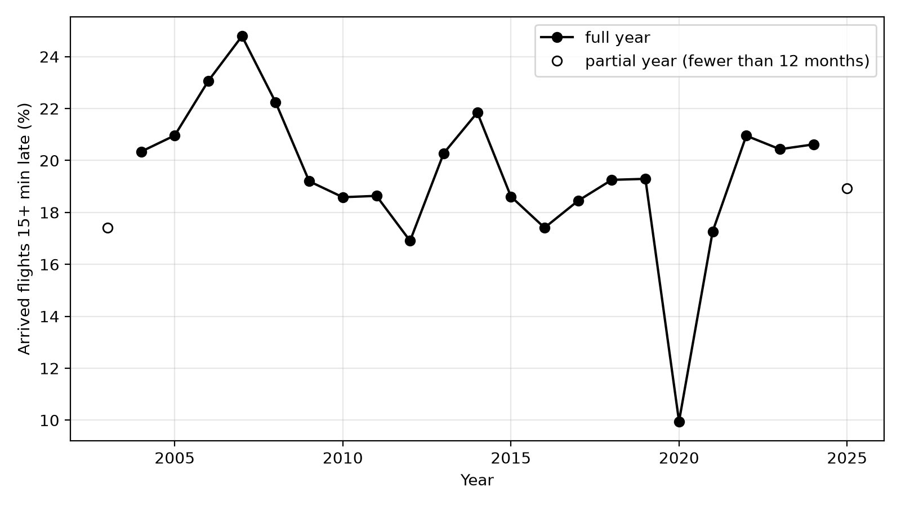
Figure 4 Annual arrival-delay percentages. Open markers denote partial years.
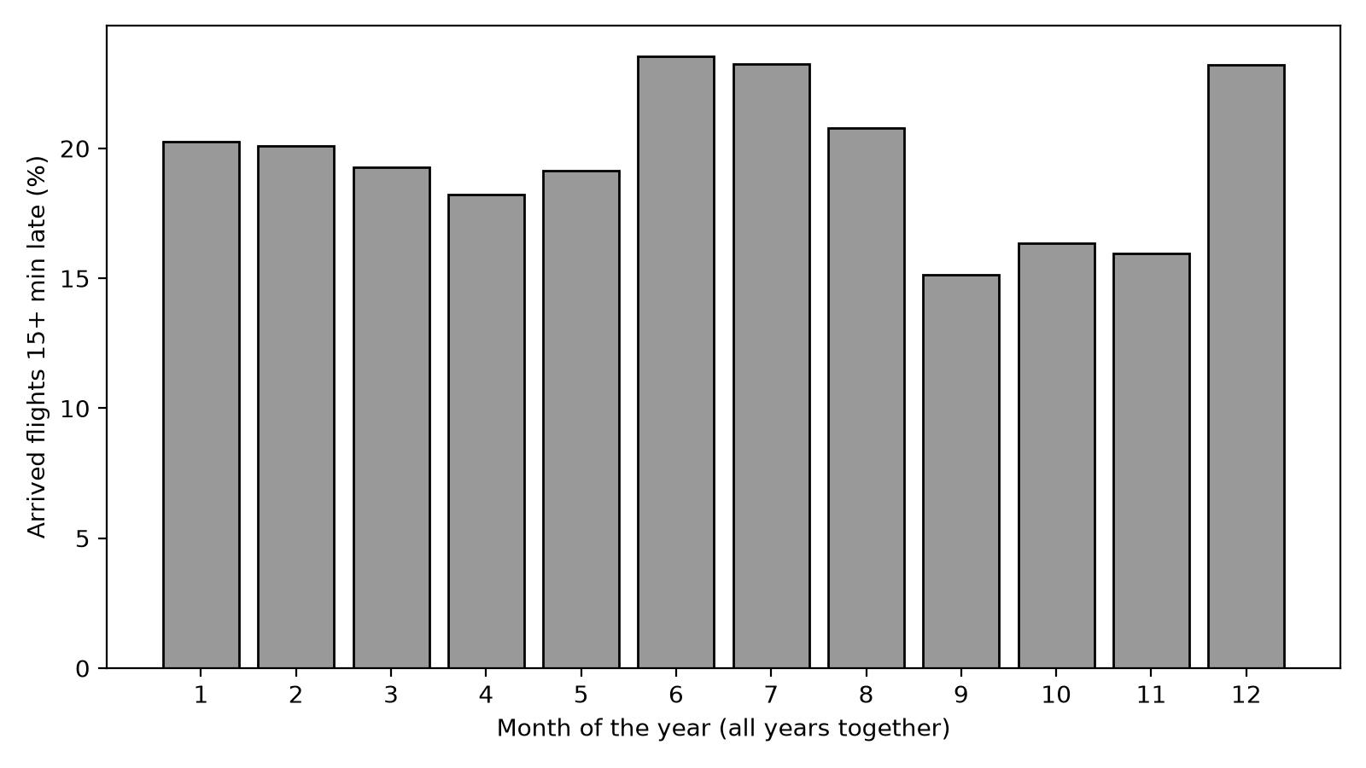
Figure 5 Arrival-delay percentages by calendar month, pooled across years.
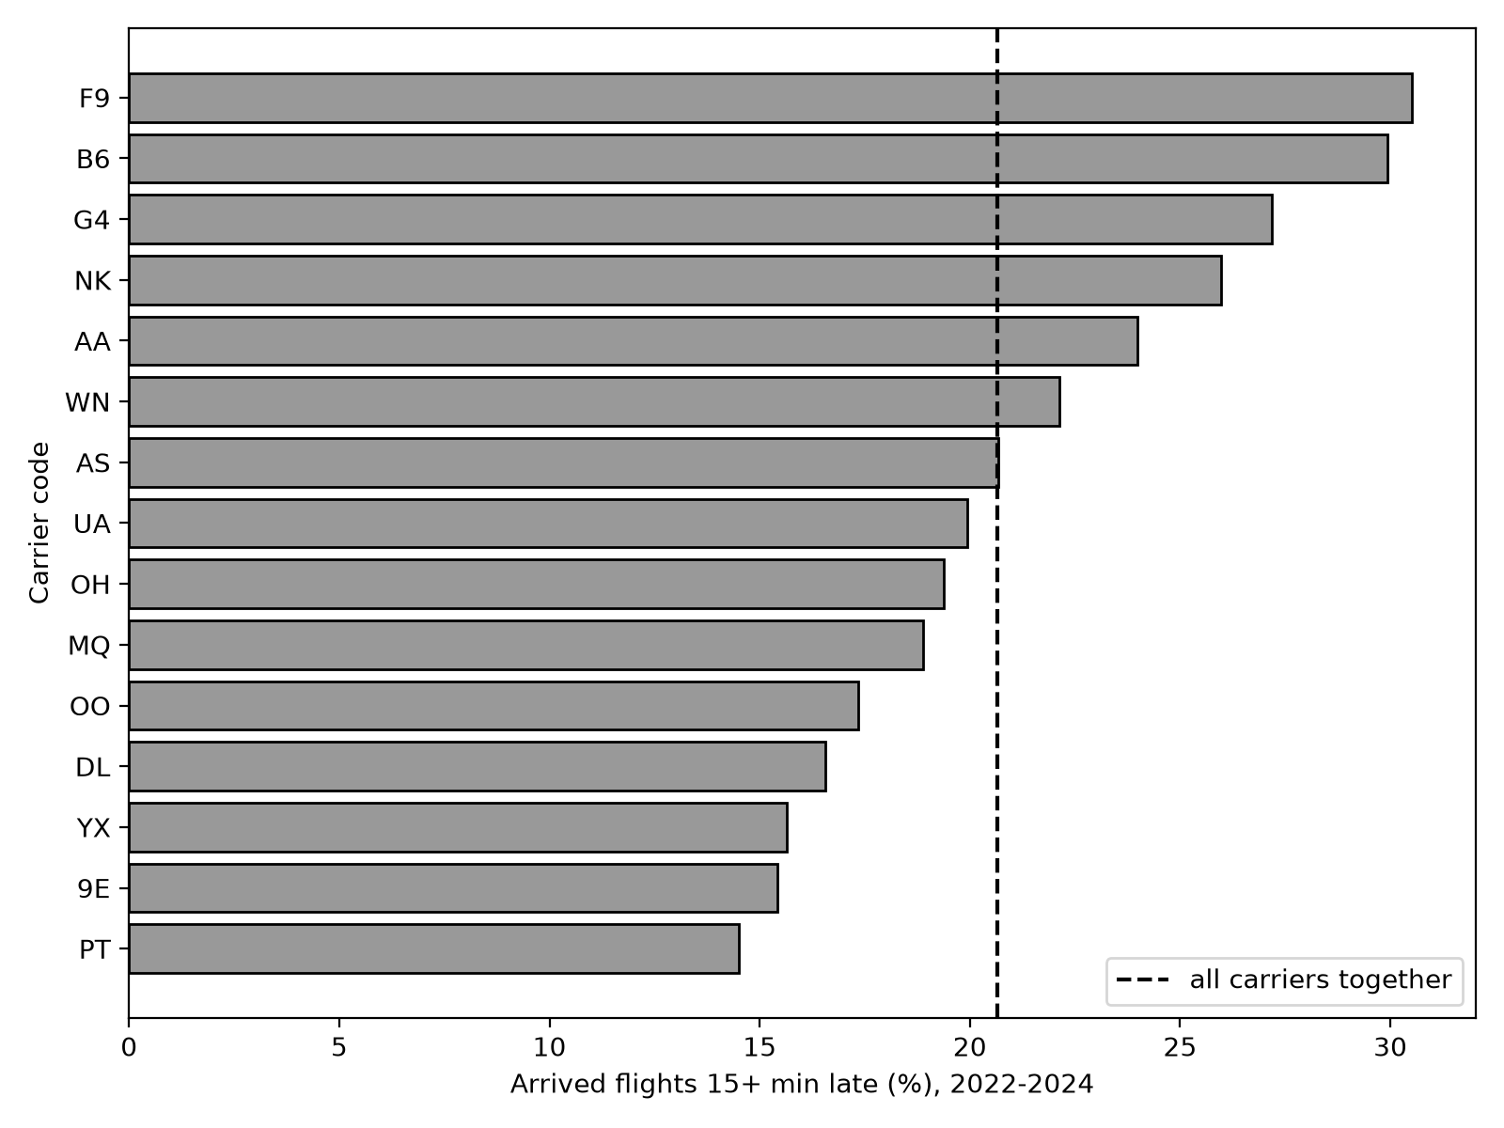
Figure 6 Delay rates for fifteen busy carriers during 2022-2024 only.
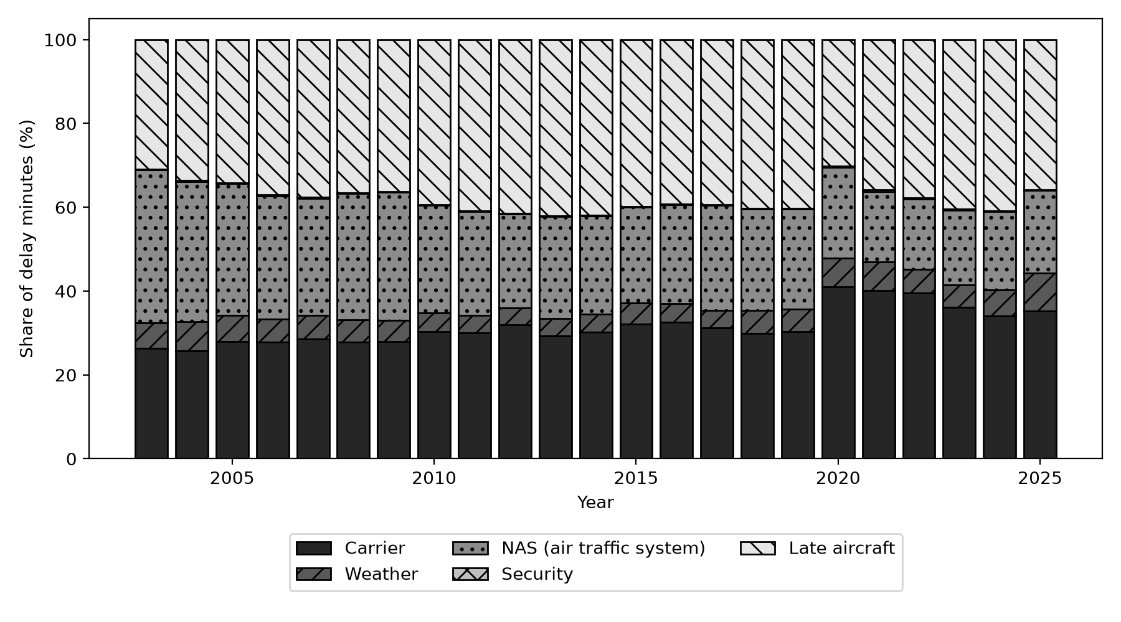
Figure 7 Shares of recorded delay minutes by cause and year.

4.4 Model
The predictive experiment estimates carrier-airport-month delay rates. Records with fewer than twenty arrived flights are excluded because a small denominator can produce unstable rates. Training uses 344,399 records before 2024, while evaluation uses 20,316 records from 2024. A chronological split gives a more relevant test of later-year performance than randomly mixing observations across years.
Two baselines are compared with HistGradientBoostingRegressor: a single training-set mean and a carrier-airport historical mean. The second baseline falls back to the overall mean when no matching historical pair is available. The saved counter reports 114 test rows without a matching training pair; it should not be described as 114 distinct pairs without a separate uniqueness calculation.
The regression features are carrier, airport, year, month and flight count. Carrier and airport codes are ordinal-encoded. Because the current implementation passes these codes as numeric features without explicitly declaring them categorical, the encoding introduces an arbitrary ordering that deserves further evaluation. The scikit-learn documentation provides the estimator's supported parameters and categorical-feature options [7].
The regression model achieved MAE 0.0692, RMSE 0.0899 and R-squared 0.2189. The historical-pair baseline achieved MAE 0.0748, while the global baseline achieved 0.0803. Thus the model improved on both baselines, but substantial variation remained unexplained. An MAE of 0.0692 corresponds to approximately 6.92 percentage points of delay-rate error, not 6.92% relative error.
Table 4 Model performance on held-out 2024 records.
Model | MAE | RMSE | R squared
baseline: same value for all | 0.0803 | 0.1018 | -0.0002
baseline: carrier+airport average | 0.0748 | 0.0971 | 0.0892
HistGradientBoostingRegressor | 0.0692 | 0.0899 | 0.2189

4.5 Interpret and analysis type
The descriptive results identify patterns worth investigating, while the held-out model adds a predictive component. They do not support prescribing a particular airline choice or claiming causal explanations for delays. Monthly realised flight counts may also be unavailable at a genuine advance forecasting time, so an operational forecasting system would need a clear feature-availability rule.
Moving towards prescriptive analysis would require explicit decisions, costs, constraints and evaluation of recommended actions. Examples include the cost of additional turnaround resources and the consequence of missed connections. The present pipeline does not optimise those decisions. Its contribution is a reproducible description, a bounded predictive comparison and evidence about processing choices.

5 Scale and distributed processing
The scale experiment follows Route A by implementing a comparable aggregation in pandas and Spark. Both read selected columns, retain usable records, group by year and carrier, sum arrived and delayed flights, calculate delay rates and sort the result. Spark executes locally with twelve logical cores. Input files contain 398,233, 1,991,165 and 9,955,825 records, created by repeating the cleaned data one, five and twenty-five times.
Replication is suitable for increasing processing volume, but it does not introduce realistic new categories, statistical variation or partition skew. The resulting experiment therefore measures this repeated workload rather than every possible larger airline dataset. A built-in comparison on the largest input confirmed matching pandas and Spark results for 439 groups before timings were collected.
Filtering and column expressions can operate within existing partitions and are narrow operations. Grouping by year and carrier requires records with the same key to be brought together, producing a shuffle. Global ordering introduces another wide operation. The captured physical plan contains exchanges corresponding to hash partitioning for grouping and range partitioning for ordering. These exchanges form boundaries between stages that can otherwise pipeline local work.
Spark builds a lazy query plan: constructing transformations does not by itself materialise the final rows. The benchmark calls collect() to trigger execution and transfer the small aggregated result to the driver. Its timings consequently include reading and executing the aggregation, rather than timing only the creation of a query object. Collecting this small result is appropriate here; collecting all raw rows at much larger scale would create a driver-memory risk.
Each operation is timed six times, discarding the first and reporting the remaining median and range. Spark startup took 8.8 seconds and is recorded separately from the repeated stage timings. The three input sizes produced one, two and eight input partitions. Settings compared default adaptive execution, adaptive execution disabled with 200 shuffle partitions, and adaptive execution disabled with twelve shuffle partitions. Spark documentation explains the role of shuffle partition settings and adaptive execution [8].
Pandas took 0.079, 0.283 and 1.404 seconds across the three sizes. Default Spark took 1.789, 1.354 and 2.204 seconds, remaining slower in every tested case. The twelve-partition configuration took 0.559, 0.622 and 0.917 seconds, outperforming pandas only at the largest size. With 200 partitions and adaptive execution disabled, Spark took 6.697, 4.284 and 5.168 seconds. Scheduling many small tasks imposed a substantial cost for this workload.
These results do not identify an exact crossover point. They only bracket a change in the relative performance of pandas and the tuned Spark configuration between the tested medium and large inputs. Processor count, memory, storage, cache state, software versions, key distribution and aggregation complexity can all change that relationship. The defensible conclusion is that tuning and workload size matter, not that one framework is universally faster.
Table 5 Median stage execution time in seconds. Spark startup is measured separately.
Rows | pandas | Spark default | Spark 200 no AQE | Spark 12 no AQE
398,233 | 0.079 | 1.789 | 6.697 | 0.559
1,991,165 | 0.283 | 1.354 | 4.284 | 0.622
9,955,825 | 1.404 | 2.204 | 5.168 | 0.917
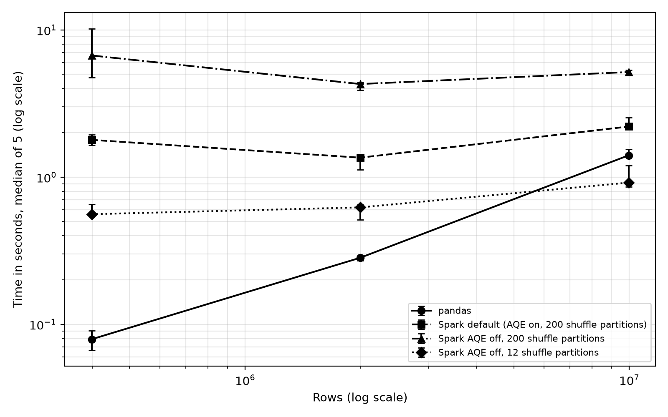
Figure 8 pandas and Spark timings across three replicated input sizes.

6 Professional practice

6.1 Version control and reproducibility
The repository separates processing, storage, analysis and Spark development through feature branches. Existing history includes merges and dated development commits. Local integration combined these branches on local/integration-validation-20261104, preserving the original main branch. The integration commit is 766530a; the subsequent local validation commit is 76cd715. No remote push was performed during this work. Some historical messages, including “Fixing”, provide little rationale and should be acknowledged as weaker documentation rather than presented as exemplary practice.
The README explains setup and execution order, while requirements.txt pins the direct Python dependencies used locally. OSEMN must run before Spark because it produces the cleaned Parquet input. Source checksums, saved summaries, physical plans and test output support repeatability. Nevertheless, successful execution in the existing environment is not equivalent to a verified clean-checkout installation. That separate check remains a useful final delivery step.
Table 6 Local execution environment.
Component | Recorded version or configuration
OS | Windows 11 10.0.26300
CPU | Intel64 Family 6 Model 154 Stepping 4
Logical cores and RAM | 12; 34.0 GB
Python and Java | 3.14.2; Java 21.0.9
pandas / NumPy / PyArrow | 2.3.3 / 2.5.4 / 26.0.1
scikit-learn / matplotlib / PySpark | 1.9.1 / 3.11.2 / 4.3.0
pytest | 9.2.0

6.2 Data protection and provenance
The inspected schema contains aggregate carrier-airport-month statistics, not passenger names, contact details, booking references or individual staff identifiers. This supports treating the extract as operational aggregate data. It does not justify assuming that every future extension will remain non-personal. Joining passenger-level records would require a new assessment before processing.
Applying the Article 5 principles as a design checklist means documenting source and purpose, retaining only necessary fields, checking accuracy, defining retention, controlling access and preserving accountability records. For this project, the checksum and cleaning report support accuracy and traceability; a restricted purpose prevents unsupported repurposing; and separate generated outputs avoid modifying the raw evidence. These engineering measures are not a legal certification. The applicable licence and any lawful basis for future personal-data processing must be verified separately [9].

6.3 Attribution and outstanding information
The download date, dataset licence, student identification and demonstration link remain to be confirmed. Local integration commits use the configured contributor identity, and the additional tests were created with AI assistance. These facts should be disclosed accurately rather than reassigned to imply independent authorship. Appendix D records the assistance used and leaves the student declaration and signature for the student to complete truthfully.

7 Reflection
The strongest aspect of the project is the connection between processing decisions and inspectable evidence. Missing-data treatment is recorded, analytical outputs can be regenerated, storage choices are measured, and Spark is compared on the same aggregation. The fifteen passing tests improve confidence in selected failure paths, especially preservation of the input and previous report when a cleaning step fails.
Several limitations remain. A mismatch between the recent-window filter and chart label was corrected before producing the final carrier outputs, demonstrating why visual claims must be checked against selection logic. Ordinal encoding gives carrier and airport codes an artificial numerical ordering, and the availability of flight counts at forecasting time is not established. Further work should evaluate explicit categorical treatment, time-aware validation across multiple years and predictors available before the forecast period. These changes should be tested separately rather than assumed to improve performance.
Scaling the dataset by copying rows increases volume without increasing category diversity or realistic skew. A more representative experiment would use independently acquired additional periods, monitor peak memory and document whether caches were warm. The earlier JSON memory failure also shows that successful execution can depend on available resources. At greater scale, full-object text deserialisation and repeated DataFrame copies are likely pressure points.

References
[1] Bureau of Transportation Statistics. Airline On-Time Statistics and Delay Causes. https://www.transtats.bts.gov/OT_Delay/OT_DelayCause1.asp (accessed 4 November 2026).
[2] Python Software Foundation. The Python Tutorial, Classes. https://docs.python.org/3/tutorial/classes.html (accessed 4 November 2026).
[3] pytest developers. How to write and report assertions in tests. https://docs.pytest.org/en/stable/how-to/assert.html (accessed 4 November 2026).
[4] pandas development team. IO tools. https://pandas.pydata.org/docs/user_guide/io.html (accessed 4 November 2026; current documentation may differ from installed pandas 2.3.3).
[5] Apache Software Foundation. Apache Parquet Overview. https://parquet.apache.org/docs/overview/ (accessed 4 November 2026).
[6] daryaheyko. Airline On-Time Statistics and Delay Causes BTS. Kaggle dataset page supplied by the project owner. https://www.kaggle.com/datasets/daryaheyko/airline-on-time-statistics-and-delay-causes-bts (licence and original download date require confirmation).
[7] scikit-learn developers. HistGradientBoostingRegressor. https://scikit-learn.org/stable/modules/generated/sklearn.ensemble.HistGradientBoostingRegressor.html (accessed 4 November 2026).
[8] Apache Software Foundation. Spark SQL Performance Tuning. https://spark.apache.org/docs/latest/sql-performance-tuning.html (accessed 4 November 2026).
[9] European Parliament and Council. Regulation EU 2016/679, Article 5. https://eur-lex.europa.eu/eli/reg/2016/679/oj/eng (official text for independent verification; automated retrieval was unavailable).

Appendix A Processing method and tests
Listing A1 Cleaner.run from preprocess/cleaning.py. Line numbers are local to this listing.
01 def run(self, df):
02 if not isinstance(df, pd.DataFrame):
03 raise ValueError("run() needs a pandas DataFrame, got " + type(df).__name__)
04 if df.empty:
05 raise ValueError("the DataFrame is empty, nothing to clean")
06
07 new_report = []
08 current = df
09 step_name = "(no step yet)"
10 start = time.time()
11 try:
12 for step in self._steps:
13 step_name = step.name
14 rows_before = len(current)
15 current = step.apply(current)
16 info = step.summary()
17 info["rows_before"] = rows_before
18 info["rows_after"] = len(current)
19 new_report.append(info)
20 except FlightDataError:
21 raise # already one of our own errors with a good message
22 except Exception as e:
23 raise CleaningError("step '" + step_name + "' failed: " + str(e)) from e
24 else:
25 self._report = new_report # only saved if every step worked
26 finally:
27 self._seconds = round(time.time() - start, 2)
28 return current
Table A1 Commentary on the method operations.
Line | Purpose
1 | Accept the input DataFrame through the public processing interface.
2 | Check the input type before starting transformations.
3 | Reject invalid input with an informative argument error.
4 | Reject empty datasets.
5 | Reject invalid input with an informative argument error.
7 | Build a temporary report so failed work cannot replace previous evidence.
8 | Begin from the supplied frame; supported steps return new frames.
9 | Track the active step for failure diagnostics.
10 | Capture the start time.
11 | Enter the protected processing sequence.
12 | Execute the configured steps in order.
13 | Track the active step for failure diagnostics.
14 | Measure the input row count for this step.
15 | Invoke the common step interface polymorphically.
16 | Retrieve the step outcome and affected-record information.
17 | Add before/after row-count evidence to the report entry.
18 | Add before/after row-count evidence to the report entry.
19 | Accumulate the completed step without publishing a partial report.
20 | Preserve already-classified domain failures.
21 | Re-raise the original exception unchanged.
22 | Catch an unexpected step failure.
23 | Identify the failing step and retain the original exception as the cause.
24 | Run only when all protected operations succeeded.
25 | Publish the completed report atomically at the end of this run.
26 | Execute cleanup/accounting on success or failure.
27 | Record elapsed time even if an error propagates.
28 | Return the cleaned output after successful processing.

Automated test evidence
test_csv_loads_values_and_records_row_count — PASS
test_schema_failure_preserves_last_successful_count — PASS
test_missing_file_raises_file_not_found — PASS
test_invalid_loader_path_raises_value_error[] — PASS
test_invalid_loader_path_raises_value_error[None] — PASS
test_invalid_loader_path_raises_value_error[input.json] — PASS
test_cleaner_rejects_invalid_input[None] — PASS
test_cleaner_rejects_invalid_input[data1] — PASS
test_cleaner_rejects_invalid_input[data2] — PASS
test_default_pipeline_cleans_without_mutating_input — PASS
test_negative_counts_are_retained_but_excluded — PASS
test_domain_error_is_preserved — PASS
test_failed_step_preserves_input_report_and_updates_elapsed — PASS
test_report_return_value_cannot_change_saved_report — PASS
test_recent_window_excludes_partial_future_year — PASS
Latest saved run: 15 passed in 4.60 seconds. The additional case verifies that January 2025 is excluded from the 2022-2024 comparison.

Appendix B Detailed measurements
Table B1 Full Spark timing ranges in seconds.
Rows | Engine | Median | Minimum | Maximum
398233 | pandas | 0.079 | 0.067 | 0.091
398233 | Spark default (AQE on, 200 shuffle partitions) | 1.789 | 1.649 | 1.938
398233 | Spark AQE off, 200 shuffle partitions | 6.697 | 4.748 | 10.199
398233 | Spark AQE off, 12 shuffle partitions | 0.559 | 0.548 | 0.653
1991165 | pandas | 0.283 | 0.271 | 0.286
1991165 | Spark default (AQE on, 200 shuffle partitions) | 1.354 | 1.119 | 1.409
1991165 | Spark AQE off, 200 shuffle partitions | 4.284 | 3.910 | 4.388
1991165 | Spark AQE off, 12 shuffle partitions | 0.622 | 0.511 | 0.650
9955825 | pandas | 1.404 | 1.369 | 1.546
9955825 | Spark default (AQE on, 200 shuffle partitions) | 2.204 | 2.146 | 2.527
9955825 | Spark AQE off, 200 shuffle partitions | 5.168 | 4.995 | 5.329
9955825 | Spark AQE off, 12 shuffle partitions | 0.917 | 0.856 | 1.198
Table B2 YAML side comparison on 10,000 rows.
Format | Rows | Size MB | Write s | Read s
YAML | 10000 | 4.817 | 1.364 | 1.503
CSV | 10000 | 1.557 | 0.072 | 0.020
Table B3 Corrected annual statistics. Delay percentage equals delay_rate × 100.
Year | Scheduled | Arrived | Delay % | Minutes per late flight | Cancelled per 100
2003 | 3,815,736 | 3,755,761 | 17.41 | 49.8 | 1.39
2004 | 7,129,240 | 6,987,699 | 20.34 | 51.4 | 1.79
2005 | 7,140,595 | 6,992,838 | 20.97 | 52.2 | 1.87
2006 | 7,141,922 | 7,003,802 | 23.07 | 54.0 | 1.71
2007 | 7,455,458 | 7,277,467 | 24.79 | 56.0 | 2.16
2008 | 7,009,726 | 6,855,029 | 22.24 | 56.8 | 1.96
2009 | 6,450,285 | 6,345,445 | 19.20 | 54.2 | 1.39
2010 | 6,450,117 | 6,321,388 | 18.59 | 53.8 | 1.76
2011 | 6,085,281 | 5,954,904 | 18.64 | 55.6 | 1.91
2012 | 6,096,762 | 6,005,381 | 16.90 | 56.1 | 1.29
2013 | 6,369,482 | 6,259,310 | 20.28 | 56.7 | 1.51
2014 | 5,819,811 | 5,678,378 | 21.85 | 56.7 | 2.18
2015 | 5,819,079 | 5,714,008 | 18.61 | 58.9 | 1.54
2016 | 5,617,658 | 5,538,145 | 17.41 | 62.1 | 1.17
2017 | 5,674,621 | 5,579,398 | 18.45 | 63.9 | 1.46
2018 | 7,848,697 | 7,694,677 | 19.25 | 65.6 | 1.71
2019 | 8,091,684 | 7,917,263 | 19.29 | 69.7 | 1.90
2020 | 5,022,397 | 4,712,931 | 9.95 | 62.5 | 5.99
2021 | 6,311,871 | 6,185,871 | 17.27 | 66.9 | 1.76
2022 | 7,013,508 | 6,806,807 | 20.95 | 67.7 | 2.71
2023 | 7,278,739 | 7,167,045 | 20.43 | 69.7 | 1.29
2024 | 7,546,968 | 7,425,229 | 20.62 | 72.2 | 1.36
2025 | 599,013 | 578,957 | 18.93 | 71.8 | 3.13
2003 contains seven months and 2025 one month. They should not be treated as complete-year observations.

Appendix C Repository and execution evidence
The following tree lists the principal reproducibility files. Generated caches and virtual environments are omitted.
preprocess/ loaders.py, cleaning.py, analysis.py, exceptions.py, config.py, utils.py
scripts/ data_summary.py, ds_demo.py, storage_formats.py, osemn.py, spark.py
tests/ test_processing.py
data/ Airline_Delay_Cause.csv, MANIFEST.txt
results/ measured CSV and JSON outputs, pytest output and run logs
figures/ storage, delay and Spark figures
README.md
requirements.txt
Selected recorded Git history. This is a text extract, not a screenshot. Later tests and the date-window correction remain local uncommitted changes.
* 766530a 2026-11-04 Merge analysis and Spark branches for local integration validation
|\
| * 6901a44 2026-10-31 Fixing
| * f4a1794 2026-10-31 Fixing
| * 8754157 2026-10-31 Merge branch 'spark' of github-coursework:sanudisarithma/bts-flight-delay-pipeline into spark
| |\
| | * 10ae66a 2026-10-31 Merge pull request #9 from sanudisarithma/osemn-pipeline
| | |\
| | | * 0b49045 2026-10-31 Outputs
| * | | 327ebf8 2026-10-31 Compare Spark with pandas: record timings, plan and chart (generated data stays ignored)
| |/ /
| * / 02981e2 2026-10-28 Preprocessing codes
| |/
* | 5db0f82 2026-10-31 Update osemn.py
* | df9fd3e 2026-10-31 Update config.py
* | 5b73b05 2026-10-31 Merge pull request #6 from sanudisarithma/storage-formats
|\ \
| * \ 21aaad3 2026-10-31 Merge branch 'main' into storage-formats
| |\ \
| |/ /
|/| |
* | | 39a7257 2026-10-30 Merge pull request #4 from sanudisarithma/processing-module
|\ \ \
| * \ \ 34f5fc4 2026-10-30 Merge branch 'main' into processing-module

Reproduction commands
.\venv\Scripts\python.exe -m pip install -r requirements.txt
.\venv\Scripts\python.exe -m pytest -v
.\venv\Scripts\python.exe scripts/data_summary.py
.\venv\Scripts\python.exe scripts/ds_demo.py
.\venv\Scripts\python.exe scripts/storage_formats.py
.\venv\Scripts\python.exe scripts/osemn.py
.\venv\Scripts\python.exe scripts/spark.py
Configure JAVA_HOME for the installed JDK, prepend its bin directory to PATH and set SPARK_LOCAL_IP=127.0.0.1 before Spark. Run commands sequentially. OSEMN creates the Parquet input required by Spark.

Appendix D Attribution and declaration
Assistance record: Codex assisted with local branch integration, dependency setup, execution, test creation, date-window correction, results checking and preparation of this document. The integration commits retain the configured local contributor identity. No GitHub push was performed during these operations.
Student declaration: ______________________________________________
________________________________________________________________
Use the institution’s official declaration wording and describe the actual assistance received. The student must complete and sign the declaration after reviewing the applicable coursework rules.
Student signature: ____________________ Date: ____________________

