DANANG SOFTWARE CORPORATION
INTERNATIONAL PROGRAMMER TRAINING CENTER
SOFTECH-APTECH
---------------------------------





THEME:

E-Administration

Instructor : Hoang Nhac Trung
Class : Batch 54B
Group : 03
Center : ACE-Danang1 - Viet Nam

Group members:
Ngo Thi Bich Van (Leader)
Nguyen Hoang Son
Phan Thanh Ngoc

Da Nang 08/2012





This is to certify that
Mr. /Ms.
has successfully designed and
developed
_____________________________
Submitted by:
Date of Issue: ________
Authorized Signature: ___________

Acknowledgement

During the project, we recalled all knowledge of previous lessons and we accumulated more experience. We want to thank Mr Hoang Nhac Trung, for all the time he guided us enthusiastically. We also thank Aptech India for all quickly support; you helped us so much for helping us in the working on project time.
Working on the project brought us a lot of lesson and knowledge. Simultaneously, we have the chances to practice our accumulation. Finally, we send to you all my good wishes for your perfect health.

Index

I. Introduction 6
1.1 Purpose 6
1.2 Scope 6
1.3 Definitions, Acronyms, and Abbreviations 6
1.4 Overview 6
II. Overall Description 6
2.1 System Environment 6
2.2 Actors 7
2.3 Architecture and Design of the Project 7
2.4 Function Requirement Specification 8
2.5 Non-functional requirements 8
2.5.1 Safety Requirements 8
2.5.2 Security Requirements 9
2.5.3 Software Quantity Attributes 9
III. Requirements Specification : 9
3.1 Use case 9
3.1.1 Diagram 9
3.1.2 Use case summary 10
3.1.3 Use case specification 11
3.2 Entity relationship diagram 24
3.3 Data flow diagram 24
3.4 Sequence diagram 29
IV. External interface specification 36
V. Functional Requirements 37
5.1 User admin 37
5.2 Service complaint 37
5.3 Software or hardware maintenance 37
5.4 Lab assignment 37
VI. Use guide 37
6.1 System requirements 37
6.2 Install and launch the project : 37

Project Ref. No : |  | Project Title | Activity Plan Prepared By | Date of Preparation of Activity Plan
Sr.No | Task | Project Title | Activity Plan Prepared By | Actual Start Date | Deadline | Actual Days | Team Member Names | Status
1 | Customer Requirement System |  | All members | 13/08/2012 | 17/08/2012 |  | All members | Done
2 | Task Sheet |  | Van.Ngo | 17/08/2012 | 20/08/2012 |  | Van.Ngo
3 | Use Case |  | Van.Ngo | 20/08/2012 | 23/08/2012 |  | Van.Ngo
4 | Use Case Specification |  | Van.Ngo&Ngoc.Phan | 20/08/2012 | 23/08/2012 |  | Van.Ngo&Ngoc.Phan
5 | Design Database |  | Ngoc.Phan | 20/08/2012 | 23/08/2012 |  | Ngoc.Phan
6 | Database diagram |  | Son.Nguyen | 20/08/2012 | 23/08/2012 |  | Son.Nguyen
 |  |  | 23/08/2012 The First Status Report
7 | Sequence Diagram |  | Ngoc.Phan | 24/08/2012 | 26/08/2012 |  | Ngoc.Phan
8 | Activity Diagram |  | Son.Nguyen | 24/08/2012 | 26/08/2012 |  | Son.Nguyen
9 | Component Diagram |  | Son.Nguyen | 26/08/2012 | 28/08/2012 |  | Son.Nguyen
10 | Design Template |  | Van.Ngo & Ngoc.Phan | 28/08/2012 | 03/09/2012 |  | Van.Ngo & Ngoc.Phan
11 | Design Entity Bean |  | Son.Nguyen&Ngoc.Phan | 28/08/2012 | 03/09/2012 |  | Son.Nguyen & Ngoc.Phan
12 | Finish Document |  | Van.Ngo | 28/08/2012 | 03/09/2012 |  | Van.Ngo
 |  |  | 03/09/2012 The second Status Report : Finish doc, entity Bean, Template
13 | Coding and Test Unit |  | All members | 03/09/2012 | 13/09/2012 |  | All members
14 | Testing and Review |  | All members | 13/092012 | 18/09/2012 |  | All members
15 | Write guidelines + slide |  | Van.Ngo & Ngoc.Phan | 18/09/2012 | 20/09/2012 |  | All members
Finish

Task sheet

- Introduction
  - Purpose
The project e-Administration of computer labs is an automated system for lab management. It eases the tasks of administrator, instructors, head of departments’ of various departments, technical staff and students. It is to provide the solution for an organization which involve computing facilities such as Computers, Printers, LCDs, Digital Boards, ACs etc. on a 24×7 bases to carry out academic experiments for all the branches with all the equipment in good working conditions and also with all the necessary software’s installed and configured. This software also helps the administrator and instructor(s) to maintain proper documentation of the computing systems.
  - Scope
The e-Administration is a web based application. It is a new attempt to speed up the process of managing Computer Labs in an educational institute. It also provides clean and user friendly interface to the users.
  - Definitions, Acronyms, and Abbreviations

No. | Acronyms | Description
1 | HOD | Head of Department

  - Overview
This system will be replaced for manual system of computer labs management. It also provides a good and safe storage capacity.

- Overall Description
  - System Environment
- Hardware Requirements :
- Pentium IV CPU 2.80 GHz
- 512 MB of RAM or higher
- Hard disk requirement: Minimum 4 GB
- Windows 2000 or XP or higher

- Software Requirements :
- IIS 4.0 or higher
- Internet Explorer 6.0 or higher
  - Actors
- HOD
- Administrator
- Instructor
- Technical Staff

  - Architecture and Design of the Project
This application will be made of a Web - based distributed three-tier architecture to support multiple user transactions at the same time.

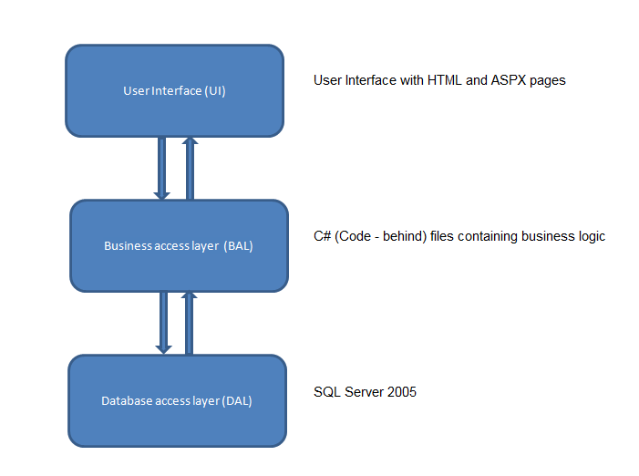
Web-Based Distributed 3-Tier Architecture of the Project

- The admin creates different users.
- Admin can generate lab assignment and assigns instructor to specific complaint or any problem and checks the report to ensure whether the complaints responded or pending.
- Users include Technical staff and Instructors.
- The user can register complaint pertaining to any lab equipments. The registered complaints will be sent to Admin.
- Instructor maintains documentation of software, hardware and he also provides the report of equipment conditions to the admin.
- He performs the tasks assigned by admin. He also checks about the warranty of product if it is out of date.
- Another profile in project is HODs profile. Here HODs can see the complaints lodged by his/her department users.
- HOD can also request for extra labs to the Admin. Based on the available slots, admin defines the slots and send a reply to HOD.
- This software should also facilitate students in getting syllabus copy, software installation procedures, different lab related software’s etc.
  - Function Requirement Specification
- It should provide schedule/time-table without any of clashes among faculties, day, time and room that must be visible to all.
- It should generate report about registered complaint to the admin and response report to the user who have submitted his queries.
- Secure registration and profile management facilities for different users.
- It should provide details like e-learning facilities, server room details, software installation procedures etc. to students.

  - Non-functional requirements
    - Safety Requirements
If there is extensive damage to a wide portion of the database due to catastrophic failure, such as a disk crash, the recovery method restores a past copy of the database that was backed up to archival storage (typically tape) and reconstructs a more current state by reapplying or redoing the operations of committed transactions from the backed up log, up to the time of failure
    - Security Requirements
Security systems need database storage just like many other applications. However, the special requirements of the security market mean that vendors must choose their database partner carefully.
    - Software Quantity Attributes
- Correctness
The system should generate appropriate report about different activities of the lab and should keep track of all records
- Maintainability
The system should maintain correct schedules of labs and the documentation of all lab equipments
- Usability
The system should satisfy maximum number of users needs.
- Requirements Specification :
  - Use case
    - Diagram
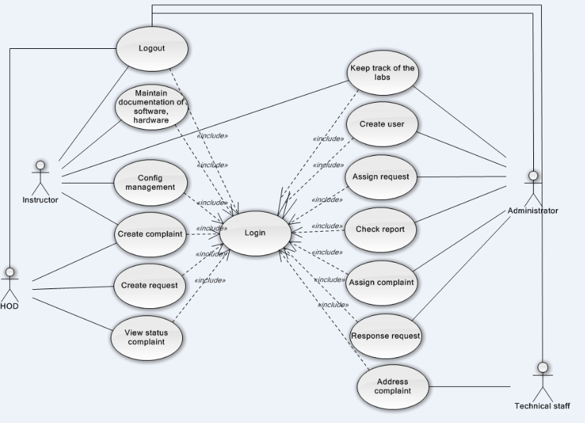
E-Administration use case diagram
    - Use case summary
Use case ID | Name | Priority | Related Use case | Remark
UC_01 | Address complaint | High |  | Actor:
UC_02 | Config management |  |  | Actor:
UC_03 | Maintain document |  |  | Actor:
UC_04 | Log in |  |  | Actor:
UC_05 | Log out |  |  | Actor:
UC_06 | Create complaint |  |  | Actor
UC_07 | Keep track of the lab |  |  | Actor:
UC_08 | Create user |  |  | Actor:
UC_09 | Assign request |  |  | Actor:
UC_10 | Check report |  |  | Actor:
UC_11 | Assign complaint |  |  | Actor:
UC_12 | Response request |  |  | Actor:
UC_13 | Create request |  |  | Actor:
UC_14 | View status complaint |  |  | Actor:
UC_15 | Update status
UC_16 | Manage profile

    - Use case specification

Use Case ID: UC_01 | Use Case Name: Address complaint |  | Version No: 1.0  Date: Aug-22-2012
Primary Actor: technical staff |  | Client Ref:
Brief Description: technical staff has the permission to solve the complaints which user created.
Stakeholders and Interests:
Stakeholder1 (Primary Actor): technical staff
Preconditions: Login with role of technical staff
Success Guarantee (Post conditions):
Update status for resource
Main Success Scenario (Basic Flow):
Main flow :
1. User solves the complaint which administrator assigned it for him.
2. After he finished the solving complaint, he drags the complaint from In-progressing column to Verify column.

Extensions (Alternative Flows):
2a. The technical staff can cancel the solving complaint by dragging the complaint from Verify column to In-progressing column.

Relationship with Other Use Cases: Login.
Special Requirements:
Automate the task of assigning complaints to specific technical staff based on the nature of problem.

Technology and Data Variations List:
Valid username and password.
In the case, the user forgot the password. The system needs the valid email.

Frequency of Occurrence: High.

Use Case ID: UC_02 | Use Case Name: Config management |  | Version No: 1.0  Date: Aug-22-2012
Primary Actor: Instructor |  | Client Ref:
Brief Description: Instructor can checks warranty of particular software, generates alert messages and helps in proper documentation of available software’s or hardware’s in labs
Stakeholders and Interests:
Stakeholder1 (Primary Actor): Instructor
Preconditions: Log into system with instructor role.
Success Guarantee (Post conditions):
Update status for resource
Main Success Scenario (Basic Flow):
Main flow :
1. User selects the software to generate alert message.
2. User presses the ‘Generate alert message’ button.
Extensions (Alternative Flows):
2a. The user cancels the generating alert message by pressing ‘Cancel’ button.
Relationship with Other Use Cases: Login.
Special Requirements:
Instructor maintains documentation of software, hardware and he also provides the report of equipment conditions to the admin.
Technology and Data Variations List:
Valid username and password.
In the case, the user forgot the password. The system needs the valid email.

Frequency of Occurrence: High.

Use Case ID: UC_03 | Use Case Name: Maintain document |  | Version No: 1.0  Date: Aug-22-2012
Primary Actor: instructor |  | Client Ref:
Brief Description: instructor maintains documentation of software, hardware and he also provides the report of equipment conditions to the admin,
Stakeholders and Interests:
Stakeholder1 (Primary Actor): instructor
Preconditions: Log into system with instructor role.
Success Guarantee (Post conditions):
Update status for resource
Main Success Scenario (Basic Flow):
      - Main flow :
1. User select resource need update status
2. User change status for that resource.
Extensions (Alternative Flows):
2a. The user cancels about change status for that resource.
Relationship with Other Use Cases: Login.
Special Requirements:
The instructor has the permission to manage the system config.

Technology and Data Variations List:
Valid username and password.
In the case, the user forgot the password. The system needs the valid email.

Frequency of Occurrence: High.

Use Case ID: UC_04 | Use Case Name: Login |  | Version No: 1.0  Date: Aug-22-2012
Primary Actor: All actors |  | Client Ref:
Brief Description: This is use case which students, facility heads, assigned people, administrator login into the system. After log inning, they can use the other functions which match with each other.
Stakeholders and Interests:
Stakeholder1 (Primary Actor): students, facility heads, assigned people, administrator
Preconditions: Log into system with instructor role.
Success Guarantee (Post conditions):
Update status for resource
Main Success Scenario (Basic Flow):
      - Main flow :
1. User opens the application. The login show with the username and the password textbox.
2. User enters the username and password and press ‘Login’ button.
3. The system checks the entered information.
4. The system show the other functions which match with each other.
Extensions (Alternative Flows):
2a. The user cancels to login into the system.
4a. If the account is invalid, the system announces to reenter username and password to the user or guides user to perform one in two actions :
- Register a new account.
- Get again the password if the user forgot the password.

Relationship with Other Use Cases: No.
Special Requirements:
The User can login into the system at the first page successful.

Technology and Data Variations List:
Valid username and password.
In the case, the user forgot the password. The system needs the valid email.

Frequency of Occurrence: High.

Use Case ID: UC_05 | Use Case Name: Logout |  | Version No: 1.0  Date: Aug-22-2012
Primary Actor: All users |  | Client Ref:
Brief Description: All users can log out to the system.
Stakeholders and Interests:
Stakeholder1 (Primary Actor): all users

Preconditions: Log into system with administrator or instructor role.
Success Guarantee (Post conditions):
The system is logout.

Main Success Scenario (Basic Flow):
- The user presses ‘Logout’ button to logout the system.
- The system returns to ‘Home’ page.
Extensions (Alternative Flows):
1. If user input invalid user name and password, the system will display message to notice that login is failed and login again.
2. If system cannot load data, it will display message to notice that load data is failed.

Relationship with Other Use Cases: “include”: UC_01

Special Requirements:
All user can log out the system
.

Technology and Data Variations List:
Valid username and password.
In the case, the user forgot the password. The system needs the valid email.

Frequency of Occurrence: High.

Use Case ID: UC_06 | Use Case Name: Create complaint |  | Version No: 1.0  Date: Aug-22-2012
Primary Actor: Admin |  | Client Ref:
Brief Description: This is use case which user can create complaint.
Stakeholders and Interests:
Stakeholder1 (Primary Actor): all users

Preconditions: Log into system with administrator or instructor role.
Success Guarantee (Post conditions):
The system is logout.

Main Success Scenario (Basic Flow):
      - Main flow :
1. User click “New complaint”
2. User enters information for complaint.
3. User click button “Ok” to finish
Extensions (Alternative Flows):
1. If user input invalid user name and password, the system will display message to notice that login is failed and login again.
2. If system cannot load data, it will display message to notice that load data is failed.

Relationship with Other Use Cases: “include”: Login
Special Requirements:
All user can log out the system
.

Technology and Data Variations List:
Valid username and password.
In the case, the user forgot the password. The system needs the valid email.

Frequency of Occurrence: High.

Use Case ID: UC_07 | Use Case Name: Keep track of the labs |  | Version No: 1.0  Date: Aug-22-2012
Primary Actor: administrator and instructor |  | Client Ref:
Brief Description: This is use case which helps the administrator and instructor to keep track of the detailed information of the labs.
Stakeholders and Interests:
Stakeholder1 (Primary Actor): administrator and instructor.

Preconditions: Log into system with administrator or instructor role.
Success Guarantee (Post conditions):
Administrator and instructor track different activities of the lab.
Main Success Scenario (Basic Flow):
1. Log into system with administrator or instructor role.
2. Select the lab needs to keep track it
Extensions (Alternative Flows):
1. If user input invalid user name and password, the system will display message to notice that login is failed and login again.
2. If system cannot load data, it will display message to notice that load data is failed.

Relationship with Other Use Cases: Login.
Special Requirements:
The administrator or instructor can view information about activities of labs.

Technology and Data Variations List:
Valid username and password.
In the case, the user forgot the password. The system needs the valid email.

Frequency of Occurrence: High.

Use Case ID: UC_08 | Use Case Name: Create user |  | Version No: 1.0  Date: Aug-22-2012
Primary Actor: administrator |  | Client Ref:
Brief Description: This is use case which helps the administrator create new user.
Stakeholders and Interests:
Stakeholder1 (Primary Actor): administrator

Preconditions: Log into system with administrator role.
Success Guarantee (Post conditions):
Administrator created new user.
Main Success Scenario (Basic Flow):
1. Log into system with administrator role.
2. Click “Create User” link for redirect to “create user” page.
3. Input valid user information format.
4. Click “Create” button to create new user.
Extensions (Alternative Flows):
1. If administrator inputs invalid user name and password, the system will display message to notice that login is failed and login again.
2. If administrator inputs invalid user information format, the system will display message to notice.

Relationship with Other Use Cases: Login.
Special Requirements:
The administrator can create new user.

Technology and Data Variations List:
Valid username and password.
In the case, the user forgot the password. The system needs the valid email.
Valid user information format.
Frequency of Occurrence: High.

Use Case ID: UC_09 | Use Case Name: Assign Request |  | Version No: 1.0  Date: Aug-22-2012
Primary Actor: administrator |  | Client Ref:
Brief Description: This is use case which helps the administrator assigns request which is from HOD for register labs.
Stakeholders and Interests:
Stakeholder1 (Primary Actor): administrator

Preconditions: Log into system with administrator role.
Success Guarantee (Post conditions):
Administrator assigned request for HOD’s request for register labs.
Main Success Scenario (Basic Flow):
1. Log into system with administrator role.
2. click on the place which is free on the schedule
3. Fill the information to request on popup appears

Extensions (Alternative Flows):
1. If administrator inputs invalid user name and password, the system will display message to notice that login is failed and login again.
2. If system cannot load requests, it will display message to notice that load requests are failed.
Relationship with Other Use Cases: Login.
Special Requirements:
The administrator can approve or reject request.

Technology and Data Variations List:
Valid username and password.
In the case, the user forgot the password. The system needs the valid email.
Valid user information format.
Frequency of Occurrence: High.

Use Case ID: UC_10 | Use Case Name: Check report |  | Version No: 1.0  Date: Aug-22-2012
Primary Actor: administrator |  | Client Ref:
Brief Description: This is use case which helps the administrator checks the report to ensure whether the complaints responded or pending.
Stakeholders and Interests:
Stakeholder1 (Primary Actor): administrator

Preconditions: Log into system with administrator role.
Success Guarantee (Post conditions):
Administrator checks the report which is made from system.
Main Success Scenario (Basic Flow):
1. Log into system with administrator role.
- The message informs that he has any emails to check report
- The admin login into his email to check report
Extensions (Alternative Flows):
1. If administrator inputs invalid user name and password, the system will display message to notice that login is failed and login again.
2. There’s not message because there’s not report to be send by instructor.
Relationship with Other Use Cases: Login.
Special Requirements:
The administrator can check report which is made from system.

Technology and Data Variations List:
Valid username and password.
In the case, the user forgot the password. The system needs the valid email.
Valid user information format.
Frequency of Occurrence: High.

Use Case ID: UC_11 | Use Case Name: Assign complaint |  | Version No: 1.0  Date: Aug-22-2012
Primary Actor: administrator, technical staff |  | Client Ref:
Brief Description: This is use case which helps the administrator assigns complaints to specific technical staff based on the nature of problem and the technical staff can assign the complaint which he is assign by his administrator for another.

Stakeholders and Interests:
Stakeholder1 (Primary Actor): administrator

Preconditions: Log into system with administrator role.
Success Guarantee (Post conditions):
Administrator assigns complaints to specific technical staff.
Main Success Scenario (Basic Flow):
1. User select complaint need to solve by draping the complaint in To-Do column the dragging it in In-Progressing column and select the person to assign it for him.
2. The status of complaint changes and the person who is assigned it will receive the email to solve the complaint.
Extensions (Alternative Flows):
1. If administrator inputs invalid user name and password, the system will display message to notice that login is failed and login again.
2. If system cannot load complaints, it will display message to notice that load complaints are failed.
Relationship with Other Use Cases: Login.
Special Requirements:
The administrator can assigns complaints to specific technical staff.
Technology and Data Variations List:
Valid username and password.
In the case, the user forgot the password. The system needs the valid email.
Valid user information format.
Frequency of Occurrence: High.

Use Case ID: UC_12 | Use Case Name: Response request |  | Version No:  Date:
Primary Actor: Admin |  | Client Ref:
Brief Description: when there is a request about using lab, actor can check the information of request and accept or reject the request. The system will send email to the relative people after admin responded the request.
Stakeholders and Interests:
Stakeholder1 (Primary Actor): admin

Preconditions: The user logins successful into the system.
Success Guarantee (Post conditions):
The user logs successful out the system.

Main Success Scenario (Basic Flow):
      - Main flow :
- Check the information of request
- Click on ‘Approve’ button to approve the request or ‘Reject’ button to reject it.
Extensions (Alternative Flows):
2a. If the request is valid (no clashed), actor accept the request. Unless, he can reject it.
Relationship with Other Use Cases: No
Special Requirements:
The admin can accept or reject the request.

Technology and Data Variations List:
Valid username and password.
In the case, the user forgot the password; the system needs the valid email.

Frequency of Occurrence: High.

Use Case ID: UC_13 | Use Case Name: Create request |  | Version No:  Date:
Primary Actor: HOD |  | Client Ref:
Brief Description: HOD can create the request to book the lab.
Stakeholders and Interests:
Stakeholder1 (Primary Actor): HOD

Preconditions: The user logins successful into the system.
Success Guarantee (Post conditions):
The user logs successful out the system.

Main Success Scenario (Basic Flow):
- Main flow :
1. Click on the place free on the schedule to create request.
2.Input data for a request : description, start time, end time, lab name, class name
3. Press ‘Create’.
Extensions (Alternative Flows):
2a. Actor can cancel the creating request.
Relationship with Other Use Cases: Login
Special Requirements:
HOD can create the request successful.

Technology and Data Variations List:
Valid username and password.
In the case, the user forgot the password; the system needs the valid email.

Frequency of Occurrence: High.

Use Case ID: UC_14 | UseCase Name:View status complaint |  | Version No:  Date:
Primary Actor: Admin |  | Client Ref:
Brief Description: Admin can view status complaint.
Stakeholders and Interests:
Stakeholder1 (Primary Actor): Admin

Preconditions: The user logins successful into the system.
Success Guarantee (Post conditions):
The user logs successful out the system.

Main Success Scenario (Basic Flow):
      - Main flow :
- Navigate to Complaint page
- View the complaints on the page at 4 columns with 4 status (To-Do, In-Progress, Verify, Done) to view status of complaints.
Extensions (Alternative Flows):
Relationship with Other Use Cases: Login
Special Requirements:
Admin can view status complaint.
Technology and Data Variations List:
Valid username and password.
In the case, the user forgot the password; the system needs the valid email.

Frequency of Occurrence: High.

Use Case ID: UC_15 | UseCase Name: Update status |  | Version No:  Date:
Primary Actor: Admin |  | Client Ref:
Brief Description:
- Admin can update the status of request, status of the lab when there is anything.
- HOD can change the status of his request when he registered the request but after he wants to close it.
Stakeholders and Interests:
Stakeholder1 (Primary Actor): Admin, HOD

Preconditions: The user logins successful into the system.
Success Guarantee (Post conditions):
The user logs successful out the system.

Main Success Scenario (Basic Flow):
      - Main flow :
- Admin :
- Select the request or the lab which admin want to update status
- Update status for the request or the lab.
- HOD :
- Go to the valid request which HOD wants to change status
- Change the status of valid request.
Extensions (Alternative Flows):
Relationship with Other Use Cases: Login
Special Requirements:
Admin and HOD can update status of request.
Technology and Data Variations List:
Valid username and password.
In the case, the user forgot the password; the system needs the valid email.

Frequency of Occurrence: High.

Use Case ID: UC_16 | UseCase Name: Manage profile |  | Version No:  Date:
Primary Actor: Admin |  | Client Ref:
Brief Description:
Admin can manage (update, change, delete) profile of all users.
Stakeholders and Interests:
Stakeholder1 (Primary Actor): Admin

Preconditions: The user logins successful into the system.
Success Guarantee (Post conditions):
The user logs successful out the system.

Main Success Scenario (Basic Flow):
      - Main flow :
- Select manage profile function
- Select the user which admin wants to change his profile.
- Enter the information of profile.
- Press ‘Save’ button
Extensions (Alternative Flows):
Relationship with Other Use Cases: Login
Special Requirements:
Admin can manage (update, change, delete) profile of all users.
Technology and Data Variations List:
Valid username and password.
In the case, the user forgot the password; the system needs the valid email.

Frequency of Occurrence: High.

  - Entity relationship diagram
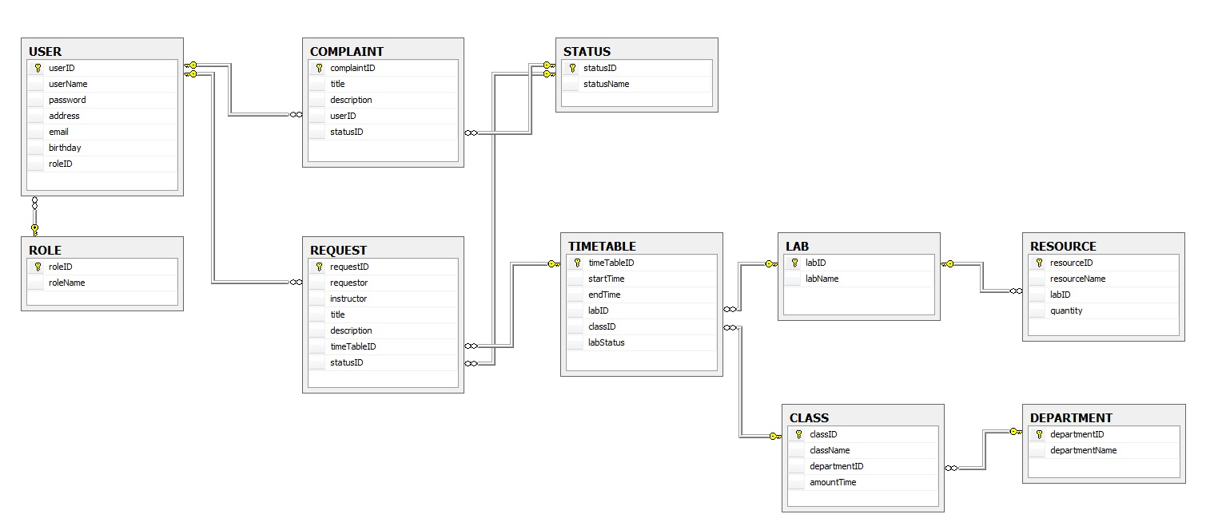
  - Data flow diagram

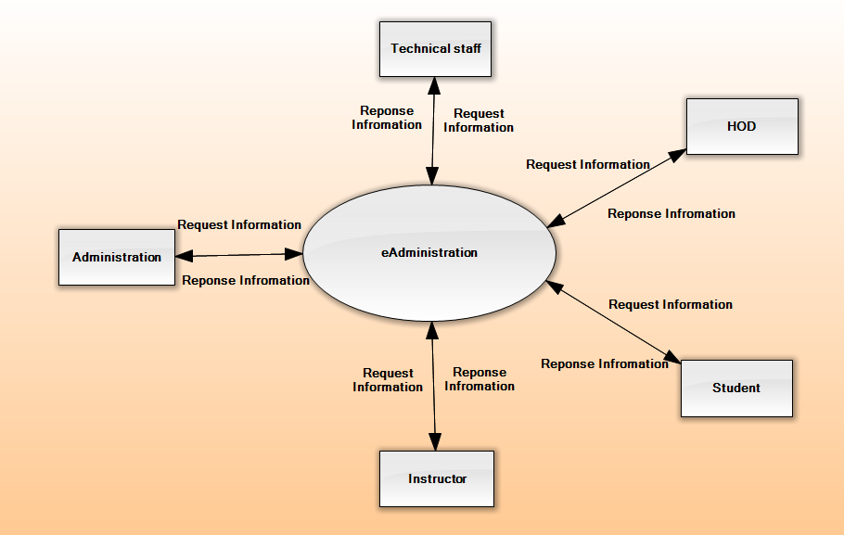
DFD - Context
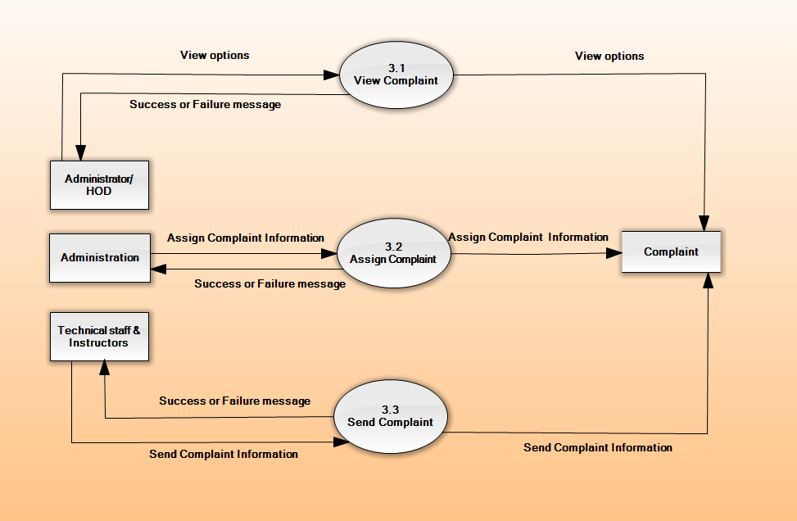
DFD-Level2_ComplaintManagement

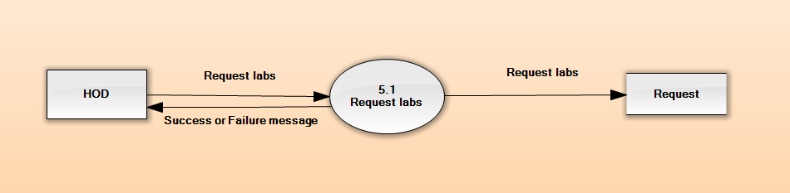
DFD-Level2_RequestManagement

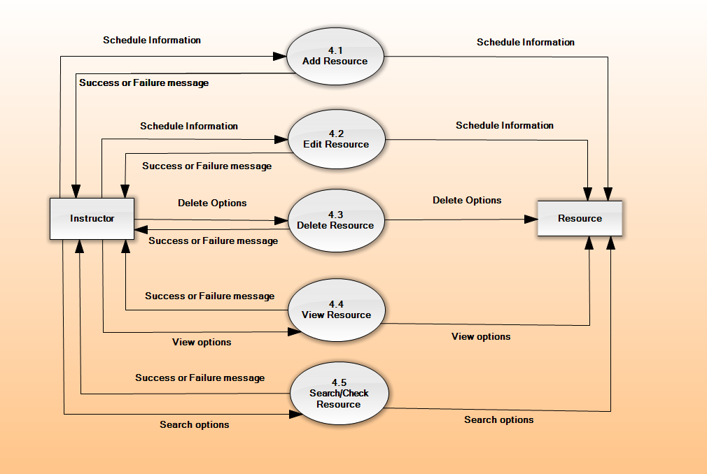
DFD-Level2_ResourceManagement

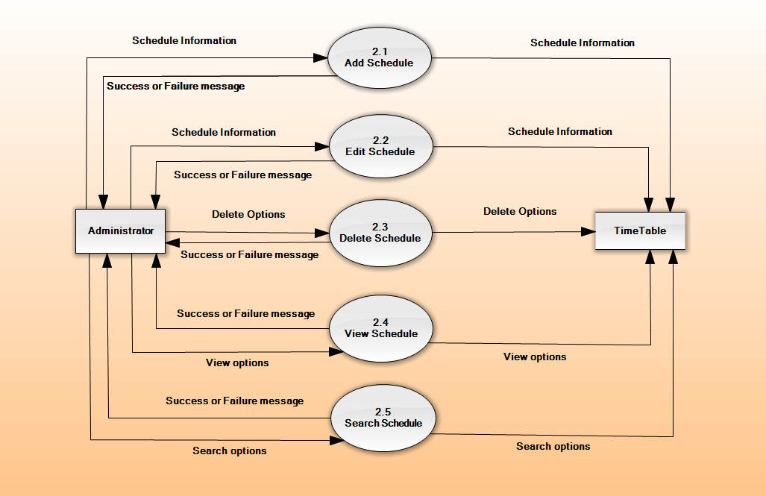
DFD-Level2_ScheduleManagement

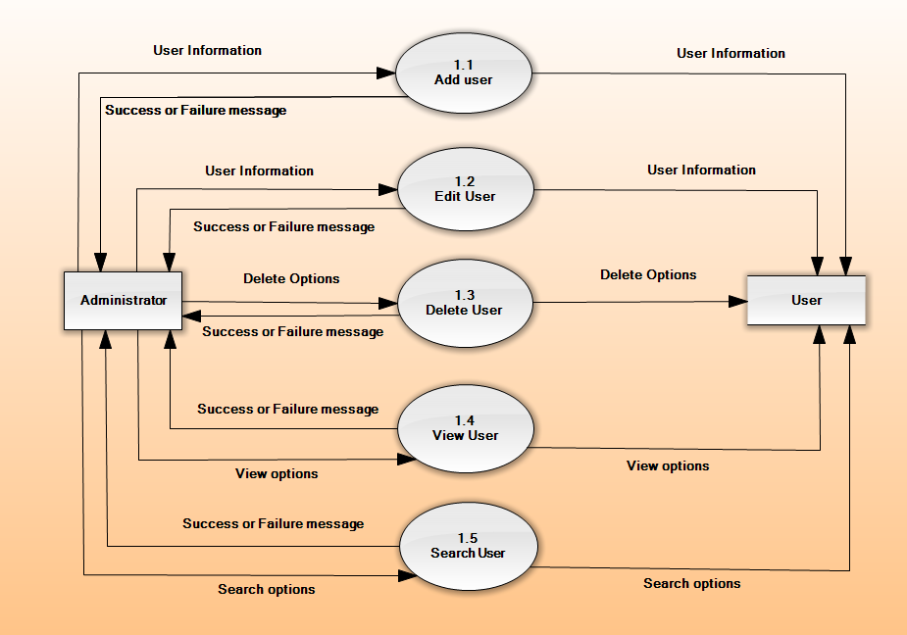
DFD-Level2_UserManagement

  - Sequence diagram

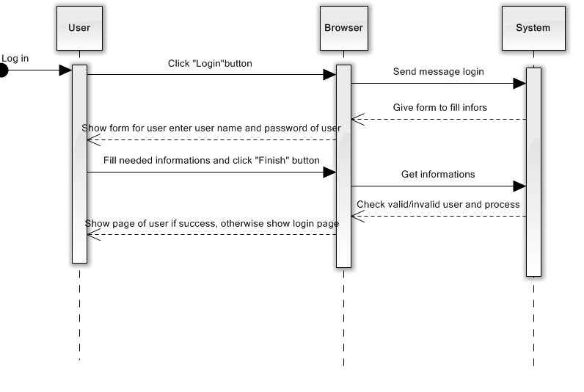
Sequence Diagram 1 - Login

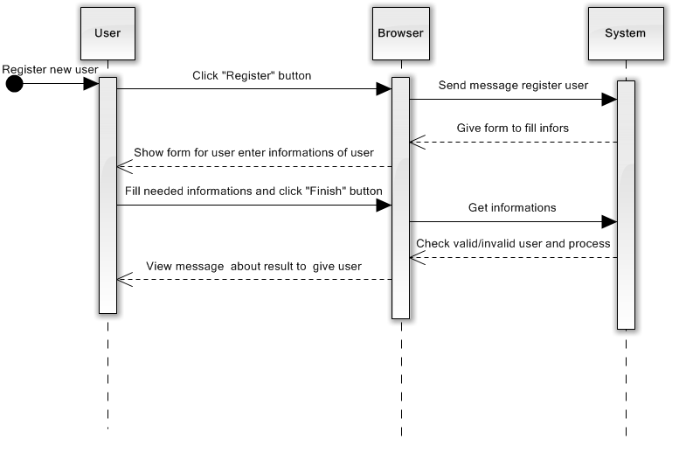

Sequence Diagram – 2 Create User

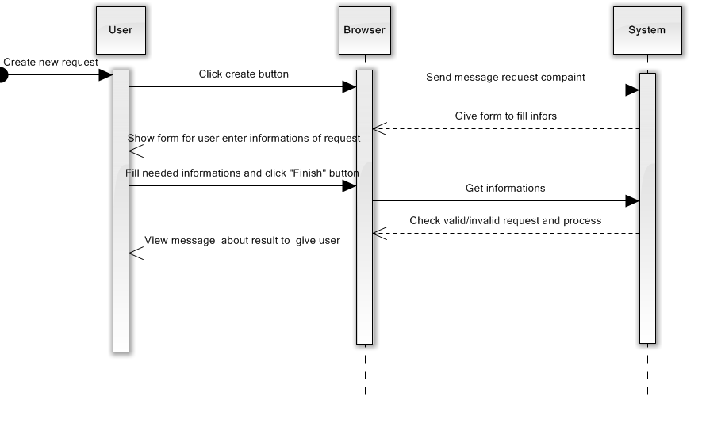

Sequence Diagram 3 – Create Request

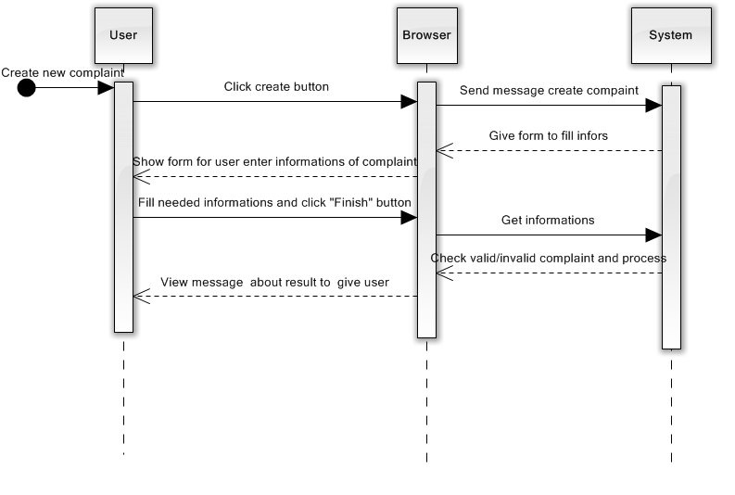

Sequence Diagram 4 – Create Complaint
Sequence Diagram 5 – Register User

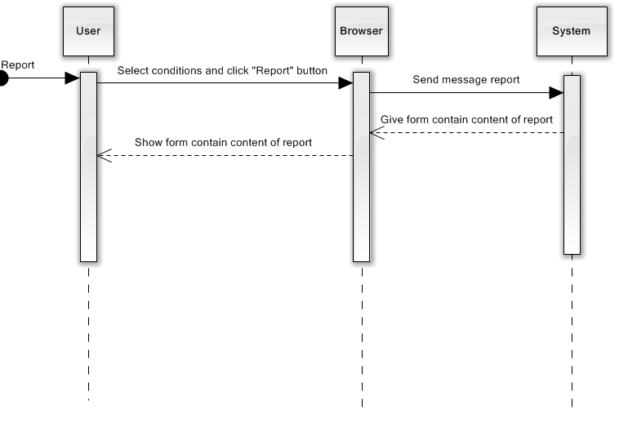
Sequence Diagram 6 – Report
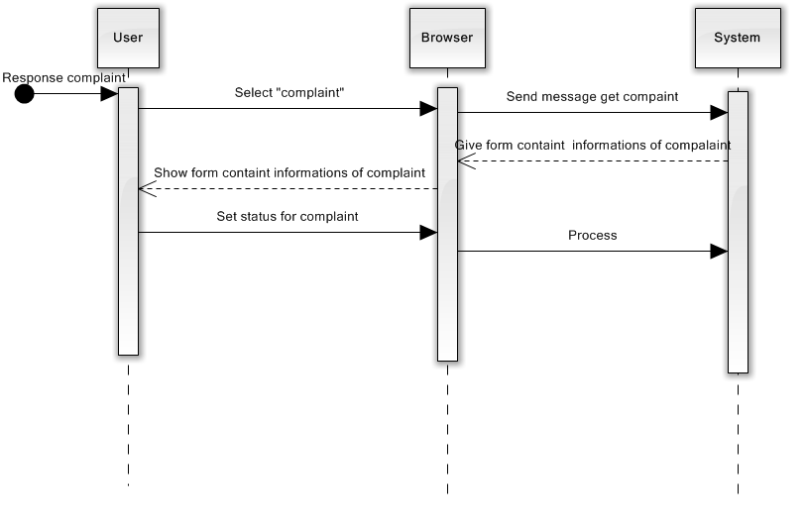
Sequence Diagram 7 – UpdateStatusComplaint

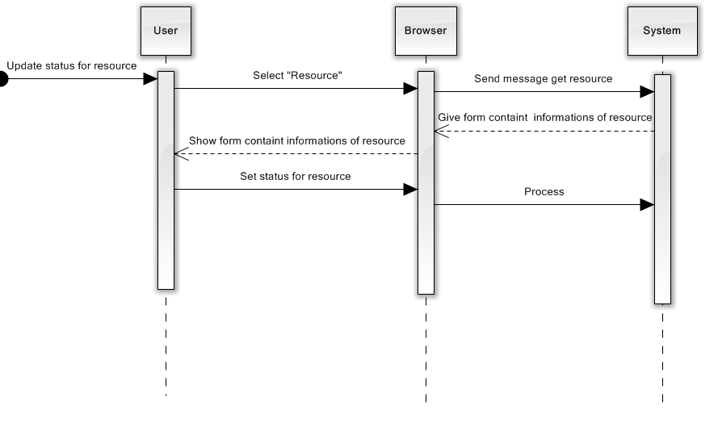
Sequence Diagram 7 – UpdateStatusResource
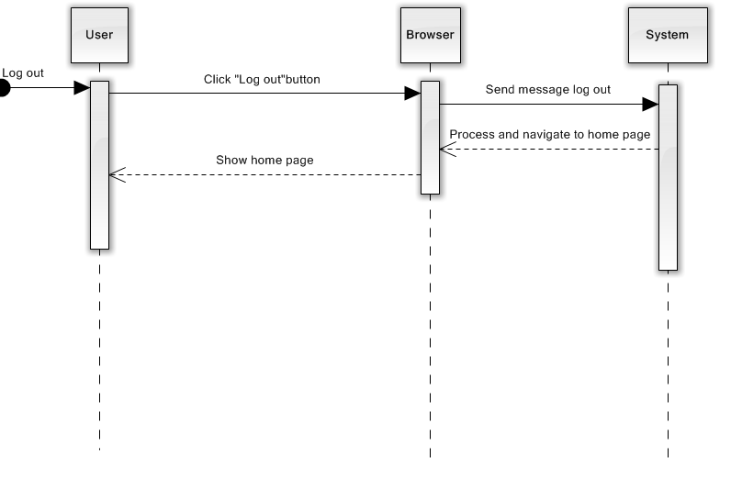
Sequence Diagram 8 – Logout

- External interface specification
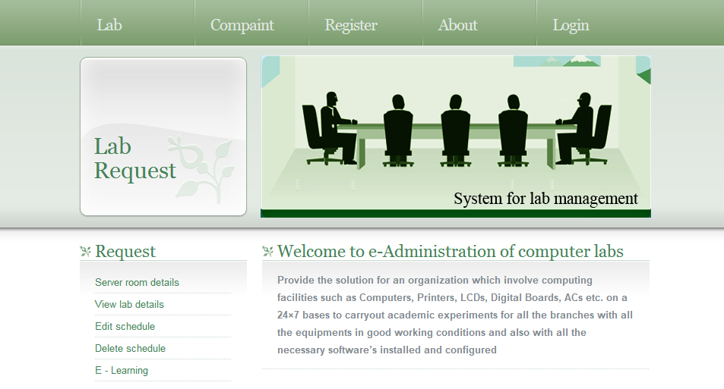
Home.xhtml page
The system has a friendly interface to use the all actor manipulate the system.
The banner of website is a slide images. This helps the website looks attractive.
About Service complaint, the website is designed drag and drop interface to help the user in using easily.
Beside the functions which relative the request, the website use the support about schedule of Prime faces library to have the interface visually.
- Functional Requirements
  - User admin
Creates user, assigns access rights, authenticates users, checks report, and assigns task. These functions are used to keep track of various activities in labs.
  - Service complaint
It includes complaint registration, assigning task to instructor, addressing complaint. These functions may be used to register a complaint about improper conditions of devices (in lab) to admin in order to get response/service.
  - Software or hardware maintenance
This module checks warranty of particular software, generates alert messages and helps in proper documentation of available software’s or hardware’s in labs
  - Lab assignment
This module defines slots, generates charts, assigns instructor’s, and would specify alternate instructor to particular labs
- Use guide
  - System requirements
No | Items | Description
1 | Operating System | Window 2000, XP or high
2 | Database | SQL Server 2005
3 | Software | Net bean 6.9, primefaces-3.3.1

  - Install and launch the project :
Step 1: Open SQL Server 2005
Step 2: Attach the e-Administration.mdf.
Step 3: Launch the application using a Web browser such as IE, Chrome and Firefox.

