INTRODUCTION

The project e-Administration of computer labs is an automated system for lab management. It eases the tasks of administrator, instructors, HOD’s of various departments, technical staff and students.
The main Objective of the project is to provide the solution for an organization which involve computing facilities such as Computers, Printers, LCDs, Digital Boards, ACs etc. on a 24×7 bases to carryout academic experiments for all the branches with all the equipments in good working conditions and also with all the necessary software’s installed and configured. This software also helps the administrator and instructor(s) to maintain proper documentation of the computing systems.
This software is a web based application and can be hosted on the Internet. It should also provide clean and user friendly interface to the users.

SURVEY
The e-Administration of Computer Labs is a new attempt to speed up the process of managing Computer Labs in an educational institute. The existing systems are time consuming and there are many difficulties faced by administrator to get information about each labs within organization. Presently in labs, most of the tasks are carried on manually such as lodging complaints, extra lab requests etc. There are many difficulties faced by instructors, HOD’s of various departments for carrying out any lab related activities.
This software should provide a solution to these problems . It provides interactive user interface and helps users in an organization to get information immediately at that instant of time. The different users of the system are the administrator, the heads of various department , technical staff and lab instructor. These users are assigned with different privileges based on level of administration.
This system helps the technical staff, instructor and head of various departments to register specific complaint and to view the status of their complaint. Here the instructor gets SMS on expiry of specific software. The head of the department can send the extra lab request and can also view complaints associated with the respective department. This software establishes a smooth communication between different users and user admin.

Objectives
- Helps the administrator and instructor to keep track of the detailed information of the labs.
- Assists in the smooth interaction between different users.
- Proper maintenance of available Resources .
- Speed up the Activities to overcome the problems associated with lab.
- Helps Technical staff/instructor to lodge complaints.
- Automate the task of assigning complaints to specific technical staff based on the nature of problem.
- Helps the HOD’s of various departments to send an extra lab request to administrator.

REQUIREMENTS
3.1 Functional Requirements
- It should provide schedule/time-table without any of clashes among faculties, day, time and room that must be visible to all.
- It should generate report about registered complaint to the admin and response report to the user who have submitted his queries.
- Secure registration and profile management facilities for different users.
- It should provide details like e-learning facilities, server room details, software installation procedures etc. to students.
3.2 Non- Functional Requirements
3.2.1 Safety Requirements
If there is extensive damage to a wide portion of the database due to catastrophic failure, such as a disk crash, the recovery method restores a past copy of the database that was backed up to archival storage (typically tape) and reconstructs a more current state by reapplying or redoing the operations of committed transactions from the backed up log, up to the time of failure.
3.2.2 Security Requirements
Security systems need database storage just like many other applications. However, the special requirements of the security market mean that vendors must choose their database partner carefully.
3.2.3 Software Quality Attributes
- CORRECTNESS:
The system should generate appropriate report about different activities of the lab and should keep track of all records.
- MAINTAINABILITY:
The system should maintain correct schedules of labs and the documentation of all lab equipments.
- USABILITY:
The system should satisfy maximum number of users needs.

4. Operational Feasibility
The present system has automated most of the manual tasks. Therefore the proposed system will increase the operational efficiency of the administrator and instructors.

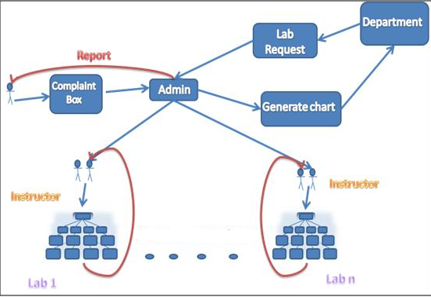

5. System Architecture of e-Administration of Computer Labs
- The admin creates different users.
- Admin can generate lab assignment and assigns instructor to specific complaint or any problem and checks the report to ensure whether the complaints responded or pending.
- Users include Technical staff and Instructors.
- The user can register complaint pertaining to any lab equipments. The registered complaints will be sent to Admin.
- Instructor maintains documentation of software, hardware and he also provides the report of equipment conditions to the admin.
- He performs the tasks assigned by admin. He also checks about the warranty of product if it is out of date.
- Another profile in project is HODs profile. Here HODs can see the complaints lodged by his/her department users.
- HOD can also request for extra labs to the Admin. Based on the available slots, admin defines the slots and send a reply to HOD.
This software should also facilitate students in getting syllabus copy, software installation procedures, different lab related software’s etc.

6. Modules
- User admin
Creates user, assigns access rights, authenticates users, checks report, and assigns task. These functions are used to keep track of various activities in labs.
- Service complaint
It includes complaint registration, assigning task to instructor, addressing complaint. These functions may be used to register a complaint about improper conditions of devices (in lab) to admin in order to get response/service.
- Report generation
This module generates service report and reports for working condition of the equipment’s in the lab.
- Software or hardware maintenance
This module checks warranty of particular software, generates alert messages and helps in proper documentation of available software’s or hardware’s in labs.
- Lab Assignment:
This module defines slots, generates charts, assigns instructor’s, and would specify alternate instructor to particular labs.

Home page
