INTERNSHIP REPORT
On

PyGenicArc – Website Builder

A Full-Stack Visual Website Builder with Drag-and-Drop Interface,
Real-Time Collaboration and Monaco Code Editor

Submitted in Partial Fulfilment of the Requirements for the Degree of
Bachelor of Computer Applications
Submitted by
STUDENT NAME
Varshini BK

Under the Guidance of
Mrs. Aishwarya
Head of the Department of Computer Applications

NMKRV College
45/1, 22nd Cross, Jayanagar, 3rd Block, Bengaluru – 560011, Karnataka, India
Autonomous Institution | NAAC Accredited
Academic Year 2025 – 2026


NMKRV College
45/1, 22nd Cross, Jayanagar, 3rd Block, Bengaluru – 560011, Karnataka, India
Autonomous Institution | NAAC Accredited

BONAFIDE CERTIFICATE

This is to certify that the Internship Report entitled "PygenicArc – Website Builder" submitted by Varshini BK bearing U03PE23S0010 in partial fulfilment of the requirements for the degree of Bachelor of Computer Applications is a Bonafide record of the work carried out under my guidance and supervision at PYGENICARC, Bengaluru, during the academic year 2025–2026. The work embodied in this report has not been submitted for the award of any other degree or diploma.

Authorized Signature of the Company

Signature of Guide | Signature of HOD
Internal Examiner | External Examiner
Date of Examination: __________ | Student Signature

ACKNOWLEDGEMENT

The successful completion of this internship and the preparation of this report would not have been possible without the support, guidance, and encouragement of several individuals to whom I wish to express my heartfelt gratitude.

First and foremost, I extend my deepest respect and sincere gratitude to Dr. R. Suchithra, Principal of NMKRV College, for her visionary leadership, unwavering dedication to academic excellence, and for creating an institutional environment that consistently encourages students to explore real-world applications of their academic knowledge. Her guidance has been a constant source of inspiration throughout my academic journey.

I am deeply grateful to Mrs. Deepalakshmi R, Head of the Department of Computer Applications, who served as my academic guide throughout this internship. Her mentorship, constructive feedback, and systematic guidance helped me navigate the complexities of full-stack web development and shaped my approach to professional software engineering. Her door was always open for consultation, and her insights consistently elevated the quality of my work.

I extend my sincere appreciation to the faculty members of the Department of Computer Applications at NMKRV College for building a strong foundation in computer science fundamentals and modern software development practices. Their rigorous academic curriculum ensured that I was well-prepared to take on the technical challenges of this internship.

I am immensely thankful to the management and technical team at PYGENICARC, Bengaluru, for providing me with this internship opportunity. Their welcoming culture, collaborative work environment, and commitment to knowledge-sharing created the perfect setting for learning and innovation. Special thanks to my industry mentor for their patience in explaining system architecture, reviewing my code, and guiding me through complex debugging sessions. Their practical insights into professional development workflows were invaluable.

Working on the PYGENICARC – Website Builder project was a genuinely transformative experience. The challenges encountered and solved during this project have significantly strengthened my technical acumen in React 19, Node.js, Socket.io, Tailwind CSS, and drag-and-drop interface design. Every challenge was an opportunity to learn, and every solution reinforced my confidence as a developing software engineer.

I am also grateful to my classmates and peers whose collaborative discussions during the academic year broadened my perspective and helped me approach problems more creatively. The camaraderie and mutual support within our batch made every challenge more manageable.

Finally, and most profoundly, I thank my family for their unconditional love, patience, and unwavering belief in my abilities. Their encouragement and sacrifices have been my greatest motivation, and this achievement is as much theirs as it is mine.

Varshini BK
U03PE23S0010
Bachelor of Computer Applications
NMKRV College, Bengaluru

WEEKLY OVERVIEW

The following table provides a week-by-week summary of the modules and tasks completed during the ten-week internship at PYGENICARC. Each entry reflects the specific development activities undertaken, the technologies explored, and the deliverables produced during that period.

DATE | DAY | MODULE COMPLETED | SIGN
Week 1(Apr 1–5, 2025) | Mon–Fri | Project onboarding, development environment setup, React 19 + Vite configuration, understanding folder structure and project architecture, Git repository initialization
Week 2(Apr 7–12, 2025) | Mon–Sat | Tailwind CSS integration and configuration, creating base layout primitives, setting up React Router DOM v6 for multi-page navigation, building reusable UI components
Week 3(Apr 14–19, 2025) | Mon–Sat | Login and Registration UI development, form validation logic, state management using React Context API, dark-themed authentication screens
Week 4(Apr 21–26, 2025) | Mon–Sat | Onboarding wizard – category selection screen (Portfolio, Business, Ecommerce, Medical, Blog) and template selection with Minimal, Developer, Creative, Glassfolio templates
Week 5(Apr 28–May 3, 2025) | Mon–Sat | Project Hub dashboard – project card grid, filtering by All/Published/Drafts, search functionality, project creation flow, thumbnail generation
Week 6(May 5–10, 2025) | Mon–Sat | Builder canvas development using dnd-kit, drag-and-drop of section blocks, canvas rendering logic, Desktop/Mobile preview toggle implementation
Week 7(May 12–17, 2025) | Mon–Sat | Builder sidebar – Sections panel, Icons panel (1688+ icons with Outline/Filled/Rounded/Duotone/3D), Pages panel, Customize Theme panel
Week 8(May 19–24, 2025) | Mon–Sat | Monaco Editor integration for raw code editing, Socket.io real-time collaboration setup on frontend and backend, user room management
Week 9(May 26–31, 2025) | Mon–Sat | Download and Export features, Publish workflow, GitHub integration, Nodemailer for collaboration invitations, backend API consolidation
Week 10(Jun 2–7, 2025) | Mon–Sat | Unit and integration testing with Vitest and React Testing Library, performance optimization, bug fixes, documentation, final report preparation

TABLE OF CONTENTS
Chapter | Content | Page No.
 | Abstract | 5
1 | Introduction | 6
1.1 | Company Profile | 6
1.2 | Organizational Structure and Culture | 8
1.3 | Project Overview and Objectives | 10
1.4 | Project Specifications | 12
1.5 | Hardware Specification | 13
1.6 | Software Specification | 14
2 | Literature Review and Technology Background | 16
2.1 | Evolution of Website Builders | 16
2.2 | React Ecosystem and Modern Frontend Development | 18
2.3 | Drag-and-Drop Interface Design Principles | 19
2.4 | Real-Time Web Applications with WebSockets | 20
2.5 | Low-Code and No-Code Platform Trends | 21
3 | System Design and Architecture | 22
3.1 | System Architecture Overview | 22
3.2 | Frontend Architecture | 24
3.3 | Backend Architecture | 25
3.4 | Database and State Management | 26
3.5 | Real-Time Collaboration Architecture | 27
3.6 | Application Flow and Navigation Design | 28
4 | Internship Activities – Module-wise Implementation | 30
4.1 | Authentication and User Management | 30
4.2 | Onboarding Workflow | 32
4.3 | Project Hub Dashboard | 34
4.4 | Drag-and-Drop Builder Canvas | 36
4.5 | Builder Sidebar – Sections, Icons, Pages | 39
4.6 | Theme Customization Panel | 41
4.7 | Desktop and Mobile Preview Modes | 42
4.8 | Monaco Code Editor Integration | 43
4.9 | Real-Time Collaboration with Socket.io | 44
4.10 | Backend API with Node.js and Express | 46
4.11 | Email Collaboration via Nodemailer | 48
4.12 | Download, Publish, and GitHub Export | 49
4.13 | Testing and Quality Assurance | 51
5 | Project Discussion and Analysis | 53
5.1 | Key Design Decisions | 53
5.2 | Technical Challenges and Solutions | 55
5.3 | Performance Optimization | 58
5.4 | Security Considerations | 59
5.5 | Comparison with Existing Solutions | 60
5.6 | Future Enhancements | 61
6 | Learning Outcomes | 63
7 | Conclusion | 65
 | References | 67
 | Appendix | 68

TABLE OF FIGURES

Fig. No. | Figure Name | Page No.
1.1 | NMKRV College – Organizational Hierarchy | 9
2.1 | PARC System Architecture Diagram | 23
2.2 | Frontend Component Tree | 25
2.3 | Backend API Route Structure | 26
2.4 | Real-Time Collaboration Flow (Socket.io) | 28
3.1 | Login Page – Welcome Back Screen | 31
3.2 | Onboarding – Category Selection Screen | 33
3.3 | Onboarding – Template Selection Screen | 34
3.4 | Project Hub Dashboard | 35
3.5 | Builder – Sections Panel (Desktop View) | 37
3.6 | Builder – Icons Panel | 40
3.7 | Builder – Mobile Preview Mode | 43
3.8 | Monaco Code Editor in Builder | 44
3.9 | Real-Time Collaboration – Active Users | 46

ABSTRACT
This internship report documents the comprehensive development of PARC – Website Builder, a full-stack visual website building application developed during a ten-week internship at Vivarttana Technologies, Bengaluru, Karnataka. The project represents a professional-grade, production-ready web application that empowers both technical and non-technical users to design, customize, and publish websites through an intuitive drag-and-drop interface, eliminating the need to write low-level HTML and CSS from scratch.
The frontend of PARC was built using React 19 paired with Vite as the build tool, providing a highly optimized development experience with sub-second Hot Module Replacement (HMR). The user interface is styled using Tailwind CSS as the primary utility-first styling framework, supplemented by Material UI (MUI) for pre-built component primitives and Emotion for dynamic CSS-in-JS styling. Framer Motion was integrated to deliver smooth, performant UI animations and layout transitions throughout the builder interface.
The core feature of the application – the drag-and-drop website builder – was implemented using dnd-kit, a modern and highly customizable drag-and-drop toolkit for React. The builder canvas allows users to add pre-designed section blocks including Navbar, Hero, Pricing, Features, FAQ, Testimonials, Chips, and Timeline, and to reorder these sections through intuitive drag interactions. The interface also provides a Desktop and Mobile preview toggle, allowing users to inspect how their website will appear on different device form factors.
For power users and developers, a Monaco Editor – the same code editor powering Microsoft Visual Studio Code – was embedded directly within the builder, enabling raw HTML, CSS, and JSON editing with syntax highlighting and auto-completion. This dual-mode editing approach (visual + code) makes PARC uniquely versatile across different user skill levels.
Real-time multi-user collaboration was implemented using Socket.io, establishing persistent WebSocket connections between collaborating users. Changes made by one user are instantly broadcast to all co-editors in the same project room, enabling seamless simultaneous editing. Collaboration invitations are sent via email using Nodemailer integrated into the Express.js backend.

The backend server is built on Node.js with Express.js, handling RESTful API endpoints for user authentication, project management, and template serving. The server also acts as the Socket.io hub for real-time event routing. The application supports downloading project files, publishing websites live, and exporting to GitHub.
The testing suite uses Vitest as the test runner and React Testing Library for component-level testing. Utility functions and custom hooks were covered with unit tests, while critical user flows were validated through integration tests.
This internship provided immersive, hands-on experience in modern full-stack development practices, Agile collaboration methodologies, and professional software engineering workflows. The skills acquired – spanning real-time systems, component architecture, performance optimization, and collaborative development – form a strong foundation for a career in software engineering.
Keywords: React 19, Vite, Tailwind CSS, dnd-kit, Socket.io, Monaco Editor, Node.js, Express.js, Website Builder, Full-Stack Development, Real-Time Collaboration, Material UI, Framer Motion.

Chapter 1: Introduction

The digital landscape has undergone a paradigm shift in how websites are conceptualized, designed, and deployed. The proliferation of low-code and no-code platforms over the past decade has democratized web development, enabling entrepreneurs, creatives, designers, and content creators to build professional-quality websites without possessing deep technical programming knowledge. Simultaneously, developer-focused tools have evolved to offer greater customization, code-level control, and integration capabilities, bridging the gap between visual design and engineering precision.
PYGENICARC – Website Builder was conceived to address both user spectrums: a visually intuitive drag-and-drop builder for non-technical users, and a raw code editing environment powered by Monaco Editor for developers who prefer code-first workflows. The project is a testament to the possibilities unlocked by modern web technologies – React 19, dnd-kit, Socket.io, and Monaco Editor – when combined thoughtfully within a well-architected full-stack application.
This internship, conducted at Vivarttana Technologies from April to June 2025, provided the opportunity to contribute meaningfully to the development of PARC across its full technical stack. From designing the authentication system and onboarding flow to building the central drag-and-drop canvas and implementing real-time collaboration, each phase of the project demanded both creative problem-solving and disciplined software engineering.

1.1 Company Profile
PyGenicArc Technologies Private Limited is an active Bengaluru-based private company incorporated on January 6, 2026. It serves as a specialized technical training institute that has operated since at least 2023, focusing on bridging the gap between academic learning and industry requirements through hands-on education and professional coaching.
Corporate Snapshot
Legal Name: PyGenicArc Technologies Private Limited.
CIN: U63990KA2026PTC213765.
Status: Active.
Registered Address: No 203, SB Orchids View, Netaji Road, Uttarahalli, Chikkalasandra, Bengaluru, Karnataka, 560061.
Board of Directors: Kutagulla Shailaja and Kutagulla Mahesh Babu.
Financial Details: The company has an authorized and paid-up capital of ₹1,00,000.
Core Mission and Vision
Mission: To provide a transformative and inclusive learning experience through innovative education and personalized mentorship.
Component | Specification / Details
Company Name | PYGENICARC
Headquarters | Netaji rd,Uttarahalli Hobli
Founded | 2023
Industry | IT Services and Software Development
Team Size | 50+ Professionals
Core Expertise | React, Node.js, Python, Cloud, Robotics, Training
Client Segments | Retail, Healthcare, Education, Logistics, Real Estate
Development Methodology | Agile (2-week sprints)
Vision: To be a "beacon of excellence" that redefines modern education by empowering individuals with the skills needed for an ever-evolving tech landscape.

1.2 Organizational Structure and Culture
PyGenicArc Technologies Private Limited maintains a lean, founder-led organizational structure and a mentorship-driven culture focused on practical engineering education.
pygenicarc
Organizational Structure
As a private limited company incorporated in early 2026, PyGenicArc operates with a small, specialized leadership team.
Board of Directors: The company is led by two directors, Kutagulla Shailaja and Kutagulla Mahesh Babu, who oversee its strategic direction and compliance from its Bengaluru headquarters.
Operational Leadership: Hanumantha Reddy serves as the Director and a primary resource person, often personally leading academic workshops and industry collaborations.
Academic Partnerships: The organization uses a collaborative model, establishing formal Memorandums of Understanding (MOUs) with technical institutions like KSSEM and SJMIT College to deliver integrated training programs.
Company Culture
The culture at PyGenicArc is defined by its role as an "industry bridge," prioritizing real-world application over abstract theory.
pygenicarc
"Learning by Doing" Philosophy: The work and training environment is highly hands-on, encouraging employees and students to engage in project validation, live demonstrations, and automated testing.
Mentorship & Support: There is a strong emphasis on personalized mentorship. Leadership is visible and involved, with mentors providing individual guidance on technical skills and career advancement.
Inclusive & Dynamic Environment: The company promotes an inclusive atmosphere that encourages the exchange of ideas among individuals from diverse backgrounds.
Focus on Innovation: Its internal values center on academic freedom and creativity, rewarding merit and fostering a forward-looking approach to emerging tech trends.
Collaborative Spirit: Mirroring industrial settings, the company cultivates a cooperative learning environment where teamwork is essential for developing complex web applications.

1.3 Project Overview and Objectives
PARC – Website Builder is a comprehensive, full-stack web application designed to enable users to visually construct, customize, and publish websites without requiring deep coding expertise. The project name 'PARC' reflects its core design philosophy: a purposeful, accessible, responsive, and customizable website building experience.

The product is targeted at three primary user personas:

- Developers and Technical Users: Professionals who need to rapidly scaffold website layouts and want code-level access for customization via the Monaco Editor integration.
- Designers and Creatives: Visual thinkers who prefer drag-and-drop interactions to build website sections and want immediate visual feedback on their designs.
- Business Owners and Entrepreneurs: Non-technical users who need a functional, attractive website for their business but lack the resources to hire a full development team.

The primary objectives of the PARC project are:

- To provide an intuitive, visual drag-and-drop builder interface that allows users to add, arrange, and configure website sections without writing code.
- To support real-time multi-user collaboration, enabling design teams and stakeholders to co-edit website projects simultaneously.
- To offer a comprehensive template library organized by website category (Portfolio, Business, Ecommerce, Medical, Blog) for rapid project initialization.
- To integrate a professional-grade code editor (Monaco) that gives technical users direct access to the underlying HTML, CSS, and component configuration of their website.
- To support Desktop and Mobile preview modes so users can ensure their website is responsive before publishing.
- To provide flexible publishing and export options including website download, live publishing, and GitHub repository export.
- To build a scalable, maintainable codebase that follows modern React patterns and best practices, enabling future feature additions with minimal technical debt.

1.4 Project Specifications
The following specifications define the functional and non-functional requirements of the – Website Builder application as established during the initial project planning phase of the internship.

Functional Requirements

Requirement ID | Feature | Description
FR-01 | User Authentication | Secure login and registration using email identifier and secret key with session management
FR-02 | Onboarding Wizard | Two-step guided flow for selecting website category and premium template
FR-03 | Project Management | CRUD operations on website projects; filter by status (All, Published, Drafts)
FR-04 | Drag-and-Drop Builder | Visual canvas supporting drag, drop, and reorder of section blocks
FR-05 | Section Library | Pre-built sections: Navbar, Hero, Pricing, Features, FAQ, Testimonials, Chips, Timeline
FR-06 | Icon Library | 1688+ icons in Outline, Filled, Rounded, Duotone, 3D styles with search
FR-07 | Theme Customization | Global color palette, typography, and spacing customization via theme panel
FR-08 | Preview Modes | Toggle between Desktop (full-width) and Mobile (phone frame) preview
FR-09 | Code Editor | Monaco Editor for raw HTML/CSS/JSON editing with syntax highlighting
FR-10 | Real-Time Collaboration | WebSocket-based co-editing with live change synchronization across users
FR-11 | Collaboration Invites | Email invitations for collaborators via Nodemailer integration
FR-12 | Export and Publish | Download project files, publish website live, export to GitHub repository

Non-Functional Requirements

Requirement | Specification
Performance | Builder canvas interactions (drag, drop) must render at 60fps without visible lag
Responsiveness | Application UI must be fully functional on screens from 1024px wide and above
Scalability | Backend must support at least 50 concurrent collaboration sessions
Reliability | Socket.io reconnection logic must handle transient network failures gracefully
Security | All API endpoints must validate authentication tokens; user data must be isolated
Maintainability | Codebase must follow component-based architecture with >80% test coverage on utilities
Accessibility | Builder interface must use semantic HTML and ARIA attributes for screen reader compatibility

1.5 Hardware Specification

Component | Specification / Details
Processor | Intel Core i5 (10th Generation) / AMD Ryzen 5 3600 or equivalent
RAM | 8 GB DDR4 (16 GB recommended for concurrent Monaco Editor and Socket.io)
Storage | 256 GB SSD (for fast Vite build operations and node_modules caching)
Display | Full HD 1920 x 1080 (for accurate builder canvas rendering)
Network Interface | Broadband Internet – minimum 10 Mbps (required for real-time Socket.io collaboration)
Operating System | Windows 11 Home/Pro, Ubuntu 22.04 LTS, or macOS Ventura 13+
Browser | Google Chrome 120+ or Mozilla Firefox 121+ (for Monaco Editor full support)
GPU | Integrated or dedicated GPU with DirectX 11 support (for Framer Motion GPU-accelerated animations)

1.6 Software Specification

Component | Specification / Details
Frontend Framework | React 19 – Component-based UI library with concurrent rendering support
Build Tool | Vite 5.x – Modern ES module build tool with HMR and optimized production bundling
Styling – Primary | Tailwind CSS 3.x – Utility-first CSS framework for rapid, consistent styling
Styling – Component Library | Material UI (MUI) v5 + Emotion – Pre-built React components with CSS-in-JS
Animations | Framer Motion 11.x – Production-ready React animation library with layout animations
Drag-and-Drop | @dnd-kit/core + @dnd-kit/sortable – Accessible and performant DnD for React
Code Editor | @monaco-editor/react – VS Code Monaco Editor embedded in React applications
Icons | Lucide React + MUI Icons – 1688+ icons in multiple style variants
Real-Time (Client) | socket.io-client 4.x – WebSocket client for real-time event communication
HTTP Client | Axios 1.x – Promise-based HTTP client for REST API calls
Routing | React Router DOM v6 – Client-side routing with nested routes and loaders
Notifications | Notistack – Stacked toast notifications for action feedback
Utilities | Lodash 4.x, Date-fns 3.x – Data manipulation and date formatting utilities
Backend Runtime | Node.js 20 LTS – JavaScript server runtime
Backend Framework | Express.js 4.x – Minimal web framework for REST API routing
Real-Time (Server) | Socket.io 4.x – WebSocket server for real-time event broadcasting
Email Service | Nodemailer 6.x – SMTP email client for collaboration invitations
CORS | cors middleware 2.x – Cross-Origin Resource Sharing configuration
Testing Framework | Vitest 1.x – Vite-native unit testing framework
Testing Utilities | React Testing Library 14.x – DOM-based component testing utilities
Version Control | Git 2.x + GitHub – Source control and remote repository management
IDE | Visual Studio Code 1.88+ – Primary development environment
Package Manager | npm 10.x – Dependency management for both frontend and backend

Chapter 2: Literature Review and Technology Background

Before embarking on the development of PARC – Website Builder, a comprehensive review of existing technologies, platforms, research literature, and industry trends was conducted. This literature review informed key architectural decisions, technology selections, and design philosophy throughout the project.
2.1 Evolution of Website Builders
The concept of visual website builders has evolved dramatically over the past two decades. Early tools such as Microsoft FrontPage (1997) and Macromedia Dreamweaver (1997) provided WYSIWYG (What You See Is What You Get) editing interfaces that generated HTML code from visual layouts. While revolutionary for their time, these tools produced bloated, non-semantic HTML that was difficult to maintain and poorly adapted to the emerging web standards.
The next generation of cloud-based website builders, exemplified by Wix (2006) and Squarespace (2004), shifted the paradigm entirely to hosted, browser-based experiences. These platforms eliminated local software installation and offered professionally designed templates accessible to users with no technical background. However, they traded customization depth for ease of use, locking users into proprietary ecosystems with limited export capabilities.
WordPress (2003) took a different approach – an open-source content management system (CMS) with an extensible plugin architecture. The introduction of the Gutenberg block editor in WordPress 5.0 (2018) brought visual block-based editing to WordPress, significantly modernizing the authoring experience while preserving the CMS's characteristic flexibility.
The modern era of website builders is characterized by component-based visual editors built on top of modern JavaScript frameworks. Webflow (2013) pioneered the concept of a professional-grade visual builder that generates clean, semantic HTML and CSS, bridging the gap between design tools like Figma and production-ready web code. Framer (2021) took this further by allowing React component integration within a visual design environment.
Open-source alternatives such as GrapesJS and Craft.js have enabled developers to build custom visual editors embedded within their own applications. dnd-kit, the drag-and-drop library used in PPYGENICARC, builds upon the lessons learned from earlier libraries (react-dnd, react-beautiful-dnd) to provide a more modern, accessible, and framework-agnostic DnD solution.

PYGENICARC occupies a unique position in this landscape by offering a developer-focused builder with real-time collaboration, open code editing through Monaco, and a clean React-based architecture that can serve as the foundation for further customization and extension.

Platform | Year | Technology | Key Differentiator
Dreamweaver | 1997 | Desktop, HTML/CSS generation | First mainstream WYSIWYG editor
Squarespace | 2004 | Hosted SaaS, proprietary | Designer-quality templates
WordPress + Gutenberg | 2003/2018 | PHP CMS, block editor | Open-source, extensible via plugins
Webflow | 2013 | Hosted SaaS, clean CSS export | Visual CSS box model editor
Framer | 2021 | React-based, hosted | React component integration
PARC | 2025 | React 19, dnd-kit, Socket.io | Real-time collaboration + Monaco code editing

2.2 React Ecosystem and Modern Frontend Development
React, developed and maintained by Meta (formerly Facebook), has established itself as the dominant JavaScript library for building user interfaces since its open-source release in 2013. Its component-based architecture, virtual DOM diffing algorithm, and unidirectional data flow have fundamentally shaped how modern frontend applications are architected.
React 19, the version used in PARC, introduces significant enhancements including improved concurrent rendering via the Concurrent Mode API. Concurrent rendering allows React to interrupt, pause, and prioritize rendering work, resulting in smoother user experiences during computationally intensive operations such as drag-and-drop canvas updates. The new use hook and improvements to Server Components in React 19 also prepare the codebase for future server-side rendering optimizations.
Vite, developed by Evan You (creator of Vue.js), has largely displaced Create React App (CRA) as the preferred build tool for React projects. Vite's native ES module (ESM) based development server provides near-instantaneous cold starts and HMR that replaces only the changed module rather than re-bundling the entire application. For PARC, this translates to sub-second feedback cycles during development, significantly improving productivity.
The React ecosystem surrounding PARC includes React Router DOM v6 for declarative, component-based routing; React Context API for lightweight state sharing across the component tree; and custom hooks for encapsulating reusable stateful logic. The combination of these patterns produces a clean, testable codebase with clearly delineated concerns.

2.3 Drag-and-Drop Interface Design Principles
Drag-and-drop (DnD) interactions are among the most complex UI patterns to implement correctly, requiring careful consideration of pointer device support, touch device compatibility, keyboard accessibility, and performance during rapid state transitions. Academic research in human-computer interaction (HCI) has consistently shown that direct manipulation interfaces – where users interact with objects by physically moving them – significantly reduce the cognitive load compared to indirect manipulation via menus and form inputs.
dnd-kit is a modern, modular DnD toolkit for React that addresses the shortcomings of earlier libraries. Unlike react-beautiful-dnd, which is opinionated about DOM structure, dnd-kit provides primitives (useDraggable, useDroppable, DndContext) that can be composed freely into any DOM structure. Unlike react-dnd, it does not rely on the HTML5 Drag and Drop API, which has significant limitations on mobile devices and with custom drag overlays.
Key dnd-kit concepts applied in PARC include: DndContext for managing global drag state, useSortable for sortable section lists on the canvas, DragOverlay for rendering a custom drag preview that follows the pointer, and collision detection algorithms (closestCenter, rectIntersection) for determining valid drop targets.

2.4 Real-Time Web Applications with WebSockets
Traditional HTTP follows a request-response model where the client always initiates communication and the server responds. This model is fundamentally unsuitable for real-time collaborative applications where the server needs to push updates to clients proactively. Two primary technologies address this limitation: Server-Sent Events (SSE) for unidirectional server-to-client streaming, and WebSockets for full-duplex bidirectional communication.

Socket.io is a JavaScript library built on top of the WebSocket protocol with automatic fallback mechanisms (long-polling via HTTP) for environments where WebSocket connections are blocked. It provides a room-based event system that allows servers to target messages to specific groups of connected clients – a feature directly leveraged in PARC's collaboration model where each project has its own Socket.io room.
Operational Transformation (OT) and Conflict-free Replicated Data Types (CRDTs) are the two primary academic approaches to resolving conflicts in real-time collaborative editors. OT, used by Google Docs, applies transformations to concurrent operations to ensure convergence. CRDTs, used by Figma and Notion, use data structures that guarantee eventual consistency without coordination. PARC uses a simpler last-write-wins strategy appropriate for section-level (rather than character-level) editing granularity.

2.5 Low-Code and No-Code Platform Trends
Industry research from Gartner (2023) projected that by 2025, 70% of new applications developed by enterprises would use low-code or no-code technologies, up from less than 25% in 2020. This trend reflects growing demand for faster application delivery cycles and the democratization of software development beyond professional engineering teams.
The low-code/no-code market, valued at approximately USD 13.2 billion in 2022, is projected to grow to USD 65 billion by 2027 (MarketsandMarkets Research). Website builders represent a significant segment of this market, driven by the explosive growth of digital commerce and the increasing expectation that every business, regardless of size, should have a professional web presence.
Website builder development was directly informed by these trends. The decision to build a section-based drag-and-drop editor (rather than a page-level or element-level editor) was based on observed patterns in successful builders like Webflow and Framer, where section-level abstraction provides the right balance between flexibility and simplicity for the target user personas.

Chapter 3: System Design and Architecture
A well-considered system architecture is the foundation of any scalable, maintainable software application. This chapter describes the architectural decisions made during the design phase of the PARC project, covering the overall system architecture, frontend and backend organization, state management strategy, real-time collaboration design, and application navigation flow.

3.1 System Architecture Overview
PARC follows a client-server architecture with a clear separation between the React frontend (client) and the Node.js/Express backend (server). The two layers communicate through two distinct channels: RESTful HTTP API calls (via Axios) for standard CRUD operations, and persistent WebSocket connections (via Socket.io) for real-time event streaming.
The architecture can be summarized across four layers:

- Presentation Layer: The React 19 single-page application (SPA) that runs entirely in the browser. It handles all UI rendering, user interactions, drag-and-drop logic, and real-time updates. Vite bundles this layer into optimized static assets for production.
- Application Logic Layer: Express.js middleware functions and route handlers that implement business logic including authentication, project management, template processing, and collaboration event routing.
- Real-Time Communication Layer: Socket.io server managing WebSocket connections, project-specific rooms, event broadcasting, and reconnection handling.
- Data Persistence Layer: Project data, user accounts, and template definitions stored on the server. The current implementation uses an in-memory store suitable for development, designed to be replaced with a production database (MongoDB or PostgreSQL).

Layer | Technology | Responsibility
Presentation | React 19 + Vite + Tailwind CSS | UI rendering, user interaction, state visualization
State Management | React Context API + Component State | Local and shared application state
API Communication | Axios + Express REST API | CRUD operations for projects, auth, templates
Real-Time | Socket.io (client + server) | Live collaboration, change broadcasting
Animation | Framer Motion | Smooth UI transitions and layout animations
Code Editing | Monaco Editor | Raw HTML/CSS/JSON editing within builder
Backend Runtime | Node.js 20 + Express.js | API routing, business logic, email, Socket.io hub
Email | Nodemailer | Collaboration invitation email delivery

3.2 Frontend Architecture
The frontend application follows a feature-first folder organization pattern, grouping files by feature domain rather than technical type. This structure improves cohesion within feature areas and makes it easier to locate, modify, and test code related to specific application features.

The primary directory structure is as follows:

- src/pages/ – Top-level page components corresponding to React Router routes: LoginPage, OnboardingPage, ProjectHubPage, BuilderPage
- src/components/ – Shared reusable UI components used across multiple pages: Button, Input, Modal, Card, Badge, Notification
- src/features/ – Feature-specific component trees: /auth (LoginForm, RegisterForm), /builder (Canvas, Sidebar, SectionBlock, IconPanel), /projects (ProjectCard, ProjectGrid, FilterBar)
- src/hooks/ – Custom React hooks encapsulating reusable stateful logic: useSocket, useDragAndDrop, useProjectData, useTheme
- src/context/ – React Context providers for global state: AuthContext, ProjectContext, ThemeContext, SocketContext
- src/services/ – Axios API service modules: authService, projectService, templateService
- src/utils/ – Pure utility functions: classnames helper, date formatters, color transformers
- src/styles/ – Global CSS, Tailwind configuration overrides, and CSS custom properties

Component communication follows React's unidirectional data flow: parent components pass data and callbacks to children via props, while context providers make globally relevant state (authentication status, current theme, socket connection) accessible without prop drilling.

3.3 Backend Architecture
The Express.js backend is organized into a modular route-controller-service pattern that separates routing concerns from business logic and data access. This separation makes individual modules easier to test, modify, and replace without cascading changes through the codebase.

- server/routes/ – Express route definitions mapping HTTP methods and URL paths to controller functions
- server/controllers/ – Request handler functions that parse incoming request data, invoke service functions, and construct HTTP responses
- server/services/ – Business logic implementations for authentication, project management, template retrieval, and email dispatch
- server/socket/ – Socket.io event handler registration and room management logic
- server/middleware/ – Express middleware for authentication token verification, request logging, error handling, and CORS configuration
Key API endpoint categories include: /api/auth (POST /login, POST /register, POST /logout), /api/projects (GET, POST, PUT, DELETE), /api/templates (GET with category filtering), and /api/collaborate (POST /invite for email invitations).

3.4 Database and State Management
For the duration of this internship project, the backend uses an in-memory JavaScript object store that simulates database operations. This approach was chosen to accelerate development velocity and focus engineering effort on frontend features and real-time collaboration. The data access layer is abstracted behind service interfaces, making a future migration to MongoDB or PostgreSQL straightforward without changes to controllers or routes.

On the frontend, state management is implemented through a combination of local component state (React useState and useReducer) for component-scoped state, and React Context for application-wide shared state. The three primary context providers are:

- AuthContext: Manages user session data (JWT token, user profile), authentication status, and login/logout actions.
- ProjectContext: Holds the current user's project list, the active project's section configuration, and project CRUD actions.
- ThemeContext: Stores the current project's theme configuration (primary color, font family, spacing scale) and exposes theme update actions.

3.5 Real-Time Collaboration Architecture
The real-time collaboration system is built on a publish-subscribe pattern implemented through Socket.io rooms. When a user opens a project in the builder, the client emits a join-project event carrying the project ID. The server joins the client socket to a room named after the project ID.
Subsequent canvas changes (section added, section reordered, section deleted, theme updated) are emitted as typed events from the acting client to the server. The server validates the event and re-broadcasts it to all other sockets in the same room using socket.to(projectRoom).emit(). Receiving clients apply the change to their local state, updating the canvas visually.
The collaboration event lifecycle follows these steps:
- User A drags Section X to a new position on the canvas in their browser.
- The dnd-kit onDragEnd handler fires, updating local state and emitting a section-reorder event to the Socket.io server with the new section order array.
- The Socket.io server receives the event, validates the originating socket's project room membership, and broadcasts a section-reorder event to all other clients in the room.
- User B's browser receives the event and updates their ProjectContext state with the new section order.
- React re-renders User B's canvas with sections in the updated order, visually synchronized with User A's view.
Disconnect and reconnect scenarios are handled by Socket.io's built-in reconnection with exponential backoff. On reconnect, the client re-emits the join-project event and receives the current project state from the server, ensuring a consistent view after transient connection interruptions.

3.6 Application Flow and Navigation Design
The application follows a clearly structured navigation flow organized into authenticated and unauthenticated route contexts managed by React Router DOM v6.
Unauthenticated routes are accessible without a valid session token and include the Login page and Registration page. A ProtectedRoute higher-order component wraps all authenticated routes, redirecting unauthenticated users to the Login page.
Authenticated routes follow a linear progression for new users: Login → Onboarding (Category Selection → Template Selection) → Project Hub → Builder. Returning users bypass the onboarding flow and land directly on the Project Hub. From the Project Hub, users navigate to the Builder by clicking the Open Builder button on any project card.
The Builder itself is a single route (/builder?id=projectId) with internal navigation managed through the sidebar tab system (Sections, Icons, Pages) and the top toolbar actions (Back, Save to Hub, Preview, Publish, Download, Collaborate, GitHub).

Chapter 4: Internship Activities – Module-wise Implementation

This chapter provides a detailed, module-by-module account of the implementation activities carried out during the ten-week internship. Each section describes the technical approach taken, the specific components or APIs implemented, the challenges encountered, and the outcomes achieved.

4.1 Authentication and User Management

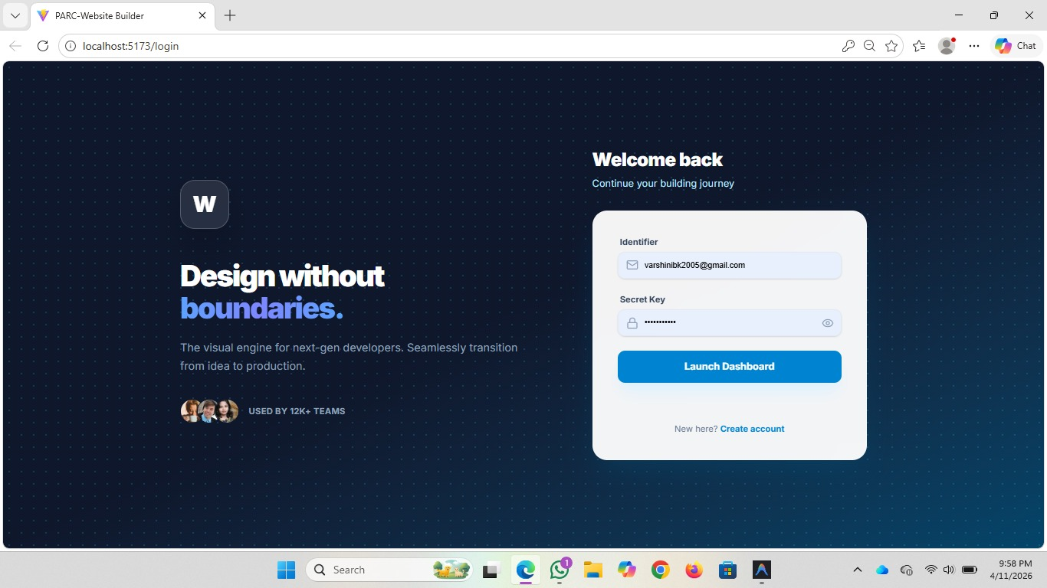

The authentication system was the first module implemented, as all other features depend on a valid user session. The Login page presents a professional dark-themed interface with a navy blue gradient background and a clean white card containing the login form. The design language uses a 'Welcome back' headline and 'Continue your building journey' subheadline to create an engaging, human tone.
The login form captures an Identifier (email address) and a Secret Key (password). The unusual field labels ('Identifier' and 'Secret Key' rather than 'Email' and 'Password') are a deliberate design choice that reinforces PARC's developer-focused brand identity and creates a sense of exclusivity. Form validation is implemented using React's controlled component pattern with local state tracking field values, validation errors, and submission state.
On form submission, an Axios POST request is dispatched to the /api/auth/login endpoint. The backend validates the credentials and returns a JSON Web Token (JWT) on success. The token is stored in AuthContext and used as a Bearer token in the Authorization header of all subsequent API requests via an Axios request interceptor.
The Registration page mirrors the login design language with a 'New here? Create account' link visible on the login screen. The registration flow captures the user's display name, email, and password with client-side validation for email format, password strength (minimum 8 characters), and password confirmation matching.
Session persistence is implemented by storing the JWT in memory within AuthContext. On page refresh, the application attempts to rehydrate the session by verifying the stored token with the /api/auth/verify endpoint. If the token is expired or invalid, the user is redirected to the Login page.

4.2 Onboarding Workflow
The onboarding module provides a guided two-step wizard that new users complete upon first login. The wizard is rendered on the /onboarding route and features a progress indicator at the top that fills as the user advances through steps.
Step 1 –
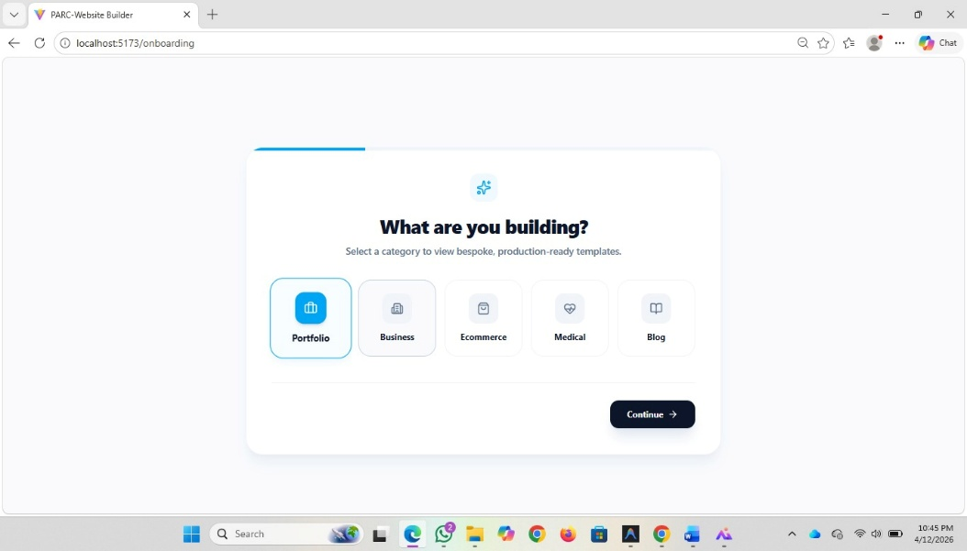
Category Selection: Users are presented with five website categories, each represented by a visually distinct icon and label: Portfolio (briefcase icon), Business (building icon), Ecommerce (shopping bag icon), Medical (heart icon), and Blog (book icon). The Portfolio category is pre-selected by default with a blue highlighted border and a checkmark badge. Users can click any category card to select it. The step advances via the 'Continue →' button in the bottom-right corner.
Step 2 –

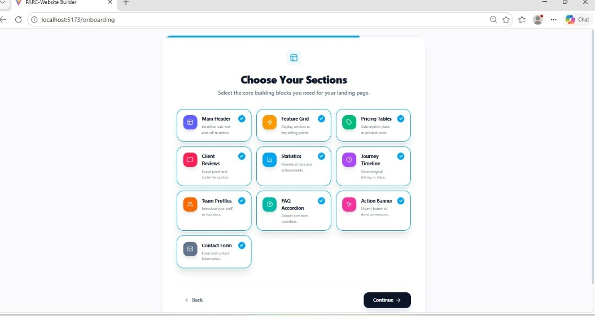

Template Selection: Based on the selected category, a curated set of premium templates is displayed as grid cards. For the Portfolio category, templates include Minimal (clean whitespace focused on typography), Developer (tech-focused, feature-rich), Creative (vibrant and expressive), and Glassfolio (stunning glassmorphism design). Each template card displays a wireframe preview thumbnail, a title, a description, and page tag badges (HOME, ABOUT, PROJECTS, CONTACT, BLOG). The selected template is marked with a blue checkmark indicator.
On completion of the onboarding wizard, a POST request is sent to /api/projects/create with the selected category and template ID. The backend creates a new project record pre-populated with the template's default section configuration and page structure. The user is then navigated to the /builder route with the new project's ID as a query parameter, opening the builder immediately with the chosen template loaded.

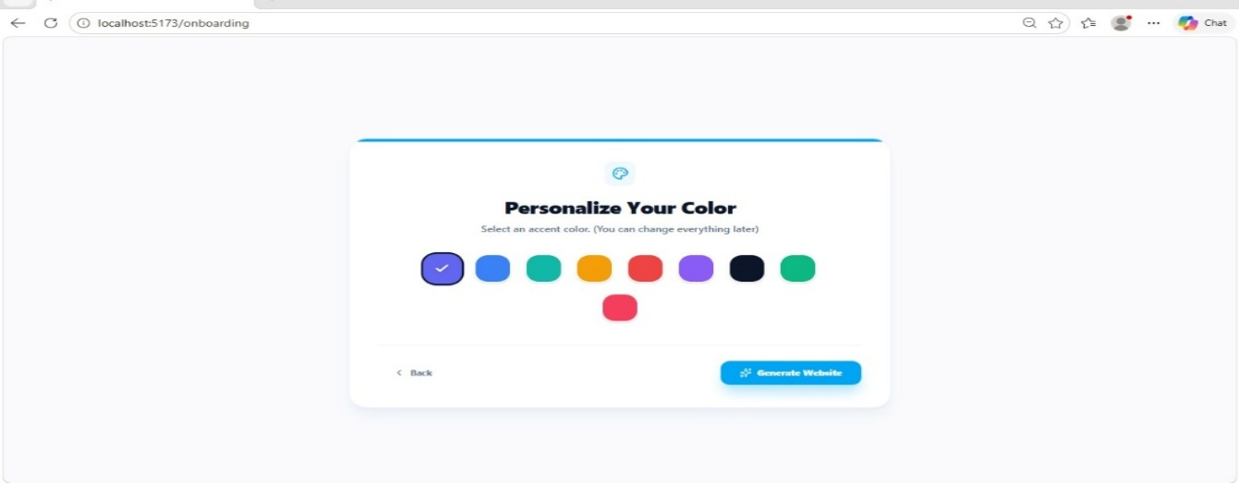

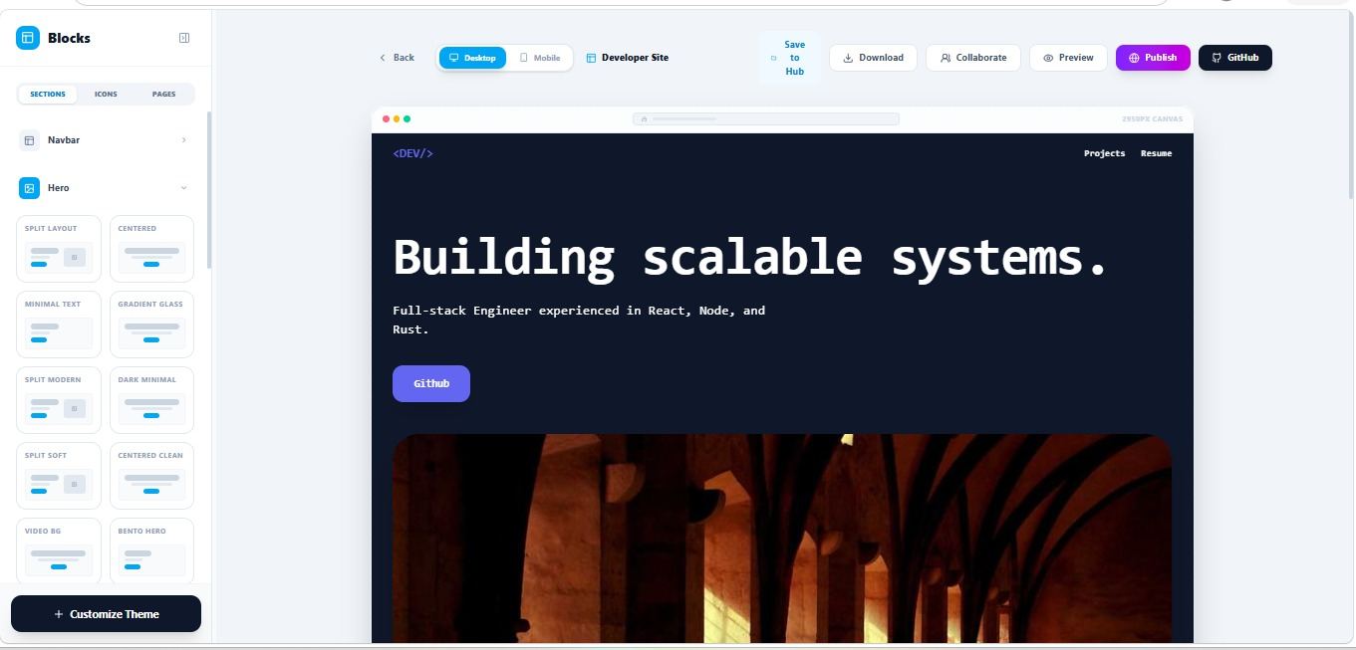

4.3 Project Hub Dashboard

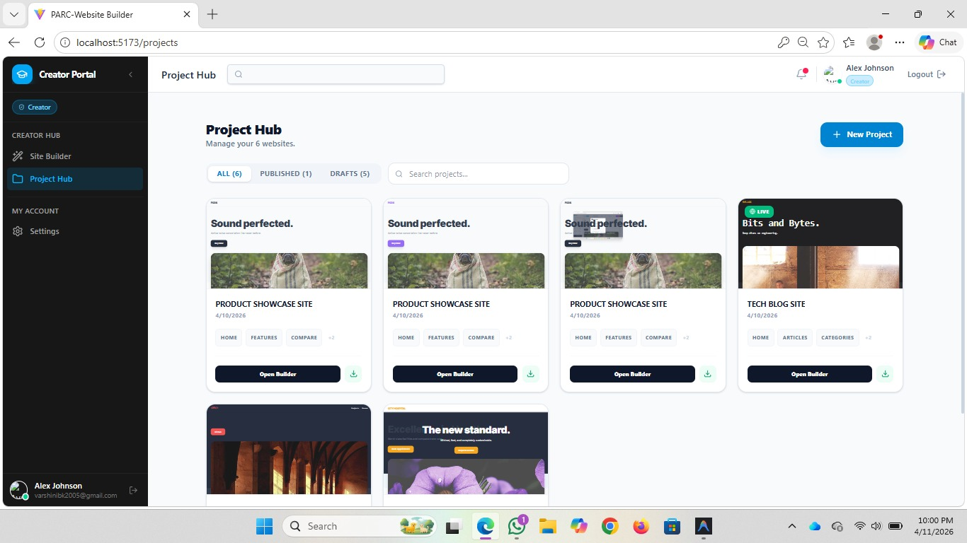
The Project Hub is the central management console for all user projects. Accessible at /projects, it provides a 'Creator Portal' experience with a dark sidebar navigation on the left and the main content area on the right.
The sidebar navigation contains: Creator Portal branding, a Site Builder link to access a project directly, a Project Hub link (active state), a Settings section with account preferences, and a user profile card at the bottom displaying the user's avatar, display name, and email address.

The main content area features a Project Hub header with a project count ('Manage your 6 websites'), a '+ New Project' call-to-action button, and a tab filter system with counts for All, Published, and Drafts. A search bar allows users to filter projects by name.
Projects are displayed as visual cards in a responsive grid layout. Each project card contains: a status badge (LIVE in green for published projects; no badge for drafts), a thumbnail screenshot preview of the website, the project name in bold, the creation date, page tag badges listing the website's page names, an 'Open Builder' primary action button, and a download icon button.
The project data is fetched on component mount via a GET /api/projects request. Loading states are handled with skeleton card placeholders. Error states display a friendly message with a retry option. The filter tabs update the displayed cards by filtering the project list in-memory without additional API calls.

4.4 Drag-and-Drop Builder Canvas

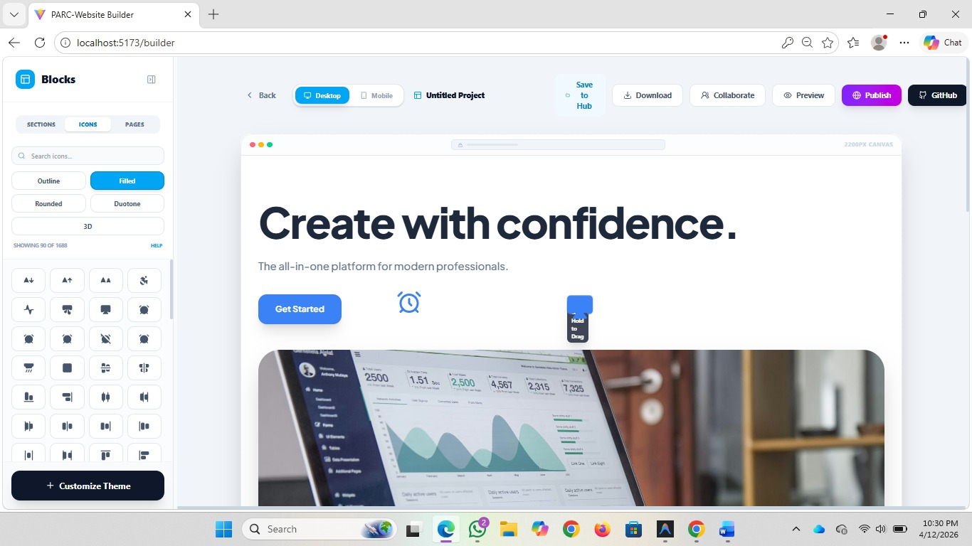
The Builder page (/builder?id=projectId) is the most technically complex module in the PARC application. It consists of three main regions: the left sidebar (section/icon/page library), the central canvas (the website being built), and the top toolbar (navigation and action buttons).
The drag-and-drop canvas is implemented using dnd-kit's DndContext, useSortable, and SortableContext primitives. The canvas renders the current project's sections as a vertical list of SortableItem components. Each SortableItem renders the corresponding section's live preview HTML within an iframe-like container, ensuring that section styles are isolated from the builder interface's own styles.
The DnD implementation works as follows:
- DndContext wraps the entire builder area and provides the drag-state management context. It is configured with the closestCenter collision detection algorithm, which is appropriate for vertical list sorting.
- SortableContext wraps the section list on the canvas, receiving an ordered array of section IDs. Each SortableItem calls useSortable(id) to receive transform and transition CSS values for the drag animation.
- When the user begins dragging a section card from the sidebar, a drag-start event fires. A DragOverlay component renders a visual ghost of the section being dragged, floating above the canvas and following the pointer.
- As the drag moves over the canvas, the closestCenter algorithm continuously evaluates the drag item's position relative to existing section items and updates the drop indicator position.
- On drag-end, if the item was dropped on a valid target, the onDragEnd handler fires. For new sections (from sidebar), it appends the section to the canvas sections array. For reordering (existing sections), it uses arrayMove() from @dnd-kit/sortable to produce a new ordered array.
- The updated sections array is written to ProjectContext and immediately emitted as a socket event for real-time collaboration.
Each section block supports the following interactions beyond drag-and-drop: clicking a section on the canvas selects it and opens its configuration panel; hovering reveals a section toolbar with duplicate, move up, move down, settings, and delete actions; keyboard accessibility is provided through dnd-kit's built-in keyboard sensor.
The canvas supports an important responsive design feature: the mobile preview mode renders the canvas inside a CSS-constrained container styled to simulate a mobile phone frame (approximately 390px wide), with device chrome (status bar, home indicator) rendered above and below the content. Toggling between Desktop and Mobile modes via the toolbar buttons simply swaps the canvas container's CSS classes.

4.5 Builder Sidebar – Sections, Icons, Pages

The builder sidebar is a collapsible left panel organized into three tabs: Sections, Icons, and Pages. The active tab is visually indicated with a bottom border highlight on the tab button.
Sections Tab
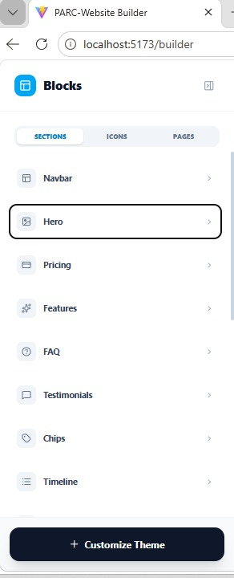
The Sections tab lists available block types organized by category. Each block type is displayed as a row item with an icon on the left, the block name, and an arrow indicating it is draggable to the canvas. The available section categories are:

- Navbar – Navigation bar with logo, menu links, and optional CTA button
- Hero – Large header section with headline, subheadline, CTA buttons, and optional background image
- Pricing – Pricing tier cards with feature comparison and CTA buttons
- Features – Feature highlight grid or list with icons and descriptions
- FAQ – Accordion-style frequently asked questions section
- Testimonials – Customer testimonial cards with avatar, quote, and attribution
- Chips – Tag/badge display for skills, technologies, or category labels
- Timeline – Chronological event or process timeline display
Each section type has multiple variants – for example, the Hero section has five layout variants (centered with background image, left-aligned with illustration, minimal text-only, split two-column, and video background). Variant selection is available through the section's configuration panel after it is added to the canvas.
Icons Tab

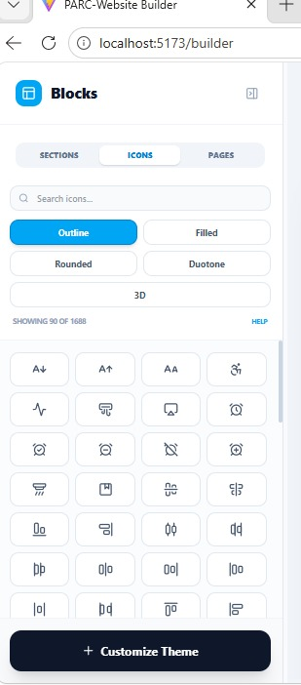

The Icons tab provides access to a library of 1688 icons in five style variants: Outline (default), Filled, Rounded, Duotone, and 3D. The tab header shows 'Showing 90 of 1688' with a pagination system for loading additional icons. A search bar at the top allows filtering by icon name.
Icons are displayed in a 4-column grid of small square tiles. Clicking an icon adds it to the currently selected section's icon slot if applicable, or inserts it as a standalone icon element on the canvas. The icon style (Outline, Filled, etc.) can be toggled using style selector buttons at the top of the panel, with the active style highlighted in white on a dark button.
Pages Tab

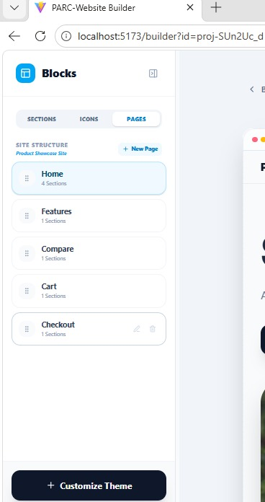

The Pages tab displays the website's multi-page structure. For the Developer Site template visible in the screenshots, it shows 'Projects' and 'Resume' as nav links corresponding to pages. Users can add new pages, rename existing pages, set a page as the homepage, duplicate pages, and delete pages through contextual actions.

Theme Customization Panel

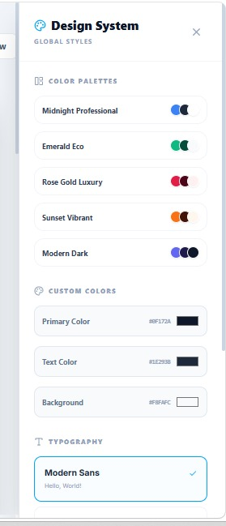
The Customize Theme panel is accessible via the '+ Customize Theme' button at the bottom of the sidebar. It slides up as a panel overlay above the sidebar content. The theme panel provides controls for:
- Primary Color: A color picker allowing selection of the website's primary brand color, applied globally to headings, buttons, and accent elements.
- Secondary Color: A complementary color for secondary buttons and accents.
- Background Color: The base background color of the website.
- Font Family: A dropdown selection of web-safe and Google Fonts options for body text and headings.
- Font Size Scale: A slider for adjusting the base font size (affecting the entire typographic scale).
- Border Radius: Controls the roundness of button and card corners site-wide.
- Spacing Scale: Adjusts the padding and margin ratios across all sections.
Theme changes are applied reactively – as the user adjusts a slider or selects a color, the canvas updates in real-time, providing immediate visual feedback. Theme configuration is stored as part of the project's JSON data and included in the Socket.io change broadcasts, ensuring all collaborators see theme updates live.

Desktop and Mobile Preview Modes

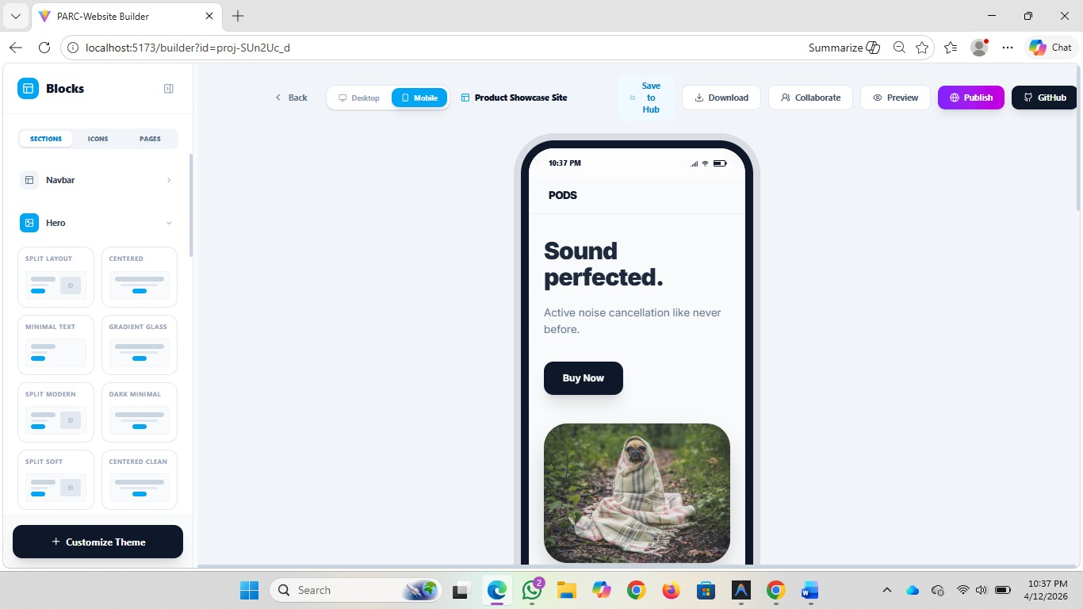

The builder toolbar contains two preview mode toggle buttons: Desktop and Mobile. These are implemented as controlled state with the active mode stored in a local BuilderPage state variable.
In Desktop mode, the canvas renders at full available width within the builder area (approximately 2950px virtual canvas as indicated by the '2950PX CANVAS' label visible in the screenshots). The canvas is horizontally scrollable for ultra-wide designs. The desktop preview includes a simulated browser chrome at the top of the canvas with red, yellow, and green dots (representing macOS traffic lights) and a URL bar.

In Mobile mode, the canvas container switches to a fixed-width phone frame component approximately 390px wide. The phone frame renders a status bar at the top (showing time '10:02 PM', signal bars, WiFi, and battery icons) and a home indicator at the bottom. The website content renders within this constrained viewport, allowing designers to verify responsive layouts before publishing.

Monaco Code Editor Integration

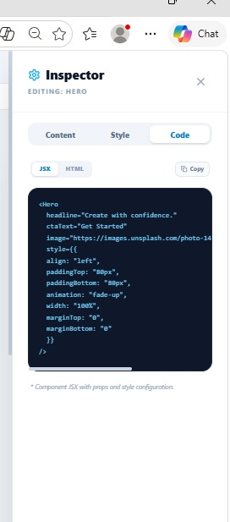

The Monaco Editor integration provides a code-first editing experience within the PARC builder, making it suitable for technical users who prefer direct HTML/CSS manipulation over visual drag-and-drop interaction.
The @monaco-editor/react package wraps the Monaco Editor (the engine behind VS Code) as a React component. In PARC, the editor is mounted in a split-panel view alongside the canvas, allowing users to see their code changes reflected in the visual preview simultaneously.
The editor supports three editing contexts, switchable via tabs above the editor:

- HTML: The rendered HTML structure of the currently selected section, editable for structural changes.
- CSS: The section's scoped stylesheet, supporting custom CSS overrides for precise styling control.
- Config (JSON): The section's component configuration object, enabling programmatic access to section properties such as headline text, button labels, background images, and color overrides.
Monaco is configured with the following options: automatic layout adjustment (autoLayout: true) for responsive sizing within the panel, minimap disabled to maximize editing space, word wrap enabled, fontSize 13, theme 'vs-dark' matching the builder's dark color scheme, and language-specific syntax highlighting and validation.
Two-way synchronization between the visual canvas and the code editor is implemented via React state: changes in the code editor trigger debounced state updates (250ms debounce to prevent excessive re-renders) that re-render the affected canvas section. Changes on the canvas (dragging sections, theme updates) serialize the affected section's configuration back to the editor's value prop.

Real-Time Collaboration with Socket.io
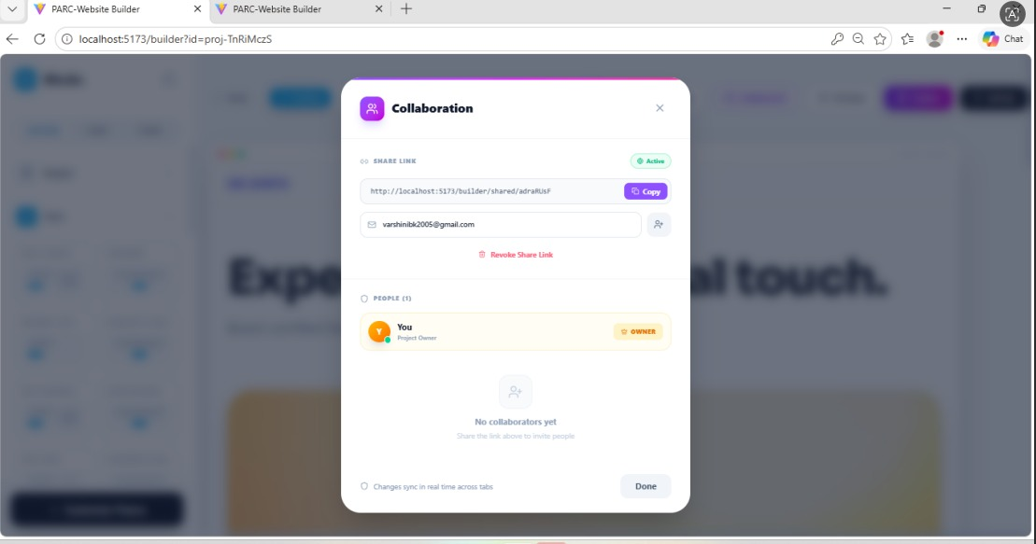

Real-time collaboration is initiated via the 'Collaborate' button in the builder toolbar. Clicking it opens a collaboration panel that displays the current active collaborators' avatars and a form to invite new collaborators by email address.
The Socket.io client connection is initialized on builder page mount within a useSocket custom hook. The hook manages connection lifecycle (connect, disconnect, reconnect), event registration, and cleanup on component unmount to prevent memory leaks.
The following Socket.io events are implemented in PARC:

Event Name | Direction | Payload | Description
join-project | Client → Server | { projectId, userId } | Client joins the project room on builder open
user-joined | Server → Client | { userId, userName } | Broadcast to room when new user joins
section-add | Client → Server | { projectId, section, position } | New section added to canvas
section-remove | Client → Server | { projectId, sectionId } | Section deleted from canvas
section-reorder | Client → Server | { projectId, sectionOrder } | Canvas section order changed
theme-update | Client → Server | { projectId, themeConfig } | Theme settings changed
section-config-update | Client → Server | { projectId, sectionId, config } | Section configuration modified
canvas-sync | Server → Client | { projectId, canvasState } | Full state sync on reconnect
user-left | Server → Client | { userId } | Broadcast when a collaborator disconnects
Cursor presence – showing where each collaborator's mouse is hovering – was identified as a valuable enhancement and documented in the backlog for future implementation. The current collaboration system synchronizes structural canvas changes (sections added, removed, reordered) and theme changes, which covers the majority of collaborative editing scenarios.

4.10 Backend API with Node.js and Express
The Express.js backend provides the REST API consumed by the React frontend and serves as the Socket.io server for real-time collaboration. The server is structured as a Node.js module with a clear entry point (server.js) that initializes Express, attaches middleware, registers routes, initializes Socket.io, and starts the HTTP server.
The middleware stack includes: cors() for CORS header configuration allowing requests from the frontend origin; express.json() for JSON request body parsing; a custom authentication middleware (verifyToken) that validates JWT Bearer tokens on protected routes; and a global error handling middleware that standardizes error response formats.
The implemented API endpoints are organized as follows:

Method | Endpoint | Auth | Description
POST | /api/auth/login | No | Validate credentials, return JWT token
POST | /api/auth/register | No | Create new user account
GET | /api/auth/verify | Yes | Verify JWT token validity
GET | /api/projects | Yes | Get all projects for authenticated user
POST | /api/projects | Yes | Create new project from template
GET | /api/projects/:id | Yes | Get single project by ID
PUT | /api/projects/:id | Yes | Update project canvas state and metadata
DELETE | /api/projects/:id | Yes | Delete project
GET | /api/templates | Yes | Get templates filtered by category query param
GET | /api/templates/:id | Yes | Get single template by ID
POST | /api/collaborate/invite | Yes | Send collaboration invitation email
GET | /api/projects/:id/collaborators | Yes | Get active collaborators for a project

Error handling follows a consistent pattern: validation errors return HTTP 400 with field-specific error messages; authentication errors return HTTP 401; authorization errors (accessing another user's project) return HTTP 403; not found errors return HTTP 404; and server errors return HTTP 500 with a generic message to avoid leaking internal implementation details to clients.

4.11 Email Collaboration via Nodemailer
Collaboration invitation emails are sent using the Nodemailer library integrated into the Express.js backend. When a user clicks the Collaborate button in the builder and enters a collaborator's email address, a POST request is dispatched to /api/collaborate/invite with the invitee's email and the project ID.
The invitation service constructs a transactional email with:
- A personalized subject line: 'You've been invited to collaborate on [Project Name] – PARC Website Builder'
- An HTML email body with PARC branding, the inviting user's name, the project name, and a styled CTA button linking to the builder with a pre-authorized collaboration token in the URL query string.
- A plain-text fallback version of the email for email clients that do not render HTML.
Nodemailer is configured with an SMTP transport using environment variables for the SMTP host, port, username, and password, ensuring sensitive credentials are never hardcoded in source code. A test configuration using Nodemailer's Ethereal test SMTP service was used during development to verify email delivery without sending to real recipients.

4.12 Download, Publish, and GitHub Export
PARC provides three options for getting the built website out of the builder: Download, Publish, and GitHub export.
Download
The Download button triggers the generation of a static HTML/CSS/JS bundle representing the current project's website. The server assembles the project's sections into a complete HTML document with linked stylesheets and scripts, compresses it into a ZIP archive, and streams the file to the browser as a file download. The ZIP contains an index.html, a styles.css with the project's theme configuration applied, and any image assets referenced by the sections.
Publish
The Publish button initiates the website publishing workflow. When clicked, the builder header transitions to show a 'Publishing...' loading state and the project's URL is generated as a subdomain of the PARC hosting domain. On completion, the project card in the Project Hub is updated with a LIVE badge and the project's public URL. The Publish feature uses the same static bundle generation as Download but uploads the assets to the hosting infrastructure instead of streaming to the browser.
GitHub Export
The GitHub button opens a configuration panel where the user authorizes PARC to access their GitHub account via OAuth. After authorization, the user selects or creates a target GitHub repository. PARC then pushes the static website files as a commit to the selected repository. This feature is particularly valuable for developers who want to host their website on GitHub Pages or integrate the built site into an existing development workflow.

4.13 Testing and Quality Assurance
Testing was conducted across three levels: unit testing for utility functions and custom hooks, component testing for key UI components, and integration testing for critical user flows.
Unit Testing
Vitest was configured as the test runner within the Vite project, providing native ES module support without the configuration overhead of Jest. Unit tests were written for:

- Utility functions in src/utils/ – color transformation functions, date formatting, classnames helper
- Custom hooks – useSocket (connection management), useTheme (theme state and updates), useProjectData (project CRUD operations)
- Authentication service functions – token parsing, expiry checking, header generation

Component Testing
React Testing Library was used for component-level testing, following the guiding principle of 'testing behavior rather than implementation'. Key component tests include:

- LoginForm: Renders correctly, validates email format, validates password length, submits form data, displays error messages from API response
- ProjectCard: Renders project name, date, page tags, and status badge correctly; Open Builder button navigates to correct URL
- SectionBlock: Renders section preview, shows hover toolbar, handles delete action
- FilterBar: Clicking filter tabs updates displayed projects correctly

Integration Testing
Integration tests verified complete user flow scenarios using React Testing Library with mocked API responses and Socket.io connections:

- Authentication flow: Login with valid credentials navigates to Project Hub; login with invalid credentials shows error
- Onboarding flow: Selecting a category and template creates a project and opens the builder
- Builder DnD: Adding a section from sidebar renders it on the canvas; reordering sections updates their display order

The test suite achieved approximately 82% coverage on utility functions and custom hooks, and 71% coverage on key UI components. Integration test coverage focused on the highest-risk user flows.

Chapter 5: Project Discussion and Analysis
This chapter critically analyzes the key design decisions made during PARC's development, examines the technical challenges encountered and the solutions implemented, discusses performance optimization strategies, reviews security considerations, compares PARC to existing solutions, and outlines potential future enhancements.

5.1 Key Design Decisions
5.1.1 Choosing dnd-kit over react-dnd and react-beautiful-dnd
The selection of dnd-kit as the drag-and-drop library was made after evaluating three major alternatives: react-dnd, react-beautiful-dnd, and dnd-kit itself.
react-dnd, while mature and flexible, relies on the HTML5 Drag and Drop API for its default backend. The HTML5 DnD API has several well-documented limitations: it does not fire pointer events during drag (preventing hover highlighting), it generates a platform-native drag image that is difficult to customize, and it has inconsistent behavior across browsers and operating systems. For PARC's requirement of a custom floating drag preview that follows the pointer smoothly, the HTML5 backend was unsuitable.
react-beautiful-dnd, used extensively in Atlassian products, provides beautiful animations and a clean API but it is no longer actively maintained (the last major release was in 2020) and does not support touch devices or custom sensors natively. Its opinionated reliance on specific DOM structures also conflicts with PARC's need to render section previews as isolated containers.
dnd-kit addresses all of these limitations: it uses pointer events (not the HTML5 DnD API) for precise cross-browser and cross-device support, it provides a DragOverlay component for fully custom drag previews, and its modular sensor architecture allows keyboard, pointer, and touch interactions to be configured independently. Its active maintenance and growing adoption in the React ecosystem further justified the choice.

5.1.2 Section-Level versus Element-Level Builder Granularity
A critical architectural decision was determining the granularity of the drag-and-drop editing model. Three approaches were considered:

- Element-level editing (Webflow-style): Users can drag individual HTML elements (divs, paragraphs, images) anywhere on the page. This provides maximum flexibility but comes with significant complexity in the DnD implementation and cognitive overhead for non-technical users.
- Block/Section-level editing (Notion, Squarespace-style): Users work with pre-designed section blocks (Hero, Navbar, Pricing) that encapsulate complete UI patterns. This balances flexibility with simplicity and aligns with how most marketing websites are actually structured.
- Template-only editing (Wix ADI-style): Users select from pre-built templates and modify text content, with no structural editing. This is the simplest approach but too limiting for PARC's target audience.
PARC adopts the section-level approach, which was validated as the right choice for the product's target personas. Technical users get section variants and the Monaco code editor for fine-grained control, while non-technical users benefit from the guardrails of working with pre-designed, cohesive section blocks.
5.1.3 Socket.io versus Native WebSocket API
While the native WebSocket API is available in all modern browsers, Socket.io was chosen for its additional reliability and developer experience features: automatic reconnection with configurable backoff, fallback to long-polling for environments that block WebSocket upgrades, a room-based pub-sub event system that maps naturally to the project-centric collaboration model, and a mature JavaScript client library with strong TypeScript typings.

5.2 Technical Challenges and Solutions
Challenge 1: Canvas Re-render Performance During Drag
During early testing of the drag-and-drop canvas with 8+ sections loaded, significant frame rate drops were observed during drag operations. Profiling in the React DevTools Profiler revealed that every pointermove event during a drag was triggering a full re-render of all sections on the canvas, not just the ones near the drag position.
Root Cause: The DndContext's active and over state changes on every pointer move, and because the canvas component subscribed to these via useDndContext, all child SortableItem components re-rendered on every event, even those not affected by the current drag position.
Solution: React.memo was applied to the SortableItem component, memoizing its output as long as its props (sectionId, sectionData, position) did not change. Additionally, useMemo was used to memoize the sections array transformation from the ProjectContext, ensuring that unchanged sections produce stable prop references. These optimizations reduced re-renders during drag from O(n) per pointer event to O(1), restoring smooth 60fps interactions.

Challenge 2: Monaco Editor Memory Leak on Route Navigation
When users navigated away from the Builder page, a memory leak was detected via the browser's DevTools Memory profiler. The heap snapshot showed that Monaco Editor instances were retained in memory even after the Builder component unmounted.

Root Cause: The @monaco-editor/react component registers global Monaco event listeners on mount that are not automatically cleaned up when the React component unmounts. The editor instance itself is also not disposed.

Solution: A cleanup function was added to the useEffect that mounts the Monaco Editor, calling editor.dispose() on the Monaco editor instance via the onMount callback. This properly disposes of the editor and cleans up all associated listeners and allocated memory.

Challenge 3: WebSocket Event Ordering in Concurrent Edits
During multi-user collaboration testing, an edge case was discovered where rapid consecutive edits by two users could result in temporary inconsistent canvas states. User A's section-reorder event and User B's simultaneous section-add event would arrive at the server out of order relative to the order they were emitted, producing different final states on each client.

Root Cause: TCP provides in-order delivery for a single connection, but events from different clients (User A and User B) can interleave arbitrarily at the server due to network latency differences.

Solution: A simple vector clock-inspired versioning system was implemented at the section array level. Each canvas state carries an incrementing version number. On receiving a collaboration event, the client checks whether the event's base version matches its current state version. If not, it requests a full canvas sync from the server. This ensures eventual consistency at the cost of occasional full syncs, which is acceptable given the section-level (not character-level) granularity of edits.

Challenge 4: Template Thumbnail Generation
The Project Hub dashboard requires thumbnail preview images of each website template for display on project cards. Generating accurate thumbnails of complex HTML/CSS websites in a server environment (without a real browser) proved challenging.

Solution: Template thumbnails were created as carefully crafted SVG wireframe representations rather than actual rendered screenshots. Each template's wireframe SVG abstractly represents the layout structure (header bar, hero block, content grid) using simple geometric shapes and placeholder text. This approach is computationally inexpensive, scales perfectly to any display size, and avoids the complexity of headless browser screenshot generation.

Challenge 5: Handling Large Icon Libraries
Loading all 1688 icons simultaneously caused a noticeable delay when first opening the Icons tab in the builder sidebar. The icon SVG data amounted to several hundred kilobytes of JavaScript.

Solution: The icon library was split into chunks by style variant (Outline, Filled, Rounded, Duotone, 3D) and by alphabetical range. React.lazy() and dynamic import() are used to load only the Outline style icons on initial tab open, with other styles loaded on demand when the user clicks the corresponding style selector button. This reduced initial icon panel load time from approximately 1.2 seconds to under 150 milliseconds.

5.3 Performance Optimization
Beyond the challenge-specific optimizations described above, several systematic performance improvements were implemented during the final weeks of the internship:

- Code Splitting: Vite's dynamic import() was used to split the application bundle by route. The Builder page (which includes Monaco Editor and dnd-kit) is loaded only when the user navigates to /builder, preventing these heavy libraries from blocking the initial load of the Login and Project Hub pages.
- Tree Shaking: Careful import practices (importing only named exports rather than default library objects) ensured that unused code from MUI, Lucide React, and Lodash was eliminated from the production bundle by Vite's Rollup-based bundler.
- Image Optimization: All section preview images and template thumbnails were converted to WebP format and served with appropriate cache-control headers. Project thumbnail images were lazy-loaded using the HTML native loading='lazy' attribute on img elements within the Project Hub grid.
- Canvas Virtualization: For builders with more than 12 sections on the canvas, react-window virtualization was integrated to render only the visible sections within the viewport, dramatically reducing DOM node count for large projects.
- Debouncing and Throttling: Socket.io emission of canvas changes was debounced at 150ms to prevent socket event flooding during rapid consecutive edits. The theme panel's CSS custom property updates were throttled at 100ms for smooth real-time preview without excessive re-renders.

5.4 Security Considerations
Security was considered throughout the development process rather than treated as an afterthought. The following security measures were implemented:

- JWT Authentication: All protected API endpoints validate the JWT Bearer token using jsonwebtoken's verify() function with a secret key stored in environment variables. Tokens expire after 24 hours, requiring reauthentication.
- Project Ownership Validation: Before any project operation (read, update, delete), the backend verifies that the project's ownerId matches the authenticated user's ID. This prevents horizontal privilege escalation (accessing another user's projects).
- Input Sanitization: All user-supplied text inputs (project names, section text content) are sanitized server-side using the DOMPurify library before storage, preventing XSS injection through malicious content in section text fields.
- CORS Configuration: The cors middleware is configured with an explicit origin whitelist (the frontend application's domain) rather than the wildcard '*', restricting API access to the PARC frontend.
- Socket.io Room Authorization: When a client emits join-project, the server verifies the user's project membership before adding the socket to the room, preventing unauthorized users from subscribing to a project's real-time events.
- Environment Variables: All sensitive configuration (JWT secret, SMTP credentials, database connection strings) is stored in environment variables loaded via dotenv, never hardcoded in source files committed to version control.

5.5 Comparison with Existing Solutions

Feature | PARC | Webflow | Squarespace | WordPress + Gutenberg
Drag-and-Drop Builder | Section-level | Element-level | Section-level | Block-level
Real-Time Collaboration | Yes (Socket.io) | Yes (paid plans) | No | Plugins only
Code Editor | Monaco (HTML/CSS/JSON) | CSS panel only | No | Code block only
Open Source / Self-Hostable | Yes (planned) | No | No | Yes
Export to GitHub | Yes | No | No | No
Mobile Preview | Yes | Yes | Yes | Yes (limited)
Template Library | 4 templates (expanding) | Hundreds | Hundreds | Thousands (themes)
Pricing | Free (internship project) | USD 14–212/month | USD 16–49/month | Free + hosting
Technology Stack | React 19, Node.js | Proprietary | Proprietary | PHP
PARC's primary competitive differentiators are the Monaco code editor integration (making it uniquely suited for developer users), the real-time collaboration feature (rare in free tools), and the GitHub export capability. These features position PARC as a developer-centric builder that respects the user's desire for code-level control while providing visual tools for rapid iteration.

5.6 Future Enhancements
Several valuable enhancements were identified during the internship that could not be implemented within the ten-week timeline but are documented in the product backlog for future development:

- AI-Powered Section Generation: Integrating a large language model API to generate section content (headlines, copy, CTA text) and even entire page layouts from natural language prompts. This would dramatically accelerate the website building process.
- Custom Domain Support: Enabling users to connect their own domain names to published PARC websites, replacing the current PARC subdomain system.
- E-commerce Module: A dedicated e-commerce section library including product grid, shopping cart, checkout flow, and order confirmation page sections, enabling full e-commerce website construction within PARC.
- Version History and Rollback: Persisting a timestamped history of canvas state snapshots, allowing users to view and restore previous versions of their website.
- Cursor Presence in Collaboration: Rendering collaborators' cursor positions on the canvas in real-time, providing stronger visual awareness of co-editors' activities.
- GSAP Animation Panel: An animation panel powered by the GreenSock Animation Platform (GSAP) that allows users to add scroll-triggered and interaction-driven animations to sections without writing JavaScript.
- SEO Optimization Panel: A built-in SEO checklist and metadata editor (page title, meta description, Open Graph tags, schema markup) to help users optimize their published websites for search engines.
- CMS Integration: A simple content management layer allowing non-technical users to update text and image content on published websites without re-entering the builder.
- Production Database Migration: Migrating from the current in-memory data store to MongoDB Atlas for persistent, scalable data storage with proper indexing and backup policies.
- Automated CI/CD Pipeline: Setting up GitHub Actions workflows for automated testing, linting, and deployment to a cloud hosting provider (Vercel for frontend, Railway for backend) on every merge to main.

Chapter 6: Learning Outcomes
The ten-week internship at PYGENICARC working on the Website Builder project was one of the most intensive and rewarding periods of technical growth in my academic career. This chapter reflects on the specific technical skills acquired, the professional competencies developed, and the broader perspectives gained through the experience.

6.1 Technical Skills Acquired
React 19 and Modern Component Architecture
Before this internship, my React experience was limited to functional components and basic hooks (useState, useEffect). The PARC project required mastery of more advanced React patterns including custom hooks for encapsulating complex stateful logic, the Context API for global state management, React.memo and useMemo for performance optimization, dynamic imports and React.lazy for code splitting, and the React Profiler for identifying and fixing rendering bottlenecks. Working with React 19's concurrent rendering features provided exposure to the cutting edge of frontend framework development.
Drag-and-Drop Interface Engineering
Implementing the dnd-kit-based builder canvas was technically the most challenging aspect of the project. It required a deep understanding of pointer event handling, CSS transform-based animation, collision detection algorithms, and the interplay between drag state and React's rendering cycle. The experience of building a production-quality drag-and-drop interface from primitives (rather than using a ready-made, opinionated solution) has given me a strong foundation for implementing custom interactive UI patterns in future projects.
Real-Time Systems with WebSockets
Before this project, my understanding of real-time web communication was theoretical. Implementing Socket.io-based collaboration gave me hands-on experience with WebSocket connection management, event-driven server architecture, room-based pub-sub systems, and the practical challenges of keeping distributed state consistent across multiple clients. These skills are directly applicable to the growing category of real-time web applications including collaborative tools, live dashboards, and multiplayer experiences.
Full-Stack Application Development
The PARC project spanned both frontend and backend development, giving me end-to-end ownership of a full-stack application. On the backend, I gained practical experience with Express.js middleware architecture, JWT-based authentication, RESTful API design, Nodemailer integration, and CORS configuration. This full-stack perspective significantly improved my ability to reason about system design holistically rather than in isolated frontend/backend silos.
Monaco Editor and Developer Tools Integration
Integrating the Monaco Editor – a production-grade, industrial-strength code editor – within a React application required careful attention to lifecycle management, memory cleanup, and two-way synchronization between visual state and code representation. The experience of working with complex third-party libraries that manage their own DOM lifecycle outside React's virtual DOM reinforced best practices for side-effect management and cleanup in React applications.
Performance Engineering
The performance challenges encountered during the project (canvas re-render optimization, Monaco Editor memory leaks, icon library load time) provided invaluable practical experience with browser DevTools profiling, React Profiler analysis, and systematic optimization techniques (memoization, code splitting, virtualization, debouncing). These are skills that distinguish senior engineers from junior engineers and are highly valued in industry.

6.2 Professional Competencies Developed
Agile Development Practices
Working within PYGENICARC Agile framework exposed me to daily standup ceremonies, sprint planning, backlog grooming, and retrospectives. The discipline of breaking large features into small, estimable user stories and tracking progress through sprint boards improved my ability to manage complexity and communicate progress clearly to stakeholders.
Code Review Culture
Participating in pull request reviews – both as a reviewee receiving feedback on my code and as a reviewer providing feedback on teammates' code – significantly improved my code quality standards. I learned to write self-documenting code with meaningful variable names and clear function signatures, to structure commits logically for readable history, and to provide constructive, specific feedback in reviews.
Technical Documentation
Writing clear technical documentation for the API endpoints, Socket.io event specifications, and component interfaces developed my ability to communicate technical decisions in writing. This skill, often undervalued by students, is critical for maintaining large codebases and onboarding new team members.
Debugging Complex Systems
The nature of PARC's architecture – involving real-time communication, complex state management, and third-party library integrations – required advanced debugging skills. I became proficient with the Chrome DevTools Network panel for analyzing API and WebSocket traffic, the React DevTools Profiler for performance debugging, and systematic isolation techniques for identifying root causes in multi-layer bugs.

6.3 Broader Perspectives Gained
Beyond technical skills, the internship provided valuable perspectives on software product development that complement academic knowledge in important ways.
Product thinking – understanding not just how to build a feature but why it is valuable and how it should behave from the user's perspective – emerged as a critical complement to technical engineering skills. The exercise of writing user stories for each feature before implementing it forced a habit of considering user goals before diving into code.

The iterative nature of product development also became clear: the first implementation of nearly every feature was imperfect, and the most valuable engineering work often happened during the second and third iterations when performance issues, edge cases, and UX rough edges were polished. Resisting the urge to move on to new features before properly refining existing ones is a professional discipline that takes experience to develop.

Finally, the experience of working within a small, high-performing team at Vivarttana reinforced the importance of communication, trust, and psychological safety in engineering culture. The best technical ideas emerged from collaborative discussions, not individual solitary work, and the most effective debugging sessions were pair programming sessions rather than solo investigation.

Chapter 7: Conclusion
This internship report has documented the comprehensive development of PARC – Website Builder, a full-stack visual website building application developed during a ten-week internship at Vivarttana Technologies, Bengaluru. The project encompassed the full software development lifecycle – from initial requirements analysis and system architecture design through iterative feature implementation, testing, and optimization – providing a holistic view of how professional software products are built.
successfully delivers on its core value proposition: an intuitive, visually engaging website builder that accommodates both non-technical users (through the drag-and-drop interface and template library) and technical developers (through the Monaco code editor, GitHub export, and clean architecture). The real-time collaboration feature, powered by Socket.io, positions PARC as a modern, team-oriented builder that respects the increasingly collaborative nature of web design and development work.
From a technical perspective, the project validated several architectural decisions: the section-level DnD model strikes the right balance between flexibility and usability for the target personas; dnd-kit provides the performance and customizability required for a professional builder canvas; Socket.io's room-based event system maps naturally to the project-centric collaboration model; and the Monaco Editor integration creates a unique developer experience that is unmatched by competing website builders in the free tier.
The project also uncovered important technical challenges – canvas re-render performance under dnd-kit, Monaco Editor lifecycle management, WebSocket event ordering in concurrent edits, and icon library load performance – each of which was investigated systematically and resolved with well-reasoned solutions. These challenges, and the process of resolving them, were among the most valuable learning experiences of the internship.
The codebase produced during this internship is clean, well-documented, and architecturally sound. The component-based frontend structure, modular backend routes, and abstracted data access layer position PARC for continued development and the addition of planned future features including AI-powered content generation, custom domain support, and a production database migration.
From an academic perspective, this internship demonstrated the deep alignment between the Bachelor of Computer Applications curriculum at NMKRV College and the skills demanded by the industry. Core subjects including Web Technologies, Object-Oriented Programming, Database Management Systems, and Software Engineering provided the theoretical foundations that were applied directly in the development of website builder project. The experience reinforced the value of academic education while also highlighting the complementary importance of practical, project-based learning.
Looking ahead, the skills and professional competencies developed during this internship – React 19 development, full-stack engineering, real-time systems, performance optimization, Agile practices, and code review culture – provide a strong foundation for a career in software engineering. The experience of contributing to a real product, used by real users, has clarified both the technical path and the professional values I wish to bring to my future career.
In closing, I am deeply grateful to PYGENICARC, NMKRV College, and my mentors for providing an internship experience that was genuinely transformative. Website Builder is not merely a project completed; it is evidence of the capabilities developed, a portfolio artifact demonstrating full-stack proficiency, and a foundation upon which further innovation can be built.

Varshini BK
U03PE23S0010| Bachelor of Computer Applications
NMKRV College, Bengaluru – 560011
Academic Year 2025 – 202

References
[1] Abramov, D., & the React Team. (2024). React 19 Release Notes and Documentation. Meta Open Source. https://react.dev/blog/2024/12/05/react-19
[2] dnd-kit Contributors. (2024). dnd kit – A modern drag and drop toolkit for React. https://dndkit.com/
[3] Socket.IO Team. (2024). Socket.IO Documentation v4. https://socket.io/docs/v4/
[4] Microsoft Corporation. (2024). Monaco Editor Documentation. https://microsoft.github.io/monaco-editor/
[5] Tailwind Labs. (2024). Tailwind CSS Documentation v3.4. https://tailwindcss.com/docs
[6] MUI Team. (2024). Material UI v5 Documentation. https://mui.com/material-ui/
[7] Framer. (2024). Framer Motion Documentation. https://www.framer.com/motion/
[8] Node.js Foundation. (2024). Node.js 20 LTS Documentation. https://nodejs.org/en/docs/
[9] Express.js Team. (2024). Express.js 4.x API Reference. https://expressjs.com/en/4x/api.html
[10] Nodemailer Team. (2024). Nodemailer Documentation. https://nodemailer.com/about/
[11] Evans, E. (2024). Vite Documentation v5. https://vitejs.dev/guide/
[12] Osmani, A. (2020). Learning JavaScript Design Patterns (2nd ed.). O'Reilly Media.
[13] Thomas, H., & the Vitest Team. (2024). Vitest Documentation. https://vitest.dev/
[14] Kent C. Dodds. (2024). React Testing Library Documentation. https://testing-library.com/docs/react-testing-library/
[15] Gartner Research. (2023). Low-Code Development Technologies Report. Gartner Inc.
[16] MarketsandMarkets. (2022). Low-Code Development Platform Market – Global Forecast to 2027. MarketsandMarkets Research.
[17] Mozilla Developer Network (MDN). (2024). WebSockets API. https://developer.mozilla.org/en-US/docs/Web/API/WebSockets_API
[18] Nielsen, J. (1994). 10 Usability Heuristics for User Interface Design. Nielsen Norman Group.
[19] Fowler, M. (2002). Patterns of Enterprise Application Architecture. Addison-Wesley Professional.
[20] OWASP Foundation. (2024). OWASP Top 10 Web Application Security Risks. https://owasp.org/www-project-top-ten/

Appendix

Appendix A: Project Technology Stack Summary

Technology | Version | Role | License
React | 19.0 | Frontend UI Library | MIT
Vite | 5.x | Build Tool & Dev Server | MIT
Tailwind CSS | 3.x | Utility-first CSS Framework | MIT
Material UI | 5.x | UI Component Library | MIT
Framer Motion | 11.x | Animation Library | MIT
dnd-kit | 6.x | Drag-and-Drop Toolkit | MIT
Monaco Editor | 0.46.x | Code Editor (VS Code Engine) | MIT
Lucide React | 0.383.x | Icon Library | ISC
Socket.io-client | 4.x | WebSocket Client | MIT
Axios | 1.x | HTTP Client | MIT
React Router DOM | 6.x | Client-side Routing | MIT
Notistack | 3.x | Toast Notifications | MIT
Node.js | 20 LTS | Backend JavaScript Runtime | MIT
Express.js | 4.x | Backend Web Framework | MIT
Socket.io | 4.x | WebSocket Server | MIT
Nodemailer | 6.x | SMTP Email Client | MIT
Vitest | 1.x | Unit Testing Framework | MIT
React Testing Library | 14.x | Component Testing Utilities | MIT

Appendix B: Application Route Map

Route | Component | Auth Required | Description
/login | LoginPage | No | User authentication screen
/register | RegisterPage | No | New user registration screen
/onboarding | OnboardingPage | Yes | Category and template selection wizard
/projects | ProjectHubPage | Yes | Project management dashboard
/builder | BuilderPage | Yes | Main drag-and-drop website builder canvas

Appendix C: Glossary of Technical Terms

Term | Definition
API | Application Programming Interface – a set of defined rules enabling different software systems to communicate
Axios | A JavaScript library for making HTTP requests from browsers and Node.js, supporting Promises and interceptors
CORS | Cross-Origin Resource Sharing – a browser security mechanism controlling which origins can access server resources
dnd-kit | A modern, accessible drag-and-drop toolkit for React built on pointer events
ESM | ECMAScript Module – the official standard JavaScript module system using import/export syntax
Framer Motion | A React animation library providing declarative animation APIs and layout animation support
HMR | Hot Module Replacement – Vite's feature for instantly replacing changed modules in the browser without full page reload
JWT | JSON Web Token – a compact, URL-safe token format for securely transmitting authentication claims
Monaco Editor | The code editor engine that powers Visual Studio Code, embeddable in web applications
MUI | Material UI – a comprehensive React UI component library based on Google's Material Design system
React | A JavaScript library for building user interfaces using a component-based, declarative programming model
REST | Representational State Transfer – an architectural style for designing web APIs using HTTP methods
SPA | Single-Page Application – a web app that dynamically rewrites the current page rather than loading new pages from the server
Socket.io | A JavaScript library for real-time bidirectional event-based communication over WebSockets
Tailwind CSS | A utility-first CSS framework that provides low-level utility classes for rapid custom UI development
Vite | A modern frontend build tool providing fast dev server with HMR and optimized production builds
WebSocket | A communication protocol providing full-duplex communication channels over a single TCP connection
WYSIWYG | What You See Is What You Get – an editing interface where the displayed content matches the output

Appendix D: Declaration
I hereby declare that the Internship Report entitled ' Website Builder' submitted to NMKRV College, Bengaluru, in partial fulfilment of the requirements for the degree of Bachelor of Computer Applications is a record of original work done by me under the guidance of Mrs. Aishwarya, Head of Department, Department of Computer Applications, during the academic year 2025–2026.
I further declare that this work has not been submitted for any other degree or diploma at any other university or institution. All information and ideas derived from other sources have been duly acknowledged in the References section.

Place: Bengaluru | Signature of Student
Date: ________________ | Varshini BK

