Data Source: <https://www.sheffield.ac.uk/mash/statistics/datasets>.

Research Question: Which diet was best for losing weight?

**One-Way ANOVA Analysis**

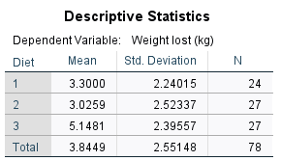

Based on the descriptive statistics above, Mean and Std. Deviation are the mean score and standard deviation of each diet respectively. N is the sample size under consideration.

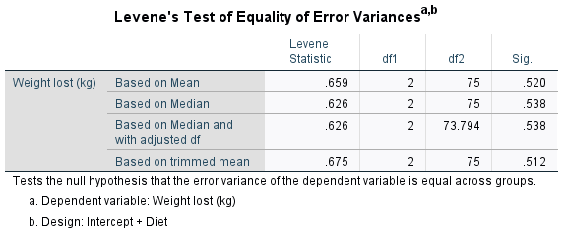

The table above indicates that, homogeneity of variance was not nonsignificant, p= 0.52 (i.e., p>0.05).

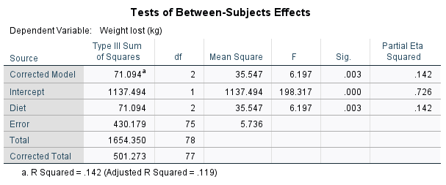

The table above was used to determine if the overall ANOVA was significant. The test was significant, F(2, 75) = 6.197, p = .003. Because p<0.05, we reject the null hypothesis that there are no differences among the diets. The ɳ2 of .142 indicate a strong relationship between the diets and weight lost (kg).

**Post Hoc Tests**

**Diet**

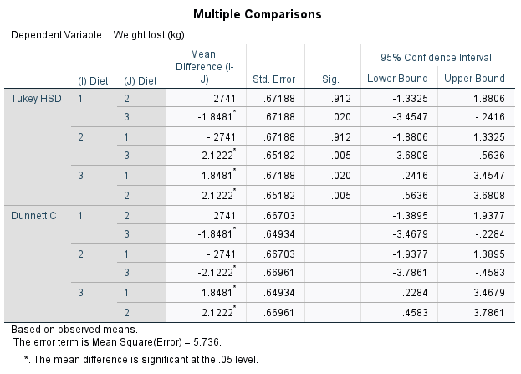

**Homogeneous Subsets**

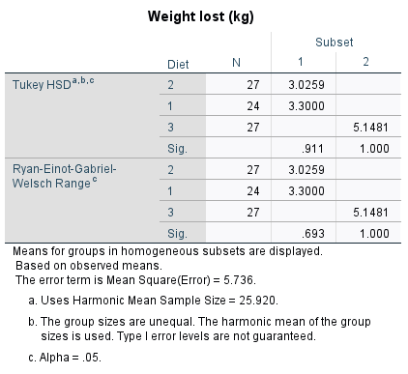

The tables above were used as follow up to evaluate pair-wise differences among the means. This indicates that diet 1, 2 and 3 differed significantly from one another.

**APA for 1-Way ANOVA**

One-way analysis of variance was conducted to evaluate the relationship between diet and weight loss. The independent variable, the diet factor, included three levels: 1, 2 and 3. The dependent variable was the weight loss. The ANOVA was significant, F(2, 75) = 6.197, p = .003. The strength of relationship between diet and weight, as assessed by ɳ2, was strong, with diet factor accounting for 14.2% of the variance of the dependent variable.

Follow up tests were conducted to evaluate pairwise differences among the means. Because the variances among the three groups ranged from 5.02 to 6.50 (Std. 2.24 – 2.55), we chose not to assume that the variances were homogenous and conducted post hoc comparison with the use of the Dunnett’s C test, a test that does not assume equal variances among the three diets. There was a significant difference between diet 1 and diet 3 and between diet 2 and diet 3, but no significant difference between diet 1 and diet 2. Diet 2 showed a greater decrease in the weight lost in comparison to diet 1. The 95% confidence intervals for the pair-wise differences, as well as the means and standard deviations for the three diets, are reported in the table below:

95% Confidence Intervals of Pair-wise Differences in Mean Changes in Weight Lost

|  |  |  |  |  |
| --- | --- | --- | --- | --- |
| Diet | M | SD | Diet 1 | Diet 2 |
| 1 | 3.30 | 2.24 |  |  |
| 2 | 3.03 | 2.52 | [-1.39, 1.94] |  |
| 3 | 5.15 | 2.40 | [-3.47, -.23] | [-3.78, -.46] |

**Kruskal-Wallis H test Analysis**

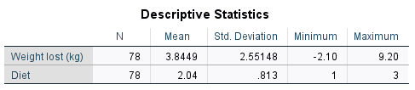

N is the total sample sizes of the dependent (weight loss) and independent (diet 1, diet 2 and diet 3) variables 78 respectively for both. The mean is the average weight loss, 3.845 and of independent variable (diet 1, diet 2 and diet 3), 2.04. The standard deviation was 2.55 for weight loss and .813, for independent variables (diet 1, diet 2 and diet 3) respectively. The minimum values were, -2.10 and 1 for dependent (weight loss) and independent (diet 1, diet 2 and diet 3) variables respectively and the maximum values were, 9.20 and 3 for dependent (weight lost) and independent (diet 1, diet 2 and diet 3) variables respectively.

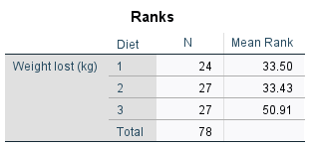

The table above provided N which is the sample size of diet 1, diet 2, and diet 3 which are 24, 27 and 27 respectively and their mean ranks of 33.50, 33.43, and 50.91 respectively.

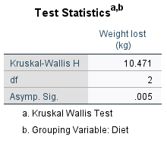

The table above provided the Kruskal-Wallis H value, 10.47, the degree of freedom 2 and the p-value, .005 which are essential in finding the effect later.

**APA for** **Kruskal-Wallis H test**

A Kruskal-Wallis H test was conducted to evaluate the differences among the diets (1, 2 and 3) on weight loss. The results of the test were significant (p = 0.005), p<.05. Therefore, we reject the null hypothesis that there was no difference between the mean of the diets. The mean rank of 33.43 for diet 2, indicates a less weight and a better weight lost compared to the two other diets.