**MANOVA**

A researcher wants to examine the potential benefits of diet and exercise on two commonly used markers of health, weight and cholesterol levels. Participants were assigned to one of four combinations of diet/exercise (2 x 2) and had their weight (pounds) and cholesterol (LDL) measured.

Run as a factorial design with a covariate (weight) and interpret the results.

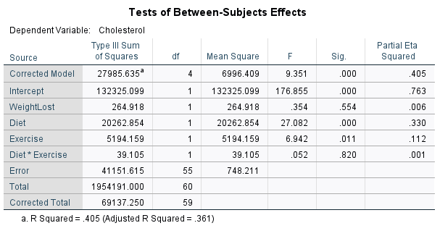

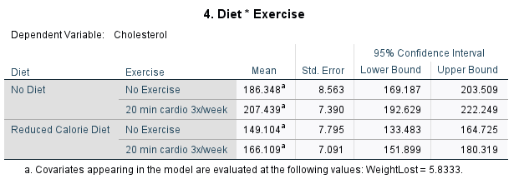

**Part 2: Question 5: Interpretation**

Analysis of covariance (ANCOVA) was conducted. The independent variables, diet, included two levels: no diet and reduced calorie diet, and exercise, included two levels: no exercise and 20 min cardio 3x/week. The dependent variable was taken to be the cholesterol and the covariant was weight. The output of the analysis indicated that the relationship between the covariant (weight) and the dependent variable (cholesterol) was nonsignificant as a function of the independent variables (diet*exercise), F(1, 55) = 0.052, p(0.820) > 0.05, partial ɳ2 = 0.01. However, the relationship between the dependent variable and exercise was significant, *F*(1, 55) = 6.942, p(0.011) <0.05, partial ɳ2 = 0.112. Furthermore, after accounting for covariant, the relationship between the dependent variable and diet was also significant, F(1, 55) = 27.082, p(0.000) <0.05, partial ɳ2 = 0.330. The means of the weight adjusted for the cholesterol indicated that, reduced calorie diet with 20min cardio 3x/week, yields a lesser and more reasonable cholesterol reduction (M = 166.11).

Run as a MANOVA with weight and cholesterol as the dependents and interpret the results.

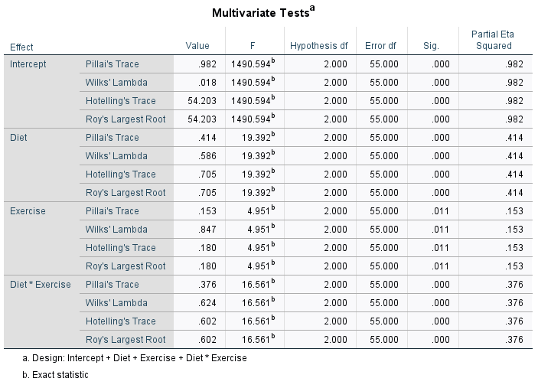

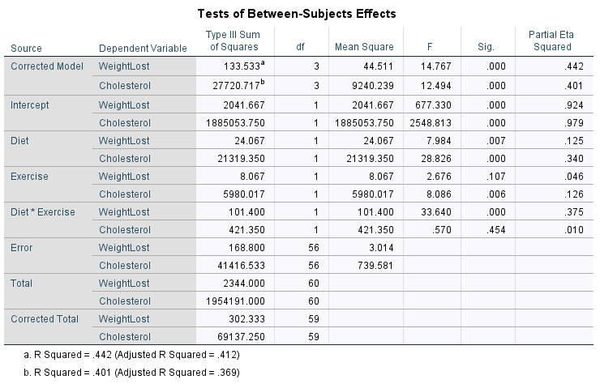

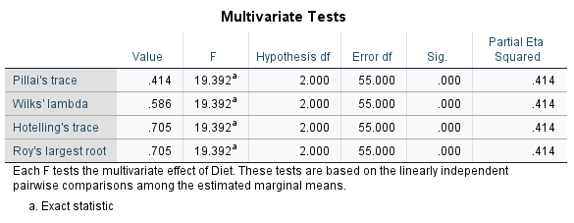

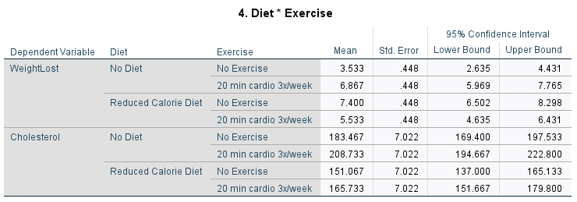

**Part 2: Question 6: Interpretation**

A multivariate analysis of variance (MANOVA) was conducted to determine the effect of diet (i.e., no diet or reduced calorie diet) and exercise (i.e., no exercise or 20 min cardio 3x/week) on two dependent variables, weight loss (kg) and Cholesterol (LDL) level. A significant differences were found among the two factors and their levels on the dependent measures, Wilks’s **˄** =0.586, *F*(2, 55) = 19.392, *p* < .05. The multivariate ɳ2 based on Wilks’s **˄** was quite strong, 0.414. Table 2.3 below contains the mean and standard deviation on the dependent variable for the two factors and their level.

**Table 2.3:** Means and Standard Deviations on the Dependent Variables for Each Factor/Levels

|  |  |  |  |  |  |
| --- | --- | --- | --- | --- | --- |
| Diet | Exercise | Weight Lost | | Cholesterol | |
| M | SD | M | SD |
| No Diet | No Exercise | 3.5333 | 1.64172 | 183.4667 | 34.52508 |
| 20 min cardio 3x/week | 6.8667 | 1.76743 | 208.7333 | 25.42908 |
| Reduced Calorie Diet | No Exercise | 7.4000 | 2.09762 | 151.0667 | 26.11094 |
| 20 min cardio 3x/week | 5.5333 | 1.35576 | 165.7333 | 20.92663 |

Analysis of variance (ANOVA) on the dependent variables were conducted as follow-up tests to the MANOVA. Each ANOVA was tested the 0.05 level. The ANOVA on the weight lost with respect to diet was significant, *F*(1, 56) = 7.984, *p*(0.007) < 0.05, ɳ2 = 0.125 level, likewise, the ANOVA on the cholesterol with respect to diet was significant, *F*(1, 56) = 28.826, *p*(0.000) < 0.05, ɳ2 = 0.340 level. However, The ANOVA on the weight lost with respect to exercise was nonsignificant, *F*(1, 56) = 02.676, *p*(0.107) > 0.05, ɳ2 = 0.046 level, but, the ANOVA on the cholesterol with respect to exercise was significant, *F*(1, 56) = 8.086, *p*(0.006) < 0.05, ɳ2 = 0.126 level. In term of interaction between diet and exercise, The ANOVA on the weight lost with respect to the interaction was significant, *F*(1, 56) = 33.640, *p*(0.000) < 0.05, ɳ2 = 0.375, while the ANOVA on the cholesterol with respect to the interaction was nonsignificant, *F*(1, 56) = 0.570, *p*(0.454) > 0.05, ɳ2 = 0.010.

Post hoc analyses consisted of conducting pairwise comparison to find which combination of diet or exercise practices enhances weight lost or cholesterol reduction most strongly. Reduced calorie diet and 20 min cardio 3x/week enhances weight lost and cholesterol reduction compared to other combinations of practices (see Table 2.6 above).

How does this interpretation differ from question 5?

In question 5, covariant was accounted for and the only one dependent variable (cholesterol) was under consideration. However, in this question two dependent variables are being considered (weight and cholesterol).

Should it differ?

Yes, because they the are two separate analysis, one is testing covariant (ANCOVA) and the other testing for multiple dependent variable (MANOVA).