Fundamentals of ROS2
Sanvi Garg
Computer Science Engineering
Formula manipal-Driverless Taskphase
MIT, Manipal

Abstract—Robot Operating System 2 (ROS 2) is a middleware framework designed to facilitate communication between different software components in robotic systems. It provides a distributed architecture in which independent programs called nodes communicate using topics, services, and actions. ROS 2 also supports parameters for configuring nodes, custom interfaces for defining application-specific data, and Quality of Service (QoS) settings for controlling communication behavior. This report explains the ROS 2 computation graph and its major communication mechanisms, compares topics and services, describes custom interfaces, and discusses the organization and compilation of ROS 2 workspaces using colcon.
Keywords— Ros2, Node, Topic, Service, Action, Graph
Part A— Concepts of ROS2, Part B— Solution of questions

Introduction
ROS 2 is an open-source middleware framework widely used for developing robotic applications. Unlike a traditional single program in which all functionality is contained in one executable, ROS 2 applications can be divided into multiple independent components. These components communicate with each other through standardized ROS 2 communication mechanisms.
This modular approach allows different parts of a robotic system to be developed, tested, and modified independently. For example, one node may process sensor data, another may control a motor, and another may perform navigation. ROS 2 provides the communication infrastructure required for these nodes to exchange information.
The main concepts discussed in this report are the ROS 2 computation graph, nodes, topics, services, actions, parameters, custom interfaces, workspaces, colcon, and Quality of Service settings.

Computation Graph
The ROS 2 computation graph is a conceptual representation of all the nodes in a ROS 2 system and the communication relationships between them. It shows which nodes publish or subscribe to topics and which nodes provide or use services and actions.
Consider a simple robotic system containing a sensor node and a processing node. The sensor node may publish sensor measurements on a topic, while the processing node subscribes to that topic.
This graph allows developers to understand how information flows through a robotic application. Tools such as rqt_graph can be used to visualize the computation graph while the system is running.
The computation graph is dynamic because nodes can start and stop during execution. This makes it useful for debugging communication problems and verifying whether the required nodes and connections are present.

Node- A node is a program that performs a particular task in a ROS 2 system. A robot usually has several nodes instead of one program that handles everything.

A robot could have a camera node that receives images, a processing node that analyses those images, and a motor node that controls the movement of the robot.

A node can publish data, subscribe to data, provide a service, or use a service. It can also work with actions and parameters.

Dividing a system into multiple nodes makes it easier to develop and debug because each part can be worked on separately.

Topics- A topic is a communication channel used by ROS 2 nodes to exchange data. Topics use a publish-subscribe model.

A node that sends information is called a publisher, while a node that receives the information is called a subscriber.

The publisher does not have to directly know which node is receiving the data. Any node interested in the topic can subscribe to it.

Topics are mainly useful when data needs to be sent continuously or whenever new data becomes available. Examples include sensor readings, camera images, robot position, and velocity commands.

Services- A service is used when one node needs to request something from another node and receive a response.

There are two parts involved-

Service client- sends the request.

Service server- receives the request and sends back a response.

A node could provide a service to reset a robot. Another node can send a reset request and receive a response indicating whether the operation was successful.

Services are generally used for short operations where a response is expected.

Actions- Actions are used for tasks that take some time to complete. Unlike a service, an action can provide feedback while the task is running.

An action has three main parts-

Goal -what the client wants the robot to do.

Feedback- information about the current progress.

Result -the final outcome of the task.

If a robot is asked to move to a particular location, the goal would contain the destination. While the robot is moving, feedback can be provided about its progress.

Once it reaches the destination, the final result is returned.

Actions are useful for tasks where the user may want to monitor or cancel the operation.

Parameters- Parameters are values used to configure a node. They can be changed without changing the actual source code of the node.
A motor-control node could have a parameter for maximum velocity. Changing this parameter would change the maximum speed without requiring the program to be rewritten.
Other examples include sensor update rates, threshold values, and controller settings.
Parameters are mainly used for configuration rather than for transferring data continuously between nodes. 

Difference between topics and services
Topics and services are both used for communication, but they are meant for different situations.

S.No. | Tools
S.No. | Feature | Topic | Service
1 | Communication | Publish-Subscribe | Request-Response
2 | Response | Not required | Expected
3 | Data flow | Continuous/asynchronous | Request followed by response
4 | Suitable for | Continuous data | Specific operations
5 | Example | Sensor readings | Resetting a robot

A topic is a better choice when data needs to be published continuously. For example, a camera can continuously publish images, and other nodes can subscribe to those images.
A service is better when a node needs to ask another node to perform a particular operation. For example, a node can request that another node reset a value and wait for the response.
For tasks that take a long time and require progress updates, an action is usually more suitable than a service.

Custom Interfaces
ROS 2 already provides many standard message types, but sometimes the data required by a particular application does not fit into one of them. In such cases, custom interfaces can be created.
The three main types of custom interfaces are-
- .msg -used for messages sent through topics.
- .srv -used for services.
- .action -used for actions.
A custom message can contain-
float32 ang_vel
float32 radius
This allows both the angular velocity and radius to be sent together as one message.
Similarly, a custom message called RT2String can contain-
string data
Custom interfaces are useful because they let the developer decide exactly what information needs to be exchanged between nodes.

Workspace structure
A workspace is the main directory in which ROS 2 packages are developed and built. A typical workspace can look like this-
ros2_ws/
├── src/
│ ├── package_1/
│ ├── package_2/
│ └── custom_interfaces/
├── build/
├── install/
└── log/
The src directory contains the packages and source code written by the developer.
The build directory contains files generated while building the packages. The install directory contains the built packages and setup files used by ROS 2. The log directory stores information about previous builds.
The developer mainly works inside the src directory, while the other directories are generated when the workspace is built.

Colcon
Colcon is the build tool commonly used with ROS 2. It is used to build the packages present in a workspace.
For example, after creating a workspace, the packages can be built using-
cd ~/ros2_ws
colcon build
After the build is complete, the workspace can be sourced using-
source install/setup.bash
Sourcing the workspace makes the packages created in that workspace available to ROS 2.
Colcon also handles dependencies between packages and builds them in the required order.

QoS(Quality of Service)

Quality of Service, commonly called QoS, controls how data is exchanged between ROS 2 nodes. Different applications may need different communication settings, so ROS 2 provides several QoS policies.

Reliability
Reliability controls whether the system tries to make sure that every message reaches the subscriber.
- Reliable- tries to deliver all messages.
- Best effort- does not guarantee delivery but can reduce communication overhead.
For important data where losing messages is a problem, reliable communication can be useful. For high-frequency sensor data, best effort may be acceptable because newer data can quickly replace older data.

Durability
Durability determines whether previously published messages can be received by a subscriber that joins later.
- Volatile- does not keep previously published messages for new subscribers.
- Transient local- allows the publisher to keep messages available for later subscribers.

History
History controls how messages are stored.
- Keep last- stores a fixed number of recent messages.
- Keep all- attempts to keep all messages, depending on available resources.

Depth
Depth determines the number of messages that can be stored in the queue when Keep last is used. For example, a depth of 10 means that up to 10 recent messages can be kept in the queue.

Deadline
Deadline specifies the expected time between messages. It can be used to detect when messages are not being published at the expected rate.

Lifespan
Lifespan specifies how long a message remains valid. Once this time has passed, the message is considered expired.
QoS is important because different robotic applications have different requirements. For example, a control system may need reliable communication, while a sensor producing data at a high frequency may prioritize speed and low latency.

Conclusion
ROS 2 provides different tools and communication methods for building robotic applications. The computation graph shows how the different nodes in a system are connected. Nodes perform individual tasks, while topics, services, and actions provide different methods for communication.
Topics are useful for continuous data, services are useful for request-response operations, and actions are useful for longer tasks where feedback is needed. Parameters are used to configure nodes, while custom interfaces allow developers to create their own message, service, and action formats.
ROS 2 workspaces help organize packages and source code, while colcon is used to build the workspace. QoS settings provide additional control over how messages are transmitted between nodes.
Understanding these concepts is important for developing and debugging ROS 2 applications and for designing communication between different parts of a robotic system.

Acknowledgments

I would like to express my sincere gratitude to the Formula Driverless team for providing me with the opportunity to work on this ROS 2 task. This task helped me understand the basic concepts of ROS 2, including nodes, topics, services, custom interfaces, workspaces, and QoS.
I would also like to thank the resources and documentation provided by the ROS 2 community, which were helpful while learning and implementing the concepts discussed in this report.
Finally, I am grateful to everyone who provided guidance and support during the completion of this task.

References

- [1] Open Robotics, “Understanding ROS 2 Nodes,” ROS 2 Documentation: Humble. [Online].
- [2] Open Robotics, “Understanding ROS 2 Topics,” ROS 2 Documentation: Humble. [Online].
- [3] Open Robotics, “Creating Custom ROS 2 msg and srv Files,” ROS 2 Documentation: Humble. [Online].
- [4] Open Robotics, “Quality of Service Settings,” ROS 2 Documentation: Humble. [Online].
- [5] Open Robotics, “Using colcon to Build Packages,” ROS 2 Documentation: Humble. [Online].
- [6] Open Robotics, “Topics vs Services vs Actions,” ROS 2 Documentation: Humble. [Online].

Part B—Solution of questions

- Longitudinal speed calculation using ROS2

Objective
The objective of this task is to calculate the longitudinal speed of a wheel using ROS 2 communication. The angular velocity and wheel radius are entered by the user, published using a custom message, and processed by a subscriber node to calculate the longitudinal speed.

Custom Message Interface
A custom message named TaskOne.msg is used to transmit the angular velocity and wheel radius.
float32 ang_vel
float32 radius
The message contains two fields- ang_vel, representing the angular velocity of the wheel in rad/s, and radius, representing the wheel radius in metres.

Node Descriptions
The solution consists of two ROS 2 nodes-
- Node 1 -Publisher- Accepts the angular velocity and wheel radius from the user, stores them in a custom TaskOne message, and publishes the message on the /taskone topic.
- Node 2 -Subscriber- Subscribes to /taskone, receives the message, and calculates the longitudinal speed using the angular velocity and wheel radius. The calculated speed is displayed in the terminal in metres per second.

ROS 2 Communication Graph
The publisher and subscriber communicate through the taskone topic using the publisher-subscriber architecture of ROS 2.

The publisher sends the input parameters through the taskone topic. The subscriber receives these parameters and performs the calculation.

Algorithm and Working
- Initialize the publisher and subscriber nodes.
- The publisher accepts the angular velocity and wheel radius from the user.
- The values are stored in a custom TaskOne message.
- The publisher sends the message through the /taskone topic.
- The subscriber receives the message and extracts the angular velocity and wheel radius.
- The subscriber calculates and displays the longitudinal speed.
The longitudinal speed is calculated using the equation-
V=r*w, where w=omega.

Results and Observations
The system was tested by entering angular velocity and wheel radius values in the publisher node. The subscriber successfully received the values and calculated the longitudinal speed.
For example, if the angular velocity is 10 and the wheel radius is 0.3, the longitudinal speed is-
V=30 m/s

Conclusion
The task demonstrates communication between ROS 2 nodes using a custom message and a topic. It also illustrates how a subscriber can process data received from a publisher to perform a mathematical calculation. The implementation provides an introduction to ROS 2 nodes, topics, custom message interfaces, and publisher-subscriber communication.

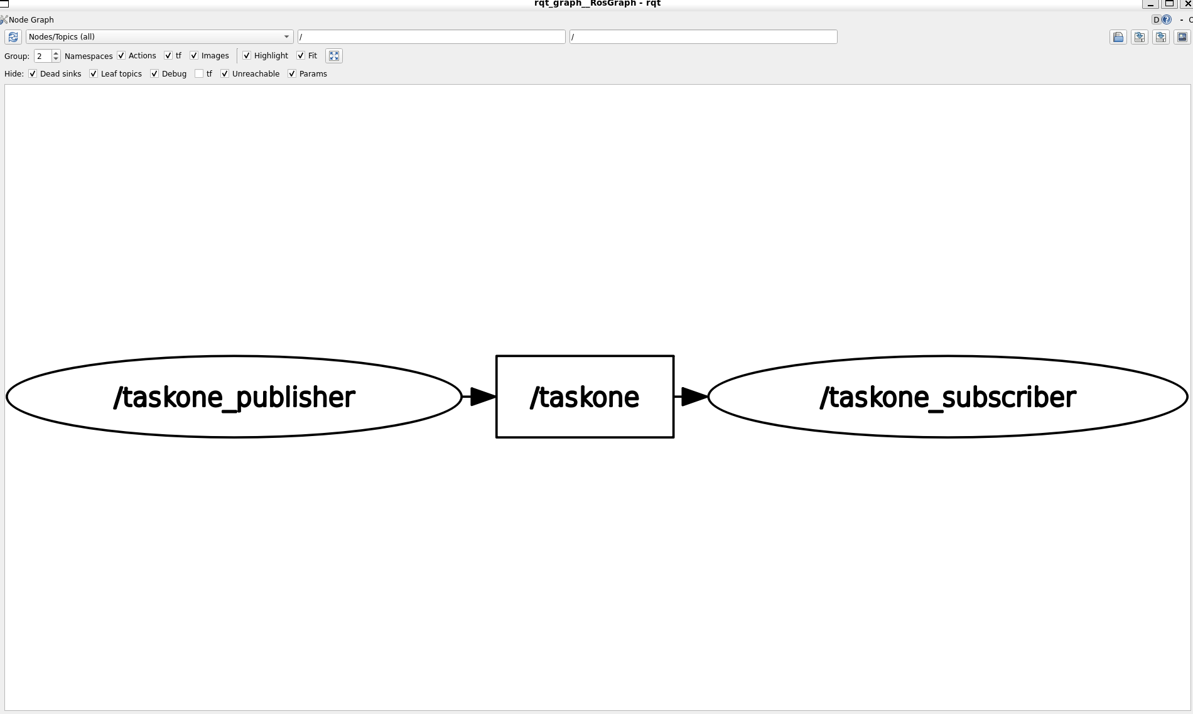

- Palindrome checker using ROS2

A.Objective
The objective of this task is to implement a palindrome checker using three ROS 2 nodes. The system accepts a string from the user, checks whether it reads the same forwards and backwards, and returns a response indicating whether it is a palindrome.

B. Node Descriptions
The solution consists of three ROS 2 nodes
- Node 1 - String Publisher- Accepts a string from the user and publishes it on the /rt2_string topic using the custom RT2String message.
- Node 2 - Palindrome Checker- Receives the string and compares it with its reverse. It publishes an integer result on palindrome_result, where 1 indicates a palindrome and 0 indicates a non-palindrome. It also receives the final response through palindrome_response.
- Node 3 -Responder- Receives the integer result and publishes Yes if the string is a palindrome or No otherwise.

C. ROS 2 Communication Graph
The nodes communicate through topics using publisher-subscriber architecture of ROS2.
The publisher sends the input string to the checker. The checker publishes the result, which is processed by the responder. The responder then sends a textual response back to the checker for display.

D. Algorithm and Working
Initialize all three ROS 2 nodes.
Node 1 accepts a string from the user and publishes it on rt2_string.
Node 2 receives the string and compares it with its reverse.
If the string equals its reverse, Node 2 publishes 1, otherwise, it publishes 0 on palindrome_result.
Node 3 receives this result and publishes Yes or No on palindrome_response.
Node 2 receives the response and displays it in the terminal.

E. Results and Observations
The system was tested by entering the following outputs.
String entered- RACECAR
Result- YES
String entered- HELLO
Result- NO
The results confirm that the three nodes communicate successfully and that the system correctly identifies palindromes.

F. Conclusion
The task demonstrates communication between multiple ROS 2 nodes using publishers, subscribers, and topics. A custom message is used to transmit the input string, while standard Int32 and String messages communicate the checking result and final response. The implementation illustrates how separate ROS 2 nodes can cooperate to perform a common task.

