CREDIT CARD PROCESSING:

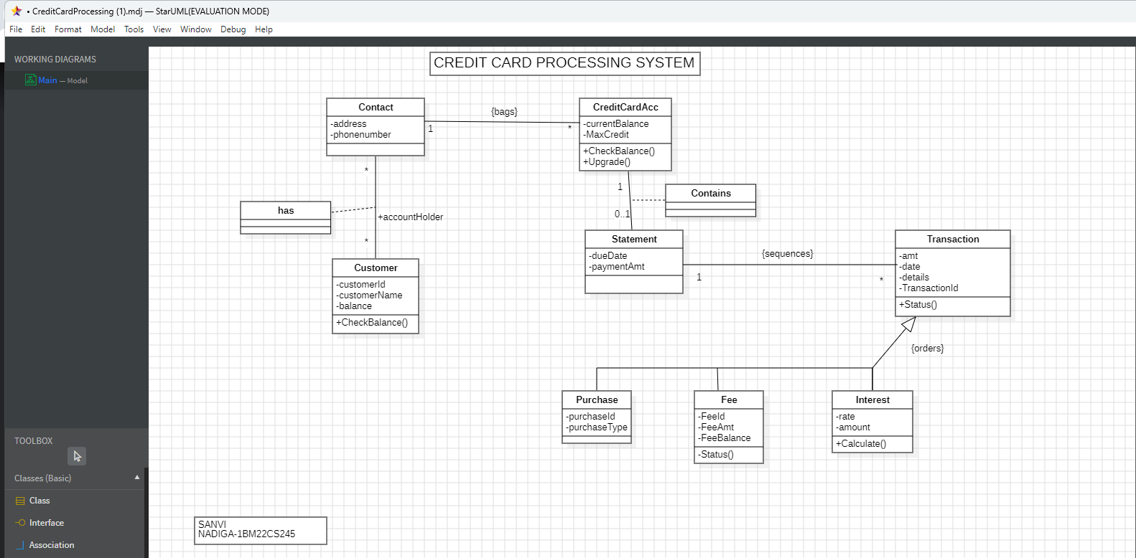

Online shopping system:

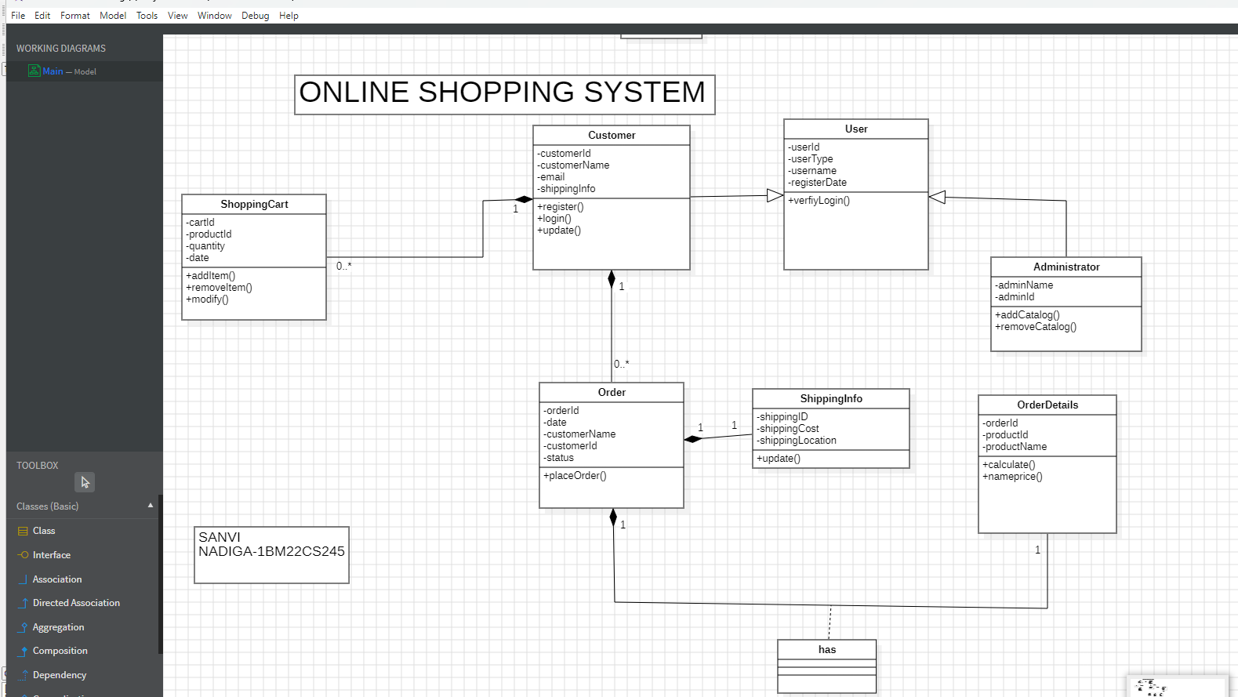

RAILWAY RESERVATION SYSTEM: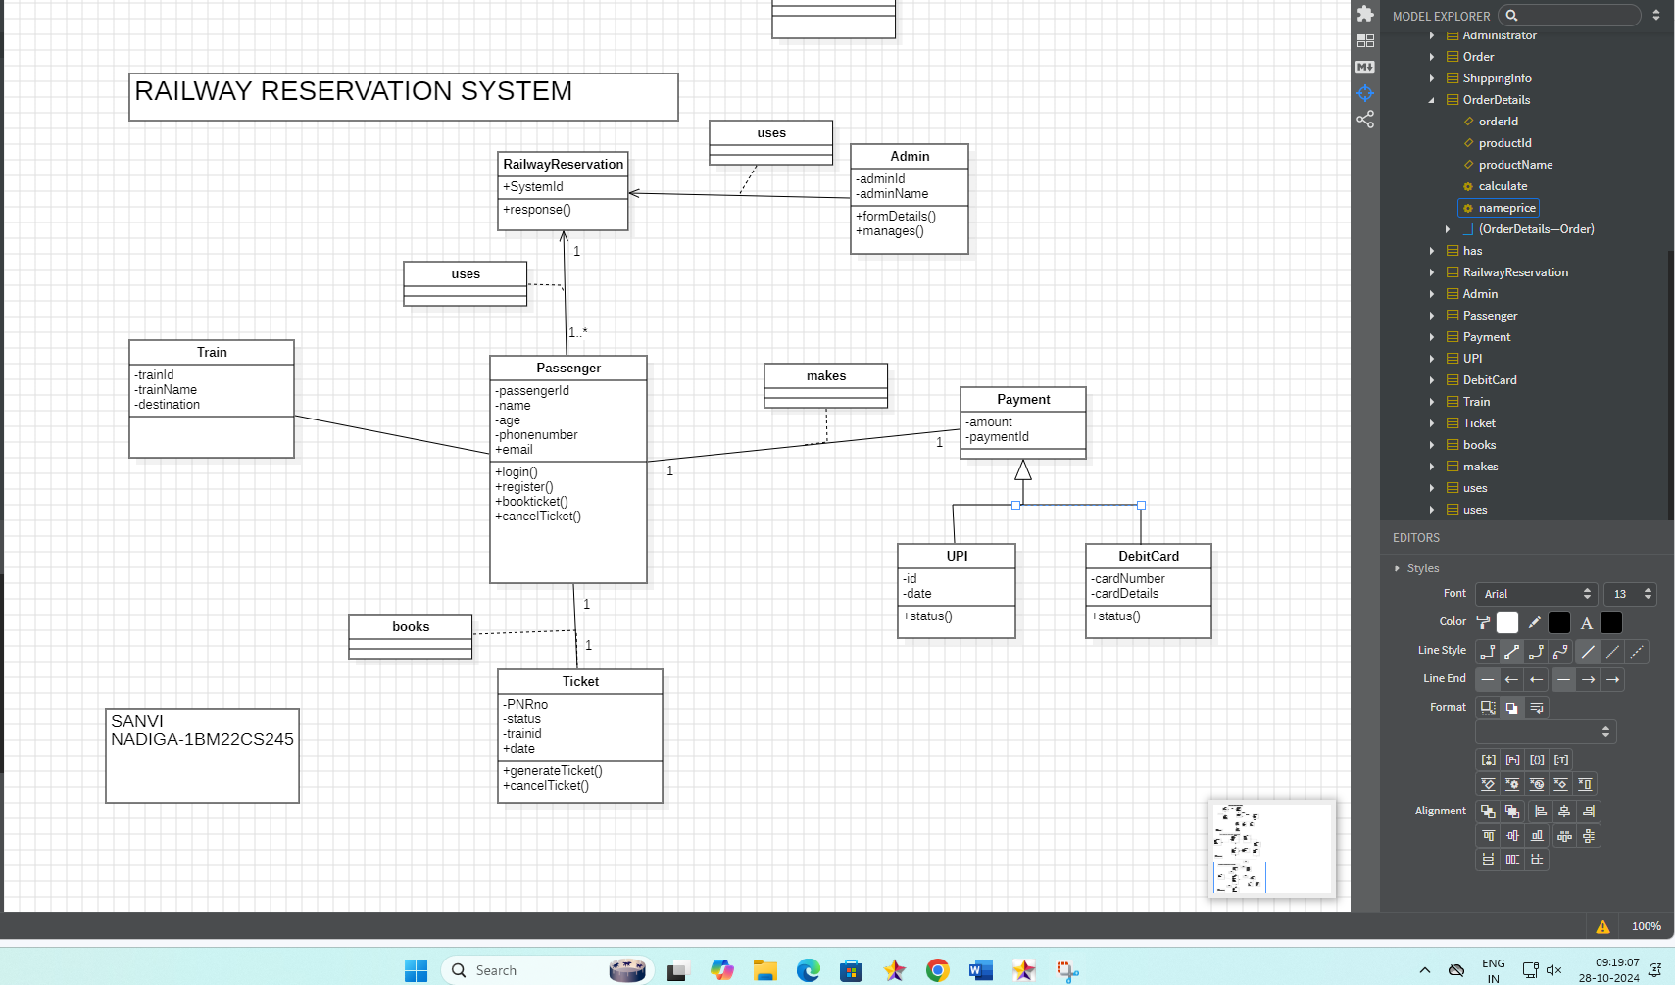

STOC MAINTENANCE SYSTEM:

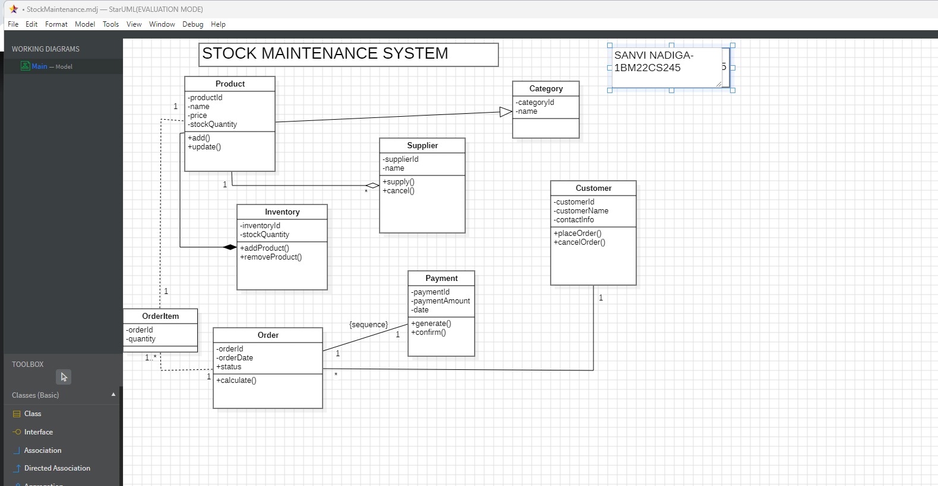

PASSPORT AUTOMATION SYSTEM:

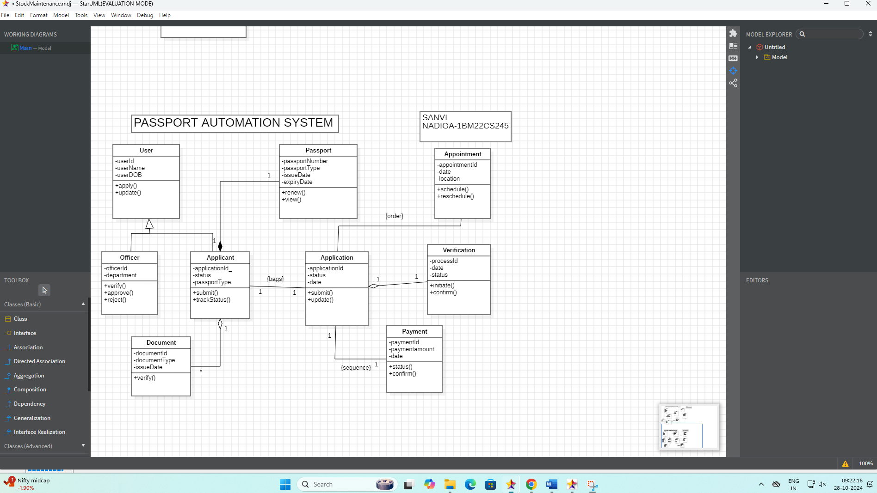  
HOTEL MANAGEMENT SYSTEM:

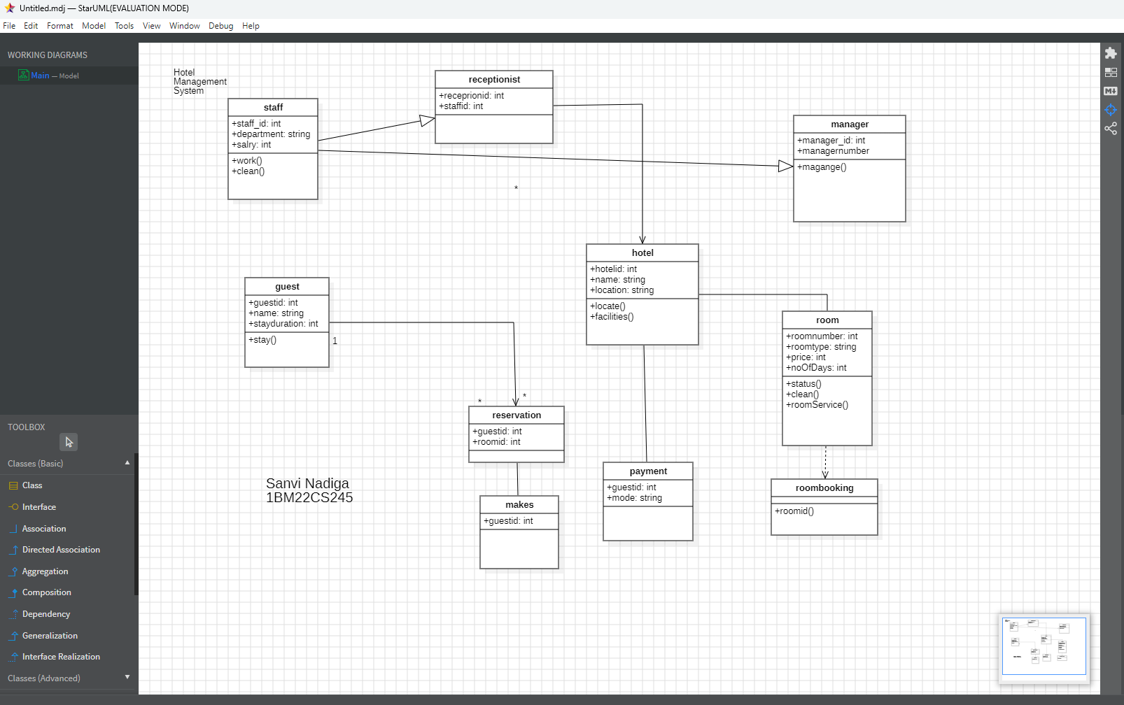

LIBRARY MANAGEMENT SYSTEM:

