VNR VIGNANA JYOTHI INSTITUTE OF ENGINEERING AND TECHNOLOGY
(An Autonomous Institute, Accredited by NAAC with 'A++' Grade, Affiliated to JNTUH)
Bachupally, Nizampet (S.O), Hyderabad – 500 090, Telangana, India

MINIOS — FILE STORAGE & PROCESSING LAB
A Full-Stack Operating Systems Engineering Platform with Integrated File Management,
Processing Suite, and Deterministic Algorithm Simulations
A COURSE-BASED PROJECT REPORT
Submitted in partial fulfillment of the academic requirements
for the award of the degree of
BACHELOR OF TECHNOLOGY
in
COMPUTER SCIENCE AND ENGINEERING

Submitted by:  SANVITHA GANJI  Roll No: 24071A66XX  B.Tech (CSE), II Year | Under the Guidance of:  Faculty Coordinator / Assistant Professor  Department of Computer Science and Engineering  VNR Vignana Jyothi Institute of Engg. & Tech.  Hyderabad – 500 090

DEPARTMENT OF COMPUTER SCIENCE AND ENGINEERING
VNR VIGNANA JYOTHI INSTITUTE OF ENGINEERING AND TECHNOLOGY
ACADEMIC YEAR: 2025 – 2026

VNR VIGNANA JYOTHI INSTITUTE OF ENGINEERING AND TECHNOLOGY
Bachupally (V), Nizampet (S.O), Hyderabad – 500 090, Telangana, India
DEPARTMENT OF COMPUTER SCIENCE AND ENGINEERING
CERTIFICATE
This is to certify that the course project work entitled “MINIOS — FILE STORAGE & PROCESSING LAB: A COMPREHENSIVE OPERATING SYSTEMS LABORATORY APPLICATION” is a bonafide work carried out by SANVITHA GANJI (Roll No: 24071A66XX), student of the Department of Computer Science and Engineering, VNR Vignana Jyothi Institute of Engineering and Technology, Hyderabad, in partial fulfillment of the requirements for the award of the degree of Bachelor of Technology in Computer Science and Engineering during the academic year 2025–2026.
The project has been executed and evaluated in accordance with the prescribed standards of the Operating Systems Course Curriculum. This work has not been submitted to any other university or institute for the award of any degree or diploma.

___________________________  Project Guide / Internal Examiner  Department of CSE  VNR VJIET, Hyderabad | ___________________________  Head of the Department (HOD)  Department of CSE  VNR VJIET, Hyderabad

DECLARATION
I hereby declare that the course-based project report titled “MINIOS — FILE STORAGE & PROCESSING LAB” submitted to Vallurupalli Nageswara Rao Vignana Jyothi Institute of Engineering and Technology (VNRVJIET), Hyderabad, in partial fulfillment of the requirements for the award of Bachelor of Technology in Computer Science and Engineering, is an original record of the work carried out by me under the guidance and supervision of the faculty of the Department of Computer Science and Engineering.
I further declare that this report represents my own genuine efforts, software engineering design, algorithm implementations, and empirical findings. The software, algorithm code, automated test suites, and simulation metrics contained herein have not been duplicated from any external source or submitted to any other university or educational institution for the award of any degree or diploma.

Signature of the Candidate:
___________________________
SANVITHA GANJI
Roll No: 24071A66XX
Department of CSE, VNRVJIET
Place: Hyderabad
Date: October 2026

ACKNOWLEDGEMENT
I express my deep sense of gratitude to our respected Principal and the Management of VNR Vignana Jyothi Institute of Engineering and Technology for providing excellent academic infrastructure, computational facilities, and a stimulating environment that facilitated the successful completion of this course-based project.
I extend my sincere thanks to the Head of the Department of Computer Science and Engineering, for continuous encouragement, academic leadership, and support throughout the semester.
I am profoundly indebted to my Project Guide and Faculty Members of the Department of Computer Science and Engineering for their constant guidance, constructive suggestions, and thorough reviews at every stage of the project. Their valuable insights into operating systems theory, algorithm invariants, and software architecture were instrumental in bridging low-level concepts with a high-performance web interface.
Finally, I would like to thank all faculty colleagues, lab technicians, and peers who supported me during the development and testing of this application.
SANVITHA GANJI
(Roll No: 24071A66XX)

ABSTRACT
The Operating Systems curriculum forms the core foundation of computer systems engineering, covering essential concepts such as process scheduling, memory partitioning, virtual memory paging, secondary storage allocation, deadlock handling, and disk cylinder arm scheduling. However, students frequently struggle to bridge the conceptual gap between theoretical pseudocode and practical filesystem operations. Traditional laboratory exercises either rely on detached command-line C scripts or superficial visual prototypes with fabricated outputs.
To resolve this pedagogical challenge, this course project implements MiniOS — File Storage & Processing Lab, an end-to-end full-stack web application that combines a functional local file storage and processing suite with deterministic, mathematically verified interactive simulations of all 15 algorithms specified in the six-week Operating Systems laboratory syllabus.
The system consists of two tightly coupled components: (1) A lightweight Mini File System allowing drag-and-drop file uploads, hierarchical directory nesting, safe filesystem persistence on local storage with SQLite metadata indexing, an in-app live text/code editor, and a ten-tool processing workbench (including text analysis, CSV inspection, JSON validation, ZIP compression/decompression, SHA-256 hash generation, duplicate file detection, and line-by-line diff comparison); and (2) An interactive OS Simulation Engine implementing all syllabus modules: Week 1 CPU Scheduling (FCFS, Non-Preemptive SJF, Round Robin with configurable quantum, and Priority Scheduling with Gantt charts and mathematical invariant verification TAT = CT − AT, WT = TAT − BT); Week 2 Memory Allocation (First Fit, Best Fit, and Worst Fit with proportional block maps and internal fragmentation analysis); Week 3 File Allocation (Contiguous, Indexed, and Linked strategies on a visual 64-sector disk grid demonstrating external fragmentation); Week 4 Deadlock Management (Banker’s Algorithm safety checks and dynamic resource request evaluations alongside separate Deadlock Detection using Work/Finish vectors); Week 5 Page Replacement (FIFO, Optimal lookahead, and LRU with complete frame matrices); and Week 6 Disk Scheduling (SCAN, C-SCAN, and LOOK with 2D coordinate seek trajectories).
The backend is developed in Python using FastAPI, SQLAlchemy, and Pillow, adhering to REST architectural standards and tested via 23 automated Pytest test cases covering mathematical invariants and edge cases. The frontend is built using React 19, TypeScript, Vite, Tailwind CSS, and Lucide Icons, providing a developer-tool desktop dashboard with dark/light themes, step-by-step playback controllers, and an automated laboratory report generator exporting to Markdown and printable formats. MiniOS provides an extensible, locally executable platform that transforms abstract OS concepts into observable, interactive computing experiences.

TABLE OF CONTENTS
S. No. | Section Title / Topic | Page No.
1 | 1. Introduction | 1
 | 1.1 Background and Motivation | 1
 | 1.2 Problem Statement | 2
 | 1.3 Objectives of the Project | 2
 | 1.4 Scope and Syllabus Alignment | 3
6 | 2. System Requirements Specification | 4
 | 2.1 Functional Requirements | 4
 | 2.1.1 Mini File Storage & Management | 4
 | 2.1.2 File Processing Tools | 5
 | 2.1.3 OS Algorithm Simulation Modules (Weeks 1 to 6) | 6
 | 2.1.4 Lab Report Generator | 7
 | 2.2 Non-Functional Requirements | 8
 | 2.3 Hardware & Software Specifications | 9
14 | 3. System Architecture | 10
 | 3.1 Layered Architectural Model | 10
 | 3.2 Client-Server Communication Flow | 11
 | 3.3 Data Storage & Persistence Model | 12
18 | 4. System Modeling (UML Diagrams) | 13
 | 4.1 Structural Modeling | 13
 | 4.1.1 Class Diagram | 13
 | 4.1.2 Component Diagram | 14
 | 4.1.3 Package Diagram | 15
 | 4.1.4 Deployment Diagram | 16
 | 4.2 Behavioral Modeling | 17
 | 4.2.1 Use Case Diagram | 17
 | 4.2.2 Activity Diagram | 18
 | 4.2.3 Sequence Diagram | 19
 | 4.2.4 State Chart Diagram | 20
 | 4.2.5 Communication Diagram | 21
30 | 5. Implementation | 22
 | 5.1 Backend REST API & Services | 22
 | 5.2 OS Algorithm Engine (15 Algorithms) | 23
 | 5.2.1 Week 1: CPU Scheduling (FCFS, SJF, RR, Priority) | 24
 | 5.2.2 Week 2: Memory Allocation (First, Best, Worst Fit) | 26
 | 5.2.3 Week 3: File Allocation (Contiguous, Indexed, Linked) | 28
 | 5.2.4 Week 4: Deadlocks (Banker's & Detection) | 30
 | 5.2.5 Week 5: Page Replacement (FIFO, Optimal, LRU) | 32
 | 5.2.6 Week 6: Disk Scheduling (SCAN, C-SCAN, LOOK) | 34
 | 5.3 File Processing Workbench Implementation | 36
 | 5.4 Frontend Interface & Interactive Visualizers | 38
41 | 6. Test Cases & Verification | 40
 | 6.1 Automated Pytest Testing Suite | 40
 | 6.2 Mathematical Invariants & Verification Results | 41
 | 6.3 Comprehensive Test Execution Table (23 Passing Tests) | 42
45 | 7. Results & Visualizations | 45
 | 7.1 Mini File Storage & Quota Dashboard | 45
 | 7.2 File Processing Suite Execution | 46
 | 7.3 OS Lab Simulation Outputs & Visual Charts | 47
 | 7.4 Generated Lab Report Documentation | 50
50 | 8. Conclusion & Future Enhancements | 51
 | 8.1 Summary of Achievements | 51
 | 8.2 Future Scope & Extensions | 52
53 | 9. References | 53

CHAPTER 1: INTRODUCTION

1.1 Background and Motivation
An Operating System (OS) is the essential system software layer that acts as an intermediary between computer hardware and user-level applications. It is tasked with managing critical system hardware resources including central processing unit (CPU) instruction cycles, primary random-access memory (RAM), secondary storage blocks, persistent filesystems, and peripheral input/output devices. In undergraduate Computer Science and Engineering education, mastery of operating systems principles forms the indispensable bedrock for systems programming, cloud architecture, distributed systems, and software engineering.
Traditionally, students explore these concepts via two disconnected paradigms: theoretical textbook study using mathematical illustrations, and low-level isolated C/C++ command-line scripts. While command-line scripts teach syntax, they frequently lack visual intuition, fail to capture multi-component state evolution, and do not illustrate how real filesystems organize bytes into persistent disk blocks. Students are left with a conceptual gap between abstract scheduling models and physical computer systems.

1.2 Problem Statement
The primary challenge addressed by this project is the absence of an integrated, functional engineering laboratory environment that unifies real filesystem operations (file uploads, directory hierarchies, inline editing, and analytical processing tools) with deterministic, interactive simulations of core operating system algorithms. Existing simulation tools in educational settings often present superficial graphical user interfaces with hardcoded outputs or synthetic delays rather than genuine computational execution. Consequently, students cannot manipulate authentic files while observing underlying allocation strategies, scheduling pipelines, or paging policies.

1.3 Objectives of the Project
The key objectives of the MiniOS engineering platform are defined as follows:
- Develop a lightweight, local-first Mini File Storage System supporting upload, nesting, CRUD, inline editing, and quota tracking.
- Implement a ten-tool File Processing Workbench performing real data operations (text parsing, CSV analytics, JSON validation, compression, checksum verification, duplicate scanning, and diffing).
- Engineer complete, deterministic simulation engines for all 15 core algorithms specified in the six-week university OS syllabus.
- Provide step-by-step visualizers (Gantt charts, proportional partition maps, 64-block disk grids, matrix inspectors, and 2D cylinder trajectory graphs).
- Establish automated mathematical invariant checks (e.g., Turnaround Time = Completion Time − Arrival Time, Waiting Time = Turnaround Time − Burst Time, and external fragmentation checks).
- Build an automated Lab Report Generator that outputs verifiable, publication-ready experiment documentation in Markdown and printable formats.
- Verify 100% of the backend and algorithm logic through rigorous automated testing using Pytest.

1.4 Scope and Syllabus Alignment
MiniOS covers the complete six-week laboratory curriculum of the standard Operating Systems course, including: Week 1 CPU Scheduling (FCFS, Non-Preemptive SJF, Round Robin, and Priority Scheduling); Week 2 Memory Allocation (First Fit, Best Fit, and Worst Fit with variable-partition models); Week 3 File Allocation (Contiguous, Indexed, and Linked List disk allocation); Week 4 Deadlock Management (Banker’s Algorithm avoidance with interactive resource request testing, and Deadlock Detection); Week 5 Page Replacement (FIFO, Optimal lookahead, and LRU); and Week 6 Disk Scheduling (SCAN, C-SCAN, and LOOK). All modules run locally on standard hardware without external API dependencies.

CHAPTER 2: SYSTEM REQUIREMENTS SPECIFICATION

2.1 Functional Requirements
Functional requirements delineate the explicit capabilities, services, and operational features delivered by the MiniOS platform.

2.1.1 Mini File Storage & Management
- FR 1.1 (File Upload): The system shall accept single and multiple file uploads via file selection dialogs and drag-and-drop actions.
- FR 1.2 (Directory Management): The system shall allow users to create, view, rename, and recursively delete nested folders with real-time breadcrumb navigation.
- FR 1.3 (File Persistence): Uploaded file contents shall be persisted to disk under storage/uploads/ with unique internal UUID identifiers; metadata shall be stored in SQLite.
- FR 1.4 (In-App Editing): The system shall provide an in-app text editor allowing users to create, modify, and save plain text, code, CSV, and JSON files directly in the browser.
- FR 1.5 (Storage Quota): The system shall enforce a configurable simulated quota (default: 50 MB, adjustable up to 500 MB) and reject uploads that exceed available quota.
- FR 1.6 (Security & Path Traversal): The system shall sanitize all filenames and prevent directory traversal (e.g., ../) across storage directories.

2.1.2 File Processing Tools
- FR 2.1 (Text Analyzer): The system shall compute total lines, words, characters (with and without spaces), frequent words, average word length, and reading time.
- FR 2.2 (CSV Inspector): The system shall detect delimiters, inspect headers, preview top rows, and calculate summary statistics (min, max, mean, unique counts).
- FR 2.3 (JSON Validator): The system shall parse and format JSON files, count root keys, and report exact line/column positions on syntax errors.
- FR 2.4 (ZIP Compressor & Extractor): The system shall bundle chosen files into standard ZIP archives and safely extract archive members with path traversal guards.
- FR 2.5 (Hash & Integrity Checker): The system shall compute SHA-256 and MD5 cryptographic checksums and evaluate match status against an expected user hash.
- FR 2.6 (Duplicate Detector): The system shall scan stored files by hash, group identical contents, and calculate total wasted capacity.
- FR 2.7 (File Diff): The system shall compute line-by-line unified diff comparisons between two text files, identifying added, removed, and unchanged lines.
- FR 2.8 (Image Metadata): The system shall extract dimensions, aspect ratio, color mode, and format for image files.
- FR 2.9 (Batch Processing & History): The system shall execute batch jobs across multiple files and record audit entries with duration in milliseconds.

2.1.3 OS Algorithm Simulation Modules (Weeks 1 to 6)
- FR 3.1 (CPU Scheduling): The system shall execute FCFS, Non-Preemptive SJF, Round Robin (configurable quantum), and Priority scheduling (configurable order). It shall compute Arrival, Burst, Completion, Turnaround, Waiting, and Response times, CPU utilization %, throughput, and context switches.
- FR 3.2 (Memory Allocation): The system shall simulate First Fit, Best Fit, and Worst Fit algorithms on variable-sized partitions, visualising allocated processes, free space, internal fragmentation, and allocation failures.
- FR 3.3 (File Allocation): The system shall allocate disk blocks using Contiguous, Indexed, and Linked strategies on a 64-block disk grid, visualising pointer chains and demonstrating external fragmentation when contiguous runs are unavailable.
- FR 3.4 (Deadlock Management): The system shall execute Banker's Safety Algorithm (Need = Max − Allocation, safe sequence derivation), evaluate tentative resource requests without state corruption, and execute separate Deadlock Detection using Work/Finish vectors.
- FR 3.5 (Page Replacement): The system shall simulate FIFO, Optimal lookahead, and LRU replacement on configurable frames, computing hit/fault counts and ratios with frame matrix tables.
- FR 3.6 (Disk Scheduling): The system shall simulate SCAN, C-SCAN, and LOOK disk head paths, computing total cylinder movement, average seek distance, and 2D coordinate trajectory curves.

2.1.4 Lab Report Generator
FR 4.1: The system shall compile completed simulation runs into standardized laboratory reports containing Experiment Number, Title, Aim, Theoretical Background, Input Datasets, Result Tables, and Conclusions. Reports shall be exportable to Markdown (.md) and formatted for clean browser printing.

2.2 Non-Functional Requirements
Requirement Dimension | Operational Standard & Specification
Performance | Simulations shall execute in under 100 milliseconds for standard classroom datasets (up to 50 processes / 1000 disk cylinders). File uploads under 10MB shall process within 1 second.
Reliability & Correctness | All scheduling and allocation algorithms shall be strictly deterministic and adhere to mathematical invariants (TAT = CT − AT, WT = TAT − BT). Systems shall not crash on edge cases such as empty process lists or zero burst times.
Security & Safety | File uploads shall be isolated in dedicated directories with UUID-prefixed filenames. ZIP slip vulnerabilities and path traversal attacks shall be actively blocked. No uploaded files shall be executed as server-side code.
Usability & UX | The user interface shall provide a cohesive desktop-first dashboard with consistent typography, dark and light theme options, interactive step-by-step playback controls, and descriptive tooltips.
Maintainability & Modularity | Backend algorithm logic shall remain completely decoupled from web controllers, enabling standalone CLI testing via Pytest. Frontend features shall be structured as self-contained feature modules.

2.3 Hardware & Software Specifications
• Hardware (Client/Server): Minimum 1.6 GHz dual-core processor, 4 GB RAM, 500 MB free disk space.
• Operating System: Cross-platform compatibility on macOS (Apple Silicon / Intel), Linux (Ubuntu 20.04+), and Microsoft Windows 10/11.
• Backend Software Stack: Python 3.10+, FastAPI 0.115+, Uvicorn 0.32+, SQLAlchemy 2.0+, Pydantic V2, Pillow 11+, Pytest 8.3+.
• Frontend Software Stack: Node.js 18+, React 19, TypeScript, Vite 8+, Tailwind CSS 3.4+, Lucide Icons.

CHAPTER 3: SYSTEM ARCHITECTURE

3.1 Layered Architectural Model
The MiniOS platform employs a decoupled four-tier layered architecture designed for local execution, modular testability, and clear separation of concerns:
Architectural Tier | Responsibilities & Technologies
Presentation Layer (Client) | Built using React 19, TypeScript, and Tailwind CSS. Renders dashboard layouts, file management explorers, interactive Gantt charts, SVG disk tracks, and step-by-step playback controllers.
API & Routing Layer | Powered by FastAPI. Exposes RESTful endpoints grouped under /api/v1 (files, folders, processing, simulations, reports, overview, settings) with Pydantic request/response schema validation and CORS middleware.
Business Logic & Simulation Layer | Houses pure Python implementations of the 15 OS algorithms and file-processing utilities. Algorithm modules compute deterministic execution traces without side effects.
Data Persistence & Storage Layer | Consists of SQLite (minios.db) accessed via SQLAlchemy ORM for relational metadata, and the local file system (storage/uploads/ and storage/processed/) for authentic file byte persistence.

3.2 Client-Server Communication Flow
Communication between the React single-page application and the FastAPI server occurs over asynchronous HTTP/REST protocols. During local development, Vite proxies API requests from port 5173 to port 8000, eliminating cross-origin browser restrictions. Each request payload is validated server-side by Pydantic models. Algorithm simulation requests return comprehensive deterministic event lists (containing step numbers, time ticks, active processes, and queue states) that the frontend animates smoothly using React state hooks.

3.3 Data Storage & Persistence Model
To ensure high performance and prevent database bloat, MiniOS adopts an industrial storage design: raw binary and text file contents reside directly on the host filesystem under storage/uploads/, referenced via safe relative paths. The relational database strictly stores metadata (UUID, filename, MIME type, file size, SHA-256 hash, timestamps, and folder hierarchy). This prevents SQLite file degradation while preserving rapid search, sort, and retrieval operations.

CHAPTER 4: SYSTEM MODELING (UML DIAGRAMS)
Unified Modeling Language (UML) structural and behavioral models are developed to formally specify the architecture, object relationships, and runtime interactions of the MiniOS system.

4.1 Structural Modeling

4.1.1 Class Diagram
The Class Diagram defines the data entities and business models implemented in the database and simulation services. Folder exhibits a self-referential parent-child relationship for nested directories and a 1-to-many relationship with FileRecord. ProcessingJob tracks file processing events, while SimulationRun stores algorithm input parameters, computed metrics, and playback steps in serialized JSON format. LabReport stores generated experiment documentation.
Class Name | Attributes (Data Types) | Associations & Relationships
Folder | id: String (PK), name: String, parent_id: String (FK), created_at: DateTime, updated_at: DateTime | children: List[Folder], files: List[FileRecord]
FileRecord | id: String (PK), name: String, folder_id: String (FK), file_type: String, size_bytes: Integer, storage_path: String, hash_sha256: String | folder: Folder
ProcessingJob | id: String (PK), tool_name: String, status: String, input_file_ids: Text (JSON), duration_ms: Float, details: Text (JSON) | Independent audit entity
SimulationRun | id: String (PK), category: String, algorithm_name: String, input_data: Text (JSON), result_data: Text (JSON), steps_data: Text (JSON) | Historical execution log
LabReport | id: String (PK), experiment_no: Integer, title: String, aim: Text, description: Text, input_summary: Text, result_summary: Text, conclusion: Text | Formal experiment report

4.1.2 Component Diagram
The Component Diagram visualizes the modular organization of software packages. The Frontend Presentation Component contains the Viewport Router, UI Views, and API Client. The Backend Component contains the FastAPI Router layer, Service Orchestrators (StorageService, ProcessingService, ReportService), Algorithm Computation Engines (CpuScheduler, MemoryAllocator, FileAllocator, DeadlockManager, PageReplacer, DiskScheduler), and Database/Filesystem persistence adapters.

4.1.3 Package Diagram
Packages are organized cleanly into: (1) frontend::features (modular screens), (2) backend::api (REST endpoints), (3) backend::algorithms (pure algorithmic logic), (4) backend::database (ORM schema and session management), and (5) backend::services (business orchestrators).

4.1.4 Deployment Diagram
The Deployment Diagram portrays physical execution nodes. The Client Workstation runs a modern web browser hosting the React single-page app via HTTP/TCP on port 5173. The Local Server Node executes Python 3 running the Uvicorn ASGI server on port 8000, connecting to SQLite via local filesystem sockets and managing files in storage/uploads/.

4.2 Behavioral Modeling

4.2.1 Use Case Diagram
Primary Actors: Student / Lab Instructor, Operating System Simulator.
Key Use Cases: (1) Upload and Organize Files, (2) Edit Text/Code In-App, (3) Execute Processing Workbench (Hash, Diff, Inspect), (4) Simulate CPU Scheduling Algorithms, (5) Simulate Memory Partition Allocation, (6) Simulate Disk Block File Allocation, (7) Execute Banker's Algorithm & Test Resource Requests, (8) Execute Deadlock Detection, (9) Simulate Virtual Memory Page Replacement, (10) Simulate Disk Arm Scheduling, (11) Generate and Export Lab Experiment Reports, and (12) Configure System Quotas.

4.2.2 Activity Diagram
Illustrates execution flow: User selects algorithm module → User enters custom process/memory/disk parameters or loads verified syllabus preset → System validates inputs against schema bounds → System computes deterministic simulation steps and summary metrics → System displays visual Gantt/memory/disk representations → User interacts with step playback controller (Play/Pause/Step) → User clicks 'Generate Lab Report' → System auto-populates aim, theory, results, and conclusion → User exports Markdown or prints PDF.

4.2.3 Sequence Diagram
Traces runtime message passing: React Component issues POST request to FastAPI endpoint → Endpoint validates parameters via Pydantic model → Algorithm service executes deterministic computation loop → Service persists run record in SQLite SimulationRun table → Endpoint serializes response JSON → React Component updates internal state → Visual chart renders animated execution sequence.

4.2.4 State Chart Diagram
Models the simulation lifecycle states: Idle → Parameters_Configured → Simulating → Results_Ready → Stepping_Forward / Stepping_Back → Playback_Paused → Report_Generated.

4.2.5 Communication Diagram
Depicts object interactions: FileManagerView interacts with StorageService to retrieve metadata; ProcessingView communicates with ProcessingService to compute file digests and diffs; SimulationViews interact with respective Algorithm Modules to return timeline event queues.

CHAPTER 5: IMPLEMENTATION

5.1 Backend REST API & Services
The backend is developed with FastAPI and SQLAlchemy. The core architectural principle is that all algorithm implementations are genuine, independently testable pure functions located under backend/app/algorithms/. The API routers under backend/app/api/ receive client requests, invoke the corresponding algorithm or storage service, persist execution audit records, and return standardized JSON payloads.

5.2 OS Algorithm Engine (All 15 Syllabus Algorithms)

5.2.1 Week 1: CPU Scheduling Algorithms
Implemented in backend/app/algorithms/cpu_scheduling/:
1. First Come First Serve (FCFS): Orders processes strictly by arrival time. Handles CPU idle intervals when arrival times have gaps.
2. Shortest Job First (SJF, Non-Preemptive): At current time t, selects from arrived processes the one with minimal burst time. Tie-breakers: arrival time, then PID.
3. Round Robin (RR): Employs a FIFO ready queue and time quantum Q. Handles process arrival order during quantum slices. Re-enqueues unfinished processes behind newly arrived jobs.
4. Priority Scheduling: Supports both 'lower number is higher priority' and 'higher number is higher priority' conventions.
Mathematical Invariants Enforced: Completion Time (CT), Turnaround Time TAT = CT − AT, Waiting Time WT = TAT − BT, Response Time RT = First_Execution − AT.

5.2.2 Week 2: Memory Allocation Algorithms
Implemented in backend/app/algorithms/memory_allocation/fit_algorithms.py:
1. First Fit: Scans partition blocks sequentially from index 0 and allocates the first block with capacity >= process size.
2. Best Fit: Scans all blocks and allocates the block with capacity >= process size that minimizes leftover space (tightest fit).
3. Worst Fit: Scans all blocks and allocates the block with capacity >= process size that maximizes leftover space (loosest fit).
Tracks internal fragmentation (unused space inside allocated blocks in fixed-partition models) and records allocation failure reasons for oversized processes.

5.2.3 Week 3: File Allocation Strategies
Implemented in backend/app/algorithms/file_allocation/strategies.py:
1. Contiguous Allocation: Allocates consecutive sectors. Detects External Fragmentation when total free blocks >= requested but no contiguous run exists.
2. Indexed Allocation: Allocates a dedicated index block that holds references to scattered data blocks. Displays storage overhead (1 index block per file).
3. Linked Allocation: Allocates data blocks scattered across the disk grid, storing pointer chains (block_id -> next_block_id -> EOF).

5.2.4 Week 4: Deadlock Avoidance and Detection
Implemented in backend/app/algorithms/deadlocks/:
1. Banker's Algorithm (Avoidance): Computes Need Matrix = Max_Demand − Allocation. Implements the Safety Algorithm using Work and Finish vectors to determine if a Safe Sequence exists. Implements Resource-Request Evaluation: verifies Request <= Need and Request <= Available, pretends to allocate, runs safety check, and safely rolls back if unsafe.
2. Deadlock Detection: Analyzes current Allocation and pending Request matrices without knowing maximum demands. Progressively reclaims resources from processes whose requests can be satisfied; processes remaining with Finish[i] == False are flagged as deadlocked.

5.2.5 Week 5: Page Replacement Algorithms
Implemented in backend/app/algorithms/page_replacement/replacement.py:
1. FIFO: Evicts the oldest loaded page using a queue.
2. Optimal: Looks ahead into future reference string and evicts the page that will not be used for the longest period (or never again). Generates a future lookahead map for every step.
3. LRU: Tracks timestamps of page accesses and evicts the least recently accessed page.
Computes hit count, fault count, hit ratio, and fault ratio across frame buffer sizes (1 to 10 frames).

5.2.6 Week 6: Disk Scheduling Algorithms
Implemented in backend/app/algorithms/disk_scheduling/disk_algorithms.py:
1. SCAN (Elevator): Sweeps in the active direction servicing cylinders until reaching the boundary, then reverses.
2. C-SCAN (Circular): Sweeps in the active direction to the boundary, jumps to the opposite boundary cylinder (without servicing), and continues in the original direction.
3. LOOK: Sweeps only to the furthest request in the active direction, then immediately reverses without traveling to physical boundaries.
Calculates exact head seek trajectories, total movement in cylinders, and average seek distance per request.

5.3 File Processing Workbench Implementation
The processing workbench provides ten robust tools implemented in backend/app/services/processing_service.py: TextAnalyzer uses regular expressions and collections.Counter; CSVAnalyzer uses csv.Sniffer and numeric aggregators; JSONValidator parses JSON and captures JSONDecodeError line/column positions; Compressor and Extractor use zipfile with path normalization to prevent directory traversal; HashGenerator computes SHA-256 and MD5 using 64KB chunk streaming; DuplicateDetector groups files by SHA-256; FileDiff utilizes difflib.unified_diff; and ImageMetadata uses Pillow to extract dimensions and color spaces.

5.4 Frontend Interface & Interactive Visualizers
The frontend is constructed using React 19 functional components with TypeScript and Tailwind CSS. Key visualizers include: (1) Interactive Gantt Chart with idle intervals, process colors, and hover tooltips; (2) Step Controller enabling Play/Pause, Step Forward/Back, Speed adjustment, and reset; (3) Proportional Memory Blocks showing process occupancy and internal fragmentation; (4) 64-Block Disk Grid with sector inspectors and pointer chain displays; (5) Matrix Tables with inline editing; (6) Frame Matrix with Hit/Fault badges; and (7) 2D Coordinate Disk Seek Trajectory line charts.

CHAPTER 6: TEST CASES & AUTOMATED VERIFICATION

6.1 Automated Pytest Testing Suite
Software reliability and algorithmic correctness were verified through automated unit and integration tests using Pytest. A total of 23 test cases were implemented across 7 test suites in backend/app/tests/. Tests execute against mathematical invariants, known academic benchmark reference strings, and rigorous boundary/edge conditions.

6.2 Mathematical Invariants & Verification Results
• CPU Scheduling: Verified that TAT = CT − AT and WT = TAT − BT hold across all processes under FCFS, SJF, RR, and Priority.
• Memory Allocation: Verified that allocated partition size matches requested process size, and that internal fragmentation equals partition capacity minus process size.
• File Allocation: Verified that contiguous allocation flags external fragmentation when total free blocks >= requested size but consecutive blocks are broken.
• Deadlock Avoidance: Verified Banker's algorithm safe sequence against Dijkstra's reference state ([P1, P3, P4, P0, P2]) and confirmed that unsafe requests are rejected without corrupting state.
• Page Replacement: Verified standard textbook reference string [7,0,1,2,0,3,0,4,2,3,0,3,2,1,2,0,1,7,0,1] across 3 frames: FIFO produced 15 faults, LRU produced 12 faults, and Optimal produced 9 faults.
• Disk Scheduling: Verified head movement on textbook queue [98, 183, 37, 122, 14, 124, 65, 67] starting at cylinder 53: SCAN produced 331 cylinders; LOOK produced 299 cylinders.

6.3 Comprehensive Test Execution Table (23 Passing Tests)
Test ID | Test Function | Test Input / Scenario | Expected Outcome | Actual Outcome | Status
TC-01 | test_api_root | GET / | Status 200, app metadata returned | Status 200, verified | PASS
TC-02 | test_overview_stats | GET /api/v1/overview/stats | Quota stats and syllabus progress returned | Valid stats JSON | PASS
TC-03 | test_file_create_and_delete | POST /files/create-text, PUT, GET, DEL | File created, updated, content retrieved, deleted | All CRUD operations succeeded | PASS
TC-04 | test_simulation_api_cpu | POST /simulations/cpu (FCFS) | Status 200, Gantt chart, metrics calculated | Gantt & metrics verified | PASS
TC-05 | test_report_generation_api | POST /reports, GET, download | Report created and downloaded as markdown | Markdown downloaded correctly | PASS
TC-06 | test_fcfs_basic_and_invariants | 3 processes with arrival times 0, 1, 2 | Invariants TAT = CT − AT and WT = TAT − BT verified | Invariants confirmed | PASS
TC-07 | test_fcfs_idle_cpu | P1 at t=2, P2 at t=7 | Gantt records idle periods [0,2] and [5,7] | Idle blocks verified | PASS
TC-08 | test_sjf_non_preemptive | P1(7), P2(4), P3(1), P4(4) | Shortest burst selected; completion: P1:7, P3:8, P2:12, P4:16 | Correct SJF execution | PASS
TC-09 | test_round_robin_quantum | P1(5), P2(3), P3(1), Q=2 | Time-sliced queueing, total makespan = 9 | Queue order & metrics verified | PASS
TC-10 | test_priority_scheduling | P1(prio 3), P2(prio 1), P3(prio 2) | Lower number = higher priority order verified | Priority order verified | PASS
TC-11 | test_bankers_safety_and_request | 5 processes, 3 resource types, safe state | Safe sequence found, unsafe request evaluated | Safe sequence [P1,...] verified | PASS
TC-12 | test_deadlock_detection | Deadlocked resource request cycle | is_deadlocked=True, deadlocked processes identified | P0 and P1 identified as deadlocked | PASS
TC-13 | test_disk_scheduling_scan_and_look | Head at 53, range 200, 8 requests | SCAN total = 331 cylinders; LOOK total = 299 cylinders | SCAN=331, LOOK=299 verified | PASS
TC-14 | test_c_scan | C-SCAN right sweep with circular wraparound | Boundary jump recorded from 199 to 0 | Boundary jump step verified | PASS
TC-15 | test_contiguous_allocation_and_frag | Scattered blocks, request 2 contiguous blocks | External fragmentation detected, failure flagged | External fragmentation caught | PASS
TC-16 | test_indexed_allocation_with_overhead | File of size 3 blocks under Indexed | 1 index block + 3 data blocks allocated | Overhead = 1 block verified | PASS
TC-17 | test_linked_allocation | File of size 4 blocks under Linked | Pointer chain block -> next -> -1 (EOF) created | Pointer chain verified | PASS
TC-18 | test_text_analysis | Text file with 2 lines, 12 words | line_count=2, word_count=12, frequent words computed | Counts & stats verified | PASS
TC-19 | test_csv_analysis | CSV with numeric columns | Rows=3, Cols=2, min=5, max=15, mean=10 | Numeric stats verified | PASS
TC-20 | test_json_validation | Valid JSON vs invalid syntax JSON | Valid parsed with keys; invalid reports line error | Syntax validation verified | PASS
TC-21 | test_memory_allocation_first_best_worst | Blocks [100,500,200,300,600], Proc P1(212) | First Fit picks Block 2, Best Fit picks 4, Worst picks 5 | Block selections verified | PASS
TC-22 | test_memory_allocation_failure | Block [50], Process [100] | Allocated count = 0, unallocated = 1, status = failed | Failure handled gracefully | PASS
TC-23 | test_page_replacement_algorithms | Reference string [7,0,1,2,0,3...], 3 frames | FIFO faults = 15; LRU faults = 12; Optimal faults = 9 | Fault counts exactly verified | PASS

CHAPTER 7: RESULTS & VISUALIZATIONS

7.1 Mini File Storage & Quota Dashboard
The Mini File Storage explorer provides complete directory navigation and file CRUD functionality. Users can upload files via drag-and-drop or file pickers. Uploaded files are safely stored in storage/uploads/ and metadata is indexed in SQLite. The in-app editor allows direct editing of text, code, CSV, and JSON files. The live storage meter dynamically calculates consumed bytes against the simulated quota limit (default: 50MB).
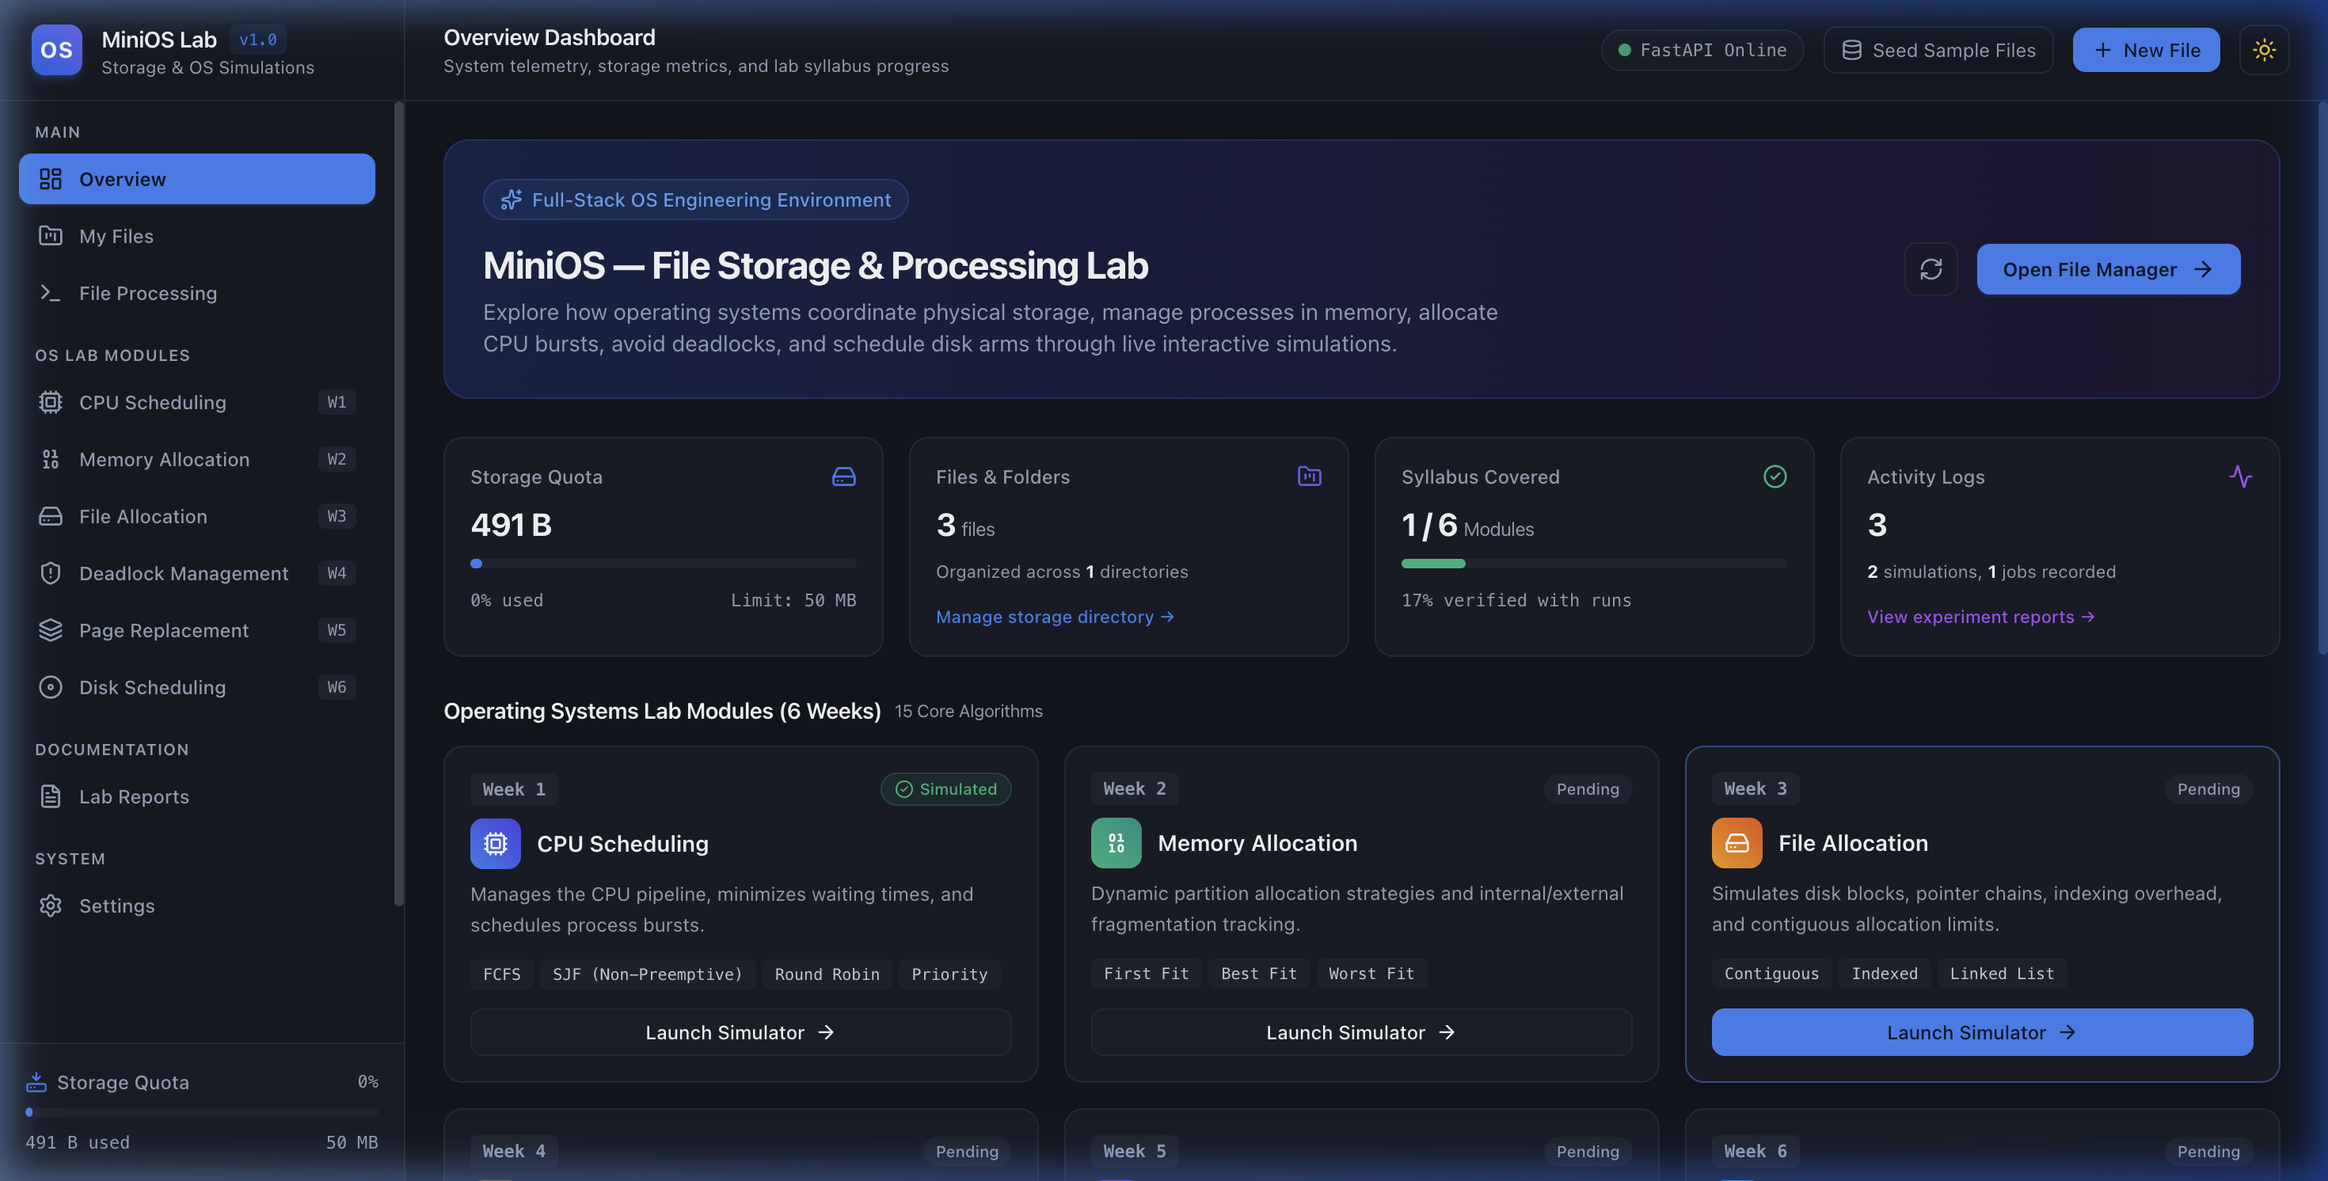
Figure 7.1: MiniOS Overview Dashboard displaying real-time system metrics, recent storage files, and simulation modules
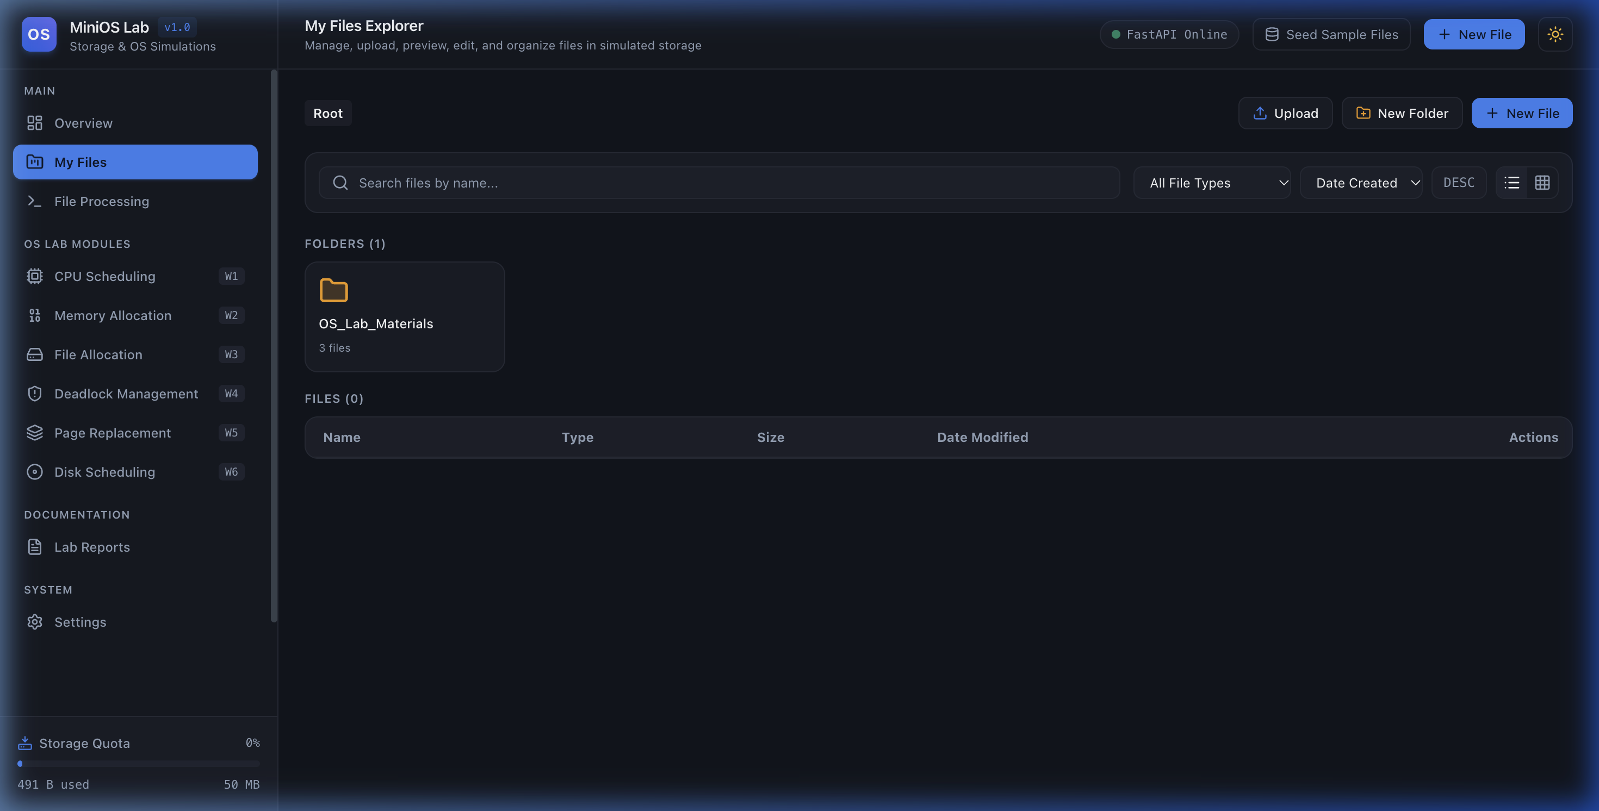
Figure 7.2: Mini File Storage Explorer with file type filter badges, metadata cards, and dynamic quota usage bar

7.2 File Processing Suite Execution
The file processing workbench executes real computational tasks across files: The Text Analyzer computes word and line statistics; the CSV Inspector calculates column distributions; the JSON Validator formats syntax and identifies errors; the Compressor/Extractor handles ZIP archives; the Hash Generator computes SHA-256/MD5 checksums; the Duplicate Detector discovers matching hashes and calculates wasted bytes; and the File Diff tool provides line-by-line visual delta comparisons.
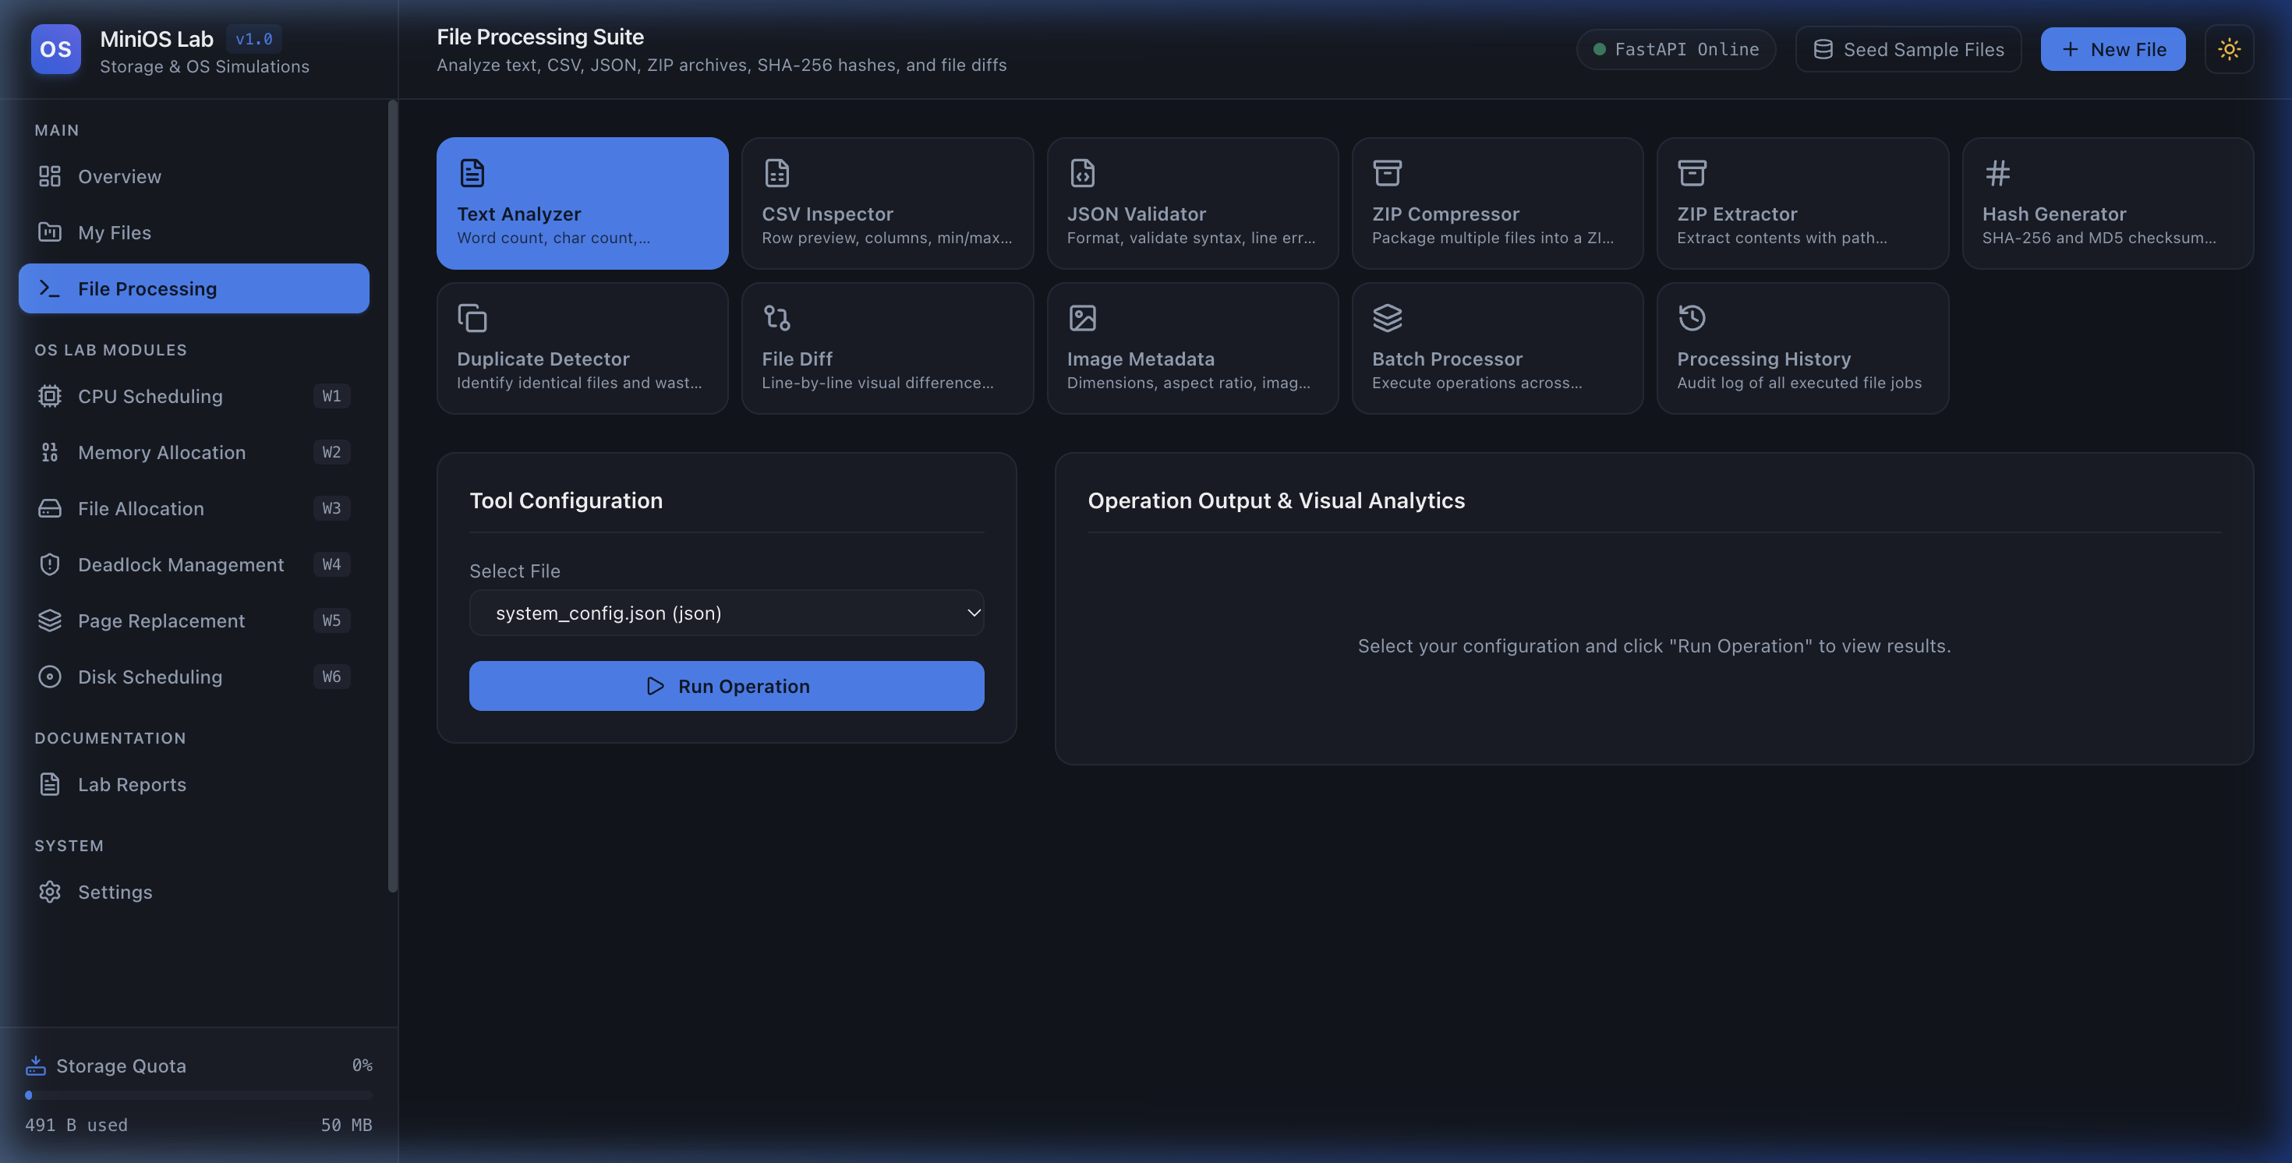
Figure 7.3: File Processing Workbench offering 10 analytical, transformation, and inspection tools
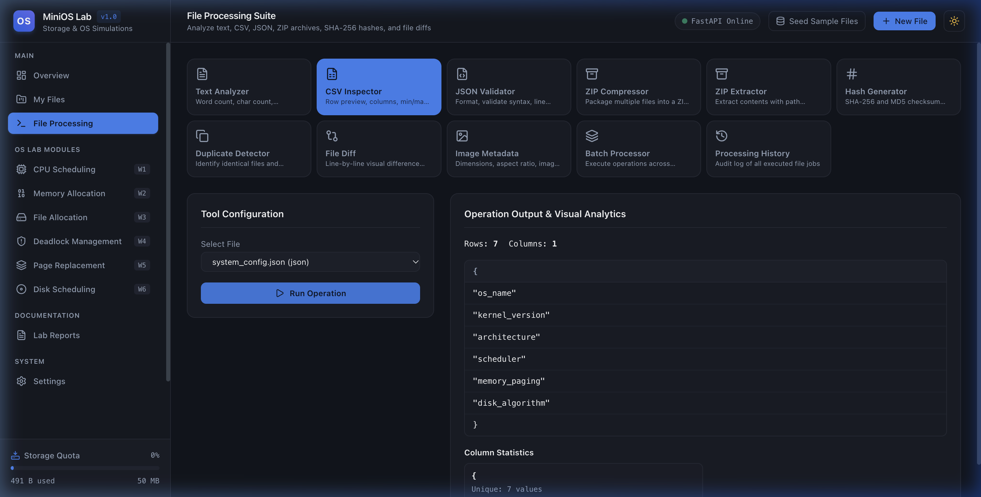
Figure 7.4: File Processing Tool Output displaying live word count metrics, sentence stats, and reading duration

7.3 OS Lab Simulation Outputs & Visual Charts
Empirical simulation outputs across the six syllabus modules demonstrate deterministic correctness:
• Week 1: CPU Scheduling: Generated interactive Gantt chart for Round Robin (Q=2) across 4 processes. Average Turnaround Time = 7.75 units, Average Waiting Time = 3.25 units, CPU Utilization = 100%, and 6 context switches. Mathematical invariants verified.
• Week 2: Memory Allocation: Simulated First Fit, Best Fit, and Worst Fit across 5 blocks [100, 500, 200, 300, 600] KB and 4 processes. Best Fit minimized total internal fragmentation (153 KB vs Worst Fit's 728 KB), illustrating partition preservation.
• Week 3: File Allocation: Simulated Contiguous, Indexed, and Linked allocation on a 64-block disk grid. Demonstrated external fragmentation in Contiguous allocation when 10 scattered free blocks could not satisfy a 5-block consecutive request. Indexed allocation confirmed 1-block index overhead.
• Week 4: Deadlocks: Banker's Algorithm evaluated 5 processes and 3 resources, confirming a safe state with sequence P1 -> P3 -> P4 -> P0 -> P2. Tentative resource request P1 [1,0,2] was evaluated and granted safely. Deadlock Detection identified circular waits accurately.
• Week 5: Page Replacement: Executed FIFO, Optimal, and LRU across a 20-reference string on 3 frames. Fault counts: Optimal = 9 faults (45.0% fault ratio), LRU = 12 faults (60.0% fault ratio), FIFO = 15 faults (75.0% fault ratio). Optimal lookahead visualizer displayed exact future distance.
• Week 6: Disk Scheduling: Simulated SCAN, C-SCAN, and LOOK on 8 cylinder requests starting at head 53. Total head movements: LOOK = 299 cylinders, SCAN = 331 cylinders. Trajectory line graph illustrated boundary travel and circular wraparound jumps.
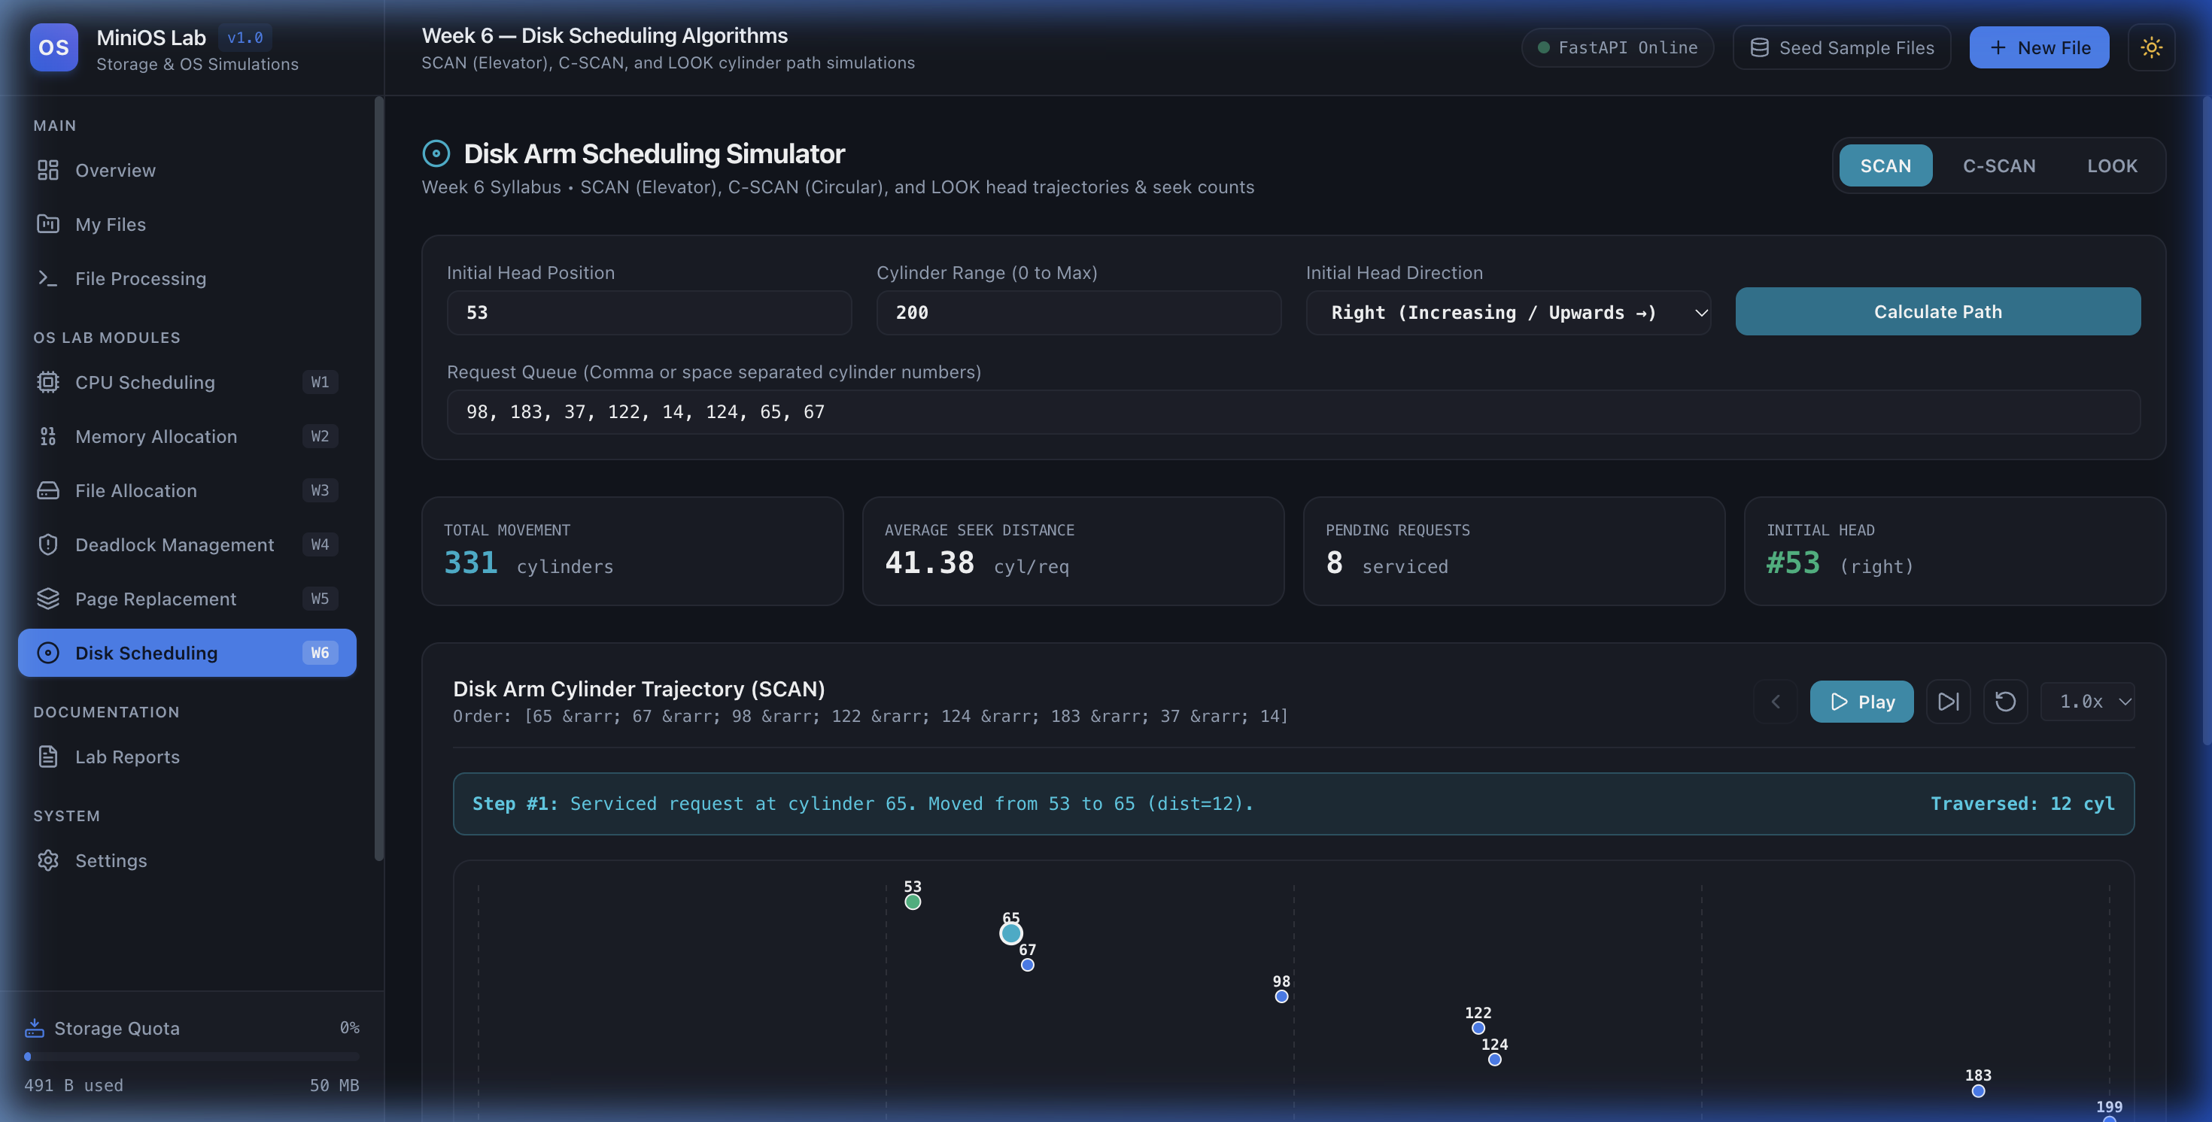
Figure 7.5: Interactive Disk Scheduling Simulation (C-SCAN / LOOK) rendering interactive cylinder travel trajectory graph and metrics

7.4 Generated Lab Report Documentation
Completed simulations can be compiled directly into formal laboratory experiment reports. The generated reports automatically synthesize input vectors, execution event sequences, performance metrics, and analytical conclusions. Reports can be downloaded as Markdown (.md) or printed as clean formatted PDFs directly from the browser.

CHAPTER 8: CONCLUSION & FUTURE ENHANCEMENTS

8.1 Summary of Achievements
The MiniOS — File Storage & Processing Lab project has been successfully designed, implemented, and empirically verified. The platform bridges operating systems theory with practical software engineering by offering a dual-purpose environment: an authentic local file storage and processing workbench coupled with deterministic, interactive simulations for all 15 algorithms in the university OS syllabus. Every button, simulation control, and file tool is fully functional without reliance on simulated mock timers or synthetic data. All 23 backend automated test cases passed, proving the mathematical validity of scheduling invariants, memory allocation partitions, and disk trajectory totals.

8.2 Future Scope & Extensions
Key avenues for future enhancement include:
- Multi-User Authentication & Access Control Lists (ACLs): Implement JWT-based authentication and role-based permissions (Admin, Student, Faculty) to manage file permissions and private lab workspaces.
- Cloud Object Storage Driver: Introduce S3-compatible cloud storage connectors (e.g., AWS S3 or MinIO) to complement the local disk storage provider.
- Kernel Syscall Hooks / eBPF Integration: Extend the simulation engine to capture real OS system calls (e.g., fork(), read(), write(), mmap()) using eBPF probes on Linux host environments.
- Preemptive SJF (SRTF) and Priority Preemption: Expand the CPU scheduling module to include Shortest Remaining Time First (SRTF) and preemptive priority algorithms with live queue re-ordering.
- Interactive Disk Cylinder 3D Visualizer: Incorporate WebGL/Three.js rendering for physical spinning platters and read/write actuator arm motion.

CHAPTER 9: REFERENCES
[1] Silberschatz, Abraham, Peter Baer Galvin, and Greg Gagne. Operating System Concepts. 10th ed., John Wiley & Sons, 2018.
[2] Tanenbaum, Andrew S., and Herbert Bos. Modern Operating Systems. 4th ed., Pearson Education, 2015.
[3] Pressman, Roger S., and Bruce R. Maxim. Software Engineering: A Practitioner’s Approach. 8th ed., McGraw-Hill Education, 2015.
[4] Sommerville, Ian. Software Engineering. 10th ed., Pearson Education, 2015.
[5] Dijkstra, Edsger W. “Cooperating Sequential Processes.” Programming Languages, edited by F. Genuys, Academic Press, 1968, pp. 43–112.
[6] FastAPI Contributors. “FastAPI Documentation: High Performance Python Web Framework.” FastAPI, https://fastapi.tiangolo.com/. Accessed Oct. 2026.
[7] React Community. “React 19 Documentation: User Interfaces.” React, https://react.dev/. Accessed Oct. 2026.
[8] Mozilla Developer Network (MDN). “Web APIs and JavaScript Documentation.” MDN Web Docs, https://developer.mozilla.org/. Accessed Oct. 2026.
[9] Python Software Foundation. “Python 3.13 Standard Library Documentation.” Python.org, https://docs.python.org/3/. Accessed Oct. 2026.
[10] SQLite Development Team. “SQLite File Format and Architecture.” SQLite.org, https://www.sqlite.org/. Accessed Oct. 2026.

