**Part A:**

1. Software Development Process Choice: Agile

Iterative and Incremental: Agile allows the development to proceed in small, manageable increments, ideal for a project like this where requirements might evolve over time.

Collaboration and Communication: Agile emphasizes collaboration with the client (Apache airlines) to ensure the final product meets their needs effectively.

Adaptability: Agile is adaptable to changes, which is crucial in a dynamic project environment like the development of a seat-booking system for new aircraft.

2.

See Functional Requirements Specification

4. Develop a seat-booking application in Python

5.

git init

git add seat-booking-system.py

git commit -m "Initial commit of seat booking system"

git branch -M main

git remote add origin <https://github.com/sanwei123/FC723-Final-Project.git>

git push -u origin main

Github link: https://github.com/sanwei123/FC723-Final-Project

**Part B**

1.

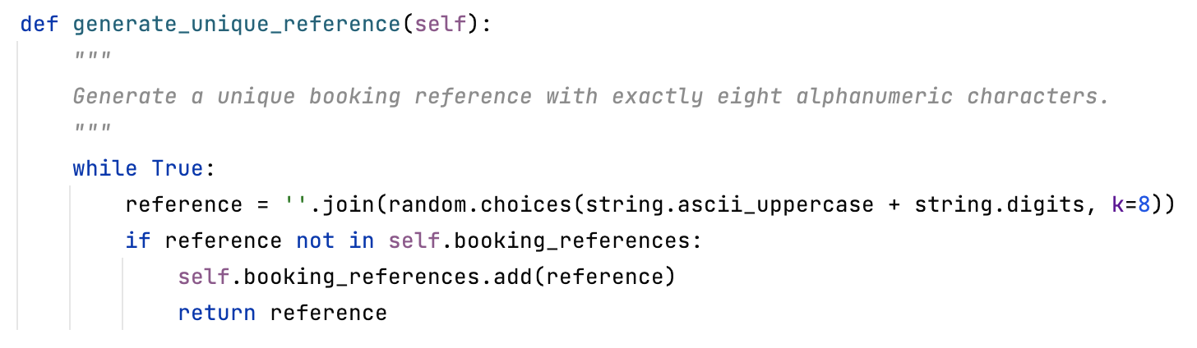

2.



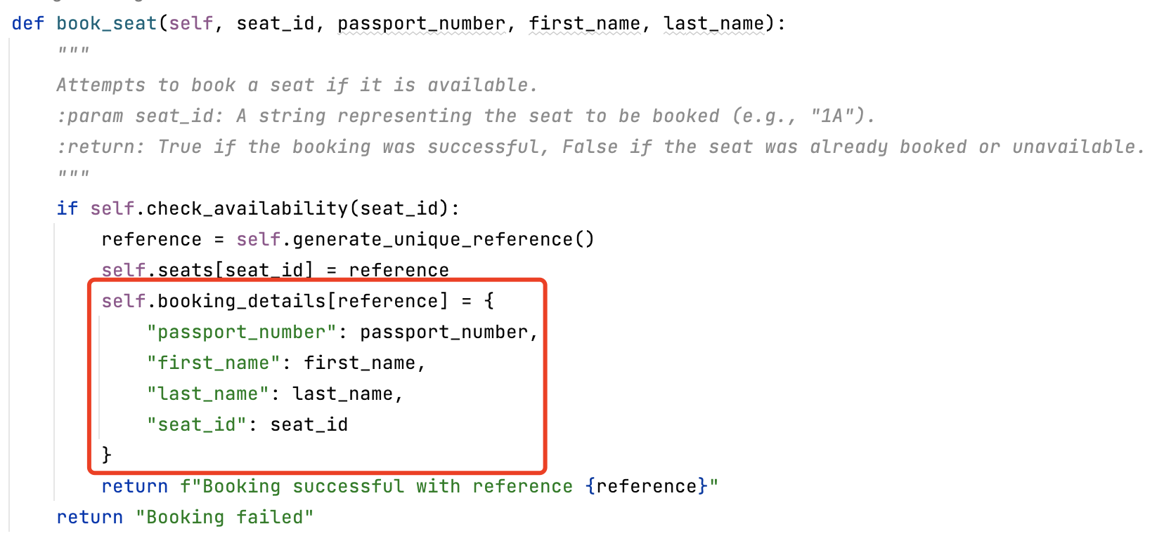

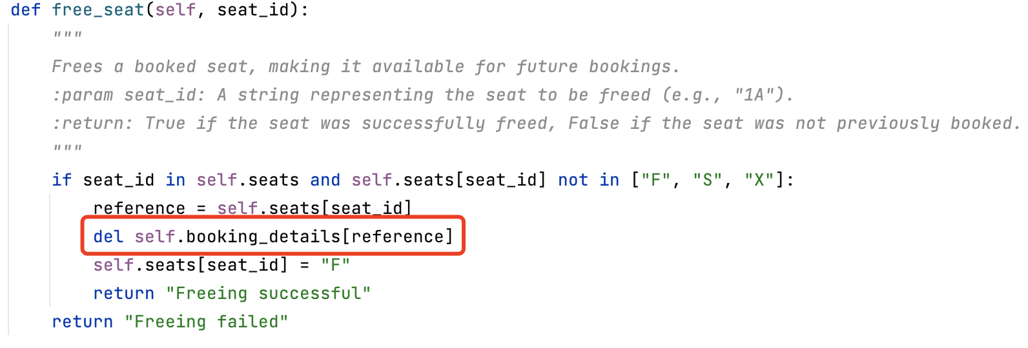

3.

git diff HEAD^ HEAD

