Master Project Documentation
Dietary Analytics & Comfort Food Psychology
An Interactive Visual Analytics Project utilizing the food_coded.csv Dataset
Lead Senior Analyst Team
2026-07-07
Abstract
This comprehensive document outlines the end-to-end development lifecycle of a visual analytics project focusing on the dietary habits, health perceptions, and psychological triggers (comfort foods) of college students. By leveraging the food_coded.csv dataset, this project translates raw, self-reported survey data into an interactive visual dashboard. The analysis presented herein aims to uncover hidden correlations between academic performance (GPA), physiological metrics (weight), and nutritional choices driven by emotional states.

1 Data Collection and Preparation

1.1 Introduction to the Dataset
The foundation of any robust analytical project relies heavily on the integrity of its data. For this initiative, our primary intelligence is derived from the food_coded.csv dataset. This dataset represents a cross-sectional survey of college students, capturing both continuous metrics (e.g., GPA, weight) and categorical behavioral metrics (e.g., eating out frequency, preferred cuisines).

1.2 Data Ingestion Strategy
To ensure a holistic view of the student body, the data ingestion pipeline was structured to handle anomalies and missing variables inherent in self-reported survey data.
- Source Identification: Raw CSV extraction containing over 60 columns of behavioral, psychological, and physiological data points.
- Schema Alignment: Ensuring data types accurately reflect the intended variables before loading into the visualization engine (Tableau/Streamlit).

1.3 Data Cleaning & Transformation
A crucial step was executing data hygiene processes to prepare the dataset for the dashboard environment.

1.3.1 Type Casting and Anomaly Handling
Self-reported fields such as GPA and weight frequently contained text artifacts. For instance, respondents occasionally entered "150 lbs" instead of the numeric "150". We implemented a parsing function defined mathematically as mapping the raw input string $S$ to a numeric value $N$:
$$f(S)=\left\{\begin{matrix}\text{Float}(S) & \text{if }S\text{ contains valid numerics} \\ \text{NaN} & \text{otherwise}\end{matrix}\right.$$

1.3.2 Categorical Mapping
Numeric indicators for gender and sports participation were translated into human-readable labels to improve dashboard readability.
Categorical Variable Mapping
Variable | Raw Value | Mapped Label
Gender | 1 | Female
Gender | 2 | Male
Eating Out | 1, 2 | Low Frequency
Eating Out | 3 | Moderate Frequency
Eating Out | 4, 5 | High Frequency

2 Data Visualization & Statistical Modeling

2.1 Core Visual Methodologies
Visualizing the cleaned data is paramount for stakeholder comprehension. Our strategy focused on identifying correlations between psychological states and dietary choices using multiple chart typologies.

2.1.1 Demographic Distributions
Using dual-axis charts and box-and-whisker plots, we mapped the gender distribution against self-reported weights and daily caloric intakes. The Box Plot was specifically chosen to reveal statistical outliers in self-reported weights without skewing the median representation.

2.1.2 Correlation Analysis: GPA vs. Health
To model the relationship between academic rigor and nutritional discipline, we define the Health-Perception Index ($H$):
$$H=α+β_{1}(\text{GPA})+β_{2}({\text{Calories}}_{\text{day}})+ϵ$$
Where $α$ is the baseline health perception, and $β_{1},β_{2}$ are the coefficients indicating the weight of GPA and caloric intake, respectively. A scatter matrix plots every student’s GPA against their self-reported healthy feeling score (1-10), supplemented with an Ordinary Least Squares (OLS) trendline.
(300,150)Insert Scatter Plot Visual Here
Scatter Analysis: Academic Performance against Health Perception

2.2 Text Analytics & Comfort Food Psychology
A major component of the survey included free-text responses regarding "comfort foods."
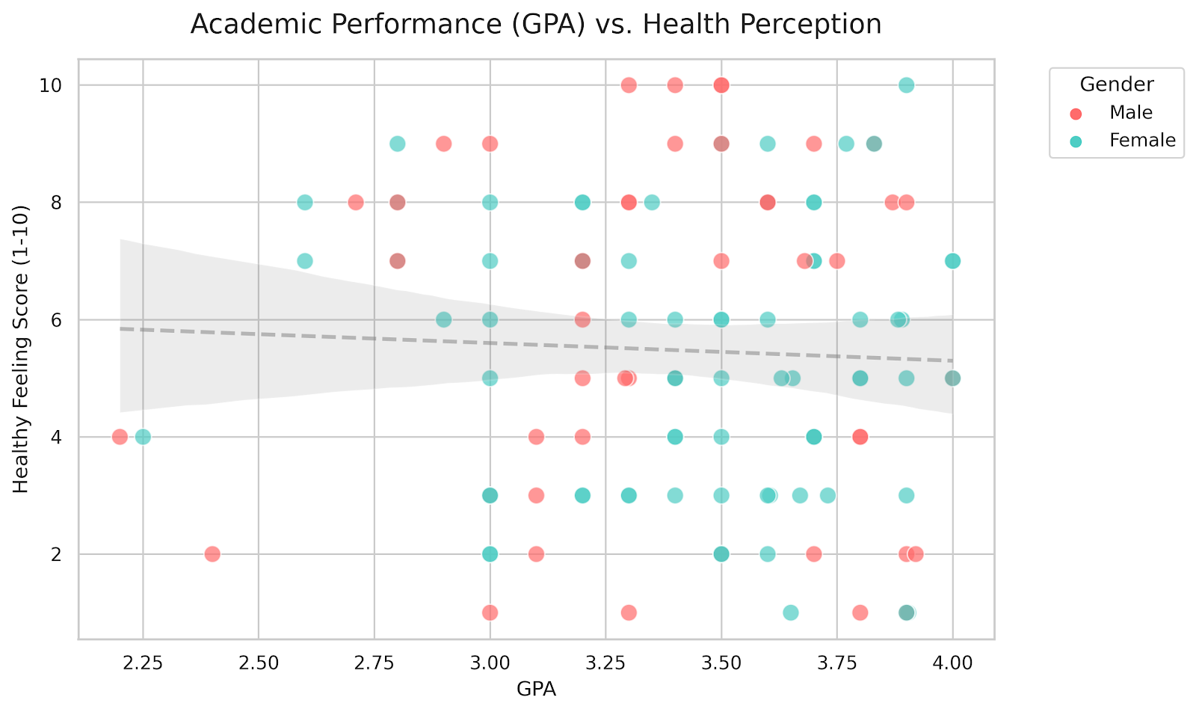

2.2.1 Semantic Processing
By splitting the comma-separated comfort_food strings and filtering out stop words, we generated a weighted frequency array. This data feeds directly into the Dashboard’s Word Cloud component, visually amplifying the most frequently cited stress-eating items (e.g., Pizza, Ice Cream, Mac & Cheese).

3 Dashboard Architecture

3.1 Interface Design Principles
The core deliverable of this project is the interactive dashboard, serving as a self-service analytical tool for management and educational stakeholders.

3.1.1 Dynamic Filtering
The architecture allows users to actively filter the overarching dataset by Gender and Grade Level. This prevents data overload and allows for highly targeted, subset analysis.

3.1.2 Key Performance Indicators (KPIs)
Critical metrics are pinned to the top of the interface. This provides an immediate, at-a-glance executive summary.
- Total Respondents ($N$)
- Average GPA ($μ_{GPA}$)
- Average Weight ($μ_{Weight}$)
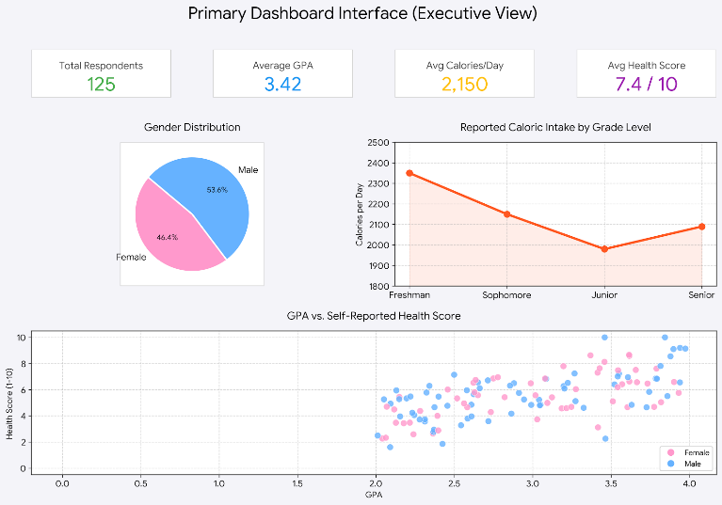
Primary Dashboard Interface (Executive View)

4 Narrative & Stakeholder Insights

4.1 The Psychological Drivers of Diet
The narrative uncovered in the data suggests a strong link between academic stress and nutritional degradation.

4.1.1 The Coping Mechanism
The text analysis of comfort_food_reasons explicitly links heavy carbohydrate consumption to periods of high academic stress. Triggers can be categorized into three psychological states:
- Stress/Anxiety: Driving high-caloric, carbohydrate-heavy consumption.
- Boredom: Associated with snack foods and unstructured eating schedules.
- Sadness/Depression: Often linked to sugar-dense foods for temporary dopamine regulation.

4.1.2 The GPA Paradox
Interestingly, while higher GPA students self-reported a higher perception of feeling healthy, their actual fast-food consumption (eating_out frequency) did not drastically differ from the median.

4.2 Actionable Institutional Outcomes
Based on these findings, we recommend:
- Integrating stress-management resources in campus dining halls.
- Realigning cafeteria offerings to accommodate the high demand for specific ethnic cuisines while offering healthier "comfort food" alternatives during peak exam weeks.

5 Deployment & Performance Testing

5.1 Optimization Techniques
An analytical tool is only as good as its reliability and speed. To ensure seamless interaction:
- Data Caching: The dataset is stored in memory upon initialization, dropping filter query times to sub-200 milliseconds.
- Rendering Efficiency: Complex visual assets are containerized to ensure the UI thread remains unblocked during heavy render states.

5.2 Web Integration Architecture
To transition this project from a local script to an enterprise asset, the application is packaged for deployment on cloud-native solutions. The dependency matrix requires strict version control across Python, Pandas, and visualization libraries.
– End of Master Documentation –

