So what is my project ?
It’s CLOUDVAULT,
What does this do ?
Here you can upload images or videos , it is basically a gallery on AWS storage.
What are the Tech Stacks used ?
I have used React, Typescript, MUI this is from Frontend side, I have used Cloud(AWS) services like S3 BUCKET, CLOUDFRONT DISTRIBUTIONS, OAC, API GATEWAY, LAMBDA, COGNITO IDENTITY POOL and my project is also live on my DOMAIN name so for that ACM(AWS Service), GO DADDY DNS.
Above are the stacks and AWS services used in this project .
Now I will explain the project step wise, not the Frontend part, I will explain the AWS part:
1st step:
I created two s3 buckets , one for files and another for media. These are private buckets, so not anyone can access this bucket, for accessing it, one should need permission.
Now let’s say a user types this “https://www.sanjana-cloud.in” wants to visit this url, this request will reach CLOUDFRONT.
2nd step:
CloudFront acts as a CDN(CONTENT DELIVERY NETWORK). It is a fast, secure, globally distributed content delivery network(CDN), a service built by AWS to deliver data, images, video, applications, and APIs with low latency. It just deliver the website. Now the react website is running inside the user’s browser. It is now running Javascript.
I created two cloudfront distributions , one for storing media which the user will upload and another for storing build files(The react website). Both distributions are for separate use cases.
So when a user hits the url , first the request comes to cloudfront, cloudfront checks whether the requested item is there in the cache or not ,if the requested item was there then cache hit(cloudfront directly transfer the data to the user) or cache miss(cloudfront didn’t find it in the cache, so it has to travel to origin(s3 bucket), to bring the requested item of user).
One important thing :
Our S3 BUCKET is private, so how CDN(CONTENT DELIVERY NETWORK) will directly access S3 BUCKET?
Here comes OAC(ORIGIN ACCESS CONTROL), You are telling s3 that don’t allow everyone to access the bucket, allow this cloudfront distribution to access it.

3rd step: The user clicks: Upload button
What actually triggers the upload?
The React application triggers it.
Not CloudFront.
Not S3.
Not Lambda.
This happened:
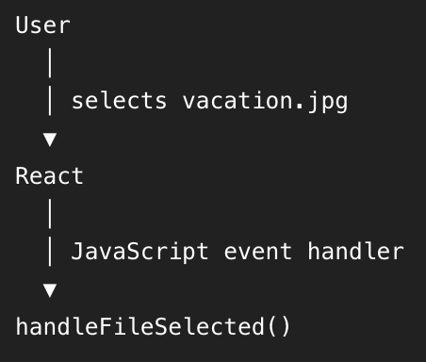
After that frontend validates the below details:
=>Is it an image/video?
=>Is it ≤ 50 MB?
=> YES
Then frontend calls: getPresignedUrl(...)
React calls the API GATEWAY, frontend sends :POST request on /upload-url
4th step: What does API Gateway do?
=>It has a route( /upload-url), it receives this /upload-url and it knows which backend function can handle this request. API Gateway takes this to Lambda.
5th step: Now Lambda runs
It’s LAMBDA, It is a serverless, event driven compute service. It isn’t always running, when we trigger it, it gets to know by event, then it does the job.
We have created a lambda named cloudvault-generate-upload-url, it contains code, when lambda triggers it runs the code and in cloudvault project it is generating a signed url to upload the media.
The code begins from this line export const handler = async (event) => {
Here at the start of the code which is written inside lambda , here the event contains the info about the HTTP request.
Lambda receives this info fileName, fileType, userId, action, s3Key.
6th step: Here lambda is creating an S3 operation that allows this specific object to be uploaded. For creating operation below are the steps:
- For an upload, Lambda creates the S3 key
We are creating S3 key by userId, filename, current date.
=> This is the object key inside S3. Think of it like the path/name of the file.

- Lambda creates an S3 PutObject command
The PutObject command is created with this 3- Bucket: BUCKET_NAME, Key: newS3Key, ContentType: fileType

7th step: Now Lambda generates the presigned url
=>The url is valid for 300 seconds, which means 5 mins.
=>So Lambda creates a temporary URL that allows the browser to perform that S3 operation.
=> Lambda returns upload url/presigned URL and s3key
uploadUrl = the presigned URL generated by Lambda for uploading the object to S3.

8th step: Lambda returns the upload url/presigned URL and s3key to API Gateway
=>Lambda returns the upload url/presigned URL and s3key to API Gateway and then API Gateway gives this info to react and then react upload that media directly inside the s3 media bucket.
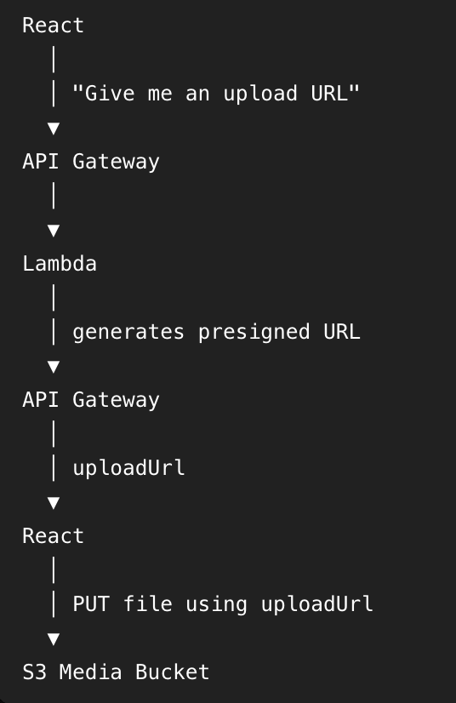
8th step: Now let's look at VIEWING a file
=>Here the same API endpoint can also handle a GET/view URL request.
=>Frontend sends action i.e. get and s3key then
=> Lambda executes the GetObjectCommand with this 2: Bucket: BUCKET_NAME, Key: s3Key
=>Lambda creates a temporary S3 GET URL and it is valid for 1 hour i.e. 3600 seconds.
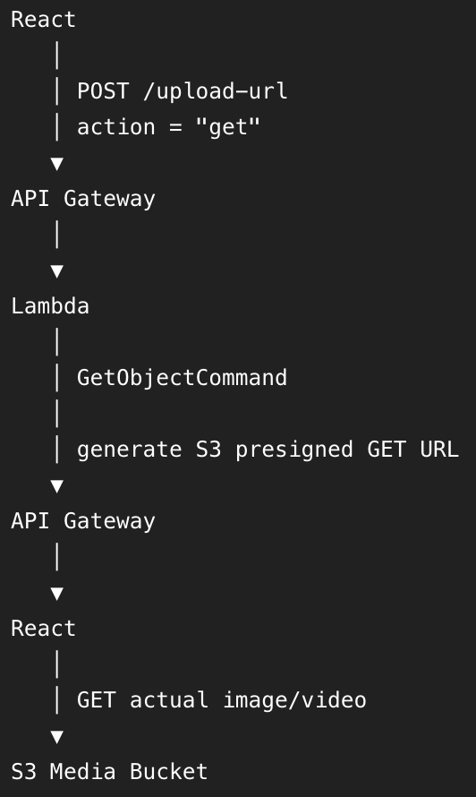

The 5 things I should remember
1. CloudFront
"I use CloudFront to distribute my frontend globally from my S3 app bucket."
2. API Gateway
"My React application calls a POST /upload-url API exposed through API Gateway."
3. Lambda
"API Gateway invokes my Lambda function, which generates temporary S3 presigned URLs."
4. Presigned URL
"The browser uses the temporary URL to upload or retrieve an object directly from S3 without exposing AWS credentials."
5. IAM Role
"The Lambda function uses an IAM execution role to obtain the permissions it needs to interact with S3."

HOW I CONNECT IT WITH DOMAIN GODADDY DNS

1st step: S3 Buckets
I created two S3 buckets:
- One for the React application/build files
- One for the uploaded images and videos
Both buckets are private, so users cannot directly access the files from S3 without permission.

2nd step: CloudFront + Domain
I created two CloudFront distributions:
- One for serving my React application
- One for media delivery
CloudFront acts as a CDN(content delivery network), which delivers my application and content efficiently to users.
My project is also connected to my custom domain: https://www.sanjana-cloud.in
The domain is managed through GoDaddy DNS.
So, when the user enters: https://www.sanjana-cloud.in
the GoDaddy DNS directs the request to my CloudFront distribution.
For HTTPS, I used AWS ACM (Certificate Manager). ACM provides the SSL/TLS(Secure Sockets Layer and TLS stands for Transport Layer Security) certificate, so my website can be accessed securely using HTTPS.
So the simple flow is:
User
↓
https://www.sanjana-cloud.in
↓
GoDaddy DNS
↓
CloudFront
↓
Private S3 App Bucket
↓
React Application

CloudFront checks whether the requested file is already in its cache.
Cache Hit → CloudFront directly serves the file.
Cache Miss → CloudFront requests the file from the S3 origin.
And because the S3 bucket is private, OAC (Origin Access Control) allows my CloudFront distribution to access the S3 bucket securely.
S3
↓
CloudFront
↓
GoDaddy DNS + ACM
↓
https://www.sanjana-cloud.in
↓
React App
↓
Upload
↓
API Gateway
↓
Lambda
↓
Presigned URL
↓
S3 Media Bucket

