Project report on predictive analytics
Employee Attrition Prediction: Model Performance and Insights


Submitted by
Sanya Goyal 23FE10CSE00684
Mahi Suchandra 23FE10CSE00570

Project Statement
This project focuses on developing and evaluating machine learning models that accurately predict employee attrition, enabling proactive human resource management and retention strategies. The primary goal is to compare the performance of a Logistic Regression model and Random Forest Classifier in predicting outcomes from input data.

Abstract
This project aims to predict employee attrition using a dataset of 1,470 employees and 35 features. The workflow encompassed comprehensive data cleaning, exploratory data analysis (EDA), feature engineering, and predictive modelling. Two classification models were implemented: Logistic Regression and Random Forest. The Logistic Regression model achieved a higher test accuracy of 87.07% and a superior AUC score of 0.8083, indicating a better overall ability to distinguish between employees who leave and those who stay. However, both models demonstrated a significant challenge in correctly identifying employees who attrite (the minority class), as evidenced by low recall scores for class 1 (40% for Logistic Regression and 9% for Random Forest). The results suggest that while the models are effective at identifying employees who will not leave, they require further refinement to become practically useful for predicting actual attrition risk.

Introduction
Employee attrition, the gradual and voluntary reduction of staff through retirement, resignation, or other reasons, is a critical challenge for organizations. High attrition rates lead to increased recruitment costs, loss of institutional knowledge, and decreased team morale. Proactively identifying employees at risk of leaving allows organizations to implement targeted retention strategies, thereby saving resources and maintaining a stable workforce.

This project leverages machine learning to address this challenge. By analysing historical employee data, we build predictive models to classify employees as likely to attrite or not. The project follows a standard data science lifecycle: data preparation, exploratory analysis, feature engineering, model building, and evaluation. The performance of two models, Logistic Regression and Random Forest, is compared to determine the most effective approach for this binary classification problem.

Workflow
- Data Loading and Initial Inspection
- Loaded “HR-Employee-Attrition” dataset (1,470 rows, 35 variables)
- Key variables:
  - Demographics: age, gender, marital status, education field
  - Job-related: department, job role, job level, job involvement, business travel, overtime
  - Compensation: monthly income, daily/hourly/monthly rate, percent salary hike, stock option level
  - Experience/tenure: total working years, years at company, years in current role, years since last promotion, years with current manager, number of companies worked
  - Satisfaction/work-life: environment satisfaction, job satisfaction, relationship satisfaction, work-life balance, training times last year
  - Other: distance from home
- Dropped constant/non-informative columns: EmployeeCount, Over18, StandardHours, EmployeeNumber
- Target variable: Attrition (encoded as 1 “Yes”, 0 “No”)
  - Imbalanced: ~16% “Yes” (left company), ~84% “No” (stayed)
- Data Cleaning
- Irrelevant Variable Removal:
Columns with no predictive value (EmployeeCount, Over18, StandardHours, EmployeeNumber) were dropped as they contained no useful variance.
- Missing Values Check:
The .isnull().sum() method confirmed there were no missing values, allowing for straightforward analysis.
- Outlier Detection & Treatment:
  - For the Logistic Regression model, which is sensitive to outliers, numerical features were capped and floored using the Interquartile Range (IQR). Values below
  - Q1−1.5×IQR
  - Q1−1.5×IQR were set to the lower bound; those above
  - Q3+1.5×IQR
  - Q3+1.5×IQR to the upper bound.
  - For the Random Forest model, which is robust to outliers, the original dataset (without outlier treatment) was retained for training.
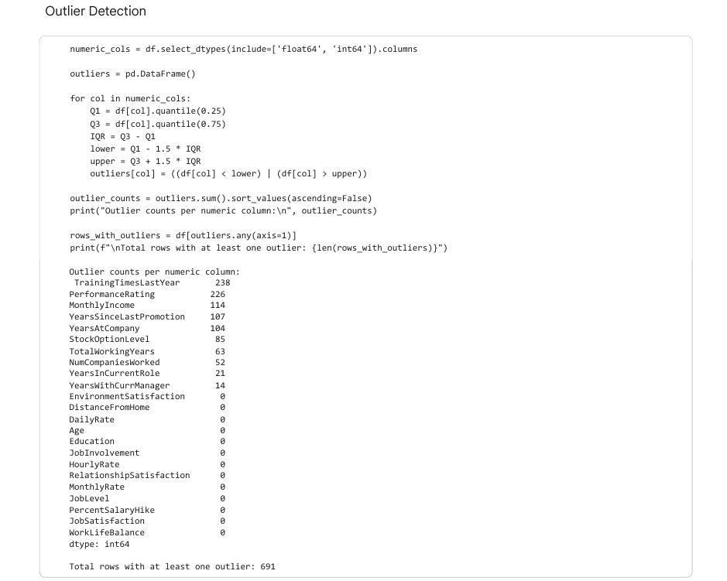
- Duplicate Check:
No duplicate rows were found in the dataset, ensuring unique employee records for analysis.
- Exploratory Data Analysis (EDA)
Categorical Analysis:
- Count plots revealed that the Research & Development department had the highest number of employees and attrition cases, while Sales had a higher proportion of attrition relative to its size.
Numerical Analysis:
- Employees who left had significantly lower MonthlyIncome.
- They tended to have fewer YearsAtCompany and more YearsSinceLastPromotion.
Outlier Analysis:
- Outliers were identified in numeric features such as TrainingTimesLastYear, MonthlyIncome, YearsSinceLastPromotion, and YearsAtCompany using the IQR method.
- Outlier treatment was critical for Logistic Regression, where extreme values were capped to reduce impact.
- Random Forest model was trained on the full dataset without modifying outliers, as this model is robust to extreme values.
Correlation Analysis:
- A correlation heatmap of numeric features was generated to identify potential multicollinearity.
- This analysis helped guide feature selection and avoid redundant variables in the modeling process
4. Feature Engineering:
To enhance model performance, two new features were created:
- CompanyExperienceRatio: YearsAtCompany / TotalWorkingYears. This indicates how much of an employee's career has been spent at the current company.
- PromotionGap: YearsSinceLastPromotion / YearsAtCompany. This indicates how long an employee has been in their current role relative to their tenure.
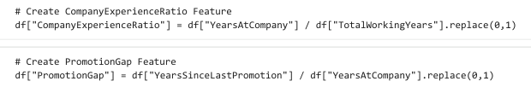
- Data Preprocessing for Modeling:
- Outlier Handling: Outliers were handled as follows:
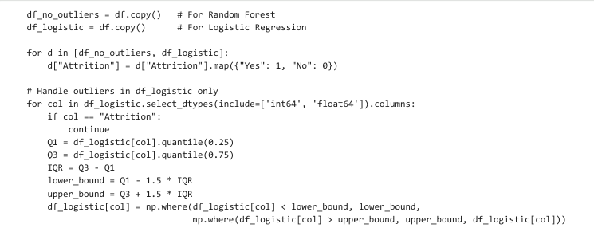
- Target Variable Encoding: The Attrition column was mapped from {'Yes', 'No'} to {1, 0} as done in the above code.
- Train-Test Split: The data was split into 80% training and 20% testing sets, with stratification on the target variable to preserve the class distribution in both sets.
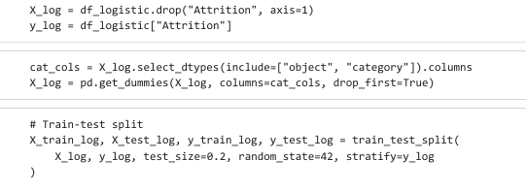
- Categorical Encoding: All categorical variables were converted into numerical format using one-hot encoding (pd.get_dummies) as done above.
- Feature Scaling: The features were standardized using StandardScaler to ensure all variables were on a similar scale, which is crucial for Logistic Regression.
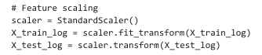
- Model Building and Training
Two models were trained to predict employee attrition:
- Logistic Regression: A linear model that estimates the probability of attrition based on input features using the logistic (sigmoid) function:
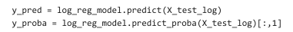
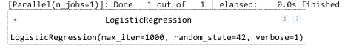
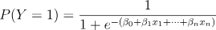 where X1,…,,Xn​ are the features and β0,…,βn​ are the coefficients learned during training. The model was trained with a maximum of 1000 iterations. Features were standardized and outliers capped to improve stability and performance on the imbalanced dataset. Logistic Regression works well for linearly separable data and provides interpretable coefficients indicating each feature’s impact on attrition.

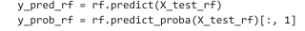
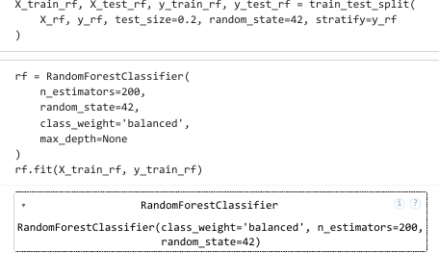
- Random Forest Classifier: An ensemble model consisting of 200 decision trees. Each tree splits on features to minimize impurity (using Gini or entropy), and the final prediction is the majority vote of all trees. The parameter class_weight='balanced' was used to handle the skewed target distribution. Random Forest captures complex, non-linear relationships between features and the target, is robust to overfitting due to averaging over many trees, and provides feature importance scores to identify key factors driving attrition.

- Model Evaluation
The trained models were evaluated on the test set using multiple metrics to assess both overall and class-specific performance:
- Accuracy: Measures the overall proportion of correct predictions.
- Classification Report: Includes Precision (correct positive predictions), Recall (ability to detect actual positives), and F1-Score (harmonic mean of precision and recall) for each class.
- Confusion Matrix: Visualizes true vs. predicted class counts, highlighting misclassifications.
- ROC Curve & AUC Score: Shows the trade-off between true positive rate and false positive rate; AUC summarizes the model’s discriminative ability.
- RMSE: Evaluates how far predicted probabilities deviate from actual binary outcomes, providing a sense of prediction error.

Results and Discussion
Dataset
The dataset consisted of 1,470 employees with 31 features after cleaning. The target variable, Attrition, was highly imbalanced, with 1,233 employees who did not leave and only 237 who did, leading to an attrition rate of approximately 16%. This class imbalance becomes a central issue in this analysis.
EDA of Data
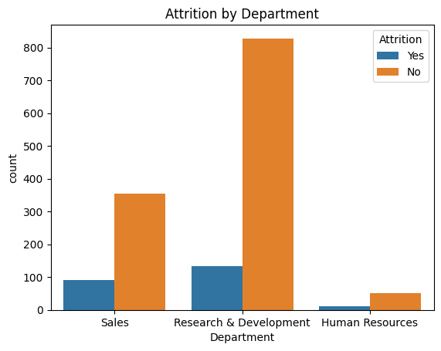
1.Attrition by Department: Most employees belong to the Research & Development department, but attrition (Yes) is relatively higher in Sales.
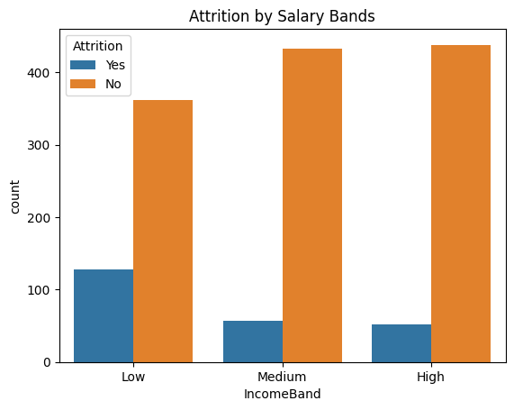
2.. Attrition by Salary Bands: Employees in the Low income band show the highest attrition compared to Medium and High income bands.
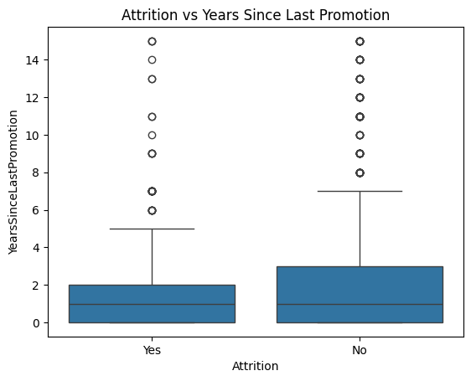
3. Attrition vs Years Since Last Promotion: Employees who left the company generally had fewer years since their last promotion, indicating promotion delays may drive attrition.
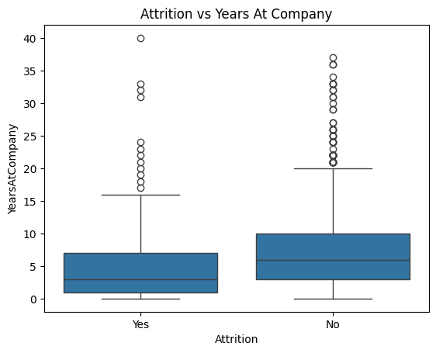
4. Attrition vs Years At Company: Employees with shorter tenures tend to leave more often, suggesting early-stage attrition is higher.

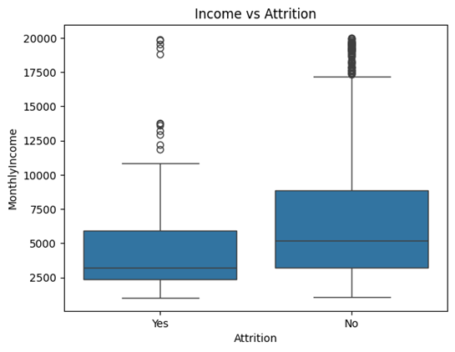
5. Income vs Attrition: Employees who left the company generally have lower monthly incomes compared to those who stayed.

6. Outlier Boxplot: Numeric features like MonthlyIncome and MonthlyRate show high
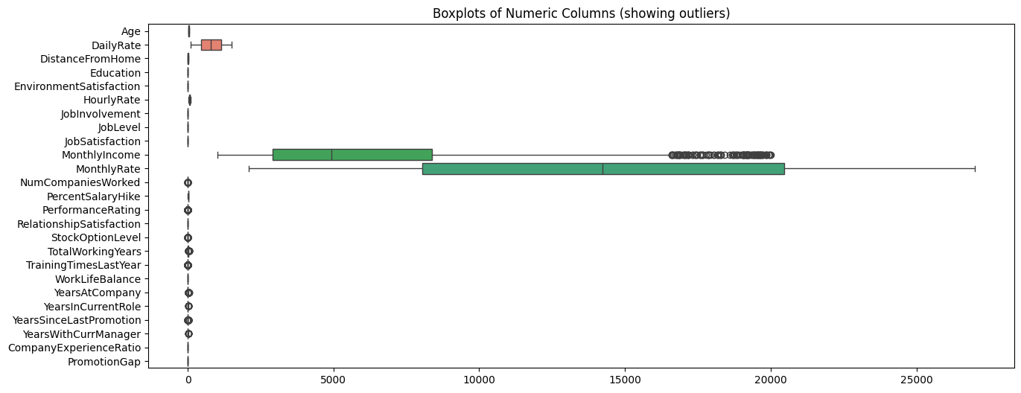
variation and many outliers.

7. Correlation Heatmap: MonthlyIncome–JobLevel and YearsAtCompany–YearsWithCurrManager are strongly positively correlated.
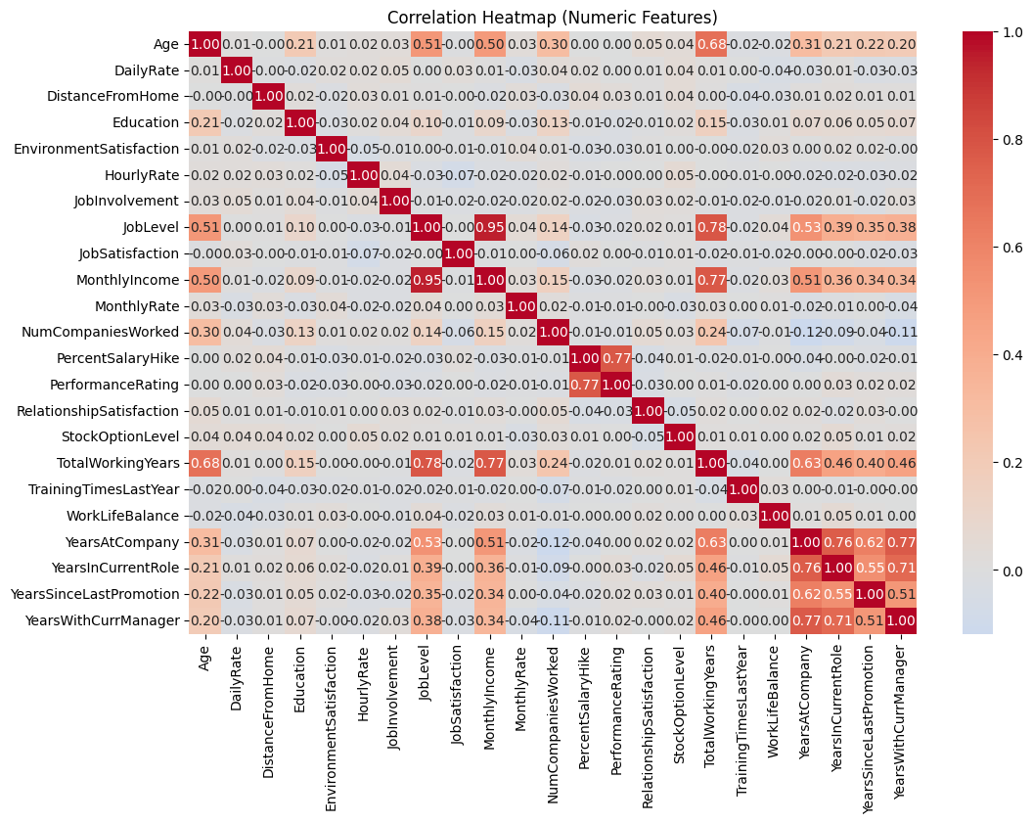
Model Performance Analysis
The Logistic Regression model outperformed the Random Forest model in this specific test. It achieved a higher test accuracy (87.07% vs. 84.01%) and a significantly better AUC score (0.8083 vs. 0.7665), indicating a stronger overall ability to rank employees by their risk of attrition.
Evaluation Criteria Used
Metric | Definition / Formula
Accuracy | $$\text{Accuracy}=\frac{TP+TN}{TP+TN+FP+FN}$$
Precision | $$\text{Precision}=\frac{TP}{TP+FP}$$
Recall (Sensitivity) | $$\text{Recall}=\frac{TP}{TP+FN}$$
F1-Score | $$F1=2⋅\frac{\text{Precision}⋅\text{Recall}}{\text{Precision}\text{ + Recall}}$$

Overall Model Comparison:
- Logistic Regression outperformed Random Forest across key metrics
Metric | Logistic Regression | Random Forest
Test Accuracy | 87.07% | 84.01%
AUC Score | 0.8083 | 0.7665
Recall for Class 1 | 40% | 9%
Precision for Class 1 | 66% | 50%
F1-Score for Class 1 | 50% | 15%
- Comparative Performance Summary:

- The Precision-Recall Curve evaluates a classification model’s ability to identify positive cases (like employees who left).
- Precision measures how many predicted positives are actually correct.
- Recall measures how many actual positives were correctly identified.
Here it shows that the Logistic Regression model (AUC = 0.572) performs better than the Random Forest model (AUC = 0.400) in identifying positive (attrition) cases.
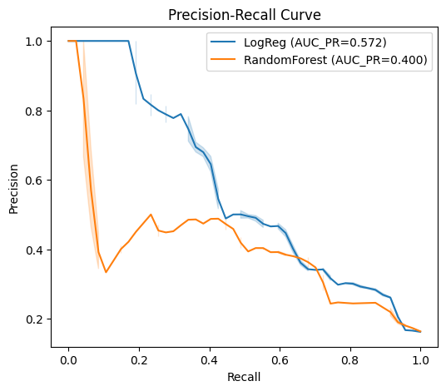

- A Confusion Matrix shows how well a model’s predictions match the actual labels by summarizing correct and incorrect classifications across all classes.
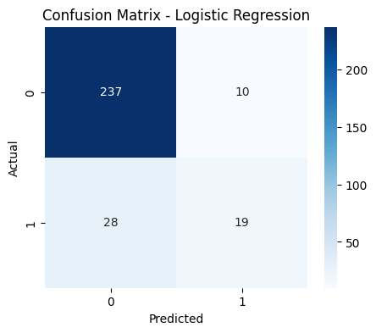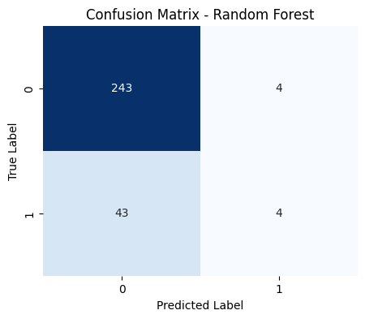

- The ROC (Receiver Operating Characteristic) Curve shows how well a classification model distinguishes between classes by plotting the True Positive Rate (Recall) against the False Positive Rate at different thresholds. A higher curve (closer to the top-left) indicates better performance.
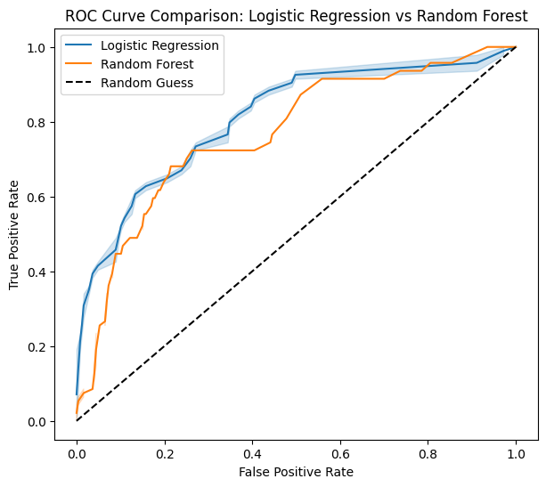
Here the Logistic Regression model consistently performs better than the Random Forest model, as its curve lies above the Random Forest curve, showing higher true positive rates for fewer false alarms.

Critical Insights and Observations:
Class Imbalance Impact:
- Both models show significantly better performance for majority class (No Attrition). It leads to a misleadingly high accuracy; misleading because this is driven almost entirely by their ability to correctly predict the majority class.
- Random Forest algorithms demonstrate higher sensitivity to class imbalance, as their ensemble structure naturally favors the majority class during the tree-building process. So it struggles more severely with minority class.
- The primary issue is not the model algorithms themselves, but the severe class imbalance in the dataset. The models are biased towards predicting the majority class.
Model Behaviour Analysis:
- Logistic Regression shows more balanced performance:
- Captures some minority class signals through outlier treatment and linear modelling.
- Showed more balanced performance across both classes.
- Random Forest underfits the minority class:
- Adopted a more conservative approach to attrition prediction
- Achieved higher precision on the majority class while minimizing false positives
- Practical Implication: For predicting attrition, Logistic Regression is clearly more useful despite slightly lower overall accuracy in absolute terms
Model Fitness Diagnosis:
- Both models are not severely overfit: Test accuracies align reasonably with training expectations. Both models show signs of being well-generalized rather than severely overfit.
- Primary issue is underfitting the minority class: Models have difficulty learning complex patterns distinguishing employees who leave. Random Forest, especially severely underfits the minority class with a recall of only 9%. The use of class_weight='balanced' in the Random Forest was an attempt to address this, but it was insufficient.
- Root cause: Severe class imbalance weakens the signal from minority class in training data
Feature Importance Insights (from Random Forest):
- The feature importance plot from the Random Forest model correctly identified MonthlyIncome, Age, TotalWorkingYears, and OverTime as some of the most influential predictors, which aligns with the insights from the EDA.
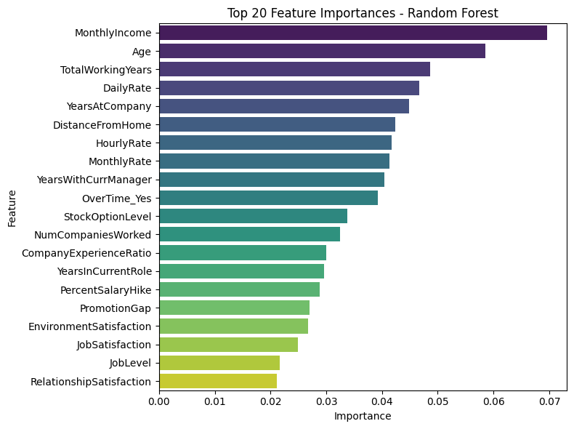
Conclusion
This project successfully built two models for predicting employee attrition where the Logistic Regression model emerged as the better of the two for this dataset, providing a more reliable ranking of attrition risk (higher AUC). However, the models demonstrated a significant performance gap for the minority class, indicating that the patterns associated with employee attrition were not sufficiently captured during the training process. The core challenge is the imbalanced nature of the dataset. Future work should focus on addressing this imbalance through techniques such as SMOTE (Synthetic Minority Over-sampling Technique), and conducting further hyperparameter tuning.

