## AARADHYA

**UCS503 Software Engineering Project Report**

### Mid-Semester Evaluation Submitted by:

**(<102003721>) Palak**

### (<102003708>) Sanya Sachdeva

**(<102003729>) Ananya Nathi**

### (<102003722>) Kunal Ranjan

**BE Third Year, COE Group No: 8**

### Submitted to: Ms. Anamika Designation of Faculty



**Computer Science and Engineering Department TIET, Patiala**

**September 2022**

## TABLE OF CONTENTS

|  |  |  |
| --- | --- | --- |
| **S. No.** | **Assignment** | **Page No.** |
| **1.** | **Project Selection Phase** |  |
| 1.1 | i. Software Bid |  |
| **2.** | **Planning Phase** |  |
| 2.1 | i. Project Write Up |  |
| 2.2 | ii. Feasibility Report |  |
| 2.3 | iii. Gantt Chart |  |
| **3.** | **Analysis Phase** |  |
| 3.4 | iv. Data Flow Diagrams –Level 0, Level 1 |  |
| 3.5 | v. Software Requirement Specification (SRS) in IEEE  Format |  |

**Software Bid/ Project Teams**

**UCS 503- Software Engineering Lab**

Group : COE28 Dated:08.08.2022

**Team Name: C-3PO**

**Team ID (will be assigned by Instructor): SE08**

Please enter the names of your Preferred Team Members:

* You are required to form **a three to four person** teams.
* Choose your team members wisely. You will not be allowed to change teams.

|  |  |  |  |  |
| --- | --- | --- | --- | --- |
| Name | Roll No | Project Experienc e | Programming Language used | Signature |
| Palak | 10200372 |  | C,C++,HTML,REAC |  |
|  | 1 | T |
| Sanya | 10200370 |  | C,C++,CSS,HTML,J |  |
| Sachdev | 8 | S |
| a |  |  |
| Ananya | 10200372 |  | HTML,CSS,NODE |  |
| Nathi | 9 |  |
| Kunal | 10200372 |  | C++,HTML,PHP |  |
| Ranjan | 2 |  |

**Programming Language / Environment Experience**

List the languages you are most comfortable developing in, **as a team**, in your order of preference. Many of the projects involve Java or C/C++ programming.

1. C

2. C++

3. Python

**Choices of Projects:**

Please select **4 projects** your team would like to work on, by order of preference:

|  |  |
| --- | --- |
| First Choice | Meditation and yoga website |
| Second Choice | E-commerce website |
| Third Choice | Spotify clone |
| Fourth Choice | Blood donation website |

## Planning

* 1. **Project Writeup**

### Project overview:

Meditation has been shown to enhance self-actualization which means ‘becoming the best version of yourself’. Aaradhya – Meditation is a new self-contained software product which will be produced by the project team in order to overcome the problems of stress, mental traumas and bring peace to their mind. The system will provide better options to handle the problems mentioned above in a very efficient way.

**Functional Requirements:**

* + 1. **Registration**: The users can register themselves to the website.
    2. **Login**: The login credentials would be the same data as used for registration and it must be valid.

### Services –

* + - * **Read Meditation Tips** – The general tips of meditation will be provided.
      * **Watching videos** - The user can select the video to watch according to her/his choice. The minimum time limit of video is 15 minutes. The user can zoom in-zoom out the video.
      * **Listening audio voices –** There will be audio voices such as OM Mantra, and other sounds such as piano relaxing, birds chirping etc . The user can download the audio sounds. Maximum time limit of the audio would be 5 minutes.
      * **Practice yoga asanas –** Proper steps describing yoga asanas such as Surya namaskar.
    1. **Feedback section** – The user will get a feedback/remark option to review the overall performance of our project.
    2. **Logout** – The user can logout from the website with her choice.

### Non-functional Requirements:

1. **User-friendly** – The software must be user friendly so that everyone can use it easily.
2. **Portability** – The software can be run on more than one system.
3. **Privacy** – The user’s login credentials would be safe and would not be shared with anyone.
4. **Manageability** – The software is easy to handle either by the creators or the users.
5. **Performance** – The performance of the software would be fast and good.
6. **Efficient** – Efficiency of the software would be high.
7. **Flexibility** – The software would be flexible in terms of adding , updating different services.
8. **Security** – The user’s credential would be confidential.
9. **Responsiveness –** The application would work on any device such as laptop, mobiles, tablets etc.

## Feasibility Report:

* **Schedule Feasibility**: The project is a semester long project and hence will be completed by the end of November. The Brainstorming and Planning phase of the project was completed in the month of August. The main phase of the project, that is the development phase is in process. It is estimated to be completed by the end of October so that testing of the application can commence. The time periods for the project are decided after careful consideration of the time periods the members can contribute both individually, and as a group. Hence, the project is schedule feasible.
* **Technical Feasibility**: The Project is a complete web based application. The main technologies and tools that are involved in the creation and the functioning of the project are –
  + 1. HyperText Markup Language (HTML)
    2. JavaScript
    3. Cascading Style Sheets (CSS)
    4. MySQL – Structured Query Language that will be used to insert, delete and update user data in the database.
    5. OpenProj – Project management tool that will also be used for Illustrating the project plan and schedule.
    6. Dia – Free and Open-source general purpose diagramming software for use in illustration of the project working.

All the technologies mentioned above are freely available and the technical skills required are manageable. The ease of technology implementation and the time for product development are synchronised.

Hence it’s clear that the project is technically feasible.

* **Economic Feasibility**: Since the project is a completely web based application, the application will be hosted on a free hosting platform. This keeps the additional cost of associated hosting down to zero. Also since the tools and technologies are all open - source and freeware, there is no cost attached to that aspect of the project. The development team and the development tools required are –

1. Programming Devices (Computers)
2. Programming tools (Freely available)
3. Programming individuals (Students)

These all are feasible and free. Also, there is no additional cost of hardware involved in the project. Hence the project is Economically Feasible

* **Operational Feasibility**: The project is Operationally feasibility as it matches all our resource objectives as well as the planning and capacity objectives. The costs are minimum due to it being a semester project for educational use. While all other objectives of resources and planning are also met, thus confirming that there will be no issue in the operational capability of the project. Hence The project is operationally feasible.
* **Legal Feasibility**: This project of ours is completely built with the help of tools and technologies that are Open-Source. They can be used without any legal implications. Hence the question of legal feasibility does not arise.

### Cultural/Behavioural Feasibility:

* **Cultural Feasibility** – The cultural feasibility of the project has not been an issue. Meditation is, and has been, a traditional practice for fitness and wellness across the world for thousands of years. The Project is in sync with the idea of spreading awareness about Meditation and the beneficial aspects it brings into one’s life. Also, the project will cater to the requirements of the individual with custom information. Hence, Cultural feasibility was achieved.
* **Behavioural feasibility** – Behavioural Feasibility includes the users behaviour towards the development of a project and how it will affect them. Constantly rising levels of stress in all age groups and regions is a grave problem. And there is also a need for awareness about meditation and how it helps us. This helped us realize that there was a positive response from the users end towards the development of such an application that catered to their health needs. Hence, giving us Behavioural feasibility.

# Software Requirements Specification

**for**

# AARADHYA

**(Online Meditation and Yoga System)**

Prepared by:

Group – COE 28 Team name – C-3PO Team id – SE08

Team members – 1. Palak

* 1. Sanya Sachdeva
  2. Ananya Nathi
  3. Kunal Ranjan

**12th September, 2022**

## Table of Contents

Table of Contents 1

1. Introduction 2
   1. Purpose 2
   2. Document Conventions 2
   3. Intended Audience and Reading Suggestions 2
   4. Project Scope 3
   5. References 3
2. Overall Description 4
   1. Product Perspective 4
   2. Product Features 4
   3. User Classes and Characteristics 6
   4. Operating Environment 6
   5. Design and Implementation Constraints 7
   6. User Documentation 7
   7. Assumptions and Dependencies 7
3. System Features 8
   1. Login 8
   2. Registration for Meditation 8
   3. Layout 9
   4. Exploration 9
   5. Feedback and Logout… 9
4. External Interface Requirements 10
   1. User Interfaces 10
   2. Hardware Interfaces 10
   3. Software Interfaces 10
   4. Communications Interfaces 11
5. Other Nonfunctional Requirements 11
   1. Performance Requirements 11
   2. Safety Requirements 11
   3. Security Requirements 11
   4. Software Quality Attributes 11
6. Other Requirements 12

Appendix A: Glossary 12

## INTRODUCTION

### Purpose

The Software Requirements Specification (SRS) will provide a detailed description of the requirements for our project Aaradhya – Meditation website. This SRS will allow for a complete understanding of what is to be expected from the newly introduced system which is to be constructed. In short, it will explain the purpose and features of the system, the interfaces of the system, functionality of the system.

### Document Conventions

* + - Convention for Main title `+
      * Font face: Times New Roman
      * Font style: Bold
      * Font Size: 32
    - Convention for Sub title
      * Font face: Times New Roman
      * Font style: Bold
      * Font Size: 18
    - Convention for body
      * Font face: Times New Roman
      * Font Size: 14
      * Line spacing: 1.5

### Intended Audience and Reading Suggestions

The intended audience of this document would be:

* Developers: To develop the right project that fulfill requirements provided in this document.
* Testers: To have an exact list of the features and functions that has to respond according to requirements and provided diagrams.
* Users: To get familiar with the idea of the project and suggest other features that would make it even more functional.
* Documentation writers: To know what features and in what way they have to explain, what security technologies are required, how the system will response in each user's action etc.
* Admin, Manager, Trainers and Customers: To know exactly what they have to expect from the system, right inputs and outputs and response in error situations.

The rest of this SRS document contains details of the goals of the project and how these goals will be achieved. The document would final provide a clear idea about the system that is building.

Brief outline of the document is,

1. Overall Description
2. System Features
3. External Interface Requirements
4. Non-Functional Requirements

### Project Scope

This software project will be a meditation website for the users who want to pursue meditation. The main purpose of this project is to maintain good mental and physical health of the user. Meditation provides a state of piece to the mind which motivate people to do their work efficiently. This software will provide each and every information related to meditation such as meditation tips, videos, soothing audio voices, types of yoga asanas etc. The software will facilitate communication between users and admins through a feedback system. The feedback given by users will ultimately help the project makers to manage pros and cons of their software. Safety, easiness of using and most importantly the efficiency of information retrieval are some benefits the development team is going to present with this system.

### References

The following references were considered while completing this SRS document:

<https://www.javatpoint.com/software-requirement-specifications> [Share and Discover Knowledge on SlideShare](https://www.slideshare.net/)

<https://www.geeksforgeeks.org/how-to-write-a-good-srs-for-your-project/>

### Overall Description

### Product Perspective

Aaradhya – Meditation is a new self-contained software product which will be produced by the project team in order to overcome the problems of stress, mental traumas and bring peace to their mind. The system will provide better options to handle the problems mentioned above in a very efficient way.

Aaradhya would be user-friendly, quick to learn and reliable software for the purpose of pursuing meditation. This software is intended to be a stand-alone product and would not depend on the availability of other software. This system will provide an easy access to the system and it will contain user friendly functions with attractive interfaces.

### Product Features

The system functions are as follows:

* + 1. It must be able to perform Identification of each user by using login id and password.
* User: whenever user login is identified then it must direct them to their corresponding pages such as Tips, Gallery containing audios, videos etc.
* Admin: Whenever admin login is identified, he will view the software as a user.
  + 1. The users must be able to register and view all the information about meditation.
    2. The admin must be able to update, delete and insert all the new information regarding the meditation process (at the backend level).

### User Classes and Characteristics

There are two user levels in this online Meditation system:

* Administrator:

The administrators have complete control over all the activities that can be performed on the system. They have full privilege on the system’s functions. They are the one who monitor, maintain and authorise the hardware components as well as software resources to the end users.

They add all the relevant information to the system, modify or remove them according to the need of everyone. They verify the user after he/she registers. They are responsible for security of the whole system.

* Public:

Everyone i.e. general public can have access to this software. They can explore all the information available on this software according to their preference after registering themselves to the website. They can also give their opinions about this software through a feedback mechanism which will even help the admin to remove the errors(if any) and improve them.

### Operating Environment

This proposed software will be used in Windows platform in the version of Windows 7 or above. MySQL will be used for the database to hold the details of registered users to the software.

1. Hardware
   * Operating system: Windows platform (NT).
   * Processor: Pentium
   * Processor speed: 2.5 GHz
   * RAM: 512MB
   * Hard disk drive: 40GB
2. Software
   * Software is designed to run on any platform above Microsoft Windows 7 (32bit).
   * Microsoft .NET Frameworks 4.0 or above.
   * Microsoft SQL Server Management Studio Express 2010.

### Design and Implementation Constraints

The system is a web based application system running in a windows environment. The system shall be developed using ASP.NET and MySQL server. Security is not a concern for this system. The database will store passwords of the registered users and in case, they forgot their password, they can update their password again. If the system is down, then customers must not notice, or notice that the system recovers quickly (seconds). The system must be reliable enough to run crash and glitch free more or less indefinitely, or facilitate error recovery strong enough such that glitches are never revealed to

its end-users. A person who has no knowledge of computers will find it difficult to understand the system. But with a little knowledge it will be very easy to handle the project.

### User Documentation

This software provides security. The login form prevents the system from being misused by unauthorized users. Only an authorized operator will be granted rights to modify as per requirements. This software is also reliable and fault tolerant. The system developed is designed to handle invalid inputs. Since reliability is major area of concern the system has a backup to avoid data loss. The user should know the programming language very well that is used to develop software.

.

### Assumptions and Dependencies

* The assumptions are:-

1. It is assumed that the users have stable internet connection to visit and explore our website.
2. The coding should be error free
3. The system should be user-friendly so that it is easy to use for the users 4.The details of all users must be stored in a database that is

accessible by the website

1. The system should have more storage capacity and provide fast access to the database
2. This online meditation system is running 24 hours a day.
3. Users may access from any computer that has Internet browsing capabilities
   * The dependencies are:

1.The specific hardware and software due to which the product will be run. 2.On the basis of listing requirements and specification the project will be developed and run.

3.The end users (admin) should have proper understanding of the product. 4.The system should have the general report stored.

5.The information of all the users must be stored in a database that is accessible by the software.

### System Features

### Login

### Description and Priority

The login form is used by all the users and admin. This module has the highest priority when compared to all the other modules. This model allows the user to enter his username and password in order to make use of the software.

### Stimulus/Response Sequences

This module has text boxes where the user can enter his username name and password. If the necessary information is not provided or if invalid inputs are given by the user then the system will pop a message box.

### Functional Requirements

Only authorized users are allowed to login. The authorized users are the administrator and general users. If invalid user name or password is given the system should inform the user. If unauthorized users try to access then it should not allow the user to work on the

system.

### Registration for Meditation

* + 1. **Description and Priority**

All users will register themselves within the time period and this feature has higher priority because this is the most essential feature of the product.

### Stimulus/Response Sequences

Once the user registers , he/she would be able to view the further information available on the software Eg – Tips, videos, audios etc.

### Functional Requirements

During registration, once the user provides the requested information, the user will be able to login and an appropriate message is displayed.

### Layout

* + 1. **Description and Priority**

After sign in, the user will be able to view the content related to meditation (meditation tips, videos and audios, types of yoga asanas, experience of professionals). Proper transitions have been used in the software.

### Functional Requirements

The layout of “Aaradhya” is decided in such a way that user feels it like an interactive session rather than being in a virtual situation.

### Exploration

* + 1. **Description and Priority**

There will be a navigation bar to explore different sections of this meditation software.

### Stimulus/Response Sequences

Once the user navigates, he will be directed towards the next page containing the features of this project. The features includes watching videos , listening audio voices, practice yoga asanas.

### Functional Requirements

The user gets to know about different sections of the software.

### Feedback and Logout

* + 1. **Description and Priority**

The feedback option provides the user to give their reviews about the software. The admin gets to know about the pros and cons of the software through feedback given by users. Also the user can logout from the website with his/her choice

### Stimulus/Response Sequences

An appreciation message will be displayed after giving the feedback.

### Functional Requirements

Through the feedback, admins and user can communicate with each other regarding the software. User can ask their doubts through this feedback option only.

### External Interface Requirements

### User Interfaces

The software provides good graphical interface for the user and the administrator can operate on the system, performing the required task such as add, update the information related to meditation and view the feedback given by users.

* It allows user to view all the information related to meditation
* The user interface must be customizable by the administrator.
* The design of interface should be simple and catchy.
* The user interface should be able to interact with the user management module and a part of the interface must be dedicated to the login/logout module.
* Login Interface:-

In case the user is not yet registered, he can enter the details and register to

create his account. Once his account is created he can ‘Login’ which asks the user to type his email and password.

### Hardware Interfaces

This system doesn't require any hardware interface. The one used here is monitor and mouse. The system should have these hardware requirements minimum of:

* Processor: Intel Pentium4 1GHz or above
* Memory: 512MB or above
* Hard Disk Drive: 40GB or above

### Software Interfaces

Operating System: Windows 7 Front End: ASP.NET, HTML, CSS.

Back End: MySQL Server, c#

### Communications Interfaces

There are no specific communication interface requirements. Here, Communication is done through emails sent via admins and feedbacks sent by users.

### Other Nonfunctional Requirements

### Performance Requirements

* The system is interactive and the delays involved are less.
* The Online Meditation System shall handle expected and non-expected errors in ways that prevent loss in information and long downtime period.
* The system should be able to handle large amount of data. Thus, it should accommodate high number of videos and audios without any fault.

### Safety Requirements

* The database may get crashed at any certain time due to virus or operating system failure. Therefore, it is required to take the database backup so that the database is not lost.
* In case the customer forgets or loses Password, the repair functionality helps by choosing "forgot password" option in the main login window.

### Security Requirements

* System will use secured database.
* Normal users can just read information but they cannot edit or modify anything except their personal and some other information.
* Proper user authentication should be provided.
* No one should be able to hack user’s password
* There should be separate accounts for admin and members such that no member can access the database and only admin has the rights to update the database.

### Software Quality Attributes

* There may be multiple admins creating the project, all of them will have the right to create changes to the system. But the members or other users cannot do changes.
* The Quality of the database is maintained in such a way so that it can be very user friendly to all the users of the database.
* The project should be open source.
* The system is reliable in its operations and for securing the sensitive details.
* The system should be available at all times i.e. 24*7 availability.
* The system can be viewed in any browser.

### Other Requirements Appendix A: Glossary

* Administrator: A login id representing a user with user administration privileges to the software
* User: A general login id assigned to most users
* Public: Intended users for the software
* SQL: Structured Query Language; used to retrieve information from a database
* SQL Server: A server used to store data in an organized format
* User Interface: The section of the assignment referring to what the user interacts with directly
* Use Case: A broad level diagram of the project showing a basic overview
* Interface: Something used to communicate across different mediums.

## 2.3 Gantt Chart WBS

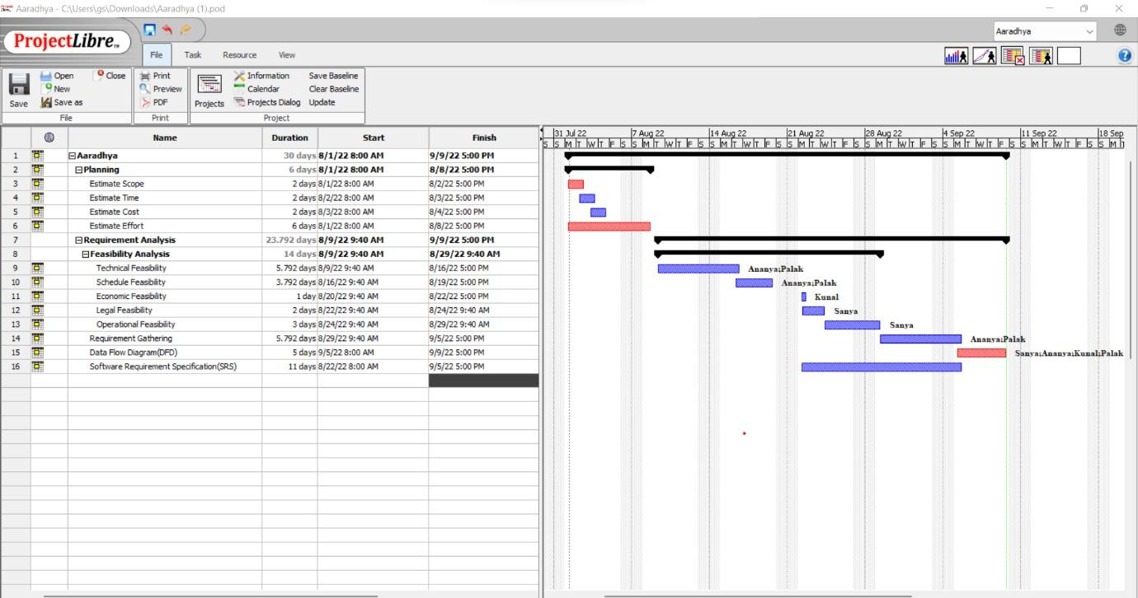

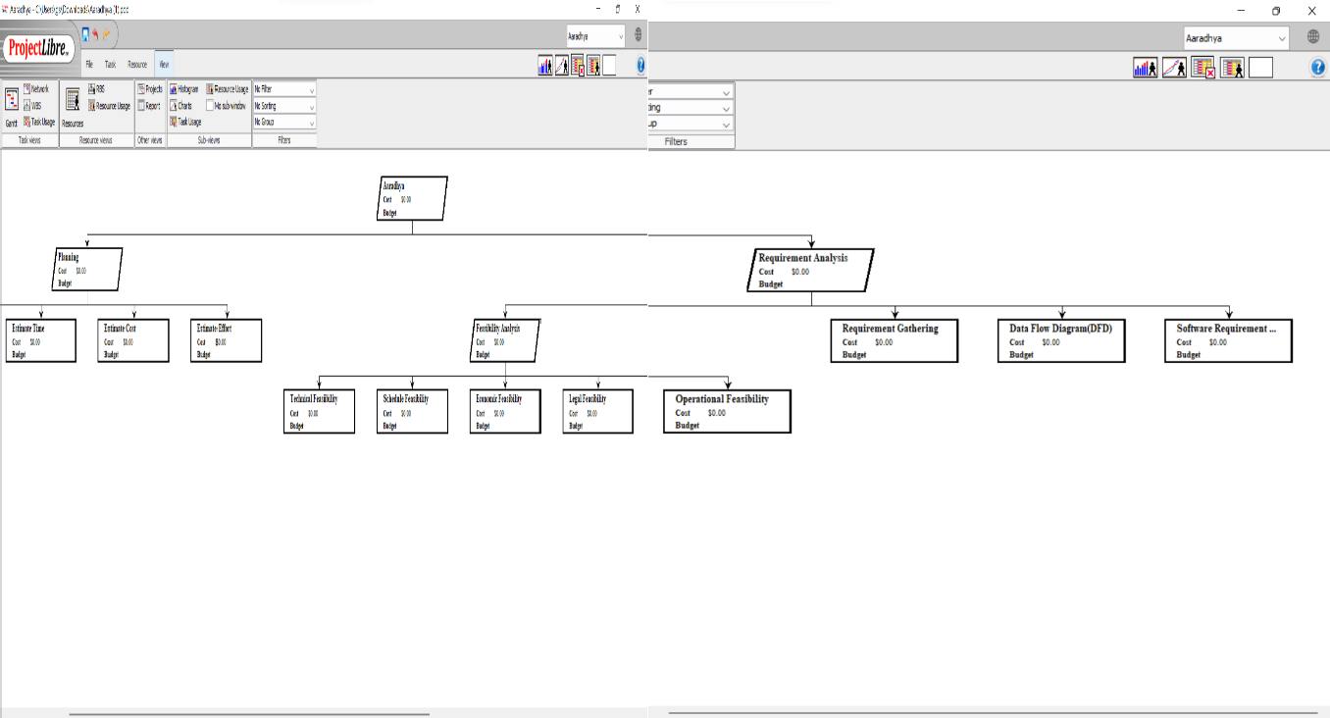

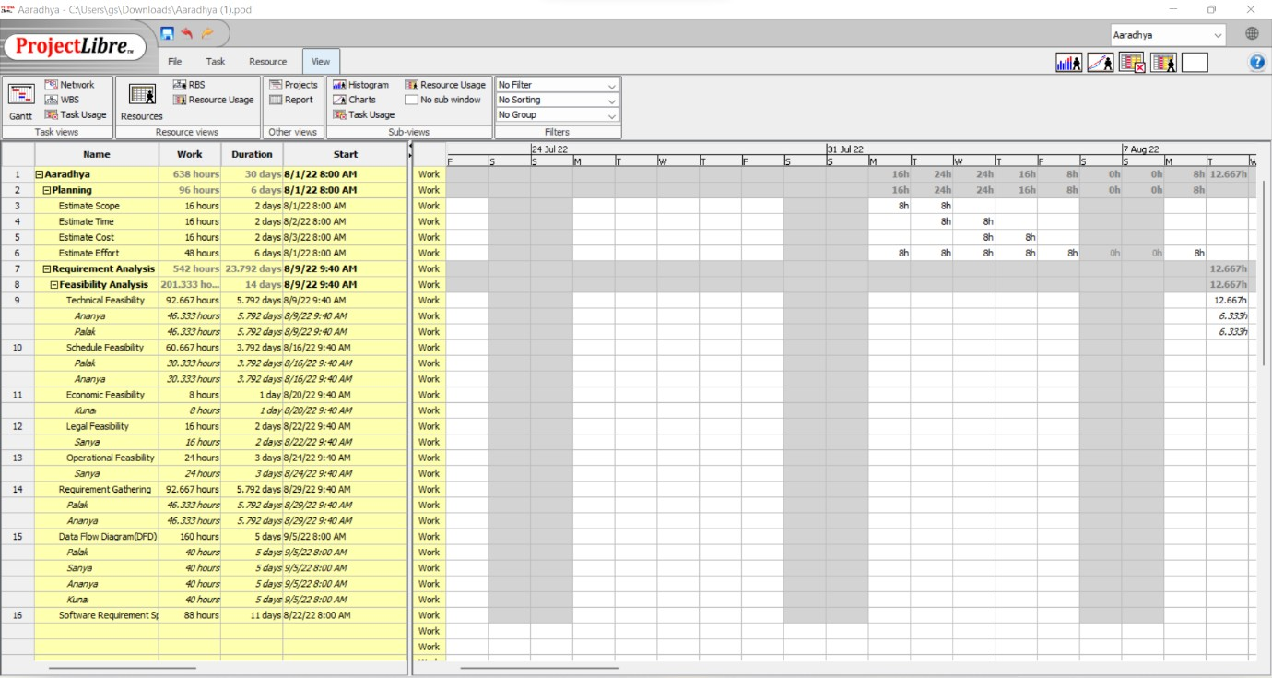

* 1. **Dataflow diagrams**
     + DFD 0

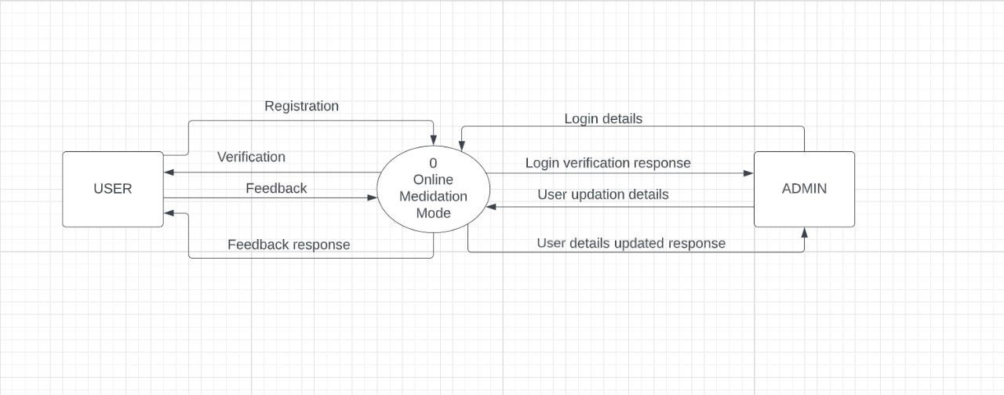

* + - DFD 1

