<!-- index.html : Home Page -->
<!DOCTYPE html>
<html>
<head>
<title>Student Portfolio</title>
<link rel="stylesheet" href="style.css">
</head>
<body>

<!-- NAVIGATION -->
<nav>
<div class="logo">Student Name</div>
<ul>
<li><a href="index.html">Home</a></li>
<li><a href="about.html">About</a></li>
<li><a href="skills.html">Skills</a></li>
<li><a href="contact.html">Contact</a></li>
</ul>
</nav>

<!-- HERO SECTION -->
<div class="hero">
<h1>Welcome to My Portfolio</h1>
</div>

</body>
</html>

OUTPUT

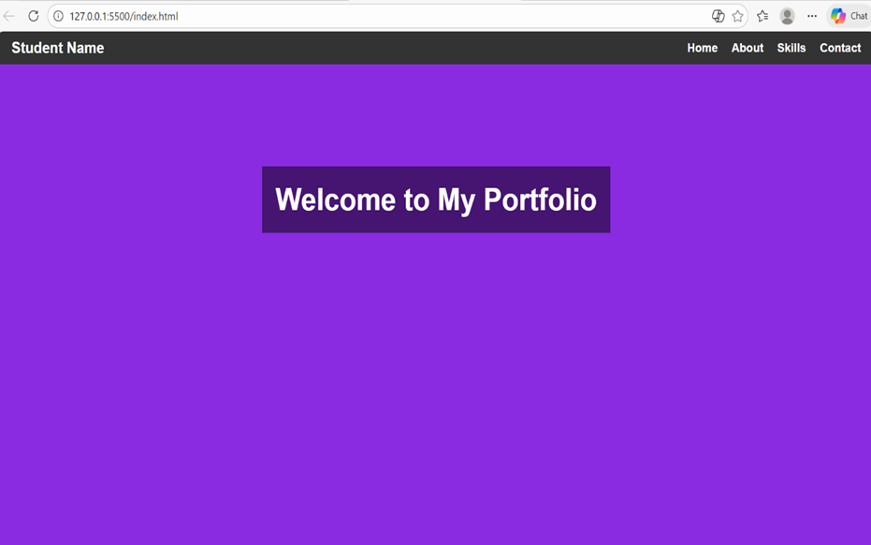

<!-- about.html : About Page -->
<!DOCTYPE html>
<html>
<head>
<title>About Me</title>
<link rel="stylesheet" href="style.css">
</head>

<body>

<!-- NAVIGATION -->
<nav>
<div class="logo">Student Name</div>
<ul>
<li><a href="index.html">Home</a></li>
<li><a href="about.html">About</a></li>
<li><a href="skills.html">Skills</a></li>
<li><a href="contact.html">Contact</a></li>
</ul>
</nav>

<!-- ABOUT CONTENT -->
<div class="about-container">
<img src="images.jpg" alt="My Photo">

<div>
<h2>About Me</h2>
<p>
I am a passionate student interested in technology, coding and design.
I enjoy creating useful projects, learning new tools and improving my skills.
My goal is to build innovative products and contribute to meaningful work.
I like working in teams and exploring new challenges.
</p>
</div>
</div>

</body>
</html>
OUTPUT
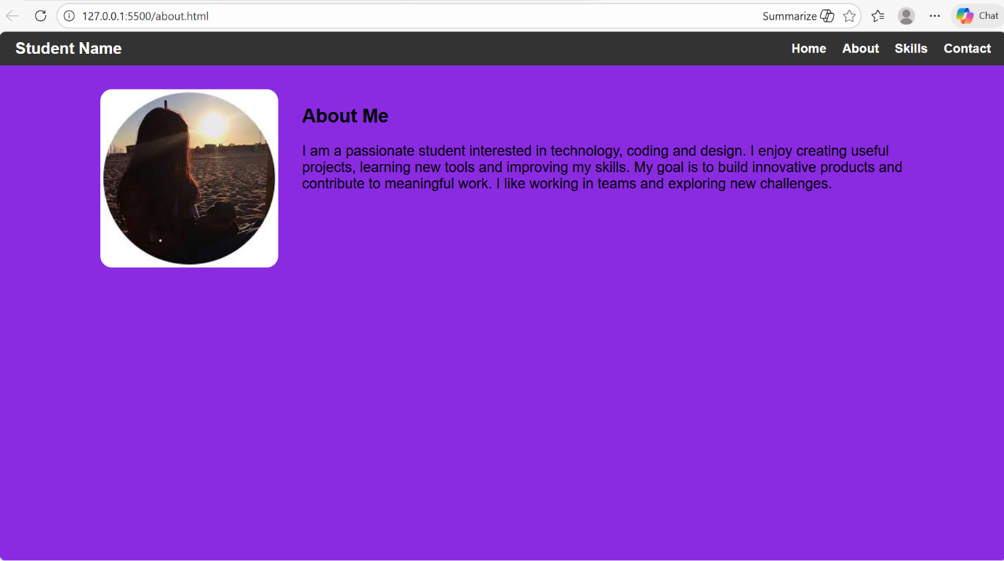
<!-- skills.html : Projects Page -->
<!DOCTYPE html>
<html>
<head>
<title>My Skills</title>
<link rel="stylesheet" href="style.css">
</head>

<body>

<!-- NAVIGATION -->
<nav>
<div class="logo">Student Name</div>
<ul>
<li><a href="index.html">Home</a></li>
<li><a href="about.html">About</a></li>
<li><a href="skills.html">Skills</a></li>
<li><a href="contact.html">Contact</a></li>
</ul>
</nav>

<!-- SKILL CARDS -->
<div class="skills-container">

<div class="card">
<h3>Web Development</h3>
<p>I build responsive websites using HTML, CSS and JavaScript.</p>

</div>

<div class="card">
<h3>Python Projects</h3>
<p>Created small automation tools and mini-applications.</p>
</div>

<div class="card">
<h3>UI/UX Designing</h3>
<p>Design simple and clean user interfaces using Figma.</p>
</div>

</div>

</body>
</html>
OUTPUT
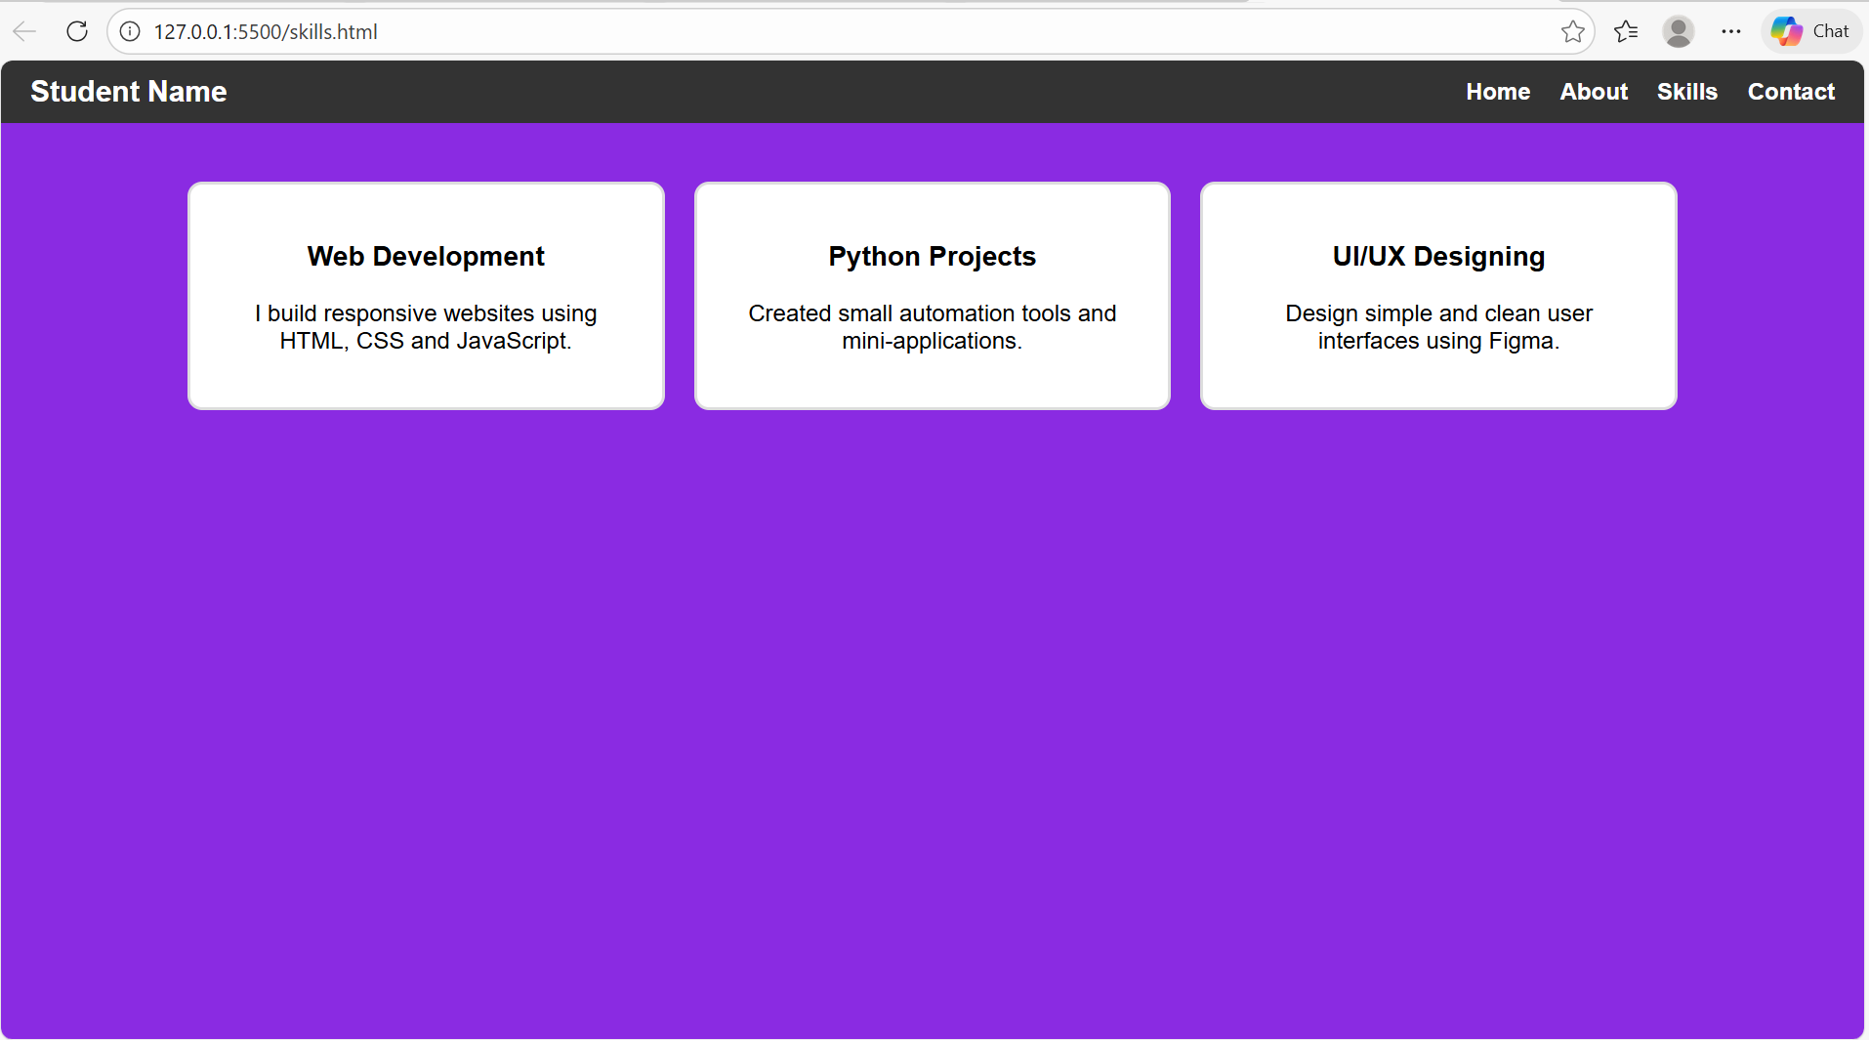
<!-- contact.html : Contact Form Page -->
<!DOCTYPE html>
<html>
<head>
<title>Contact Me</title>
<link rel="stylesheet" href="style.css">
</head>

<body>

<!-- NAVIGATION -->
<nav>
<div class="logo">Student Name</div>
<ul>
<li><a href="index.html">Home</a></li>
<li><a href="about.html">About</a></li>
<li><a href="skills.html">Skills</a></li>
<li><a href="contact.html">Contact</a></li>
</ul>
</nav>

<!-- FORM -->
<div class="form-container">
<h2>Contact Me</h2>

<form>
<label>Name</label>
<input type="text" required>

<label>Email</label>
<input type="email" required>

<label>Subject</label>
<input type="text" required>

<label>Message</label>
<textarea rows="5" required></textarea>

<button type="submit">Send Message</button>
</form>
</div>

</body>
</html>
OUTPUT
