SION!Browser / SION!Server
A Rules Based Browsing Solution

Author: Gilles Fabre

Rule Based Browsing Overview:

General Objective:

The rule based browsing solution aims to provide computer/content servers users with the ability to seamlessly classify and browse large heterogeneous data storages and content sources.
With the increasing number of high capacity mass storages now accessible to computers or Home Appliances (TVs, Set Top Boxes, etc), either directly (physically connected peripherals -HDD, USB keys, etc-) or remotely (WEB, Email, RSS, News, Video/Audio, FTP, DLNA, etc servers), users face the problem of easy and rapid content browsing.
The rule based browsing enables users to filter and organize her multimedia content easily and overall to see what she wants, where she expects to see it, independently of the content sources physical organization.
Imagine you could plug an external disk or MP3 player, pair a BT device that supports FTP profile, turn on a DLNA server and immediately find the videos, music, photographs where you expected to find them. Moreover, everytime new content is published, it'll appear at the appropriate location wherever it's located on the source:

MySetTopBox:
Music
Rock
70's
Hendrix
Ambient

Video
Action
90's

Die Hard 28

Romance
SciFi

Pictures

Kids
House
Motorcycle

MyExternalHDD

Pictures

Kids
House
Motorcycle

Music
Videos

....

Architecture:

Client/Server Design:

The solution basically relies on two distinct components: a client browser and a rule based content indexing server.
The client and the server can run on separate machines, and a client can potentially connect to any server on any remote host. The communication protocol between the browser client and the indexing server has been designed such that there's no dependency between the client hosting OS and the one running the server.

Extensible Design:

The server uses plug-ins to index the content (files, web pages, emails, etc). A plug-in is a piece of code, dynamically loaded by the server and dedicated to a specific content/source. A plug-in is responsible for providing access to the associated content/source specific attributes and behaviors. For example, a file plug-in will publish file 'date' (creation, access, modification), 'length', 'type' (extension), 'name', 'path', etc attributes and 'deletion', 'content matching' (regular expression search in file content) methods. An MP3 file plug-in will add to the latter attributes such as MP3 tags ('artist', 'track' and 'album', etc). A Web plugin will add attributes such as 'header', 'links', etc. There's no limit to the type of content nor the indexing rules the indexing server supports through the plug-ins.

Flexibility of the Solution:

The server deals with 'Filters' that are responsible for watching a source (TCP/IP Address, Local or Remote -RFS- Physical Directory). When created (instanciated on the server), a Filter is provided one or several plug-ins. When initially created, a filter will scan the source, searching for new content to index, and if possible register with the source content modification system (inode notification service on a linux FS for example). If registered with the source modification notification system, the filter will check new or modified content against the indexing rules. To index content, the filter will delegate the filtering work to the plug-ins.
A filter can be created 'under' a parent filter. In this case, the child filter will apply to and only to the content retained by the parent filter. The source which a child filter will 'watch' must be under (either directly or several levels under) it's parent filter's source (sub-directory, sub HTTP address, etc).
References to the content retained by the filters is stored by the server in a database, which the browser client will use (through requests to the server) to display sorted content, based on the filters hierarchy and associated rules.

Powerful Filtering/Indexing Mechanism:

Every plug-in can be associated a javascript rule, which, based on the content's attributes published by the plug-in, will either retain or reject the content.

Because plug-ins know the specifics of the content they're dealing with, they can perform powerful operations (find the name of a song on the web, recognize a character's face in a photography, check for the presence of a regular expression in a text file, of a signature in a binary file, etc). There's no limit to the type of filtering criteria a user can use to retain/classify content.

Proof of Concept:

A proof of concept has been implemented, which applies to files stored on the File System hosting the indexing server. This covers only the directly accessible content browsing part, but the solution is architectured such that it can easily be extended to support remote content browsing (RSS, DLNA, Web, Email, etc).
The proof of concept is divided into the two afore mentioned components:
- SION!Browser: the client browser.
- SION!Server: the rule based indexing server.

SION!Browser and SION!Server are implemented in Qt for purpose of rapid development. Both components can be executed on any computer with Qt 4.7 installed. The communication between the server and the client (interface) rely only on String exchanges over TCP. Hence, the protocol can be modified to rely on any other connection oriented communication protocol that supports text string exchanges.
For security reasons, the proof of concept doesn't allow the client and server to be running on different machines (hard coded host address and port).
SION!Server uses a MySQL server to store the filetered/indexed files. SION!Browser only communicates with SION!Server to create, view, edit or delete virtual folders.

The proof of concept can be used to filter (recursively or not) content in any directory on any local mass storage and later/real time browse the filtered content. The content can be filtered on:

Basic plug-in:
. name
. length
. type
. content (match against reg exp from Javascript)
. path
. access dates
. hidden attribute
. directory/regular file type

Mp3Plugin:
. same as basic plug-in +
. mp3 files by default (Javascript default filter)

. MP3 tags (author, album, genre, etc)

A couple screen shots of the proof of concept, the Browser:
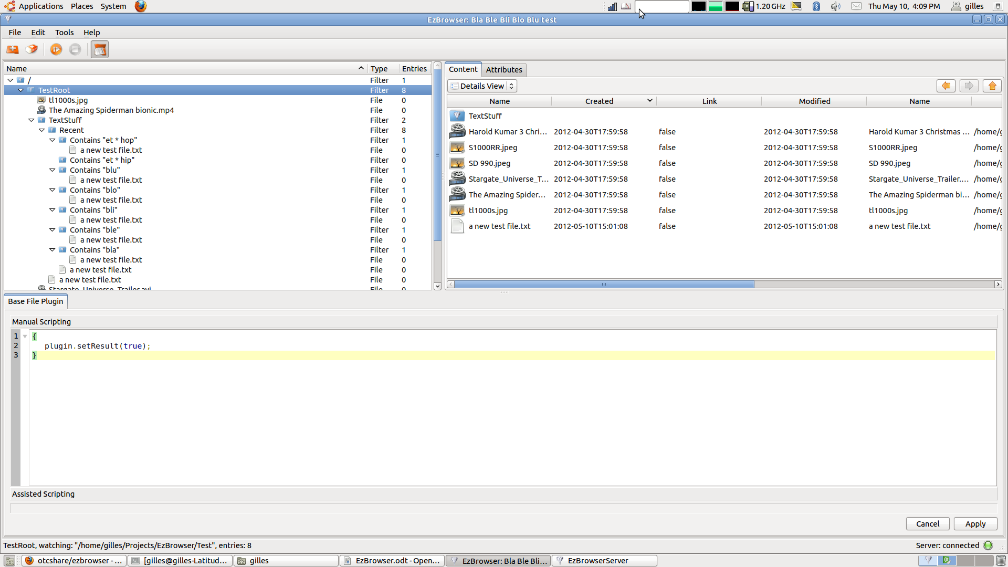
The Server Window:
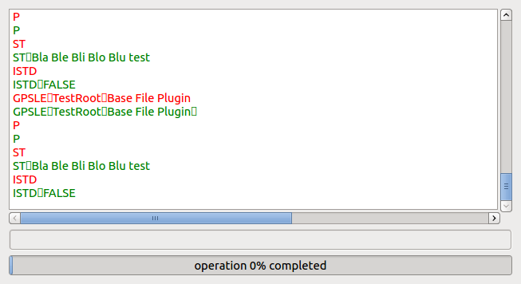

Creating a new Filter:

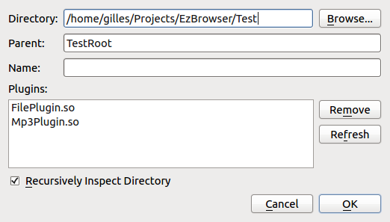

Architecture:
Local Content
HTTP, RSS, POP3, IMAP, etc...
Content Browsing
Overview:
Client Browser
Filtering/Indexing Server
Filters creation/editing/deletion

Content Indexing
Index DB

Server Architecture:

Classifier
Javascript Engine
Plugin n
Plugin n
Server
Server Remote Interface
Plugin 1
FileFilter 1
Plugin 1
FileFilter n
Javascript Execution Support
Remote Filters Management Service
Source Watching Service
Content Attributes Handling
Plug-ins Management
Watch a Source
Watch a Source
. Manage Filters (loading, instanciation, deletion, etc)
. Report filtered content to DB
. Publish Content Attributes
. Invoke filters on new/modified content

Extensions:

The architecture is designed to support the seamless extensions of the content filtering to any type of local or remote content (source addressing, content management decoupled). We could think of dealing with DLNA provided content, while retrieving additional information about the new/modified content from a remote content analysis/tagging service (recognize MP3 track, download tags, then filter). We could also think of smart plug-ins that'd find people faces in the photographs and filter them based on the name of the people appearing on the pictures, etc

The client browser could also be ported to set top boxes or other home appliances, since it require basic UI, Database and File System services only.

