MARKET BASKET ANALYSIS
PROJECT REPORT
Group No. 219

Submitted by
24BCE10129 SANYA BAKSHI
24BCE10150 PRANAV RAVINDRA KHAIRNAR
24BCE10043 HARSHIL MISHRA
24BCE10617 PARTH SHARMA
24BCE11292 AGASTHYA TIWARI

In partial fulfillment for the award of the degree of

BACHELOR OF TECHNOLOGY
in
PROGRAM OF STUDY


SCHOOL OF COMPUTER SCIENCE AND ENGINEERING
VIT BHOPAL UNIVERSITY
KOTHRIKALAN, SEHORE
MADHYA PRADESH- 466114
March 2026
VIT BHOPAL UNIVERSITY, KOTHRIKALAN, SEHORE
MADHYA PRADESH – 466114

BONAFIDE CERTIFICATE

Certified that this project report title MARKET BASKET ANALYSIS is the Bonafide work of Group no. 219 – Sanya Bakshi (24BCE10129), Pranav Khairnar (24BCE10150), Harshil Mishra(24BCE10043), Parth Sharma (24BCE10617) and Agasthya Tiwari (24BCE11292) who carried out the project work under my supervision. Certified further that to the best of my knowledge the work reported at this time does not form part of any other project/research work based on which a degree or award was conferred on an earlier occasion on this or any other candidate.

PROGRAM CHAIR PROJECT GUIDE
Dr. Vikas Panthi Dr. Daood Saleem
School of Computer Science and Engineering School of Computer Science and Engineering
VIT BHOPAL UNIVERSITY VIT BHOPAL UNIVERSITY

The Project Exhibition II Examination is held on 2nd March 2026.

ACKNOWLEDGEMENT

First and fore most I would like to thank the Lord Almighty for His presence and immense blessings throughout the project work. I wish to express my heartfelt gratitude to Dr. Vikas Panthi, Program Chair, School of Computer Science and Engineering for much of his valuable support encouragement in carrying out this work. I would like to thank my internal guide Dr. Daood Saleem, for continually guiding and actively participating in my project, giving valuable suggestions to complete the project work. I would like to thank all the technical and teaching staff of the School of Computer Science and Engineering, who extended directly or indirectly all support.
Last, but not least, I am deeply indebted to my parents who have been the greatest support while I worked day and night for the project to make it a success.

LIST OF ABBREVIATIONS

- MBA- Market Basket Analysis
- ML- Machine Learning
- CSE- Comma Separated Values
- UI- User Interface

ABSTRACT

Market Basket Analysis (MBA) is a widely used data mining technique that helps in discovering hidden patterns and relationships between products in large transactional datasets. The primary purpose of this project is to analyse customer purchasing behaviour and identify items that are frequently bought together in retail environments. Understanding these associations enables businesses to improve product placement, enhance recommendation systems, and design effective marketing strategies such as cross-selling and product bundling.

The methodology adopted in this project involves collecting a transactional retail dataset and preprocessing it to convert raw purchase records into a structured format suitable for analysis. The Apriori algorithm was implemented using Python to generate frequent item sets based on a defined minimum support threshold. Further, association rules were derived from these item sets using confidence and lift metrics to evaluate the strength and usefulness of the relationships between products. Data visualization techniques were also employed to present the results in a clear and interpretable manner.

The findings of the project reveal meaningful associations between various products, demonstrating how data-driven insights can support decision-making in retail management. The generated rules highlight which items are most likely to be purchased together, providing valuable information for inventory planning, store layout optimization, and targeted promotions. Overall, the project successfully demonstrates the practical applicability of market basket analysis in real-world business scenarios and highlights the importance of data mining techniques in extracting actionable knowledge from large datasets.

TABLE OF CONTENTS

Serial No. | Title | Page No.
 | Project Description and Outline | 7
2. | Related Work and Investigation | 8
3. | Requirements | 9
4. | Design Methodology | 10
5. | Technical implementation and analysis | 11
6. | Project Outcome and Applicability | 12
7. | Conclusions and Future work | 14

PROJECT DESCRIPTION AND OUTLINE

Market Basket Analysis (MBA) is a data mining technique used to discover patterns and relationships among items in large transactional datasets. It is widely used in retail and e-commerce industries to understand customer purchasing behaviour and identify products that are frequently bought together. The insights derived from such analysis help businesses make informed decisions regarding product placement, marketing strategies, inventory management, and recommendation systems.
The primary objective of this project is to implement a Market Basket Analysis system using the apriori algorithm to analyse transactional retail data and generate meaningful association rules. The project aims to demonstrate how data mining techniques can transform raw transaction records into valuable business intelligence. By identifying frequent item combinations, the system helps highlight potential cross-selling opportunities and improves the overall shopping experience for customers.
The project begins with data collection and preprocessing, where raw transaction data is cleaned and converted into a structured format suitable for analysis. This is followed by encoding the transactions into a binary matrix representation, which is required for applying the apriori algorithm. The algorithm is then used to generate frequent item sets based on a predefined minimum support threshold. Association rules are further derived from these item sets using confidence and lift metrics to evaluate the strength and reliability of product relationships.
The outline of the project includes understanding the theoretical concepts of association rule mining, implementing the algorithm using Python, analysing the generated results, and visualizing the discovered patterns. The final stage involves interpreting these patterns to demonstrate their practical applicability in real-world retail scenarios. This structured approach ensures that the project not only focuses on technical implementation but also emphasizes the interpretation and usefulness of the generated insights.

RELATED WORK INVESTIGATION

Market Basket Analysis has been extensively studied in the field of data mining and has become an important technique for understanding customer purchasing behaviour. Early research focused on discovering association rules from large transactional datasets to identify relationships between items frequently purchased together. These association rules are typically measured using metrics such as support, confidence, and lift, which help evaluate the strength and usefulness of the identified patterns.

One of the most widely used algorithms for market basket analysis is the Apriori algorithm, which generates frequent item sets by iteratively scanning the dataset and eliminating infrequent combinations. However, due to its high computational cost on large datasets, researchers have proposed alternative approaches such as the FP-Growth algorithm, which uses a compressed tree structure to improve efficiency and reduce the number of database scans. Studies comparing Apriori and FP-Growth have shown that while Apriori performs well on smaller datasets, FP-Growth is more scalable and efficient for large-scale transactional data.

Market basket analysis has been successfully applied in various domains, including retail, e-commerce, and recommendation systems. Retail businesses use association rules to optimize store layouts, design promotional bundles, and develop product recommendation engines that enhance customer experience and increase sales. Recent research also explores the integration of market basket analysis with machine learning and big data platforms to improve performance and real-time decision making.

Overall, existing literature demonstrates that association rule mining is a powerful tool for extracting meaningful patterns from large datasets. This project builds upon these established techniques by implementing the Apriori algorithm and demonstrating its practical applicability in analysing retail transaction data.

REQUIREMENTS AND DATASETS

Hardware Requirements:
- Computer/ Laptop – To run Python, Process datasets and execute algorithm.
- Storage Space- To store datasets, project files and outputs like graphs and tables.

Software Requirements:

- Python – primary programming language to implement the technique.
- Google Colab – Environment for writing and visualizing code.
- Pandas library- For data cleaning, manipulation and handling datasets.
- NumPy Library- For numerical computations and array operations.
- Mlxtend library- Have built-in functions to implement apriori algorithm and generate association rules efficiently.

Datasets Requirements:
- Retail Transactional Dataset – Required to analyze customer purchase patterns. The dataset should contain transaction IDs and product names to allow the generation of frequent item sets and association rules.

DESIGN METHODOLOGY AND NOVELTY

The design methodology of this project follows a systematic data analysis pipeline to ensure accurate and meaningful results from the transactional dataset. The system is designed to transform raw retail data into actionable insights using association rule mining techniques.
- The first stage of the methodology involves data collection and preprocessing. The transactional dataset is gathered and cleaned to remove missing or inconsistent values. The data is then transformed into a structured format where each transaction contains a list of purchased items. This step is important because the Apriori algorithm requires data in a standardized format for efficient processing.

- In the second stage, the dataset is converted into a binary transaction matrix, where rows represent individual transactions and columns represent items. Each cell in the matrix indicates whether a particular item is present in a transaction. This representation allows the algorithm to easily compute item frequencies and combinations.

- The third stage involves applying the Apriori algorithm to identify frequent itemsets based on a predefined minimum support threshold. The algorithm works iteratively by generating candidate itemsets and eliminating those that do not meet the minimum support requirement. This reduces the search space and improves computational efficiency.

- Once frequent itemsets are generated, association rules are derived using confidence and lift metrics. These measures help evaluate the strength and reliability of relationships between products. The final stage of the design includes visualization and interpretation of results to present the findings in a clear and understandable manner.

The novelty of this project lies in integrating data preprocessing, algorithm implementation, and visualization into a single workflow, making complex data mining techniques easier to understand and apply in real-world retail scenarios.

TECHNICAL IMPLEMENTATION AND ANALYSIS

The technical implementation of the Market Basket Analysis system was carried out using Python and various data analysis libraries. The project utilized a sample retail transactional dataset consisting of multiple transactions, where each transaction contained a list of items purchased by a customer. The dataset was provided in a structured CSV format and was imported into the working environment using the Pandas library.
The first step in the implementation involved data preprocessing. The dataset was cleaned to remove missing or duplicate entries and then transformed into a transactional format suitable for analysis. Each transaction was grouped based on transaction ID and converted into a list of purchased items. This data was further encoded into a binary matrix using one-hot encoding, where each column represented a unique item and each row represented a transaction. A value of 1 indicated the presence of an item in a transaction, while 0 indicated its absence.

After preprocessing, the Apriori algorithm was applied using the mlxtend library to generate frequent item sets. A minimum support threshold was defined to filter out infrequent item combinations. The algorithm iteratively generated candidate item sets and retained only those that met the support criteria, thereby reducing computational complexity and focusing on meaningful patterns. Once frequent item sets were identified, association rules were generated using confidence and lift metrics. Confidence was used to measure the likelihood of purchasing an item given another item, while lift was used to evaluate the strength of the association compared to random occurrence. Only rules with confidence and lift values above predefined thresholds were considered significant.

The analysis of the results revealed several strong product associations, indicating that certain items were frequently purchased together. These insights were visualized using bar charts and tabular representations to improve readability and interpretation. The generated rules demonstrated the practical usefulness of market basket analysis in identifying cross-selling opportunities and understanding customer purchasing behaviour.

PROJECT OUTCOMES AND APPLICABILITY

The project successfully generated meaningful insights from transactional retail data by identifying frequent itemsets and strong association rules. The results were presented using both tabular outputs and graphical visualizations to improve interpretability and ease of analysis.

Bar graphs were used to represent the support values of the most frequent itemsets. These graphs made it easier to visually compare which product combinations appeared most often in transactions. By observing the height of the bars, it was possible to quickly identify the most popular product pairs and groups without manually scanning large tables of numerical values.
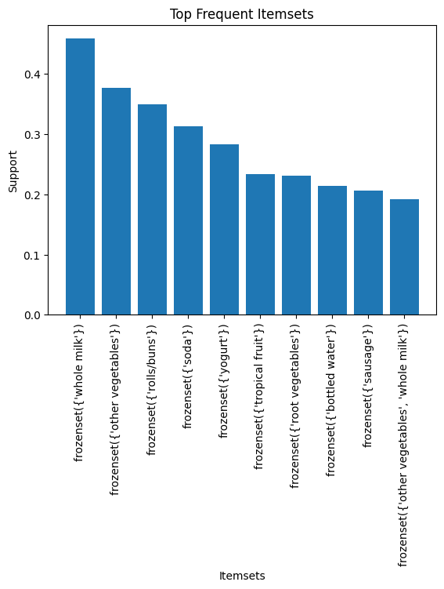

Scatter plots were used to visualize the relationship between confidence and lift for the generated association rules. Each point in the scatter plot represented a rule, with the x-axis showing confidence and the y-axis showing lift. This graphical representation helped in identifying strong and meaningful rules, as rules with both high confidence and high lift appeared in the upper-right region of the graph. Such rules indicate strong associations between products and are useful for making business decisions related to cross-selling and promotions.
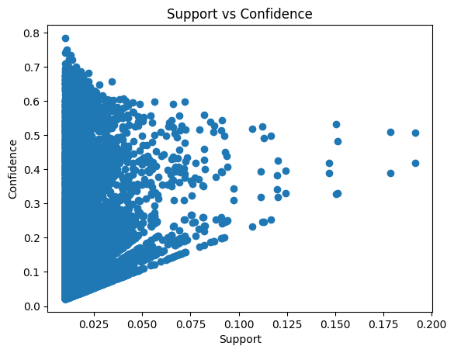

These visualizations improved the overall usability of the system by transforming complex numerical outputs into intuitive graphical insights. The graphical analysis helped demonstrate how association rule metrics such as support, confidence, and lift can be used to evaluate the strength and usefulness of product relationships.
The outcomes of the project show that market basket analysis can be effectively used in retail environments to optimize product placement, improve recommendation systems, and enhance marketing strategies based on actual customer purchasing patterns.

CONCLUSIONS AND FUTURE WORK

The project demonstrates that Market Basket Analysis is an effective method for extracting valuable insights from transactional data. The Apriori algorithm proved to be reliable for discovering frequent itemsets and generating meaningful association rules.
Future improvements may include:
- Using larger real-world datasets
- Implementing more efficient algorithms like FP-Growth
- Developing a graphical user interface for easier interaction

