2. ReactJS-HOL-student-app

//About.js

import React, { Component } from "react";
export class About extends Component{
render(){
return(
<div>
<h3>Welcome to the About page of the Student Management Portal</h3>
</div>)
}
}

//contact.js
import React, { Component } from "react";
export class Contact extends Component{
render(){
return(
<div>
<h3>Welcome to the Contact page of the Student Management Portal</h3>
</div>)
}
}

//Home.js
import React, { Component } from "react";
export class Home extends Component{
render(){
return(
<div>
<h3>Welcome to the Home page of the Student Management Portal</h3>
</div>)
}
}

//App.css
.container {
padding: 20px;
max-width: 1200px;
margin: auto;
display: flex;
flex-direction: column;
align-items: center;
justify-content: center;
gap: 20px;
}
body {
font-family: Arial, sans-serif;
font-style: italic;
margin: 0;
}

//App.js
import './App.css';
import {Home} from './components/Home';
import {About} from './components/About';
import {Contact} from './components/Contact';

function App() {
return (
<div className="container">
<Home/>
<About/>
<Contact/>
</div>
);
}

export default App;

//index.js
import React from 'react';
import ReactDOM from 'react-dom/client';
import App from './App';
import reportWebVitals from './reportWebVitals';

const root = ReactDOM.createRoot(document.getElementById('root'));
root.render(
<React.StrictMode>
<App />
</React.StrictMode>
);

// If you want to start measuring performance in your app, pass a function
// to log results (for example: reportWebVitals(console.log))
// or send to an analytics endpoint. Learn more: https://bit.ly/CRA-vitals
reportWebVitals();

//reportWebVitals.js
const reportWebVitals = onPerfEntry => {
if (onPerfEntry && onPerfEntry instanceof Function) {
import('web-vitals').then(({ getCLS, getFID, getFCP, getLCP, getTTFB }) => {
getCLS(onPerfEntry);
getFID(onPerfEntry);
getFCP(onPerfEntry);
getLCP(onPerfEntry);
getTTFB(onPerfEntry);
});
}
};

export default reportWebVitals;

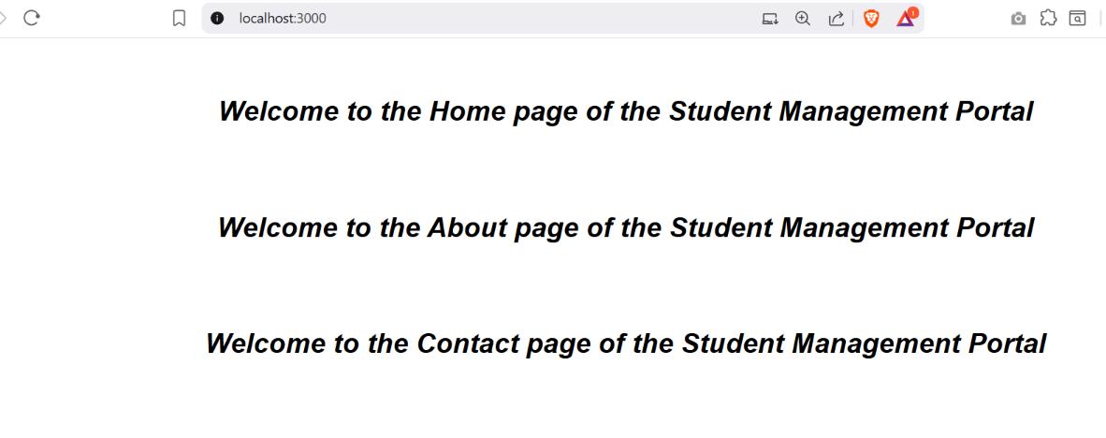
OUTPUT:

