TDD using JUnit5 and Mockito
Exercise 4: Arrange-Act-Assert (AAA) Pattern, Test Fixtures, Setup and Teardown Methods in Junit

//Calculator.java
package com.AAA.patterns;

public class Calculator {
public int add(int a, int b) {
return a + b;
}

public int subtract(int a, int b) {
return a - b;
}
}

//CalculatorTest.java
package com.AAA.patterns;

import org.junit.jupiter.api.*; // JUnit 5 imports
import static org.junit.jupiter.api.Assertions.*; // JUnit 5 assert

public class CalculatorTest {

private Calculator calculator;

@BeforeEach
void setUp() {
calculator = new Calculator();
System.out.println("Setup complete.");
}

@AfterEach
void tearDown() {
calculator = null;
System.out.println("Teardown complete.");
}

@Test
void testAddition() {
// Arrange
int a = 10;
int b = 5;

// Act
int result = calculator.add(a, b);

// Assert
assertEquals(15, result);
}

@Test
void testSubtraction() {
// Arrange
int a = 10;
int b = 3;

// Act
int result = calculator.subtract(a, b);

// Assert
assertEquals(7, result);
}
}

//pom.xml
<project xmlns="http://maven.apache.org/POM/4.0.0"
xmlns:xsi="http://www.w3.org/2001/XMLSchema-instance"
xsi:schemaLocation="http://maven.apache.org/POM/4.0.0 https://maven.apache.org/xsd/maven-4.0.0.xsd">
<modelVersion>4.0.0</modelVersion>

<groupId>AAA</groupId>
<artifactId>AAA_Pattern</artifactId>
<version>0.0.1-SNAPSHOT</version>

<dependencies>
<!-- JUnit Jupiter (API + Engine) -->
<dependency>
<groupId>org.junit.jupiter</groupId>
<artifactId>junit-jupiter</artifactId>
<version>5.9.3</version>
<scope>test</scope>
</dependency>
</dependencies>

<build>
<plugins>
<!-- Correct Surefire Plugin version to support JUnit 5 -->
<plugin>
<groupId>org.apache.maven.plugins</groupId>
<artifactId>maven-surefire-plugin</artifactId>
<version>3.0.0-M9</version>
</plugin>
</plugins>
</build>
</project>

OUTPUT:
Junit Test:
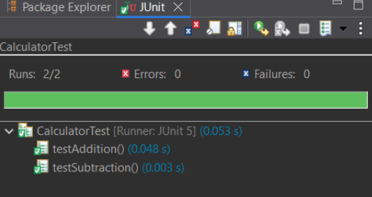

Maven Test for CalculatorTest:
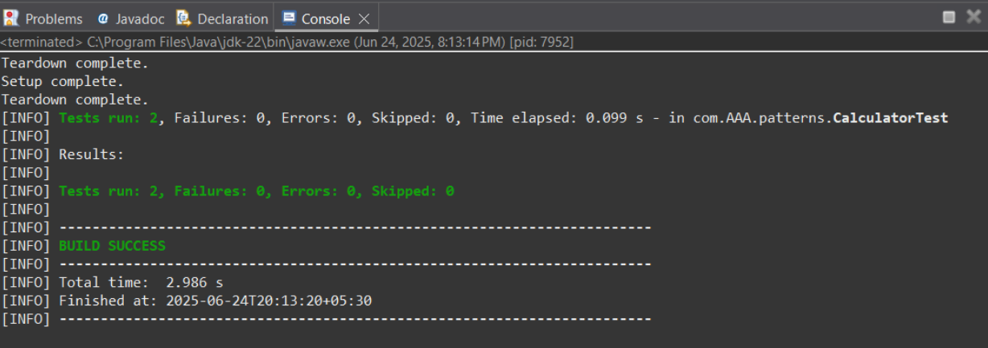

Maven Test for Calculator:
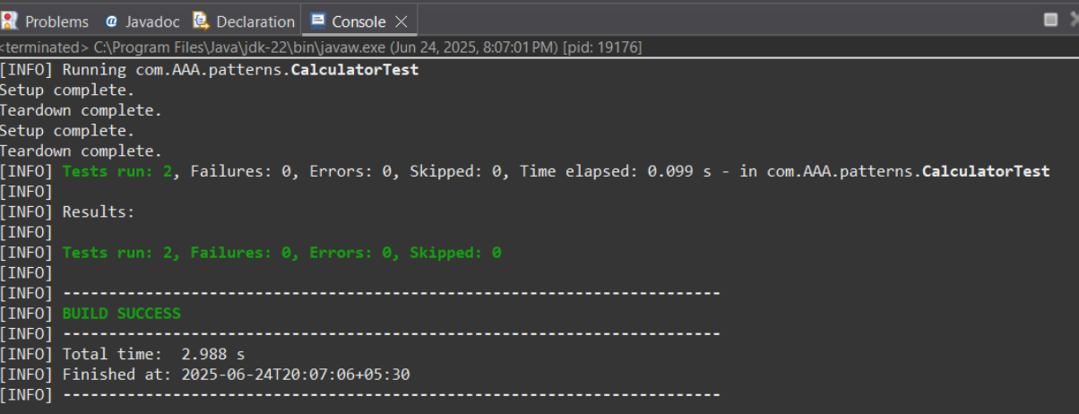
Pom.xml:
