TDD using JUnit5 and Mockito
Exercise 3: Assertions in JUnit
//Assertion.java
package com.AssertionInJUnit.junit;

import org.junit.jupiter.api.Test; // Required to mark the method as a test

import static org.junit.jupiter.api.Assertions.*;

public class Assertion {

@Test
public void testAssertions() {
// Assert equals
assertEquals(5, 2 + 3);

// Assert true
assertTrue(5 > 3);

// Assert false
assertFalse(5 < 3);

// Assert null
assertNull(null);

// Assert not null
assertNotNull(new Object());
}
}
//pom.xml
<project xmlns="http://maven.apache.org/POM/4.0.0"
xmlns:xsi="http://www.w3.org/2001/XMLSchema-instance"
xsi:schemaLocation="http://maven.apache.org/POM/4.0.0 https://maven.apache.org/xsd/maven-4.0.0.xsd">
<modelVersion>4.0.0</modelVersion>

<groupId>sudeep</groupId>
<artifactId>AssertionInJUnit</artifactId>
<version>0.0.1-SNAPSHOT</version>

<dependencies>
<!-- JUnit Jupiter (API + Engine) -->
<dependency>
<groupId>org.junit.jupiter</groupId>
<artifactId>junit-jupiter</artifactId>
<version>5.9.3</version>
<scope>test</scope>
</dependency>
</dependencies>

<build>
<plugins>
<!-- Correct Surefire Plugin version to support JUnit 5 -->
<plugin>
<groupId>org.apache.maven.plugins</groupId>
<artifactId>maven-surefire-plugin</artifactId>
<version>3.0.0-M9</version>
</plugin>
</plugins>
</build>
</project>

OUTPUT:
Junit Test:
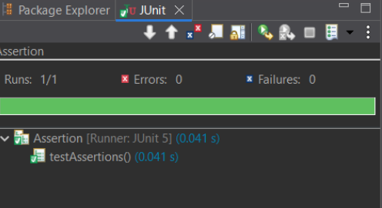

Maven Test:
