SLF4J logging framework

Exercise 1: Logging Error Messages and Warning Levels

//TestErrorMessage.java
package com.logging;

import org.slf4j.Logger;
import org.slf4j.LoggerFactory;

public class TestErrorMessages {
private static final Logger logger = LoggerFactory.getLogger(TestErrorMessages.class);

public static void main(String[] args) {
logger.error("This is an error message");
logger.warn("This is a warning message");
}
}
//pom.xml
<project xmlns="http://maven.apache.org/POM/4.0.0"
xmlns:xsi="http://www.w3.org/2001/XMLSchema-instance"
xsi:schemaLocation="http://maven.apache.org/POM/4.0.0
https://maven.apache.org/xsd/maven-4.0.0.xsd">

<modelVersion>4.0.0</modelVersion>

<groupId>Log</groupId>
<artifactId>SLF4J</artifactId>
<version>0.0.1-SNAPSHOT</version>

<dependencies>
<!-- SLF4J API -->
<dependency>
<groupId>org.slf4j</groupId>
<artifactId>slf4j-api</artifactId>
<version>1.7.30</version>
</dependency>

<!-- Logback (SLF4J Binding) -->
<dependency>
<groupId>ch.qos.logback</groupId>
<artifactId>logback-classic</artifactId>
<version>1.2.3</version>
</dependency>
</dependencies>

</project>

OUTPUT:
Maven Test for TestErrorMessage:
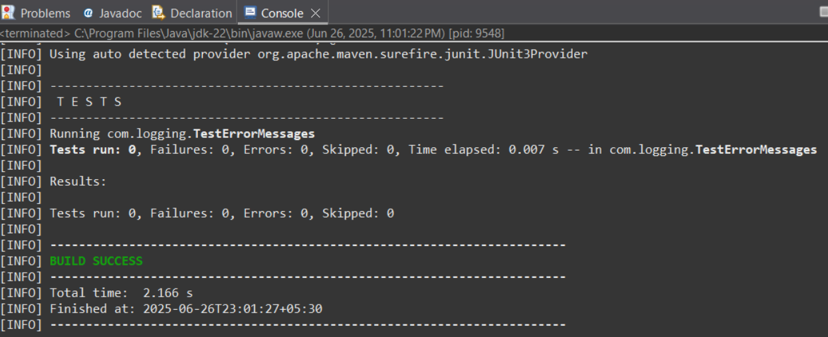

Pom.xml:
