Mockito exercises
Exercise 1: Mocking and Stubbing

//ExternalApi.java
package com.mockito.stubbing;

public interface ExternalApi {
String getData();

String getData1();
}
//MyService.java
package com.mockito.stubbing;

// Service that uses ExternalApi
public class MyService {
private ExternalApi api;

public MyService(ExternalApi api) {
this.api = api;
}

public String fetchData() {
return api.getData();
}
}
//TestCase.java
package com.mockito.stubbing;

// Needed for assertEquals
import static org.junit.jupiter.api.Assertions.*;
import static org.mockito.Mockito.*;

import org.junit.jupiter.api.Test;
import org.mockito.Mockito;

// Test class
public class TestCase {

@Test
public void testExternalApi() {
// Create a mock for the ExternalApi
ExternalApi mockApi = Mockito.mock(ExternalApi.class);

// Stub the getData() method
when(mockApi.getData()).thenReturn("Mock Data");

// Inject mock into MyService
MyService service = new MyService(mockApi);

// Call the method under test
String result = service.fetchData();

// Assert the result
assertEquals("Mock Data", result);
}
}

//pom.xml
<project xmlns="http://maven.apache.org/POM/4.0.0"
xmlns:xsi="http://www.w3.org/2001/XMLSchema-instance"
xsi:schemaLocation="http://maven.apache.org/POM/4.0.0 https://maven.apache.org/xsd/maven-4.0.0.xsd">

<modelVersion>4.0.0</modelVersion>
<groupId>TDDMockito</groupId>
<artifactId>mockito</artifactId>
<version>0.0.1-SNAPSHOT</version>

<properties>
<maven.compiler.source>11</maven.compiler.source>
<maven.compiler.target>11</maven.compiler.target>
<project.build.sourceEncoding>UTF-8</project.build.sourceEncoding>
<junit.jupiter.version>5.10.0</junit.jupiter.version>
<mockito.version>5.11.0</mockito.version>
<surefire.version>3.2.3</surefire.version> <!-- Updated surefire version -->
</properties>

<dependencies>
<!-- JUnit 5 -->
<dependency>
<groupId>org.junit.jupiter</groupId>
<artifactId>junit-jupiter</artifactId>
<version>${junit.jupiter.version}</version>
<scope>test</scope>
</dependency>

<!-- Mockito Core -->
<dependency>
<groupId>org.mockito</groupId>
<artifactId>mockito-core</artifactId>
<version>${mockito.version}</version>
<scope>test</scope>
</dependency>

<!-- Mockito JUnit 5 integration -->
<dependency>
<groupId>org.mockito</groupId>
<artifactId>mockito-junit-jupiter</artifactId>
<version>${mockito.version}</version>
<scope>test</scope>
</dependency>

<!-- Add ByteBuddy dependency for Mockito's modern mocking -->
<dependency>
<groupId>net.bytebuddy</groupId>
<artifactId>byte-buddy</artifactId>
<version>1.14.9</version>
<scope>test</scope>
</dependency>
</dependencies>

<build>
<plugins>
<!-- Updated Maven Surefire Plugin configuration -->
<plugin>
<groupId>org.apache.maven.plugins</groupId>
<artifactId>maven-surefire-plugin</artifactId>
<version>${surefire.version}</version>
<configuration>
<argLine>
--add-opens java.base/java.lang=ALL-UNNAMED
--add-opens java.base/java.util=ALL-UNNAMED
</argLine>
</configuration>
</plugin>

<!-- Add Maven Compiler Plugin for explicit configuration -->
<plugin>
<groupId>org.apache.maven.plugins</groupId>
<artifactId>maven-compiler-plugin</artifactId>
<version>3.11.0</version>
<configuration>
<release>11</release>
</configuration>
</plugin>
</plugins>
</build>
</project>

OUTPUT:
JUnit for TestCase:
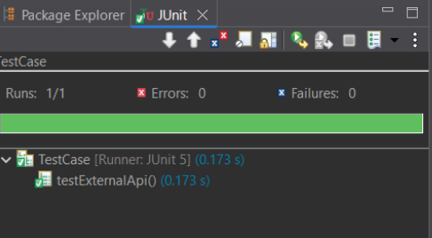

Maven Test for ExternalApi:
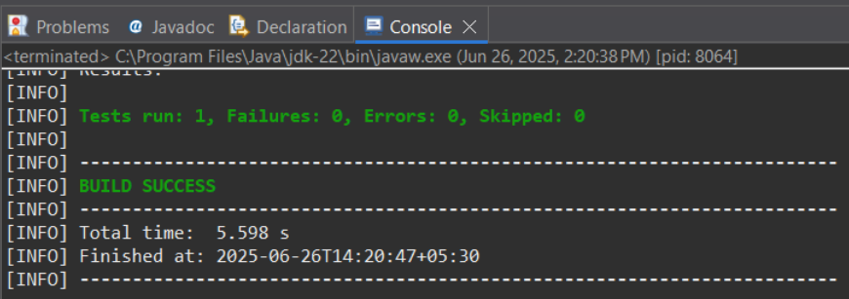
Maven Test for MyService:
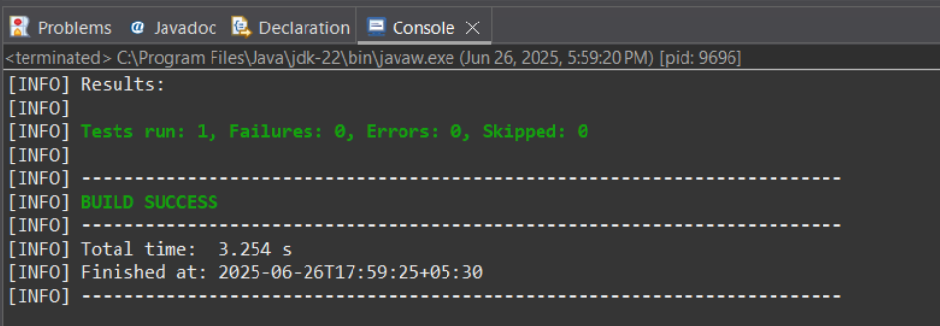
Maven Test for TestCase:
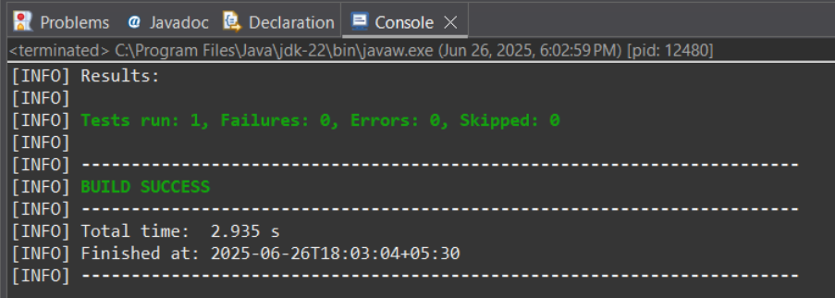
Pom.xml
