TDD using JUnit5 and Mockito

JUnit_Basic Testing Exercises

Exercise 1: Setting Up Junit

//Test3.java
package com.settingUp.junit;

import static org.junit.jupiter.api.Assertions.*;

import org.junit.jupiter.api.Test;

public class Test3 {
@Test
public void testAssertions() {
// Assert equals
assertEquals(5, 2 + 3);
// Assert true
assertTrue(5 > 3);
// Assert false
assertFalse(5 < 3);
// Assert null
assertNull(null);
// Assert not null
assertNotNull(new Object());
}
}

//pom.xml
<project xmlns="http://maven.apache.org/POM/4.0.0"
xmlns:xsi="http://www.w3.org/2001/XMLSchema-instance"
xsi:schemaLocation="http://maven.apache.org/POM/4.0.0 https://maven.apache.org/xsd/maven-4.0.0.xsd">
<modelVersion>4.0.0</modelVersion>

<groupId>SettingJUnit</groupId>
<artifactId>SJUnit</artifactId>
<version>0.0.1-SNAPSHOT</version>

<dependencies>
<!-- JUnit Jupiter (API + Engine) -->
<dependency>
<groupId>org.junit.jupiter</groupId>
<artifactId>junit-jupiter</artifactId>
<version>5.9.3</version>
<scope>test</scope>
</dependency>
</dependencies>

<build>
<plugins>
<!-- Correct Surefire Plugin version to support JUnit 5 -->
<plugin>
<groupId>org.apache.maven.plugins</groupId>
<artifactId>maven-surefire-plugin</artifactId>
<version>3.0.0-M9</version>
</plugin>
</plugins>
</build> </project>
OUTPUT :
JUnit Test:
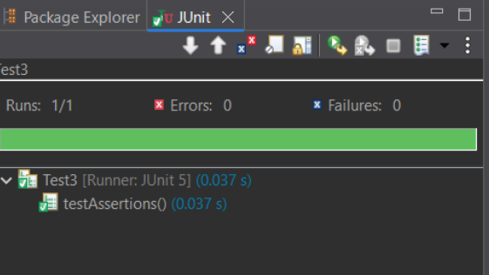
Maven Test:
