Mockito exercises
Exercise 2: Verifying Interactions
//DataUploader.java
package com.mockito;

public class DataUploader {
private final NetworkClient client;

public DataUploader(NetworkClient client) {
this.client = client;
}

public void performUpload() {
client.upload("TestPayload");
}
}
//NetworkClient.java
package com.mockito;

public interface NetworkClient {
void upload(String payload);
}
//TestDataUploader.java
package com.mockito;

import static org.mockito.Mockito.*;
import org.junit.jupiter.api.Test;
import org.mockito.Mockito;

public class TestDataUploader {
@Test
public void testUploadCalledWithCorrectArgument() {
// Step 1: Create mock
NetworkClient mockClient = Mockito.mock(NetworkClient.class);

// Step 2: Call method with specific argument
DataUploader uploader = new DataUploader(mockClient);
uploader.performUpload();

// Step 3: Verify interaction
verify(mockClient).upload("TestPayload");
}
}
//pom.xml
<project xmlns="http://maven.apache.org/POM/4.0.0"
xmlns:xsi="http://www.w3.org/2001/XMLSchema-instance"
xsi:schemaLocation="http://maven.apache.org/POM/4.0.0 https://maven.apache.org/xsd/maven-4.0.0.xsd">

<modelVersion>4.0.0</modelVersion>

<groupId>Verify</groupId>
<artifactId>VerifyingInteractions</artifactId>
<version>0.0.1-SNAPSHOT</version>

<dependencies>
<!-- JUnit 5 (Jupiter) for testing -->
<dependency>
<groupId>org.junit.jupiter</groupId>
<artifactId>junit-jupiter</artifactId>
<version>5.10.0</version>
<scope>test</scope>
</dependency>

<!-- Mockito core library -->
<dependency>
<groupId>org.mockito</groupId>
<artifactId>mockito-core</artifactId>
<version>5.11.0</version>
<scope>test</scope>
</dependency>
</dependencies>

<build>
<plugins>
<!-- Maven Surefire Plugin to run JUnit 5 tests -->
<plugin>
<groupId>org.apache.maven.plugins</groupId>
<artifactId>maven-surefire-plugin</artifactId>
<version>3.2.5</version>
<configuration>
<useModulePath>false</useModulePath>
</configuration>
</plugin>
</plugins>
</build>

</project>

OUTPUT :
JUnit test for TestDataUploader:
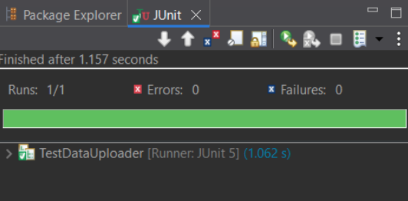
Maven Test for DataUploader:
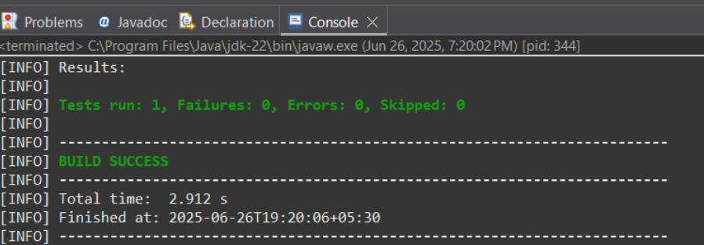
Maven Test for NetworkClient:
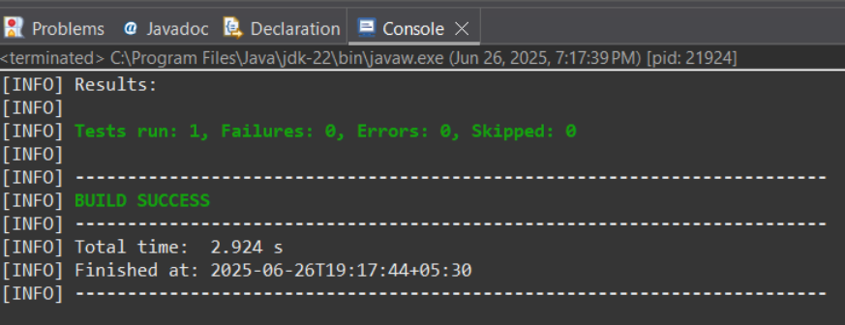
Maven Test for TestDataUploader:
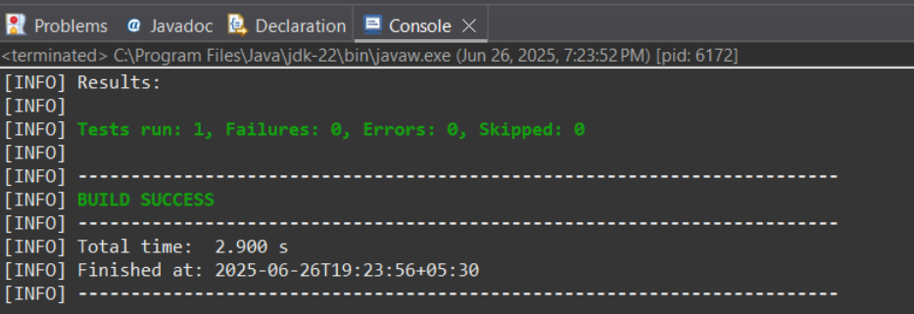
Pom.xml:
