Post-Mortem Audit of a Batch-Aware Inventory Engine for Perishable Goods
Geetha Lahari Barlapudi, Weevern Gong, Muhtadin Mushfiq, Rachana Peddi, and Harika Rangisetty
University of the Cumberlands
MSCS 532: Algorithms and Data Structures
Professor Michael Solomon
November 8, 2026

Executive Summary
Between Friday’s design sprint and Saturday’s optimization sprint, the project moved from a batch-level design to a working inventory prototype and then to a faster dashboard query. The core design survived. The reported top-10 query became 3.02 times faster on the 2,000-batch reference workload. The appropriate next step is to validate the measured version and run the larger workloads required for the dashboard before considering a store pilot.
Friday Design and Saturday Implementation
A grocery store can receive the same product in several lots with different expiration dates. Phase 1 used a dictionary as the authoritative batch ledger, per-product min-heaps for first-expiring-first-out allocation, and a store-wide heap to schedule expiry. The dictionary supports expected constant-time lookup by batch ID. Heap updates cost O(log H), where H includes stale entries. The design assumed a 90% read and 10% write workload for testing (Phase 1 Team, 2026).
Phase 2 implemented batch receiving, holds, fulfillment, cancellation, and expiry reconciliation. Its running per-product count supports expected constant-time availability retrieval when no expiry processing is due. That speed depends on updating the counter alongside the underlying quantities. The implementation also introduced a default three-day sell-by buffer and tracked order holds so expiry can reconcile affected orders. The handoff reports 42 tests and limits fulfillment to whole orders for one product (Phase 2 Team, 2026).

Dashboard Requirement and Optimization
The instructor’s dashboard requirement called for a read-only, store-wide query with k supplied at call time. It must return sellable batches by soonest expiry, breaking ties by batch ID. Sellable batches must be unexpired with positive on-hand quantity after subtracting reservations (MSCS 532 Residency, 2026a). This required ranked reporting across products in addition to the original point lookups and expiry processing.
The baseline profile attributed 73.7% of mixed-workload time to top_k_expiring. The baseline scanned the batch records and sorted all eligible candidates. The optimized implementation described in the report kept the scan and used heapq.nsmallest for bounded selection. With n scanned batches and m eligible candidates, the baseline costs O(n + m log m). For small k greater than one, bounded selection costs O(n + m log k). It reduces sorting work without adding a persistent index that every update must maintain (Phase 3 Team, 2026).
Reported Performance
At 2,000 batches, the reported top-10 time fell from 1,252.42 to 414.64 microseconds per call. Mixed profile time dropped from 0.217 to 0.093 seconds, a 2.33-fold speedup. Insert time fell from 4.38 to 3.70 microseconds, and peak traced memory declined from 1.15 to 1.06 MB. The top-2,000 query stayed near baseline at 1,200.30 versus 1,209.43 microseconds. The results support a small-k improvement. The dashboard acceptance workload calls for seeded runs near 10,000 and 100,000 records, with 500 top-10 queries interleaved with 500 updates at each size (MSCS 532 Residency, 2026a; Phase 3 Team, 2026).

Figure 1
Reported Dashboard Query Time at 2,000 Batches
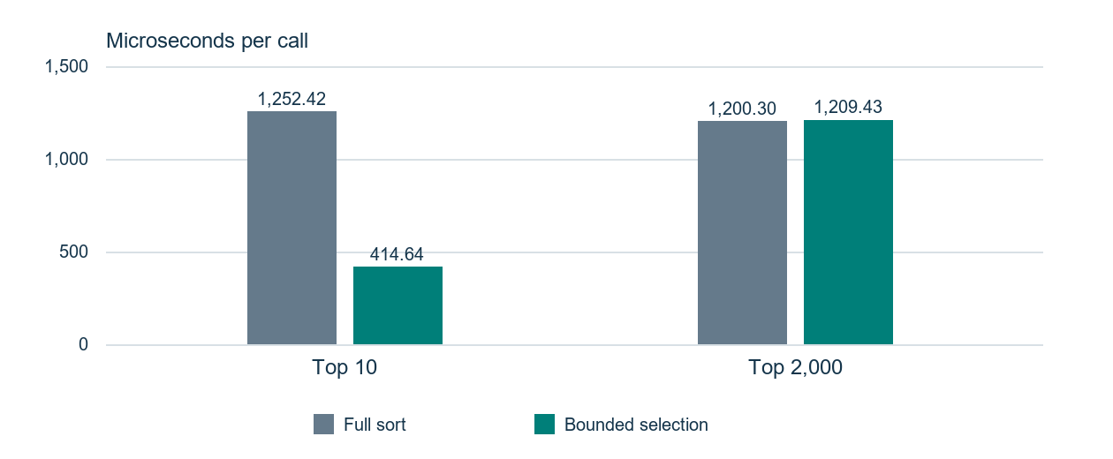
Times are microseconds per call. Source: Phase 3 profiling reports cited in the audit draft. The top-10 result improved about threefold. The top-2,000 result stayed near baseline.
For a stakeholder evaluating the dashboard, the relevant next comparison is the mixed workload with top-10 requests and interleaved updates at the two required scales. That comparison should pair the reported total run time with agreed query and update latency targets.
Critical Verdict and Next Iteration
The prototype retained the original batch lookup, expiry scheduling, and allocation model. The availability counter is a practical refinement for frequent stock checks, but it introduces another state invariant. The benchmark directly exercises ranked reporting and offers limited evidence about how reservation and expiry costs scale under churn. The baseline counted 2,699 expiry-heap entries for 1,000 live batches after 5,000 churn cycles. That observation shows why the heap cost must account for stale entries as well as live batches (Phase 3 Team, 2026).
The Phase 3 optimization handoff presents the clearest reproducibility risk. The improved report describes timing working-tree changes that were uncommitted when measured. The Phase 2 notes report tests, document the availability counter, and identify prototype limits. The Phase 3 finding is provisional until the measured implementation can be matched to the frozen tag. Dashboard correctness should be checked for expired and fully reserved batches, equal expiry dates, and state preservation across calls.
The next iteration should compare the three frozen phase tags, run the regression suite on the Phase 3 checkout, and publish the seeded generator, environment, and full-sort versus bounded-selection timings at both required scales. Then measure how often heap cleanup runs and test a compaction threshold against update latency. Protect the batch ledger from direct mutation before extending the service to durable storage or concurrent checkout. These steps make the prototype suitable for a more representative evaluation of dashboard and checkout workloads.
Set a dashboard latency target and an update-latency limit before the scale runs. Bounded selection keeps ranking work on demand. A maintained ordered index would trade extra memory and update work for faster ranked reads. Measure the same mixed workloads before making that trade. Stop tuning the query when it meets the agreed targets with headroom and passes the correctness checks. The in-memory benchmark does not measure storage or network latency (MSCS 532 Residency, 2026b).

References
Goh, C. H., Lu, H., Ooi, B. C., & Tan, K.-L. (1996). Indexing temporal data using existing B+-trees. Data & Knowledge Engineering, 18(2), 147–165. https://doi.org/10.1016/0169-023X(95)00034-P
Haijema, R. (2014). Optimal ordering, issuance and disposal policies for inventory management of perishable products. International Journal of Production Economics, 157, 158–169. https://doi.org/10.1016/j.ijpe.2014.06.014
Ketzenberg, M., Gaukler, G., & Salin, V. (2018). Expiration dates and order quantities for perishables. European Journal of Operational Research, 266(2), 569–584. https://doi.org/10.1016/j.ejor.2017.10.005
MSCS 532 Residency. (2026a). The curveball: The dashboard request [Course handout].
MSCS 532 Residency. (2026b). Trade-offs, scaling, and knowing when to stop [Lecture 4 slides].
Phase 1 Team. (2026). A batch-aware inventory engine for perishable goods [Design brief]. MSCS532.pdf.
Phase 2 Team. (2026). Implementation notes [Repository documentation]. IMPLEMENTATION_NOTES.md.
Phase 3 Team. (2026). Baseline profiling and optimized baseline [Repository profiling reports]. profiling/BASELINE.md and profiling/BASELINE_IMPROVED.md.

