SOFTWARE REQUIREMENTS
SPECIFICATION
AI Helpdesk University Chatbot
IEEE-Style SRS Document
Prepared from the project documentation and elicitation document
Team Members
Sanidhya Singh
Sanyam Jain
Sarthak Raheja
Samridh Raj
September 2026

1. Introduction

1.1 Purpose
This Software Requirements Specification (SRS) defines the requirements for the AI Helpdesk University Chatbot. The system is intended to provide students with a centralized conversational interface for obtaining quick, relevant and understandable answers to common university-related questions.

1.2 Scope
The AI Helpdesk University Chatbot is an AI-based conversational system for university helpdesk services. Students can ask questions in natural language about admissions, courses, examinations, fees, attendance, scholarships, departments, campus facilities and basic administrative processes. The system processes the query using AI/NLP techniques and retrieves or generates an appropriate response from the university's available information.
The system is intended to reduce repetitive queries and administrative workload while improving student access to university information. It supports the university helpdesk rather than completely replacing university administrative staff.

1.3 Definitions, Acronyms and Abbreviations
Term | Meaning
AI | Artificial Intelligence
NLP | Natural Language Processing
SRS | Software Requirements Specification
FAQ | Frequently Asked Question
Knowledge Base | University information used by the chatbot to provide responses
Authorized User | University user permitted to maintain or update the knowledge base

1.4 References
- AI Helpdesk University Chatbot – Project Documentation
- AI Helpdesk University Chatbot – Elicitation Document
The requirements in this SRS are derived from the supplied project documentation and elicitation material.

2. Overall Description

2.1 Product Perspective
The proposed system is a standalone AI-based university helpdesk solution that can be deployed on a university website or web application. It consists of a user interface, chatbot/AI engine, university knowledge base, query processing module, response generation module and an admin/update module.

2.2 Product Functions
- Allow students to submit university-related questions through a conversational interface.
- Understand and process natural-language queries.
- Identify the intent or category of a student's question.
- Retrieve relevant information from the university knowledge base.
- Generate and display an appropriate response.
- Support common academic, examination, admission, fee, scholarship, department, campus and basic administrative queries.
- Allow authorized users to update university information.
- Avoid exposing confidential student information without authentication.

2.3 User Classes and Characteristics
User Class | Role / Needs
Students | Primary users; need quick, accurate, understandable answers and access beyond normal working hours.
University Administrative Staff | Provide and maintain university information; need reduced repetitive workload and centralized information.
University Departments | Provide department-specific academic and administrative information.
System Administrator / Authorized User | Maintain the knowledge base and update system information when required.

2.4 Operating Environment
- Web-based university website or web application.
- Python-based implementation may be used.
- Natural Language Processing and AI/ML models may be used.
- Database systems may be used for storing university information.
- APIs/LLM services may be integrated if required.

2.5 Design and Implementation Constraints
- The chatbot must use university information as the basis for relevant responses.
- Confidential student information must not be exposed without authentication.
- The system must not make legally binding administrative decisions.
- The system must not make official changes to student records.
- The system must not process actual fee payments.
- Only authorized users should update university information.

2.6 Assumptions and Dependencies
- Students have access to the web interface through a supported device and browser.
- University information is available to the knowledge base.
- Authorized university users are available to maintain current information.
- AI/NLP services and supporting database/web technologies are available where required.

3. Functional Requirements

3.1 Student Query Submission
FR-01: The system shall provide a conversational interface through which students can submit university-related questions.
FR-02: The system shall accept questions expressed in natural language.

3.2 Natural Language Processing
FR-03: The system shall process natural-language student queries using AI/NLP techniques.
FR-04: The system shall identify the intent or category of the student's question.

3.3 Knowledge Retrieval
FR-05: The system shall retrieve relevant information from the university knowledge base.
FR-06: The system shall support information concerning academics, examinations, admissions, fees, scholarships, departments, campus information and basic administration.

3.4 Response Generation
FR-07: The system shall generate and display an appropriate response to the student's query.
FR-08: Responses shall be relevant and understandable to students.

3.5 Knowledge Base Management
FR-09: The system shall allow authorized users to update university information in the knowledge base.
FR-10: The system shall support maintenance of university information so that responses can remain current.

3.6 Confidential Information
FR-11: The system shall not provide confidential student information without authentication.

3.7 Handling Unsupported Queries
FR-12: If a relevant answer cannot be found, the system should avoid presenting unsupported information as an official answer. The supplied project documents identify this as an elicitation question but do not specify a final fallback workflow; therefore, the exact fallback behavior is to be finalized during detailed design.

4. Non-Functional Requirements

4.1 Performance
NFR-01: Responses should be quick enough to provide a practical helpdesk experience.

4.2 Usability
NFR-02: The interface should be simple and require minimal training.
NFR-03: Responses should be understandable and relevant to students.

4.3 Availability and Accessibility
NFR-04: The chatbot should be available beyond normal working hours and support 24/7 access to university information.

4.4 Maintainability
NFR-05: University information shall be maintainable so that responses remain current.
NFR-06: Authorized users shall have an update mechanism for maintaining university information.

4.5 Security and Confidentiality
NFR-07: Confidential student information shall not be exposed without appropriate authentication.
NFR-08: Knowledge-base updates shall be restricted to authorized users.

4.6 Accuracy and Relevance
NFR-09: The system should provide accurate and relevant information based on the university's available information.

4.7 Scope Compliance
NFR-10: The system shall support university helpdesk activities and shall not completely replace administrative staff or perform legally binding administrative decisions.

5. External Interface Requirements

5.1 User Interface
- A simple conversational question-and-answer interface.
- An input area through which students can enter natural-language questions.
- A response area for displaying chatbot answers.
- The interface should require minimal training.

5.2 Software Interfaces
- University information database/knowledge base.
- AI/NLP or AI/ML components for query understanding and response generation.
- Web application or university website hosting environment.
- APIs/LLM services may be used if required.

5.3 Database / Knowledge Base Interface
The system shall access university information covering policies, departments, academics, fees, examinations and other supported categories. Authorized users shall be able to maintain this information.

5.4 Communication Interface
The chatbot is intended to operate through a web-based interface. Specific communication protocols, API endpoints and network-security configurations are not defined in the supplied project documentation and therefore remain design-level decisions.

6. Other Requirements

6.1 Information and Content Requirements
- The knowledge base should contain current university information.
- Information should cover common student needs such as examinations, scholarships, admission documents, attendance, fees and department information.

6.2 Authentication and Authorization
- Authentication is required before confidential student information is provided.
- Only authorized users may update the university knowledge base.

6.3 Out-of-Scope Requirements
- Making official changes to student records.
- Processing actual fee payments.
- Making admission decisions.
- Completely replacing university administrative staff.
- Providing confidential student information without authentication.
- Taking legally binding administrative decisions.

7. Appendices

Appendix A – Acceptance Criteria
ID | Requirement | Acceptance Condition
AC-01 | Student Query | A student can enter a university-related question through the chatbot interface.
AC-02 | Natural Language | The chatbot can process common student questions expressed in natural language.
AC-03 | Relevant Response | The chatbot returns information relevant to the query from available university information.
AC-04 | Information Coverage | The chatbot handles common academic, examination, admission, fee, scholarship, department, campus and basic administrative queries.
AC-05 | Knowledge Base | Authorized users can maintain/update university information used by the chatbot.
AC-06 | Accessibility | The chatbot is available to students beyond normal working hours.
AC-07 | Confidentiality | The chatbot does not provide confidential student information without authentication.
AC-08 | Usability | The interface is simple enough for students to use with minimal training.
AC-09 | Scope Compliance | The system does not process actual fee payments, make admission decisions, change student records or take legally binding administrative decisions.

Appendix B – Key Stakeholders
Stakeholder | Primary Interest
Students | Fast, accurate, easy-to-understand university information.
University Administrative Staff | Reduced repetitive workload and centralized information.
University Departments | Correct department-specific academic and administrative information.
System Administrator / Authorized User | Ability to maintain and update the knowledge base securely.

Appendix C – Key Findings from Elicitation
- Students need a centralized way to obtain university information without searching through multiple sources.
- Common queries include examinations, scholarships, admission documents, attendance, fees and department information.
- A conversational natural-language interface can simplify access to university information.
- The chatbot should provide quick, relevant responses and be available 24/7.
- A university knowledge base is essential for providing relevant information.
- Authorized users need an update mechanism so university information remains relevant.
- The chatbot should reduce repetitive helpdesk queries and administrative workload.
- Confidential student information must not be exposed without authentication.
- The chatbot is intended to support the university helpdesk, not completely replace administrative staff.

Appendix D – Data Flow and Decision Tree Diagrams
D.1 Data Flow Diagram (DFD) – Level 0
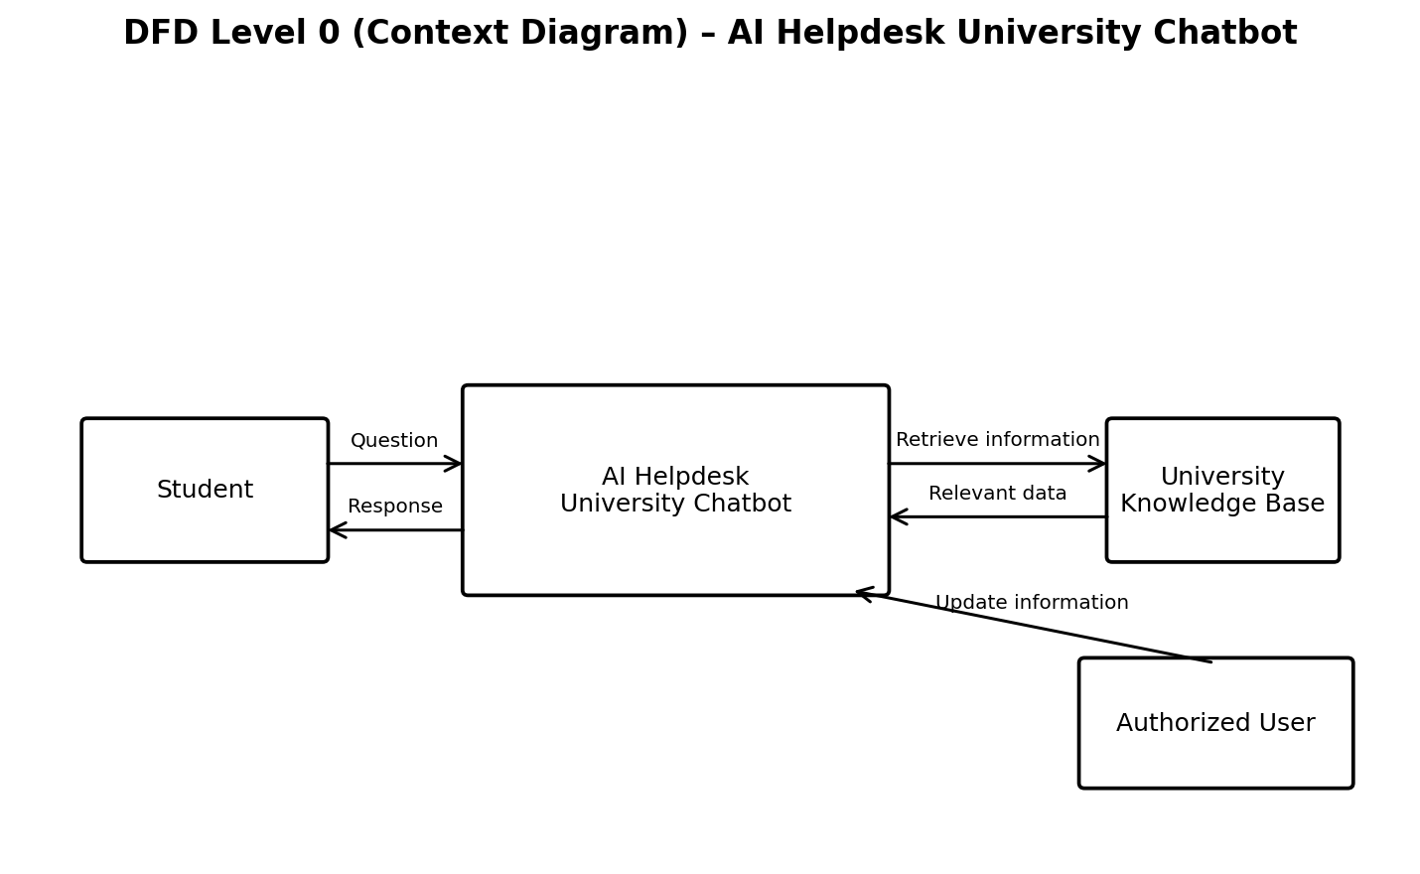
The Level 0 DFD shows the main interaction between the Student, the AI Helpdesk University Chatbot, the University Knowledge Base, and the Authorized User. Students submit questions and receive responses; the chatbot retrieves relevant university information; authorized users maintain the knowledge base.
D.2 Data Flow Diagram (DFD) – Level 1
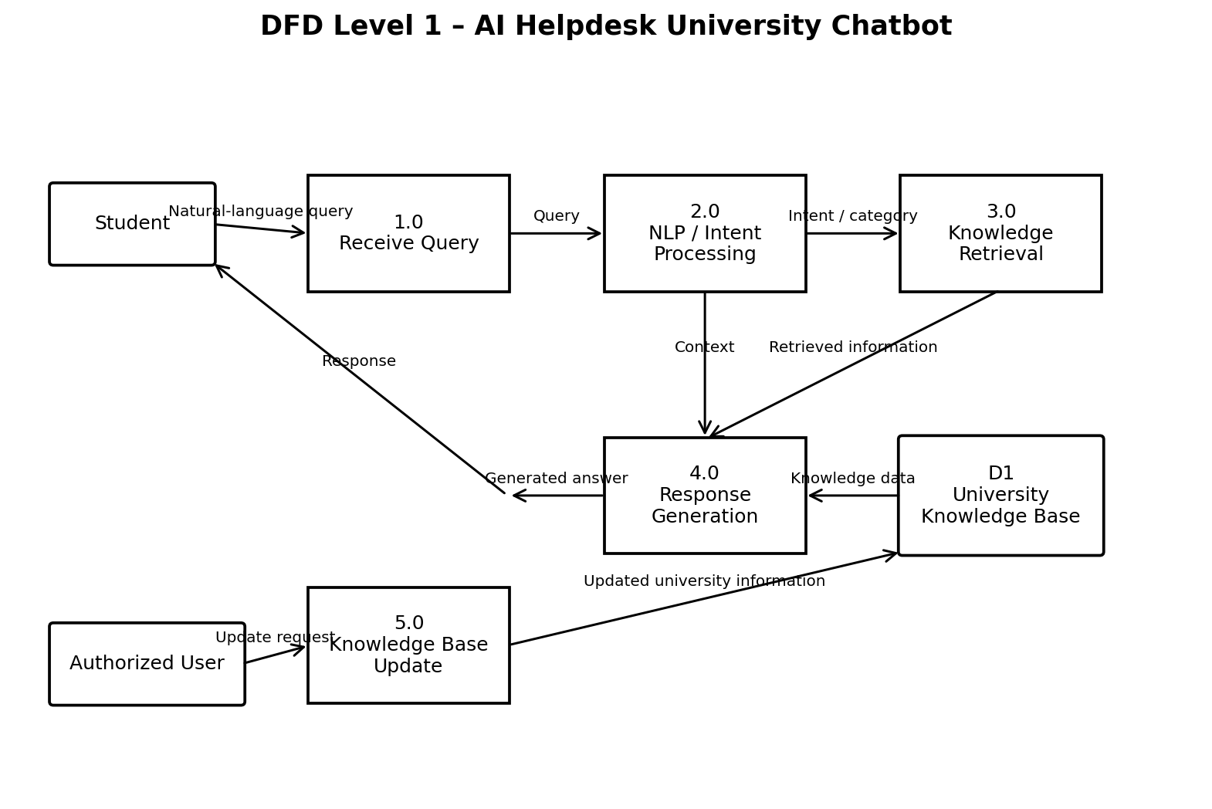
The Level 1 DFD decomposes the chatbot into query reception, NLP/intent processing, knowledge retrieval, response generation, and knowledge-base update processes. These processes reflect the functional requirements defined in the SRS.
AI HELPDESK UNIVERSITY CHATBOT - DECISION TABLE
Conditions / Actions | Rule 1 | Rule 2 | Rule 3 | Rule 4
User Authenticated? | Y | Y | Y | N
Authentication Required? | Y | Y | N | -
Relevant Answer Found? | Y | N | - | -
Actions
Process Query | Y | Y | Y | N
Retrieve Information | Y | N | Y | N
Generate & Display Response | Y | N | Y | N
Deny Confidential Information | N | Y | N | N
Handle Unsupported Query | N | Y | N | N
Note: Y = condition/action applies, N = does not apply, and - = not applicable. If no relevant answer is found, the chatbot should not present unsupported information as an official answer.

