CAMPAIGN CONTENT AGENT
What it is, how it works, and how to architect it
Research report covering concepts, workflow, frontend, backend, safety and overall system design
Summary
A campaign content agent is an AI agent that turns a marketing brief into a full campaign: strategy, content calendar, copy and visuals for each channel, brand and compliance checks, scheduling and publishing, and performance-based improvement.
Architecturally it is a web application with a campaign workflow engine, a brand knowledge base the model is grounded in, an agent orchestrator that calls tools, and channel integrations (social, email, CMS, ads).
The main design rule: ground every piece of content in approved brand and product facts, run automated checks, and require human approval before anything is published or money is spent.

1. What is a campaign content agent?
A marketing campaign needs many coordinated pieces: a goal and audience, messaging, posts, emails, landing-page copy, ad variants, images, and a schedule. A campaign content agent plans these steps and carries them out with tools. Unlike a chat window that writes one post on request, it works from a structured brief, remembers the brand, produces content for several channels at once, checks it, routes it for approval, and learns from the results.
 | Generic text generator | Marketing automation tool | Campaign content agent
Starting point | A prompt | Content you already wrote | A brief with goal, audience, channels
Brand awareness | Only what you paste | None (just schedules) | Brand kit and past content retrieved automatically
Multi-channel | One piece at a time | Yes, manual content | Plans and drafts all channels together
Quality control | None | None | Brand, claim and compliance checks
Learns from results | No | Reports only | Uses metrics to suggest and generate improvements

Core capabilities
- Brief intake: turn a loose request into a structured brief (objective, audience, offer, tone, channels, dates, budget, legal constraints).
- Research and strategy: summarize the product, audience and competitors; propose themes, messages and a content calendar.
- Content generation: posts, emails, ad copy and variants, blog outlines, landing-page copy, video scripts, alt text, and image prompts or generated images.
- Quality checks: brand voice, factual claims versus approved sources, platform length rules, regulatory wording, duplicate or near-copy detection.
- Workflow and publishing: review comments, versions, approval, scheduling and (when permitted) publishing through channel APIs.
- Optimization: read engagement and conversion data, explain what worked, and draft the next round of variants for A/B tests.
Typical prompts: "Plan a two-week launch campaign for our new plan on LinkedIn, Instagram and email", "Give me five headline variants for the festive sale", "Rewrite this post in our brand voice for a younger audience", "Which posts performed best last month and why?"

2. How it works

2.1 The campaign lifecycle
The agent follows a loop that mirrors how a marketing team works. Each stage is a set of tool calls, and the backend tracks the campaign state so work can pause for human review and resume.
- Brief: capture goal, audience, offer, channels and constraints in a structured form; ask for anything essential that is missing.
- Plan: retrieve the brand kit, product facts and past top performers; propose messaging pillars and a calendar.
- Generate: draft each asset per channel, with two or three variants where useful.
- Check: run automated brand, claim, compliance and similarity checks; revise and re-check (with a limit on loops).
- Review: a human edits, comments, approves or rejects; the agent applies the feedback to the right assets.
- Publish: schedule or publish approved items; send emails; launch ads within an approved budget.
- Measure and learn: ingest metrics, compare variants, store insights, and feed them into the next plan.

2.2 Worked example: "Two-week launch campaign for product X"
Step | Who | What happens
1 | Agent + frontend | Reads the brief; notices the budget and launch date are missing and asks one short question.
2 | Tool | search_brand_kb("tone, do-not-say list, product X facts") returns the approved voice rules and claims.
3 | Tool | get_past_performance(channel="linkedin", top=10) shows which formats and hooks worked before.
4 | Agent | Proposes three message pillars and a 14-day calendar across LinkedIn, Instagram and email.
5 | Content tools | Drafts 8 posts, 3 emails and image briefs, each tagged with the source fact it relies on.
6 | Checkers | Flags an unapproved "best in class" claim and a post over the character limit; the agent fixes both.
7 | Human | Reviews in the calendar view, edits two posts, approves the rest. Only then is scheduling allowed.

2.3 One agent or many?
An MVP can use a single agent with tools. As complexity grows, the work is often split into specialist roles that share campaign state: a planner (strategy and calendar), writers per channel, an editor/brand checker that critiques drafts, a designer for visuals, and an analyst for metrics. A writer-and-critic pair is the most useful split because an independent check catches errors the writer misses. More agents add cost and latency, so add roles only when a single agent's quality or reliability plateaus.

2.4 Grounding: how the agent stays on brand and accurate
- Brand kit: voice and tone rules, vocabulary, do-not-say lists, example posts, logo and color rules, stored as documents and structured fields.
- Product and claims library: approved facts, prices, offers and legal disclaimers. The agent must cite which entry supports each claim; unsupported claims are flagged.
- Retrieval (RAG): relevant brand and past-content snippets are fetched per task and put into the prompt, rather than relying on the model's memory of the brand.
- Performance memory: short summaries of what worked per channel and audience, updated after each campaign.

3. Overall architecture
The system separates the user experience, the controlling backend, the AI that creates and critiques, and the channels that affect the outside world.
Layer | Responsibility | Typical technology
Frontend | Brief, calendar, editor, previews, review and approval, analytics | React + TypeScript, Vite
Backend API | Auth, roles, endpoints, workflow state machine, streaming | FastAPI (Python) or Node
Agent orchestrator | Prompt assembly, tool loop, planner/writer/checker roles | Provider SDK tool calling, LangGraph
Tools + knowledge | Content, brand retrieval, checkers, analytics, channel actions | Typed functions, vector search
Integrations + workers | OAuth to channels, scheduling, publishing, metrics sync | Social/ESP/CMS APIs, Celery or Arq
Data layer | Campaigns, versions, brand KB, assets, metrics, logs | PostgreSQL, vector DB, object storage + CDN
Security + governance | Roles, approvals, spend limits, injection defence, audit | RBAC, KMS, policy checks

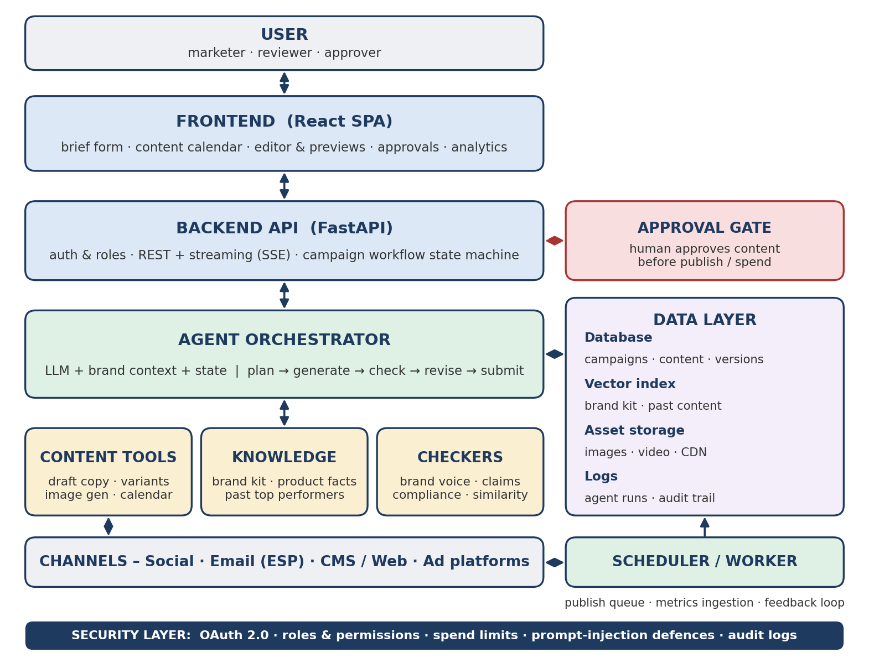
Figure 1. Layered architecture of a campaign content agent

4. Frontend
The frontend is a marketing workspace, not just a chat box. Marketers need to see the whole campaign, compare options, edit precisely and approve with confidence. It holds no credentials and talks only to your backend.
Screen / component | Purpose and key details
Campaign brief | Structured form (goal, audience, offer, channels, dates, budget, constraints) with an optional chat to refine it. Shows what the agent understood before it starts.
Brand kit and library | Upload and edit voice rules, do-not-say list, approved claims, product facts and example content. Changes here immediately affect generation.
Content calendar | Day/week view of every asset by channel and status (draft, in review, approved, scheduled, published). Drag to reschedule.
Editor with variants | Side-by-side variants, inline "regenerate this part", tone sliders, version history and diffs, and which source fact supports each claim.
Channel previews | Realistic previews per platform with character limits, hashtags, image crops and email rendering, plus a mobile view.
Review and approval | Comments on specific text, assign reviewers, approve or request changes. Publishing is disabled until the required approvals exist.
Analytics | Performance by asset, channel and variant, with agent-written insights and a "generate next round" action.

Design patterns that matter
- Show checks, not just output: display brand and compliance results next to each draft (passed, warning, blocked) with the reason.
- Fast iteration: stream drafts, allow partial regeneration, keep every version, and make undo trivial.
- Role-based views: creators edit, reviewers approve, admins manage the brand kit, integrations and budgets.
- Safe preview: render generated HTML (emails, pages) sanitized and sandboxed; never store channel tokens in the browser.

5. Backend
The backend is the trusted core: it authenticates users, owns the campaign workflow, runs the agent, and is the only component allowed to call publishing APIs.

5.1 Main services
Component | What it does
API layer | REST endpoints and a streaming endpoint for agent progress. Authentication, role checks, validation, rate limiting.
Workflow engine | State machine for each asset: draft, in review, approved, scheduled, published, failed. Enforces who may move an asset to the next state.
Agent service | Builds prompts with brand context, runs the tool loop and critic pass, limits steps and cost, records every run.
Knowledge service | Ingests brand documents, chunks and embeds them, serves hybrid (keyword + vector) retrieval with metadata filters such as brand, product and region.
Asset service | Stores images and video in object storage behind a CDN; image-generation calls; checks licenses and adds alt text.
Integration service | OAuth and token storage for social, email service provider, CMS and ad platforms; handles each platform's format and quota rules.
Scheduler and workers | Publish at the planned time with retries and idempotency; pull metrics on a schedule; run batch generation jobs.
Observability | Traces per run (prompts, tool calls, cost, latency), content-quality metrics, error alerts, spend monitoring.

5.2 Example API surface
Endpoint | Purpose
POST /campaigns, GET /campaigns/{id} | Create a campaign from a brief; fetch plan, assets and status.
POST /campaigns/{id}/generate (streaming) | Run the agent to plan or draft; stream progress and results.
PATCH /assets/{id}, POST /assets/{id}/regenerate | Edit text or regenerate part of an asset with instructions.
POST /assets/{id}/review, /approve | Comment, request changes or approve; checked against role rules.
POST /campaigns/{id}/schedule | Queue approved assets for publishing (rejected if approvals are missing).
POST /brand/documents, GET /brand/search | Add brand material; test what the agent would retrieve.
GET /campaigns/{id}/metrics | Normalized performance data and agent insights.

5.3 Data model
Collection / table | Key contents
brands, brand_documents | Voice rules, do-not-say lists, approved claims, product facts, source files, embeddings and metadata.
campaigns | Brief, goals, audience, channels, budget, dates, status, owner and plan.
assets, asset_versions | Channel, text, media references, status, supporting-source IDs, check results, who changed what and when.
approvals | Required approvers, decisions, comments, timestamps (feeds the audit trail).
channel_accounts | Connected accounts, granted scopes, encrypted tokens, rate-limit state.
metrics, insights | Per-asset and per-variant performance snapshots and the agent's stored learnings.
agent_runs, audit_log | Prompts, tool calls, models, cost; append-only record of approvals, publishes and spend.

5.4 Orchestration choices
- Workflow plus agent: keep the lifecycle (states, approvals, scheduling) in deterministic code and use the LLM inside each step. This is more reliable than letting the model decide the entire process.
- Writer and critic pass: a second model call with a checklist (brand rules, claims, platform limits) reviews each draft before a human sees it; unsupported claims are removed or flagged.
- Structured outputs: require JSON for plans and assets (channel, text, source IDs) so the backend can validate and the frontend can render reliably.
- Durable pauses: a framework such as LangGraph, or your own state machine, lets a run wait days for approval and then resume.

6. Tools and risk levels
Risk level | Tools | Policy
Read | get_brief, search_brand_kb, get_product_facts, get_past_performance, get_metrics | Automatic, scoped to the brand
Analyze | audience_summary, trend_and_keyword_research, competitor_summary | Automatic; cite sources used
Create | draft_post, draft_email, generate_variants, generate_image, build_calendar | Automatic; saved as drafts only
Check | brand_voice_check, claim_check, compliance_check, similarity_check, platform_limits | Automatic; failures block submission
Reversible | save_version, schedule_unpublished, add_tags | Allowed; logged and undoable
Irreversible / costly | publish_post, send_email_campaign, launch_ad, change_budget | Approval required; budget and frequency caps

7. Safety, legal and reliability
- Hallucinated claims: the biggest content risk is an invented statistic, price or promise. Require every factual claim to map to an approved source ID, and block publishing when it does not.
- Brand safety and tone: do-not-say lists, sensitivity checks (politics, religion, tragedies, competitors), and a human review for new or sensitive topics.
- Intellectual property: run similarity checks against known content, track the license and origin of images, and avoid imitating a named living creator or a competitor's copy. Review the terms of your model and image providers on commercial use.
- Disclosure and regulation: follow advertising rules (for example ASCI guidelines in India, FTC rules in the US) on endorsements, comparative claims and sponsored content. Respect platform policies on AI-generated content labelling where they apply.
- Email consent and privacy: only send to people who have consented; support unsubscribe; follow CAN-SPAM, GDPR or India's DPDP Act as applicable; keep customer data out of prompts unless needed.
- Prompt injection and data trust: web pages, competitor content and uploaded documents can contain hidden instructions. Treat retrieved text as data, never let it change tools or permissions, and keep publish rights behind approval.
- Cost and spend control: cap tokens, image generations and ad budgets per campaign; require approval to raise limits; alert on anomalies.
- Reliability: idempotent publishing to avoid duplicate posts, retries with backoff, platform rate limits, token refresh, and a clear failed state with a human fallback. Platform API rules and approval requirements change, so verify them for each channel.
- Evaluation: track brand-voice score from a labelled test set, first-draft approval rate, edit distance (how much humans change), fact-check pass rate, time saved, cost per asset, and real engagement or conversion lift through A/B tests.

8. Recommended stack, roadmap and limits
Part | Suggested choice | Notes
Frontend | React, TypeScript, Vite, Tailwind | Rich-text editor such as TipTap; calendar component
Backend | Python, FastAPI, Pydantic | Async I/O; separate API and worker processes
Agent | Provider SDK tool calling; LangGraph for long workflows | Structured (JSON) outputs for plans and assets
Models | Strong text model; separate image model | Use smaller models for checks and variants
Data | PostgreSQL, Qdrant/Chroma/pgvector, S3-style storage + CDN | Metadata filters on brand and region
Channels | Social, ESP, CMS and ads APIs | Start with one or two; review each platform's approval process

Phase | Scope
V1 (MVP) | Brief form, brand kit upload and retrieval, text generation for 2 channels, brand and claim checks, export or copy (no auto-publish).
V2 | Content calendar, versions, review and approval workflow, image generation, scheduling to one channel.
V3 | Metrics ingestion, A/B variant generation, performance insights, multi-channel publishing, email campaigns.
V4 | Multi-brand and multi-region, ad management with budget controls, specialist multi-agent roles, localization.

Known limitations: generated content can sound generic without strong brand examples, models can misstate facts, creative quality and cultural nuance still need human judgment, channel APIs restrict what can be automated, and measured results are noisy. The agent speeds up production and iteration; strategy and final accountability stay with people.

Key takeaways
Campaign agent = brief + brand knowledge + generation tools + checkers + workflow + channel integrations + feedback loop.
Flow: Brief, Plan, Generate, Check, Human review, Publish, Measure, Learn.
Build order: grounded drafting with checks first, then approval workflow and scheduling, then automated optimization.
Compared with an inbox agent, the main risk shifts from private data access to brand, legal and cost risk, so approvals, claim checks and spend limits matter most.

References for further reading
Documentation for the channel APIs you plan to use (for example Meta, LinkedIn, X, your email service provider, and your CMS). OWASP Top 10 for LLM Applications. Advertising Standards Council of India (ASCI) guidelines and the US FTC endorsement guides. Anthropic and OpenAI documentation on tool use, structured outputs and retrieval. LangGraph documentation on human-in-the-loop workflows.

