SALES AI AGENT PLATFORM
Knowledge-Based Agent
System Architecture & Technical Design
The core knowledge and context layer of a centralized six-agent Sales AI automation system
Document | Version | Primary Focus | System Context
Knowledge-Based Agent: Technical Design | 1.1 (revised) | Knowledge and context intelligence | Centralized Sales AI Platform
Prepared using the supplied Oldy Buddy System Architecture & MVP Flowchart documents as architectural reference.

1. Purpose and Project Context
This document defines the architecture and technical design of the Knowledge-Based Agent. It is the shared intelligence layer that collects, organizes, retrieves, validates and assembles the information the other sales agents need. The design follows one lifecycle: ingest → understand → store → retrieve → assemble context → ground agent decisions → update.
Overall project context: The Sales AI Agent Platform consists of six specialized agents: Knowledge-Based, Lead Research, Campaign Content, Outreach, Inbox/Reply Intelligence, and Lead Lifecycle/Next Action. The Knowledge-Based Agent acts as the centralized knowledge and context layer, providing trusted, relevant and up-to-date information to the other agents.

Core principle: The Knowledge-Based Agent is not a generic chatbot or a single vector database. It is a governed knowledge and context service that combines structured business data, semantic knowledge, event history and current interaction context.

2. Problem Statement and Goals

The problem
- Sales knowledge is scattered across CRM records, documents, playbooks, emails, calls and notes.
- Different agents may work from different or incomplete versions of the same lead or company.
- Vector search alone cannot provide reliable business state, permissions, recency or lifecycle context.
- LLMs can produce plausible but unsupported statements if evidence is not retrieved before they reason.
- Every interaction changes a lead's state, so knowledge must be updated from events, not kept as static documents.

What the agent must achieve
- One trusted layer: give all six agents the same relevant, current and permission-aware context.
- Combined knowledge: unite structured data, semantic knowledge and event history, and keep the relationships between leads, people, companies, campaigns, products and conversations.
- Task-based retrieval: return evidence for the current task, not undifferentiated information.
- Trust and provenance: keep source, timestamp and confidence for key knowledge, and stop unsupported claims reaching customers.
- Continuous updates: learn from new research, outreach, replies, meetings, CRM changes and human corrections.
- Clean interface: expose an API and event interface so other agents never need to know how knowledge is stored.

3. Role in the Overall Platform
The Knowledge-Based Agent is a shared dependency, not a step in a linear chain. Agents request knowledge from it, and their completed actions produce new events that are written back into the knowledge layer.
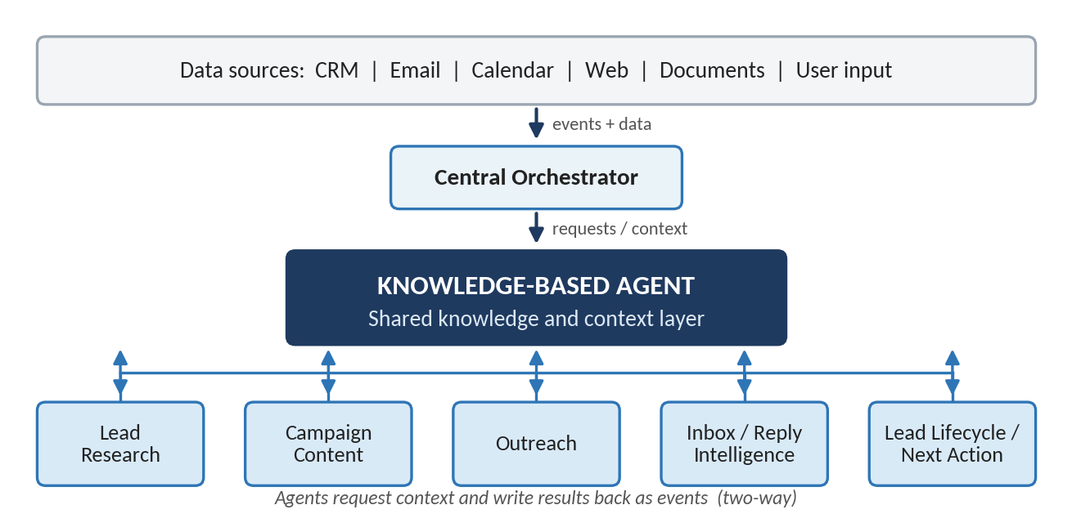
Figure 1: Position of the Knowledge-Based Agent in the Sales AI platform

Functional responsibilities
Capability | Responsibility
Ingestion and normalization | Brings in documents, CRM data, communications, research and events, and converts them into consistent entities, fields, metadata and timestamps.
Entity resolution | Links people, leads, companies, campaigns, products and conversations correctly.
Knowledge storage | Maintains structured records, semantic representations and historical events.
Retrieval and context assembly | Finds information relevant to a specific agent task and packages it as compact, task-specific context.
Grounding and provenance | Exposes sources and evidence, and records where knowledge came from, when it was observed and how it was transformed.
Updates and conflict handling | Applies new facts, research and human corrections; detects conflicting information and applies source and recency rules.
Access control | Ensures retrieved knowledge respects user, tenant and agent permissions.
Context freshness | Refreshes stale information before high-impact actions.

4. Knowledge-Based Agent Architecture
Figure 2 shows the internal architecture. Knowledge flows downward through six layers: sources, ingestion, processing, storage, retrieval and context assembly. The result, a ContextPackage, goes to the orchestrator and agents. Their results return as events (green arrow), and governance applies to every layer.
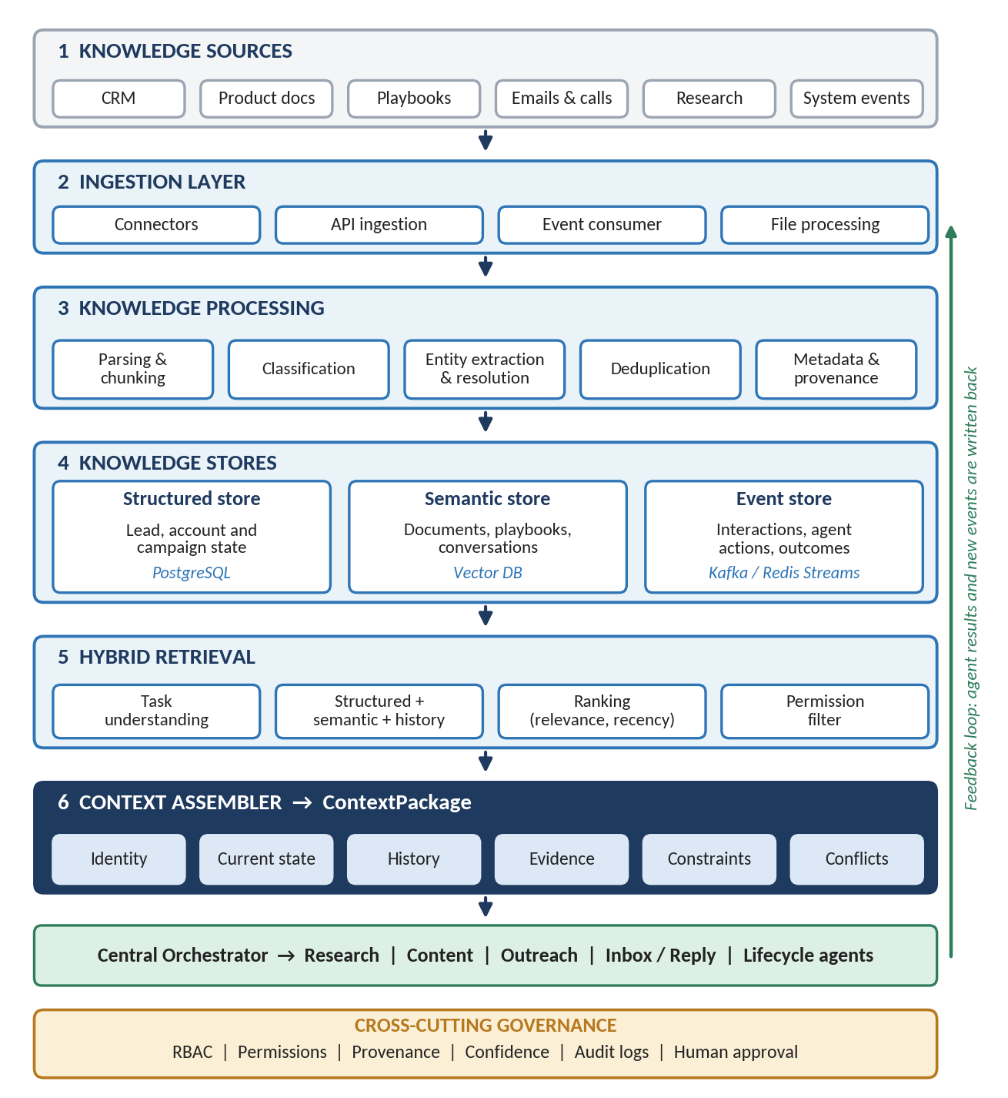
Figure 2: Knowledge-Based Agent architecture

5. Knowledge Domains
The agent organizes sales knowledge into nine domains, each serving a different purpose.
Domain | Examples | Why it matters
Company knowledge | Products, services, positioning, case studies, pricing rules | Grounds customer-facing claims
Customer / account | Company profile, industry, size, technology, business signals | Supports research and personalization
Contact / lead | Role, persona, qualification, preferences | Determines relevance and messaging
Conversation | Emails, replies, calls, meeting notes | Maintains continuity and intent
Campaign | Objective, audience, messaging, sequence, content | Keeps campaigns consistent
Sales playbooks | ICP, qualification, objection handling, lifecycle rules | Provides governed sales guidance
Activity history | Outreach, engagement, meetings, CRM changes | Records what actually happened
Research knowledge | News, hiring, expansion, strategic signals | Adds current external evidence
User corrections | Seller edits, approvals, overrides | Improves trust and future context

6. Knowledge Lifecycle and Updates
Knowledge is never static. Every agent action creates new information, which flows back into the same lifecycle.
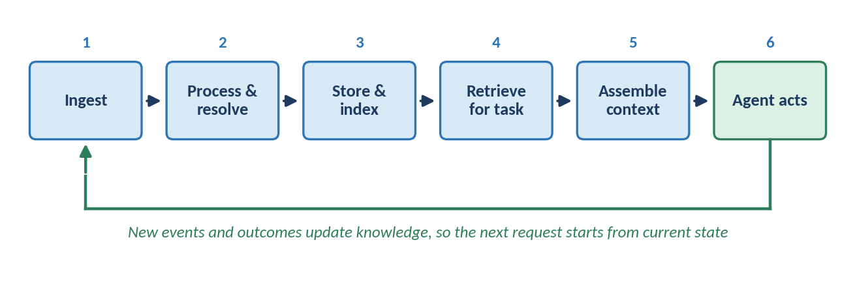
Figure 3: Knowledge lifecycle

Ingestion and processing pipeline
- Receive source data from the CRM, email, document stores, research tools, user input or platform events.
- Parse and chunk each source into usable text and structured fields (for example, text from a PDF, email or transcript).
- Normalize and classify names, dates and identifiers; identify document type, knowledge domain and sensitivity.
- Extract entities and facts such as person, company, product, campaign, pain point and interaction; store key facts separately from document text.
- Resolve and deduplicate against existing records so 'ABC Tech' is linked to the existing ABC Technologies account instead of creating a copy.
- Attach metadata: source, timestamp, author or system, confidence, permissions and version.
- Persist and announce: write to the structured, semantic and event stores, then publish a knowledge-updated event when material information changes.

Short workflow: new lead to personalized outreach
- A new lead enters the CRM and the orchestrator requests its context from the Knowledge-Based Agent.
- The agent resolves the person and company, then retrieves existing knowledge, history and campaign data.
- The Research Agent researches only what is missing; findings return with sources and timestamps, and an updated ContextPackage goes to the Campaign Content and Outreach agents.
- The outreach event is recorded, and later replies update the knowledge layer and trigger the next lifecycle decision.

Event-driven updates
Knowledge stays current through events, each triggering a specific update:
Event | Knowledge action
LEAD_CREATED | Create or resolve the lead and account entities.
RESEARCH_COMPLETED | Store findings, evidence and timestamp.
OUTREACH_SENT | Record the communication and update activity state.
EMAIL_RECEIVED / REPLY_CLASSIFIED | Store the message, link it to the conversation and save intent or objection signals.
MEETING_BOOKED / COMPLETED | Update lifecycle state; store the outcome and notes.
CRM_UPDATED | Synchronize authoritative structured state.
HUMAN_CORRECTION | Record the corrected fact with an audit trail.
CAMPAIGN_UPDATED | Refresh campaign context and invalidate affected cached context.

7. Knowledge Representation and Data Stores
No single store suits every kind of sales knowledge, so the agent keeps three representations: structured data (state and relationships), semantic knowledge (documents, playbooks, conversations) and event history (what happened and when). Retrieval combines all three.
Store | Purpose | Example technology
Relational database | System of record for structured sales state | PostgreSQL
Vector database | Semantic retrieval of documents and conversations | Production vector DB with embeddings
Event store / broker | Chronological events and asynchronous agent triggers | Kafka, Redis Streams or equivalent
Cache | Short-lived context, jobs, rate limits and workflow state | Redis
Object storage | Original documents, transcripts and artifacts | S3-compatible storage
LLM / embedding service | Reasoning, extraction, classification and embeddings | Enterprise LLM and embedding provider

8. Retrieval and Context Assembly
Retrieval is hybrid. Semantic similarity finds relevant text, but sales decisions also depend on exact identifiers, lifecycle state, permissions and recency. Each request follows the same path: the agent request is analyzed, a retrieval plan queries the structured, semantic and event stores in parallel, results are ranked by relevance, recency, source quality and confidence, restricted items are removed by the permission filter, and the remainder is assembled into context.
The output is a structured ContextPackage, not a raw list of search results:
Context section | Typical contents
Identity | Lead ID, contact, company, role, account relationships
Current state | Lifecycle stage, campaign, owner, open tasks, pending action
Relevant knowledge | Product and service information, playbook guidance, relevant documents
Interaction history | Recent and important communications and meetings
Research and signals | Current research findings, intent, engagement and qualification signals
Constraints | Messaging and channel rules, permissions, approval requirements
Evidence | Sources, timestamps, confidence and provenance
Conflicts | Known discrepancies that require caution or resolution
Context freshness. Stable, frequently used knowledge can be cached, while current lead state and recent interactions use short freshness windows. High-impact actions trigger a refresh when material information may have changed; updates invalidate affected cached context, and cached context always carries a timestamp and version.

9. Knowledge Quality, Provenance and Confidence
- Every important fact keeps a source reference (external research also keeps its URL and observation time), and observed facts are kept separate from AI-generated inferences.
- Stale information is marked or deprioritized, never silently treated as current.
- Conflicting sources are preserved as conflicts until defined source and recency rules resolve them.
- Human corrections are auditable and never overwrite history without a recorded change; downstream agents receive enough provenance to avoid presenting weak evidence as fact.

Knowledge type | Example | Recommended treatment
Verified structured fact | CRM account owner | High confidence; direct use
Approved company knowledge | Official product capability | High confidence; preferred source
Recent external evidence | Company hiring signal | Use with source and timestamp
Conversation-derived fact | Prospect says budget is approved | Attribute to the conversation; keep timestamp
AI inference | Likely pain point | Label as inference; never present as fact
Conflicting or stale information | Two company sizes; an old job title | Flag the conflict and prefer the governed source; refresh stale data before use

10. Agent Interface and How Other Agents Use Knowledge
Endpoint | Purpose
GET /knowledge/context/{lead_id} | Return the assembled ContextPackage for a lead
POST /knowledge/retrieve | Run a task-specific retrieval
POST /knowledge/ingest | /update | Submit source data; apply new facts or events
GET /knowledge/entity/{id} | /history/{id} | Fetch an entity record and its change history
POST /knowledge/feedback | /resolve-conflict | Record feedback; resolve a flagged conflict

Example ContextPackage
{ "lead": {...}, "company": {...}, "current_state": {...},
"relevant_knowledge": [...], "interaction_history": [...],
"research_signals": [...], "constraints": [...],
"evidence": [...], "conflicts": [...],
"context_timestamp": "...", "retrieval_confidence": 0.0 }

How the other five agents consume knowledge
Agent | Knowledge request | Knowledge response
Lead Research | What is already known, and what is missing? | Existing profile, gaps, prior research and source history
Campaign Content | What is relevant for this message? | Persona, pain points, product evidence, approved messaging, recent interactions
Outreach | What must be known before execution? | Lead and campaign state, previous sends, channel constraints, timing
Inbox / Reply Intelligence | What context is needed to interpret this reply? | Conversation history, lead profile, campaign, previous objections, relevant knowledge
Lead Lifecycle | What is the current complete state? | Lifecycle, interactions, engagement, research, playbook rules, open tasks

11. Security, Governance and Failure Handling
- Role-based access control for users and agents, with agent-specific tool and data permissions.
- Tenant and account isolation where required; source-level permissions carried into retrieval results.
- Encryption in transit and at rest, plus audit logs for knowledge access, changes and agent decisions.
- Protection against prompt injection hidden in external documents, websites or emails.
- Sensitive-information filtering before data reaches downstream agents, and human approval for corrections or actions with material commercial impact.

Failure | Knowledge-Based Agent response
Source unavailable | Return the available knowledge and explicitly mark the source as unavailable.
Retrieval or vector failure | Fail safely and never invent missing context; fall back to structured or keyword retrieval where possible.
Entity ambiguity | Request resolution or keep a safe unresolved state.
Conflicting or stale knowledge | Return conflict metadata instead of silently choosing a source; mark stale items and refresh when needed.
LLM extraction failure | Retry or use deterministic parsing; preserve the raw source.
Permission failure | Exclude restricted knowledge and record the access decision.
Duplicate event | Use idempotency and event IDs to prevent duplicate updates.

12. Evaluation, Implementation Stack and MVP Scope

Evaluation and quality metrics
Metric | What it measures
Retrieval precision and recall | Whether retrieved items are relevant and whether important knowledge is found.
Groundedness | Whether agent outputs are supported by retrieved evidence.
Freshness | Whether current facts are preferred over stale ones.
Entity resolution accuracy | Whether information is linked to the correct lead or company.
Provenance coverage and conflict detection | Share of important facts with traceable sources, and ability to surface contradictions.
Context usefulness | Whether downstream agents can complete their tasks with the ContextPackage.
Latency and cost | Time and spend per context request (retrieval, embedding and LLM).

Recommended implementation stack
This is a direction, not a fixed choice; vendors can be finalized during engineering.
Layer | Recommended direction
Backend API | Python + FastAPI
Data and cache | PostgreSQL for structured data; Redis + workers for cache and jobs; object storage for documents
Semantic retrieval and AI | Production vector database; enterprise LLM and embedding models
Orchestration | Application-level orchestrator with event-driven workflows
Frontend and auth | React/TypeScript or existing sales application; OAuth2/OIDC + JWT + RBAC
Deployment | Docker-based cloud deployment

MVP scope
The MVP should prove the core value without trying to build a full enterprise knowledge graph on day one:
- CRM lead and company synchronization; product, playbook and email/conversation ingestion.
- Basic entity resolution and hybrid structured + semantic retrieval.
- Lead-level ContextPackage generation with source and provenance tracking.
- Knowledge update events, basic freshness and conflict handling.
- APIs for the other five agents, with audit logging and RBAC.

13. Conclusion
Design principle: Know what the system knows → determine what is relevant → retrieve evidence → assemble current context → expose provenance and uncertainty → support agent reasoning → record the outcome → update knowledge.

The Knowledge-Based Agent is the foundation of the centralized Sales AI architecture. The other five agents should not keep their own versions of company, lead, campaign and conversation knowledge; they request task-specific context from this shared layer and return new information through structured updates and events.

