SALES AI AGENT PLATFORM
Lead Lifecycle / Next Action Agent
System Architecture & Technical Design
The decision layer of a centralized six-agent Sales AI automation system
Document | Version | Primary Focus | System Context
Lead Lifecycle Agent: Technical Design | 1.0 | Lead stage tracking and next-best-action decisions | Centralized Sales AI Platform
Companion to the Knowledge-Based Agent design document; follows the same platform architecture and conventions.

1. Purpose and Project Context
This document defines the architecture and technical design of the Lead Lifecycle / Next Action Agent. It is the decision layer of the platform. For every lead it answers three questions: where is this lead in the sales journey, what just changed, and what should happen next? The design follows one cycle: receive event → assess state → decide → check guardrails → plan action → record outcome.
Overall project context: The Sales AI Agent Platform consists of six specialized agents: Knowledge-Based, Lead Research, Campaign Content, Outreach, Inbox/Reply Intelligence, and Lead Lifecycle/Next Action. The Lead Lifecycle Agent is the decision-maker: it uses trusted context from the Knowledge-Based Agent and signals from the other agents to choose the next best action for each lead.

Core principle: The Lead Lifecycle Agent is not a scheduler or a chatbot. It is a governed decision service that combines sales-playbook rules, scoring and AI reasoning, then applies safety checks and human approval before any action is taken.

2. Problem Statement and Goals

The problem
- Leads move through many stages, and without one owner of that state, follow-ups are missed, duplicated or mistimed.
- Replies, opens, clicks and meetings arrive from different systems, and no single view says what they mean together.
- Fixed rules alone are too rigid for real conversations, while AI alone is too unpredictable for customer-facing decisions.
- Contacting the wrong person, too often, or after an opt-out creates compliance and brand risk.
- Sellers need to know why the system recommended an action before they trust it.

What the agent must achieve
- Single source of lead state: keep one accurate lifecycle stage per lead.
- Right next action: choose the action, channel, timing and owner using full context.
- Hybrid decisions: rules for clear cases, scoring for priority and AI reasoning for ambiguity.
- Safety first: enforce opt-outs, contact limits and compliance before anything is sent.
- Human in the loop: route low-confidence or high-impact decisions to a seller for approval.
- Explainable and auditable: record every decision with its reason, evidence and rule version.

3. Role in the Overall Platform
The Lead Lifecycle Agent sits downstream of the Knowledge-Based Agent and the Inbox/Reply Intelligence Agent, and upstream of the agents that act. It reads context, decides, and issues tasks. Outcomes return as events so the next decision starts from current facts.
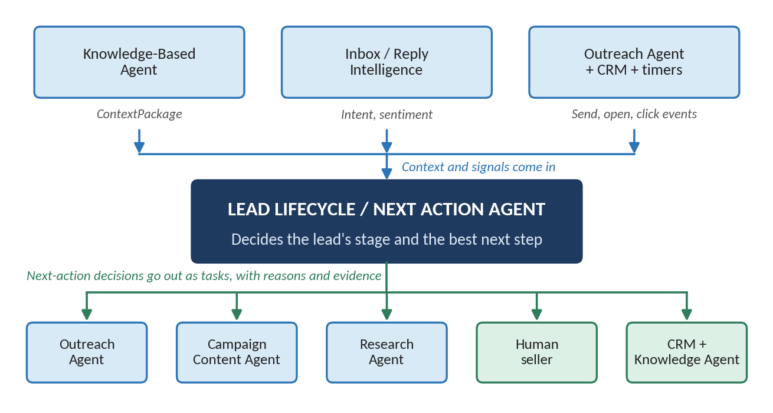
Figure 1: Position of the Lead Lifecycle Agent in the Sales AI platform

Functional responsibilities
Capability | Responsibility
Lifecycle state management | Maintains the current stage of each lead and records every stage change with its cause.
Event interpretation | Turns replies, sends, opens, clicks, meetings and CRM changes into meaningful signals.
Next-action decisions | Chooses the best action, channel, timing and owner for each lead.
Prioritization | Ranks leads and tasks so sellers and agents focus on the highest-value work.
Guardrail enforcement | Applies do-not-contact, consent, frequency and compliance rules before any action.
Approval routing | Sends low-confidence or high-impact decisions to a human for review.
Timers and follow-ups | Schedules waits, reminders and re-engagement, and detects stalled leads.
Decision logging | Records what was decided, why, using which evidence and which rule version.

4. Lead Lifecycle Agent Architecture
Figure 2 shows the internal architecture. Events flow downward through six layers: inputs, event intake, state assessment, the decision engine, guardrails and the action planner. The result, a NextActionDecision, goes to the orchestrator, which dispatches it. Outcomes return as new events (green arrow), and governance applies to every layer.
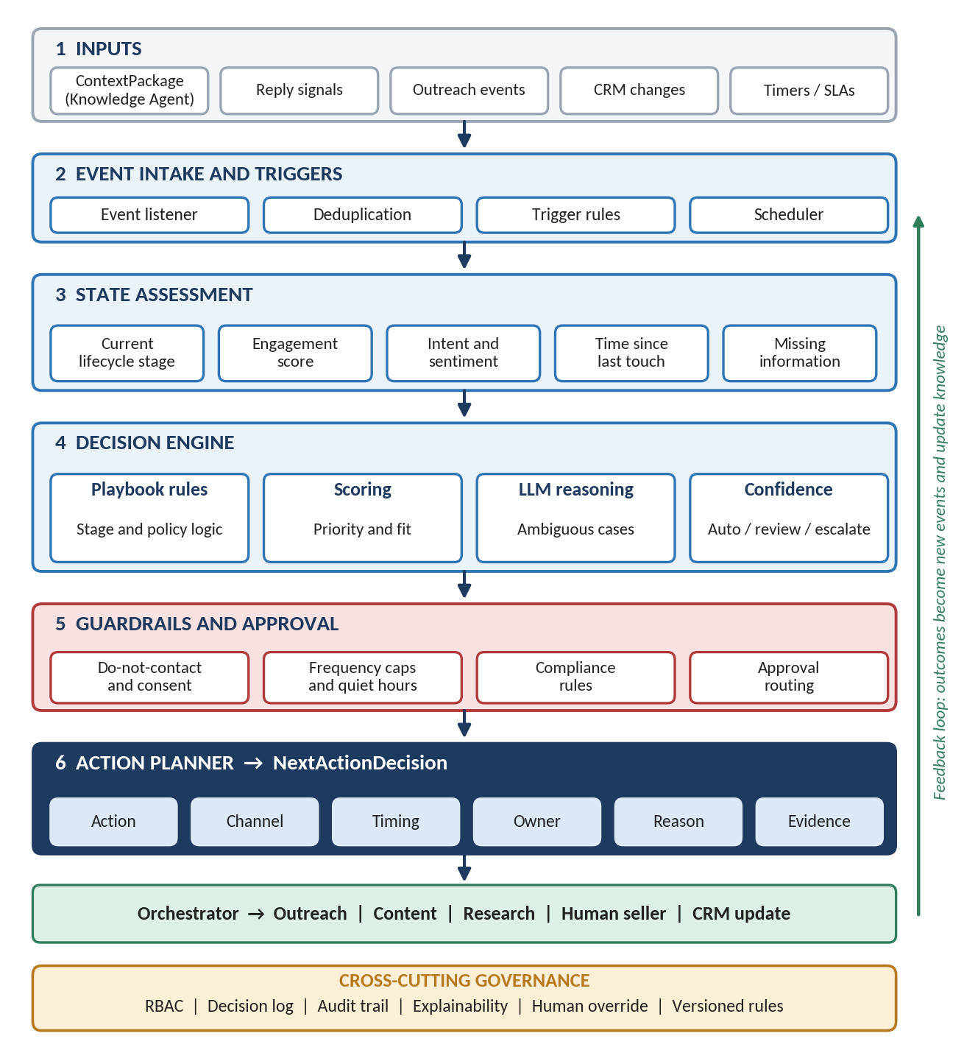
Figure 2: Lead Lifecycle / Next Action Agent architecture

5. Lifecycle Stages
Every lead is in exactly one stage. Figure 3 shows the main path and the common exits; the table explains each stage. Stage names can be adapted to the company's own sales process.
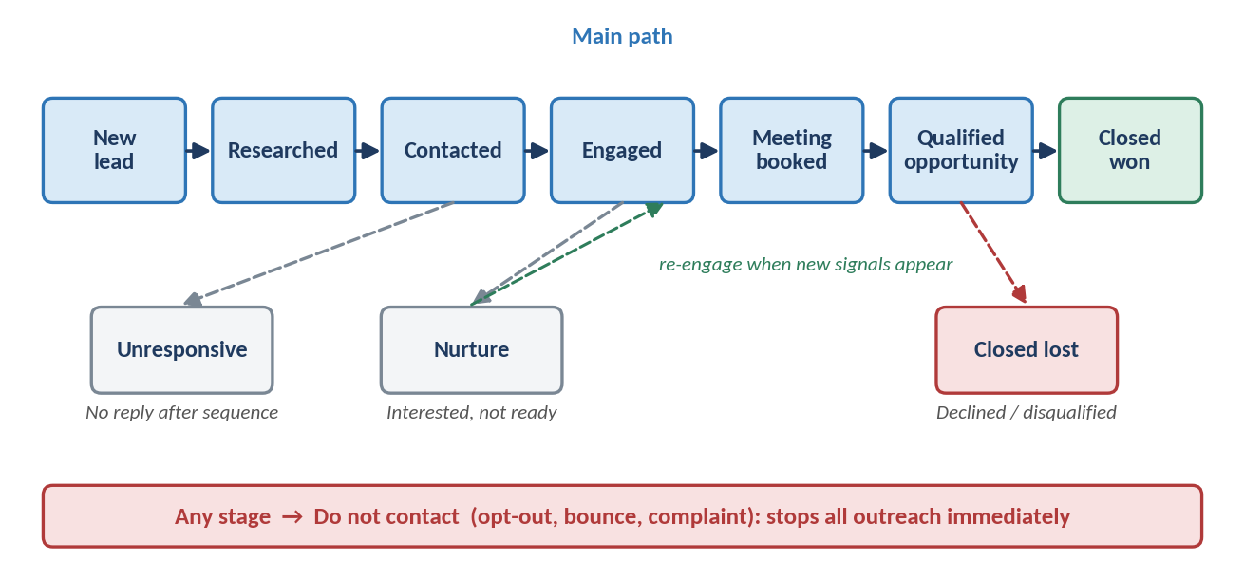
Figure 3: Lead lifecycle stages and transitions
Stage | Lead enters when | Typical next action
New lead | Lead is created in the CRM or captured from a form | Request context; trigger research if knowledge is thin
Researched | Research and context are complete | Request personalized content and plan first outreach
Contacted | First message has been sent | Wait for reply; schedule follow-up if none
Engaged | Lead replies, clicks or shows clear interest | Respond, answer questions, propose a meeting
Meeting booked | A meeting is confirmed | Prepare the seller with a briefing; send reminders
Qualified opportunity | Meeting outcome meets qualification rules | Hand over to a seller; update CRM and forecast
Nurture / Unresponsive | Interested but not ready, or no reply after the sequence | Low-frequency touches; re-engage on new signals
Closed won / lost | Deal result is recorded | Stop outreach; store the outcome and learning

6. Signals and Triggers
The agent acts on events, not on a fixed timetable alone. Each trigger below causes a re-assessment of the lead.
Trigger | Effect on the lead
LEAD_CREATED | Set stage to New lead and request context from the Knowledge-Based Agent.
RESEARCH_COMPLETED | Move to Researched; plan first outreach.
OUTREACH_SENT | Move to Contacted; start the follow-up timer.
REPLY_CLASSIFIED | Interested, question, objection, not now, wrong person, out of office or unsubscribe each lead to a different next step.
MEETING_BOOKED / COMPLETED | Update stage; prepare briefing or record the outcome.
NO_RESPONSE_TIMEOUT | Send a follow-up, switch channel or move to Unresponsive.
OPT_OUT / BOUNCE | Set Do not contact immediately and cancel all pending actions.
HUMAN_OVERRIDE | Apply the seller's decision and record it for learning.

7. Decision Logic
Decisions use three methods in order of certainty. Clear situations are handled by playbook rules. Scoring ranks leads and actions by priority and fit. AI reasoning handles ambiguous cases, such as a reply that is neither a clear yes nor a clear no. Every decision carries a confidence level that controls what happens next.
Confidence | What the agent does
High | Plans the action automatically, if guardrails allow it.
Medium | Plans the action and asks a seller to approve before it runs.
Low | Does not act; escalates to a human with the evidence and options.

Next-action type | Example
Send or draft a message | Follow-up after three days, or a reply to a question
Wait | Hold until a timer expires or a new signal arrives
Change channel | Switch from email to phone or LinkedIn after no response
Book or prepare a meeting | Propose times, or create a seller briefing
Request more knowledge | Ask the Research or Knowledge agent to fill a gap
Hand off to a human | Complex objection, high-value account or unclear intent
Pause, nurture or close | Not ready, lost, or do not contact

8. Guardrails and Human Approval
Guardrails run after the decision and before the action. They can block, delay or reroute a decision, but they never invent one.
Guardrail | Rule
Do-not-contact and consent | Never contact a lead who opted out, bounced or complained; honor regional consent rules.
Frequency caps | Limit touches per lead and per account within a time window.
Quiet hours and time zones | Send only at suitable local times.
Compliance checks | Apply required content, opt-out and data rules for each region and channel.
Approval matrix | Require human approval for high-value accounts, low confidence, pricing or contract topics, and any unusual action.

9. Working with Other Agents and the API
Agent | Lifecycle Agent receives | Lifecycle Agent sends
Knowledge-Based | ContextPackage: state, history, evidence, rules, conflicts | Stage changes, decisions and outcomes as events
Inbox / Reply Intelligence | Intent, sentiment, objections, requests, confidence | Requests for clarification when intent is unclear
Outreach | Send, delivery, open, click and bounce events | Approved tasks with channel and timing
Campaign Content | Content-ready confirmations | Content requests with goal and context
Lead Research | Research-complete events | Research requests for missing information

Endpoint | Purpose
POST /lifecycle/events | Submit an event for assessment
GET /lifecycle/state/{lead_id} | Return the current stage and status
POST /lifecycle/decide/{lead_id} | Request a next-action decision
POST /lifecycle/override | Record a human override or approval
GET /lifecycle/history/{lead_id} | Return stage changes and past decisions

Example NextActionDecision
{ "lead_id": "...", "stage": "Engaged", "action": "send_reply",
"channel": "email", "timing": "within_4h", "owner": "outreach_agent",
"reason": "Prospect asked for pricing details",
"evidence": [...], "confidence": 0.86,
"approval_required": false, "rule_version": "..." }

10. Security, Governance and Failure Handling
- Role-based access for users and agents; the agent sees only the lead data its role allows.
- Immutable decision log and audit trail, with reasons, evidence and rule version for every decision.
- Versioned playbook rules, so any past decision can be explained and any change can be rolled back.
- Human override at any time, and every override is recorded and used to improve future decisions.

Failure | Lifecycle Agent response
Knowledge context unavailable | Do not act on guesses; wait or escalate to a human.
Unclear or conflicting signals | Lower confidence and route to a seller instead of choosing silently.
Duplicate or out-of-order events | Use event IDs and timestamps so state is never updated twice.
Guardrail service failure | Fail closed: block the action rather than risk a violation.
LLM failure or stalled lead | Fall back to deterministic rules or escalate; timers flag stalled leads for a human.

11. Evaluation, Implementation Stack and MVP Scope

Evaluation and quality metrics
Metric | What it measures
Decision acceptance rate | How often sellers approve rather than change the recommended action.
Stage accuracy | Whether leads are in the correct stage.
Response time | Time from a reply or event to the next action.
Guardrail violations | Messages sent that should have been blocked (target: zero).
Conversion and escalation | Whether decisions lead to meetings and opportunities, and how often a human must step in.

Recommended implementation stack
Layer | Recommended direction
Backend | Python + FastAPI; workers for timers and scheduled checks
State, logs and events | PostgreSQL for lead state and the decision log; Redis for queues and timers; Kafka or Redis Streams for events
Rules and AI | Versioned rules engine (configuration or code) plus an enterprise LLM for ambiguous cases
Auth and deployment | OAuth2/OIDC + RBAC; Docker-based cloud deployment

MVP scope
- Core stages with clear transition rules and a stage-change log.
- Rule-based next actions for the common reply types, with timers for follow-ups.
- Basic guardrails: do-not-contact, frequency caps and approval for low confidence.
- Integration with the Knowledge-Based Agent, Inbox/Reply and Outreach agents.
- Decision log, RBAC and a simple seller approval screen.

12. Conclusion
Design principle: Receive the event → assess the lead's real state → decide using rules, scoring and reasoning → check every guardrail → plan a clear action → explain it → record the outcome → learn.

The Lead Lifecycle Agent turns knowledge into action. Backed by the Knowledge-Based Agent for facts and bounded by guardrails and human approval, it keeps every lead moving through the sales journey safely, on time and with a clear reason behind every step.

