LEAD RESEARCH AGENT
Research, Architecture and Technical Design
AI Sales Co-Pilot — Agent 2 of 6
Version 1.0

Purpose
This document explains what the Lead Research Agent does, how it works, what data it needs, how it checks information, and how it passes a clean research result to the next sales agent.

1. What is a Lead Research Agent?
A Lead Research Agent is an AI system that researches a sales lead before outreach. It identifies the person and company, collects useful information, finds recent business signals, checks the lead against the Ideal Customer Profile (ICP), and returns a structured result.
The agent should not simply generate a paragraph about a lead. It should produce evidence-backed facts that another agent can safely use.

2. Problem
- Salespeople spend too much time collecting information manually.
- Lead records can be incomplete, duplicated or outdated.
- Person and company information is spread across many systems.
- Recent events such as funding, hiring and leadership changes are easy to miss.
- Wrong or unverified information can create bad personalization.
- Different sources can disagree, so the agent needs a way to handle conflicts.

3. Main Objectives
- Identify the correct person and company.
- Collect current person and company information.
- Verify important contact information.
- Find useful buying signals.
- Keep the source and confidence of important facts.
- Calculate an understandable ICP score.
- Apply suppression and safety rules.
- Return a clean Lead Research Package.

4. System Architecture
The agent follows one clear flow. Research steps are grouped together, then their results are checked before the final score and output are created.
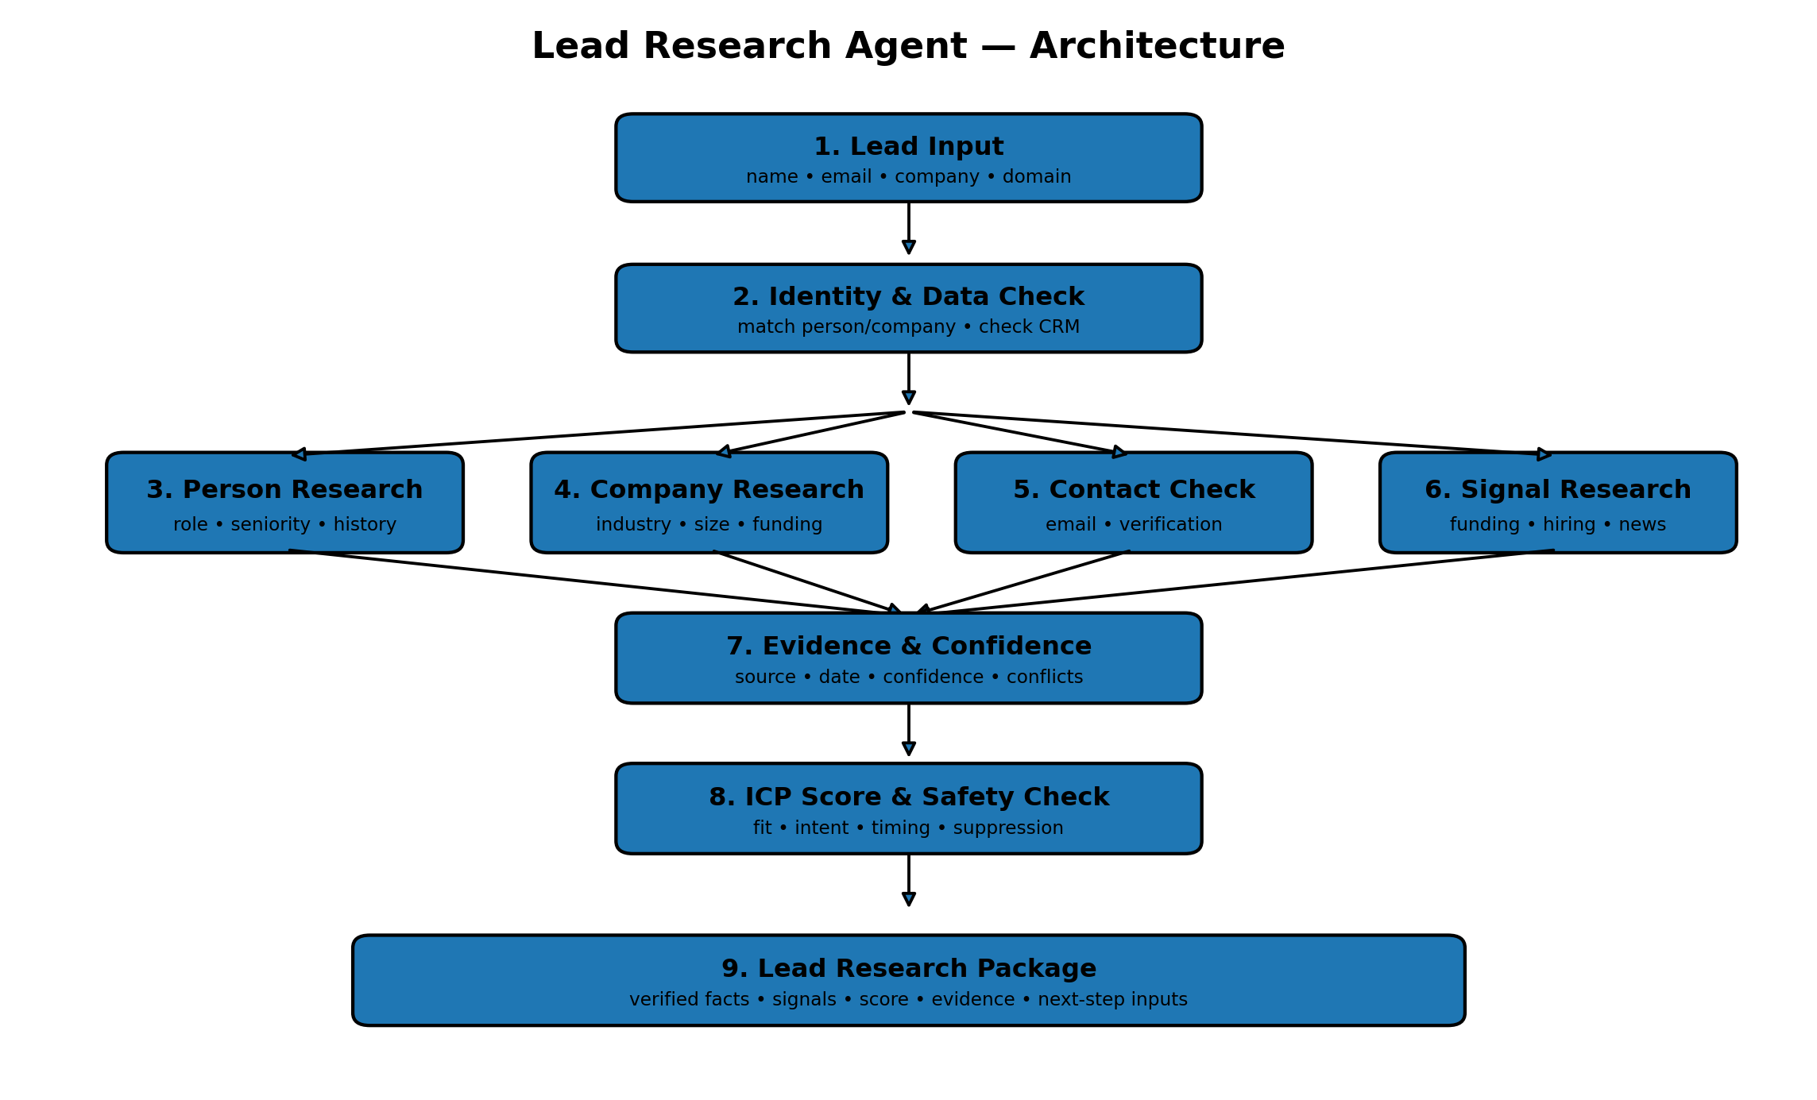
Figure 1. Lead Research Agent architecture.

5. How the Agent Works
- Receive the lead.
- Match the person and company.
- Check existing CRM data.
- Research person, company, contact and business signals.
- Attach evidence and confidence to important facts.
- Calculate ICP fit and lead priority.
- Run the safety and suppression check.
- Create the Lead Research Package.
- Pass the package to the next sales agent.

6. Input Data
Input | Purpose
Lead ID | Find the lead in the internal system.
Name | Help identify the person.
Email | Identify or verify the professional contact.
Company | Find the correct organization.
Domain | Strong company identity signal.
Profile URL | Help distinguish people with similar names.
ICP / Campaign ID | Select the correct scoring rules.

7. Information the Agent Collects

Person information
- Name
- Job title and department
- Seniority
- Location
- Work history
- Professional contact details where permitted

Company information
- Company name and domain
- Industry
- Employee count
- Location
- Funding
- Leadership
- Hiring activity
- Technology
- Recent company activity

8. Buying Signals
Signal | Example | Why it matters
Funding | New funding round | May indicate growth and budget.
Hiring | Hiring for a target team | May indicate an active business need.
Leadership | New executive | Can change priorities.
Expansion | New market or office | Can create new requirements.
Product | New product launch | Can create new operational needs.
Technology | New relevant technology | May show a technical priority.
Company news | Major partnership | Provides current sales context.

9. Data Sources and Tools
The agent should access external systems through separate tool adapters. This keeps the main agent independent from any single provider.
Tool type | Use
CRM / database | Existing lead data, history and suppression status.
B2B enrichment | Person and company information.
Email verification | Find or verify professional email addresses.
Business data | Funding, hiring, leadership and company signals.
Approved web/news search | Recent public company information.
Internal knowledge | ICP, product and sales rules.

10. Waterfall Enrichment
Use the cheapest and most trusted available information first. Do not call every service when the needed field is already fresh and verified.
Lead → CRM → Primary enrichment → Fallback enrichment → Verification → Signal research → Final package
- Check internal data first.
- Use the primary provider for missing or stale fields.
- Use a fallback provider only when needed.
- Verify important contact details.
- Record which tool supplied each important value.

11. Evidence and Confidence
Important facts should be traceable. The agent must separate a fact from an AI-generated interpretation.
Field | Meaning
Claim | The information being reported.
Source | Where the information came from.
Date | When it was observed or retrieved.
Confidence | How reliable the information is.
Status | Verified, conflicting or unverified.
Example: “The company raised funding” is a fact and should have evidence. “The company may be expanding quickly” is an inference and should be labelled as such.

12. ICP and Lead Priority Score
Use fixed rules for the number. The AI can explain the result, but it should not freely invent the score.
Area | Example weight | Checks
ICP Fit | 40% | Industry, size, location, role and technology.
Intent | 30% | Funding, hiring, leadership and other signals.
Timing | 20% | How recent and useful the signals are.
Confidence | 10% | Identity and evidence quality.
Example priority levels: 80–100 High, 60–79 Medium, 40–59 Low, below 40 Do Not Prioritize. These values should be tuned using real sales results.

13. Lead Research Package
Section | Contains
Lead | Name, role, company and domain.
Company | Industry, size, location, funding and other verified data.
Signals | Important recent events.
Evidence | Source, date and confidence.
ICP | Fit, intent, timing and total score.
Compliance | Eligible, review required or blocked.
Personalization inputs | Approved facts for the content agent.

14. Agent State
State | Purpose
lead_input | Original lead request.
identity | Matched person and company.
person_profile | Person information.
company_profile | Company information.
contact_data | Email and verification status.
signals | Business signals.
evidence | Sources and confidence.
icp_score | Score and reasons.
compliance_status | Allowed, review or blocked.
research_summary | Final result.
errors | Problems during the run.

15. Recommended Technical Stack
Area | Technology
Backend | Python + FastAPI
Agent workflow | LangGraph
Validation | Pydantic
Database | PostgreSQL
Cache / queue | Redis when needed
Secrets | Environment variables or secret manager
Dashboard | Existing sales frontend

16. Security and Privacy
- Keep API keys and secrets on the backend.
- Use only data needed for the sales purpose.
- Restrict access to lead information.
- Keep an audit record of important research actions.
- Do not give the research agent permission to send emails.
- Do not allow unrestricted external requests.
- Treat external web content as untrusted input.
- Check suppression rules before outreach eligibility.
- Define retention and deletion rules for stored lead data.

17. Failure Handling
Problem | Action
Person cannot be matched | Ask for more information or send for review.
Provider unavailable | Retry within limits or use a fallback.
Conflicting data | Keep the conflict and lower confidence.
Missing data | Return unknown; never guess.
Low confidence | Send for human review when important.
Blocked lead | Do not pass the lead to outreach.
Invalid AI output | Validate and retry using the required schema.

18. Connection to Other Sales Agents
Agent | How it uses Lead Research
Context & Knowledge | Provides ICP, product information and rules.
Campaign Content | Uses verified research for personalization.
Outreach | Uses verified contact and eligibility information.
Inbox & Reply | Can provide new information for future research.
Lead Lifecycle | Uses research and score for lead progression.

19. MVP Scope
- Accept a person, company or domain.
- Resolve identity.
- Use one main enrichment service and one fallback.
- Verify a professional email when required.
- Find key business signals.
- Store evidence for important claims.
- Calculate an ICP score.
- Run the suppression check.
- Return the Lead Research Package.
- Log the research run and errors.

20. Implementation Order
- Create Pydantic models.
- Create the PostgreSQL tables.
- Build identity resolution.
- Build the first enrichment adapter.
- Add email verification.
- Add fallback enrichment.
- Add business signal research.
- Add evidence and conflict handling.
- Add deterministic ICP scoring.
- Add the safety gate.
- Connect the workflow with LangGraph.
- Connect the output to the Campaign Content Agent.
- Test missing, conflicting and incorrect data.

21. Final Recommendation
The Lead Research Agent should be a controlled research workflow, not a free-running chatbot. Its main job is to collect useful information, verify it, find current business signals, score the lead and return a structured result.
The most important design rule is: the AI may summarize and explain information, but the system should control identity matching, validation, scoring, permissions, suppression and final state changes.

