CENTRALIZED SALES AI
AGENT PLATFORM
Unified Research, Architecture & Technical Design
Integrated design for six connected AI sales agents

Platform scope | Specialized agents
Shared intelligence | Knowledge-Based Agent
Research & qualification | Lead Research Agent
Campaign creation | Campaign Content Agent
Execution | Outreach Agent
Conversation intelligence | Inbox / Reply Intelligence Agent
Decision layer | Lead Lifecycle / Next Action Agent

Design objective
Create one governed sales system where each specialist agent has a clear job, uses shared context, returns structured results, and never acts outside the permissions and approval rules of the platform.

Prepared from the six supplied agent architecture and research documents. The report consolidates their common patterns into one platform design.

1. Executive Summary
Why the six agents should be designed as one platform
The supplied designs describe six specialist agents that solve different parts of the sales process. The common architectural pattern is a centralized orchestrator, a shared knowledge/context layer, persistent lead state, tool-based execution, event-driven updates, and human approval for risky actions.
- Lead Research finds and verifies useful person, company and buying-signal information before outreach.
- Campaign Content turns a structured brief into strategy, content, checks, approvals and performance learning.
- Outreach coordinates prospecting, qualification, personalization, execution, follow-up and CRM updates.
- Inbox / Reply Intelligence searches live mail, understands conversations, prioritizes replies and drafts responses.
- Lead Lifecycle / Next Action keeps one current stage per lead and chooses the next best action.
- Knowledge-Based Agent is the shared intelligence layer that retrieves evidence and assembles task-specific context for every other agent.

The central idea
The agents should not operate as six independent applications. They should work as specialist services around one sales state. The orchestrator routes work, the knowledge layer provides trusted context, the lifecycle agent decides what should happen next, action agents execute approved tasks, and every result becomes a new event.
Simple mental model
KNOW → RESEARCH → QUALIFY → CREATE → ACT → UNDERSTAND REPLY → DECIDE NEXT → UPDATE KNOWLEDGE

Expected benefits
Area | Platform outcome
Consistency | All agents use the same lead, account, campaign and conversation context.
Quality | Important claims carry evidence, source and confidence.
Automation | Routine research, content, outreach and inbox work can run with fewer manual steps.
Control | Suppression, permissions, approval gates and audit logs are enforced centrally.
Learning | Sends, replies, meetings, corrections and outcomes update shared state and knowledge.

2. Platform Scope and Agent Responsibilities
Six agents, six clear responsibilities
Agent | Primary responsibility | Main output
Knowledge-Based | Collect, normalize, store, retrieve and assemble trusted context. | ContextPackage
Lead Research | Identify people/companies, enrich data, find signals, score ICP fit and verify evidence. | Lead Research Package
Campaign Content | Plan campaigns, generate channel assets, check brand/claims/compliance and learn from results. | Campaign + approved content assets
Outreach | Discover/enrich/qualify prospects, personalize, execute approved outreach and manage follow-ups. | Outreach action + sequence state
Inbox / Reply | Search/read email, classify intent, summarize threads, draft replies and escalate meaningful conversations. | Reply intelligence + draft/handoff
Lead Lifecycle | Maintain stage, interpret events, choose next action, enforce guardrails and route approval. | NextActionDecision

Shared responsibilities
- Every agent receives a task-specific context package instead of raw database access.
- Every agent uses typed tools; the language model proposes tool calls but the backend executes them.
- Every important result is written back as an event or state update.
- Every customer-facing or irreversible action passes through policy and permission checks.
- Every important decision can be traced to evidence, confidence, rule version and actor.

What should not happen
Anti-pattern | Why it is unsafe / difficult
One giant agent doing everything | Large context, unclear ownership, hard testing and weak governance.
Direct LLM access to CRM or mailbox | Model can bypass permission and validation boundaries.
Independent memory per agent | Agents can disagree about lead state and repeat work.
Unverified personalization | Creates hallucinated claims and poor customer experience.
Automatic sending without a gate | High-impact external action is not controlled by policy.
Static knowledge only | The system becomes stale as leads, replies and campaigns change.

3. Main Unified Architecture
The complete platform view
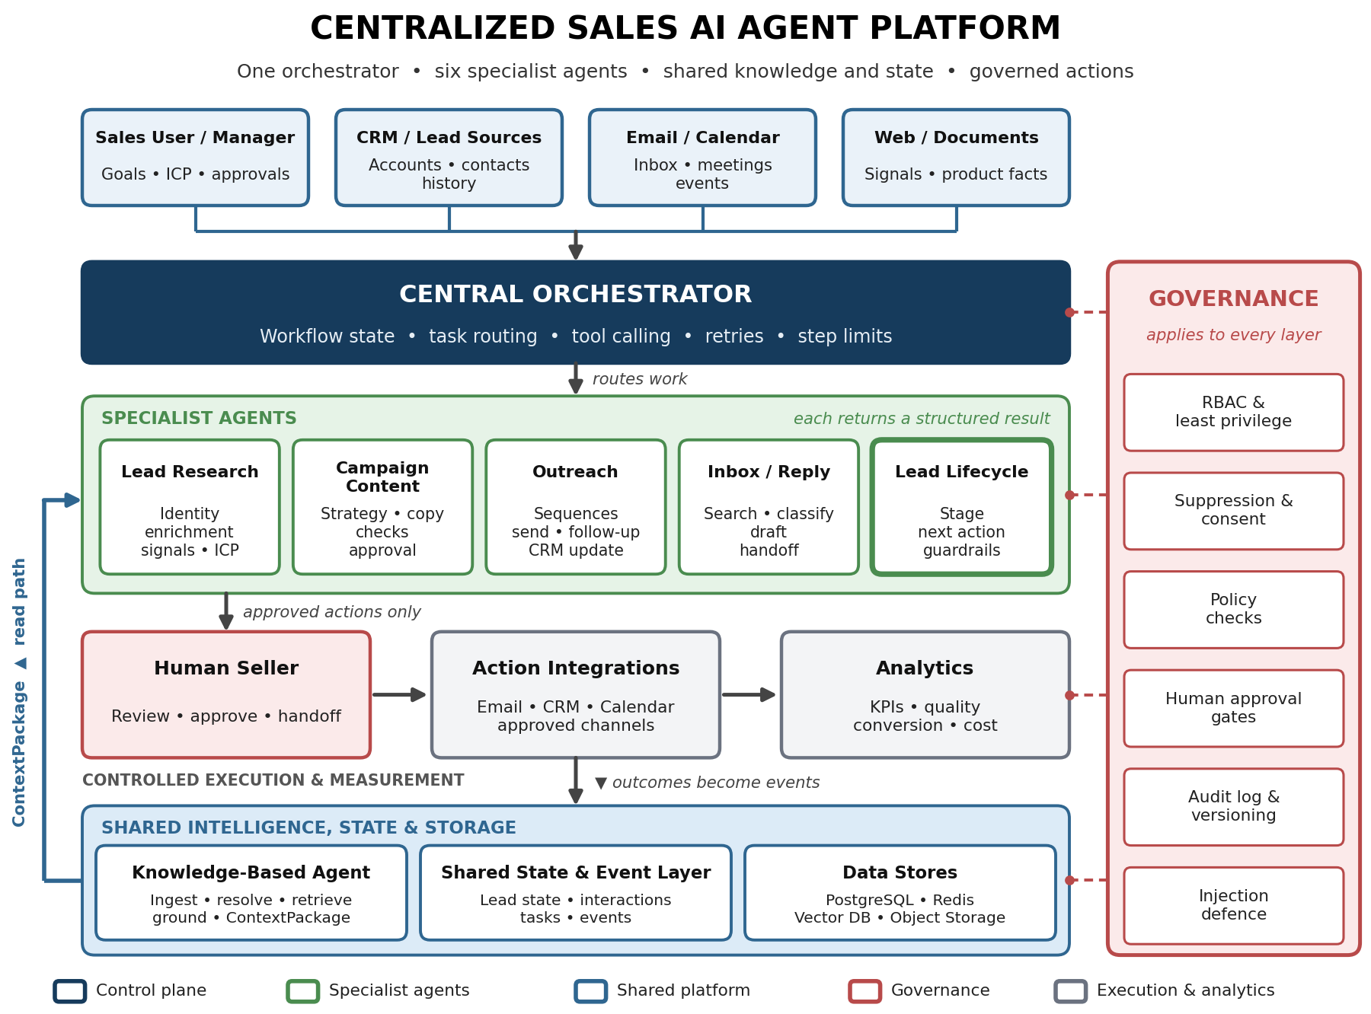
Figure 1. Main architecture of the centralized Sales AI Agent Platform.
The architecture combines the six supplied designs into one control plane. Inputs enter through business systems and user goals. The Central Orchestrator decides which specialist should work. The Knowledge-Based Agent and shared state layer provide common context. Governance applies across the platform. Actions are executed only through approved integrations, and outcomes return as events.
Most important connection
Lead Lifecycle is the decision layer, while Knowledge-Based is the shared context layer. The other specialist agents perform focused work and return structured evidence or outcomes.

4. Shared Knowledge and Context Layer
How all agents use the same trusted information
The Knowledge-Based design treats knowledge as more than a vector database. It combines structured business data, semantic knowledge, event history and current interaction context. It ingests information, resolves entities, stores it, retrieves task-specific evidence and assembles a compact ContextPackage.
Layer | Role | Examples
Sources | Original business and interaction inputs | CRM, product docs, playbooks, emails, calls, research, events
Ingestion | Bring information into the platform | Connectors, APIs, event consumers, file processing
Processing | Make information usable | Parsing, chunking, classification, entity resolution, deduplication, metadata
Stores | Keep different forms of knowledge | PostgreSQL, vector store, event store, object storage
Hybrid retrieval | Find the right context | Keyword + semantic + structured + history + permission filters
Context assembly | Prepare task-specific context | Identity, current state, history, evidence, constraints, conflicts
Governance | Control use of knowledge | RBAC, provenance, confidence, audit, human approval

Why shared context matters
- Lead Research can ask what is already known and what is missing.
- Campaign Content can retrieve persona, product facts, approved messaging and recent interactions.
- Outreach can check lead state, previous sends, channel constraints and timing before execution.
- Inbox can interpret a reply using conversation history, objections and campaign context.
- Lead Lifecycle can combine lifecycle, interactions, engagement, research, open tasks and playbook rules.
The result should be a ContextPackage with identity, current state, relevant knowledge, evidence, constraints and conflict information. This prevents each agent from inventing its own view of the customer.

5. Lead Research Agent
From raw lead to evidence-backed research package
The Lead Research design focuses on accurate identity, current person and company information, business signals, ICP fit, evidence and confidence. It is not a paragraph generator; its output is intended to be safely consumed by downstream agents.
- Receive lead input and campaign/ICP rules.
- Match the person and company and check existing CRM data.
- Research person, company, contact and business signals.
- Attach source, date, status and confidence to important facts.
- Calculate ICP fit, intent, timing and confidence using fixed scoring rules.
- Run suppression and safety checks.
- Create the Lead Research Package and pass it to the next agent.
Research area | Examples
Person | Name, title, department, seniority, location, work history
Company | Industry, size, location, funding, leadership, hiring, technology, recent activity
Buying signals | Funding, hiring, leadership change, expansion, product launch, technology change, major partnership
Evidence | Claim, source, date, confidence, status
Scoring | ICP fit 40%, intent 30%, timing 20%, confidence 10% as an example framework
Output | Lead identity, company data, signals, evidence, score, compliance and personalization inputs

Waterfall enrichment
The supplied design recommends using the cheapest and most trusted available information first: internal CRM data, then primary enrichment, fallback enrichment when necessary, contact verification, signal research and finally the packaged result. This reduces cost and unnecessary external calls.

6. Campaign Content Agent
Turning a campaign brief into approved multi-channel content
The Campaign Content design treats content creation as a controlled workflow rather than a one-shot generation task. The agent works from a structured brief, retrieves approved brand and product knowledge, generates assets, checks them, routes them for approval, publishes when permitted and learns from performance.
Stage | What happens
Brief | Capture objective, audience, offer, channels, dates, budget and constraints.
Plan | Retrieve brand kit, product facts and past performance; propose message pillars and calendar.
Generate | Create channel-specific posts, emails, ad copy, outlines, scripts and image prompts.
Check | Run brand, claim, compliance, similarity and platform-format checks.
Review | Human edits, comments, approves or rejects; feedback is applied to assets.
Publish | Schedule or publish approved content through integrations.
Measure & learn | Read performance, compare variants and inform the next plan.

Grounding rules
- Brand voice and do-not-say rules are retrieved instead of remembered by the model.
- Product facts, prices, offers and legal disclaimers are treated as approved claims.
- Each important claim should be traceable to the supporting knowledge entry.
- Unsupported claims are flagged rather than silently accepted.
- Human approval is required before publishing or spending budget.

Connection to the other agents
Campaign Content can use Lead Research evidence for audience-specific messaging, Knowledge-Based context for product and brand facts, Outreach state for campaign sequencing, Inbox signals for objections and Lead Lifecycle decisions for when new content is needed.

7. Outreach Agent
The execution engine for qualified prospects
The Outreach design combines prospect discovery, enrichment, research, qualification, personalization, policy checks, execution, reply monitoring, follow-up, CRM memory and analytics. Its core goal is relevant conversations, not simply more messages.
- Define campaign goal, target audience, offer and constraints.
- Discover prospects from permitted sources or CRM segments.
- Enrich missing contact and company information.
- Research current and relevant signals.
- Qualify against ICP, intent/readiness and exclusion rules.
- Prioritize high-fit and high-intent prospects.
- Personalize from verified evidence and approved value propositions.
- Validate factual grounding, missing variables, tone and policy.
- Obtain approval when required and execute the approved action.
- Track sends, timestamps, content versions and statuses.
- Monitor replies, bounces and out-of-office events.
- Classify replies and stop, follow up or hand off as appropriate.
- Update CRM/shared state and measure performance.
Personalization rule
Use a specific, verified observation connected to a relevant business problem. If a required variable is missing, use a safe generic structure rather than inventing information.

Connection to the platform
Outreach receives research and context from shared knowledge, uses Lifecycle decisions to determine when and how to act, sends through permissioned integrations, and sends every outcome back as an event so Inbox and Lifecycle can react.

8. Inbox / Reply Intelligence Agent
Understanding live conversations and protecting the handoff to humans
The Inbox Agent connects to Gmail or Outlook through OAuth. It searches and reads mailbox data, summarizes threads, classifies intent, identifies messages needing action, drafts replies and can take approved actions. The model never touches the mailbox directly; backend tools execute all operations.
Capability | Platform behavior
Search | Find by sender, date, label, keyword or semantic meaning.
Understand | Summarize threads; detect intent, sentiment and urgency.
Prioritize | Surface replies, waiting threads and approaching deadlines.
Extract | Pull names, dates, amounts, requests and action items.
Draft | Create a reply in the approved user style without sending.
Act | Send, label, archive or schedule only when permission and approval allow it.
Background mode | Use events/webhooks and workers to classify new mail and notify or prepare drafts.

Reply decision examples
Reply type | Default platform response
Interested | Stop automated sequence and create seller handoff.
Question | Use approved knowledge to draft/answer; escalate if uncertain.
Objection | Prepare approved response or route to seller.
Not interested | Stop sequence and record disposition.
Unsubscribe | Immediately suppress future outreach.
Wrong person | Identify or request the correct contact when policy allows.
No reply | Lifecycle agent evaluates whether a follow-up is eligible.

OAuth tokens remain on the backend, email content is treated as untrusted input, and sending is enforced as a backend approval-controlled action.

9. Lead Lifecycle / Next Action Agent
The decision layer that connects all other agents
The Lifecycle Agent answers three questions for every lead: where is the lead now, what just changed, and what should happen next? It maintains one current stage, interprets events, chooses the next action and applies guardrails before action dispatch.
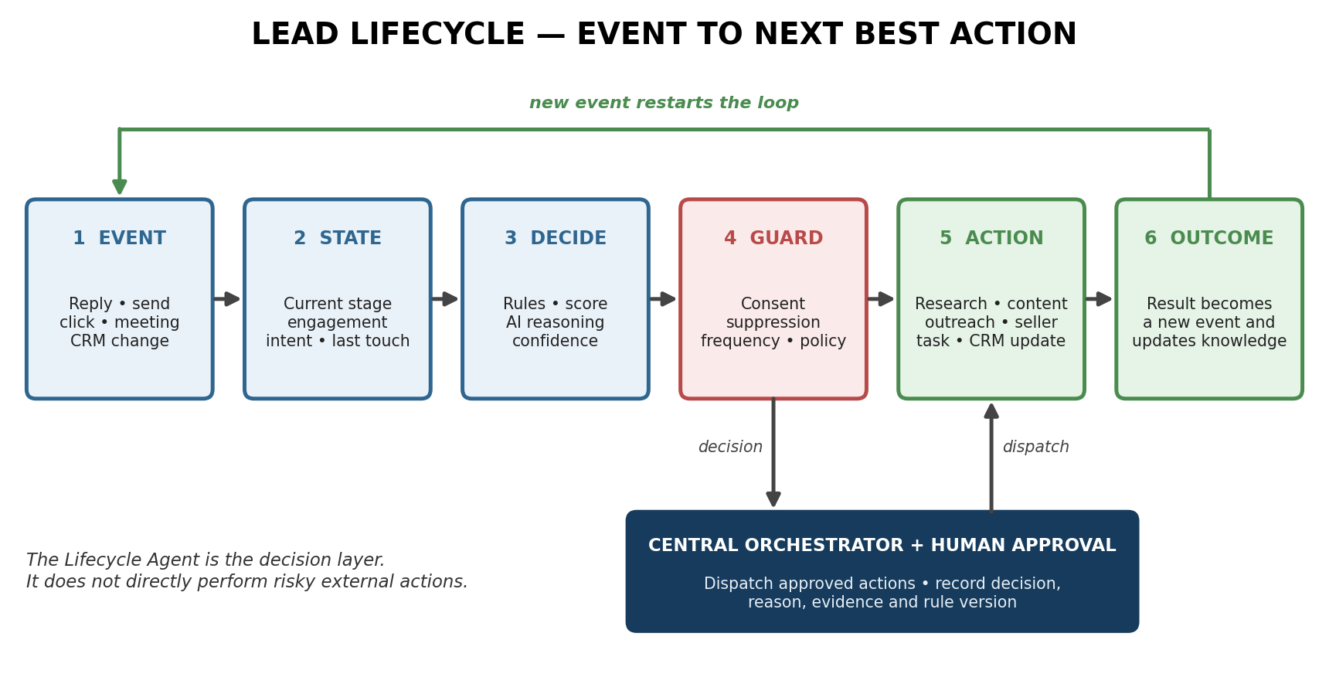
Figure 2. Event-driven lifecycle decision loop.
Decision input | Examples
Context | Lead identity, company, research, campaign and knowledge.
Engagement | Replies, opens, clicks, meetings and recent activity.
Time | Time since last touch, scheduled timers, stalled-lead rules.
Decision methods | Playbook rules, scoring, LLM reasoning and confidence.
Guardrails | Do-not-contact, consent, frequency caps, compliance and approval.
Output | Action, channel, timing, owner, reason and evidence.

10. Agent-to-Agent Interaction and Handoffs
How the specialists work together without becoming one large agent
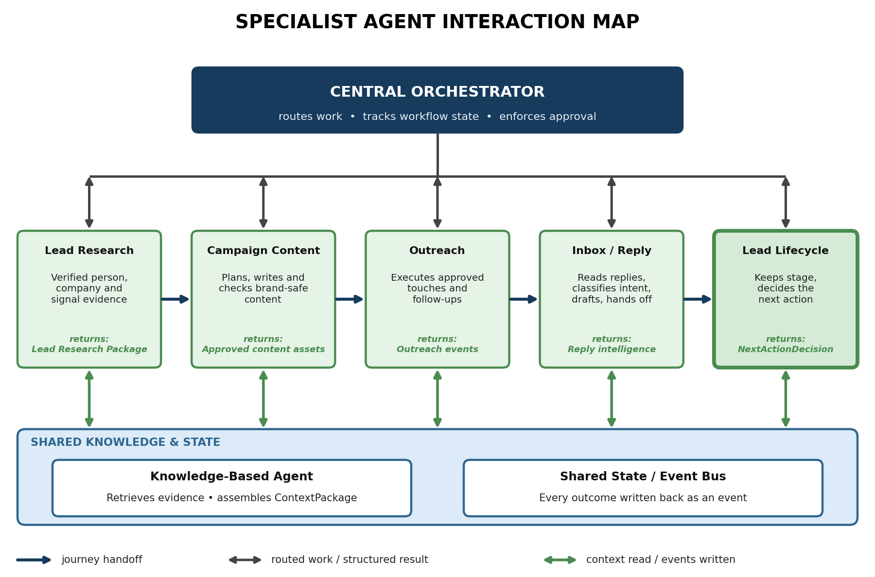
Figure 3. Specialist interaction map. The arrows represent routed work and shared context, while the event layer keeps the system state current.

Typical end-to-end lead journey
- New lead enters CRM or campaign segment.
- Lifecycle requests context and research when information is thin.
- Lead Research creates an evidence-backed research package.
- Lifecycle evaluates the lead and requests Campaign Content or Outreach work.
- Campaign Content creates approved messaging; Outreach executes approved touches.
- Outreach events and inbox replies are written to shared state.
- Inbox classifies replies and creates a draft or human handoff when needed.
- Lifecycle reads the new event and chooses the next action.
- Knowledge-Based Agent updates the shared record with new evidence, interaction history and human corrections.
- The loop continues until the lead reaches a terminal state such as qualified, converted, lost or suppressed.

11. Data, State and Event Model
The shared data contract that keeps the agents synchronized
A centralized platform needs one reliable representation of the lead and its history. The individual agents can own specialist outputs, but they should not create separate competing lifecycle records.
Core object | Key fields / purpose
Lead | Identity, contact, company, source, lifecycle stage, owner, consent/suppression.
Company | Domain, industry, size, location, technology, business signals.
ResearchPackage | Verified facts, signals, score, evidence, confidence, research timestamp.
Campaign | Goal, audience, channels, offer, schedule, budget, constraints.
ContentAsset | Channel, version, status, evidence, checks, reviewer, publish time.
OutreachEvent | Channel, timestamp, content version, status, provider event ID.
Conversation | Thread, participants, messages, intent, sentiment, open requests, handoff.
NextActionDecision | Action, channel, timing, owner, reason, evidence, confidence, rule version.
KnowledgeItem | Claim, source, timestamp, provenance, permissions, confidence, freshness.
AuditEvent | Actor, tool, action, inputs/outputs metadata, approval and result.

Event-driven pattern
Examples of events include LeadCreated, ResearchCompleted, OutreachSent, EmailReceived, ReplyClassified, MeetingBooked, HumanApproved, ContentPublished and LeadStageChanged. Each event should be idempotent so retries do not create duplicate state changes.

12. Security, Governance and Reliability
Safety is a platform feature, not a prompt instruction
Control | Implementation direction
Least privilege | Give each agent only the tools and scopes required for its job.
Human approval | Require approval for sending, publishing, high-impact decisions and sensitive cases.
Suppression | Check do-not-contact, consent and frequency limits before outreach.
Evidence | Require sources and confidence for important factual claims.
Injection defence | Treat email, web pages and external documents as untrusted input.
Secrets | Keep API keys and OAuth tokens on the backend, encrypted and out of the browser.
Audit | Record important research, tool calls, decisions, approvals and external actions.
Versioning | Version prompts, playbooks, campaign rules and decision policies.
Failure safety | When a source fails or data conflicts, mark uncertainty instead of inventing an answer.
Retention | Define what lead, email and research data is retained and when it is deleted.

Failure handling
- External source unavailable → use available trusted data and clearly mark the gap.
- Retrieval failure → fall back to structured/keyword retrieval where possible; never invent missing context.
- Entity ambiguity → keep the lead unresolved or request clarification.
- Conflicting data → preserve conflict metadata and use source/recency rules rather than silently choosing.
- LLM extraction failure → retry or use deterministic parsing while preserving the raw source.
- Permission failure → exclude restricted information and record the access decision.
- Duplicate event → use event IDs and idempotency keys.
Governance principle
The model may recommend. The platform decides whether the recommendation is permitted, approved and executable.

13. Technical Stack, APIs and Implementation Roadmap
A practical build plan based on the supplied architectures
Layer | Recommended direction
Frontend | React + TypeScript or the existing sales frontend
Backend API | Python + FastAPI
Agent orchestration | LangGraph or application-level workflow orchestration
Validation | Pydantic / typed schemas
Structured data | PostgreSQL
Cache / jobs | Redis + worker system
Semantic retrieval | Production vector database + embeddings
Documents / assets | Object storage + CDN where needed
Email | Gmail API / Microsoft Graph with OAuth 2.0
External actions | Typed integration services with permission checks
Authentication | OAuth2/OIDC + JWT + RBAC
Deployment | Docker-based cloud deployment

Recommended implementation order
- Build the shared data model, authentication, audit log and central API.
- Build the Knowledge-Based Agent and ContextPackage contract.
- Build Lead Research with evidence and scoring.
- Build Lead Lifecycle as the decision and routing layer.
- Build Campaign Content with brand grounding and approval.
- Build Outreach execution with strict suppression and send controls.
- Build Inbox / Reply Intelligence with OAuth and backend approval for sending.
- Connect events, analytics and feedback loops across all agents.
- Add optimization only after quality, safety and state consistency are measurable.

MVP boundary
Start read-heavy and approval-heavy. Research, retrieval, classification and drafting can be automated first. External sending, publishing and other irreversible actions should remain gated until confidence, logging and failure handling are proven.

14. Evaluation, KPIs and Final Architecture Principles
How to know the platform is working
Area | Useful measures
Knowledge | Retrieval precision/recall, groundedness, freshness, entity-resolution accuracy, provenance coverage.
Research | Research completeness, evidence coverage, score consistency, stale-data rate.
Campaign Content | Brand-check pass rate, claim accuracy, approval rate, revision rate, content performance.
Outreach | Qualified lead rate, valid contact rate, bounce rate, reply rate, positive reply rate, meeting rate.
Inbox | Classification accuracy, urgent-email recall, draft acceptance, handoff accuracy, response latency.
Lifecycle | Stage accuracy, next-action acceptance, stalled-lead reduction, policy-block rate.
Platform | Latency, cost per run, tool failure rate, duplicate-event rate, audit coverage.

Final architecture principles
- One shared state: all agents work from the same current lead and account reality.
- One shared knowledge layer: evidence is retrieved once and reused across tasks.
- Specialist agents: keep responsibilities narrow enough to test and govern.
- Central orchestration: route work and enforce workflow state rather than letting agents call each other freely.
- Event-driven feedback: every important outcome becomes a new fact for future decisions.
- Rules + scoring + AI: deterministic policy for clear cases, scoring for priority, AI reasoning for ambiguity.
- Approval by risk: drafting can be automated; irreversible actions require explicit permission.
- Evidence before personalization: do not invent prospect facts, claims or business events.
- Audit everything important: decisions should be explainable after the fact.
- Measure before optimizing: improve prompts and workflows only after quality and safety are observable.
Final conclusion
The strongest design is not six separate AI bots. It is one governed Sales AI platform with a central orchestrator, a shared knowledge/context service, shared lead state and events, six specialist agents, and controlled human approval. This structure keeps the system modular while allowing every agent to contribute to the same sales journey.

End of report

