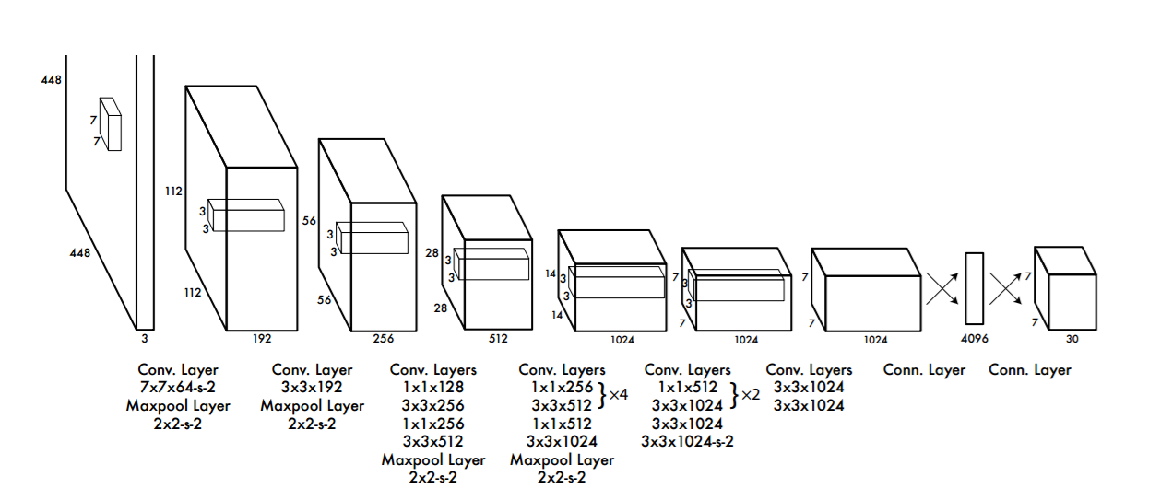 OBJECT

AVOIDANCE

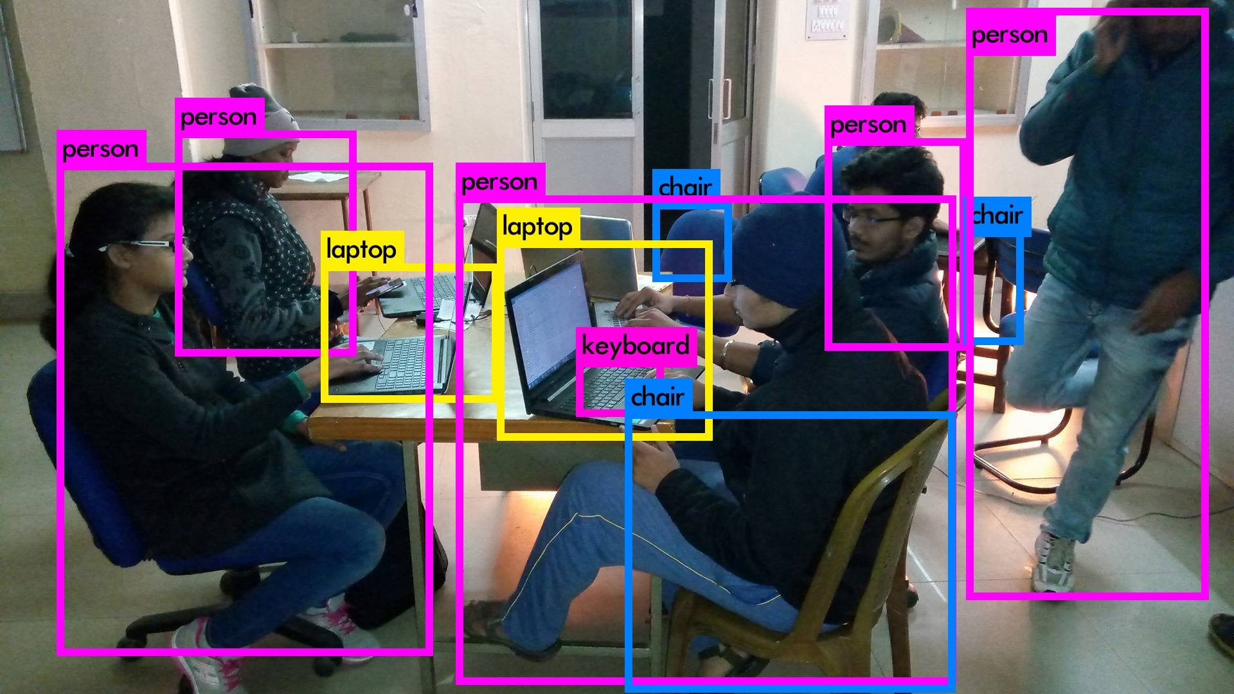A SYSTEM WHICH AVOIDS AND LOCALIZES THE OBSTACLES IN THE PATH OF A BOT MOVING ON A ROAD

ABSTRACTION:-

* USE OF CNN FOR TRAINING DATASET OF IMAGES
* USE OF YOLO(DARKNET) VIN :-DETECTION SYSTEM TO TRAIN AND TEST DATA

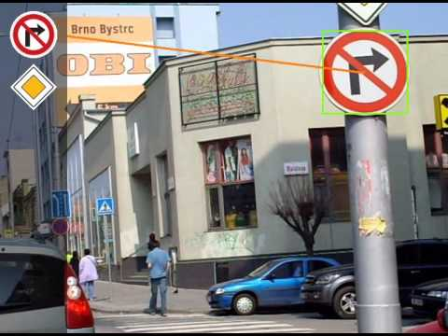

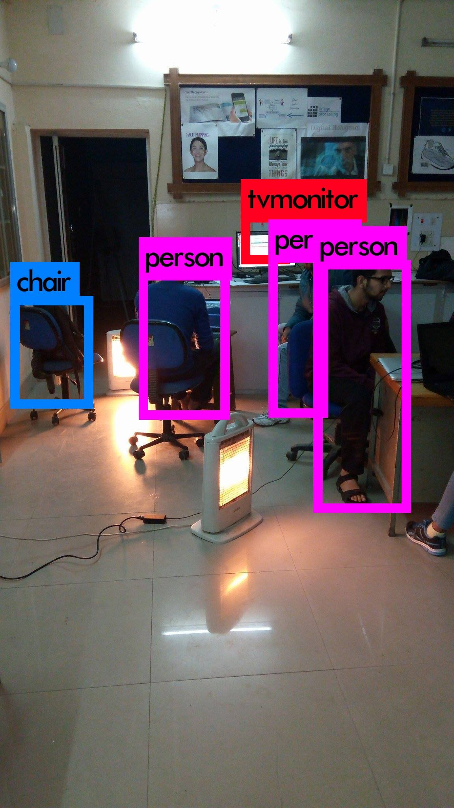

TEAM MEMBERS:

* KARAN , ECE , II YEAR
* SANYAM , ECE , II YEAR
* AALIND , ECE , II YEAR