***Ultrasonic detector of a person in temple lab file experiment.***

***Circuit diagram:***

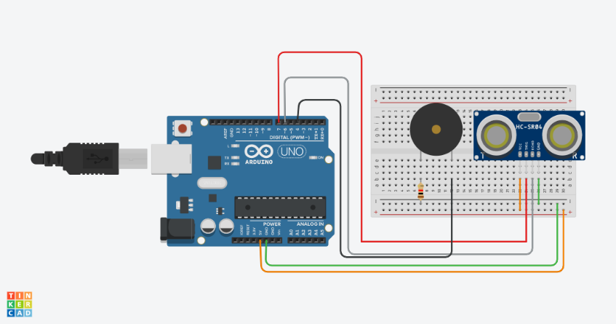

***THEORY:***

***Concept Used:-***

***In this project we have used a concept of ultrasonic object detector(sensor). It detects the person entering a temple through some distance and then the buzzer gets on and runs for 2ms until another person enters the temple including the fact that only one person enters the temple at a time.***

***LEARNING AND OBSERVATIOBS:***

***Learnings: -***

* ***How to make use of ultrasonic sensors for object detection and the concept of buzzers.***
* ***To do coding on Arduino software as well on tinkercad.***
* ***Compiling and uploading codes done on tinkercad.***
* ***Use of tinkercad for making hardware and software and multimeters (for resistance calculation).***
* ***Use od breadboard and to make and execute circuits on it.***

***Observations: -***

* ***Working of a software on tinkercad.***
* ***Ringing of buzzer when sensor detects some object.***
* ***Software and hardware used for making circuit.***

***PROBLEMS AND TROUBLESHOOTING:***

* ***Uploading and compiling of codes.***
* ***Checking connections and underlining defective buzzers or sensors.***
* ***Checking correct port for software on tinkercad and type of Arduino.***
* ***Correct working of various hardware and software used.***

***Precautions:***

* ***Don’t make loose connections.***
* ***Don’t connect Arduino to the respective pc until the circuit is complete.***
* ***Carefully look on the working of all the devices used while making circuit.***
* ***Carefully look on the working of ultrasonic sensors and buzzers.***

***Outcomes:***

* ***The circuit is complete and ringing of buzzer when ultrasonic sensor detects any object at a particular distance is observed.***
* ***Can be used also for security purpose for many temples.***
* ***Can be used as a smart way to detect a person entering in a temple.***